

Computer Games Development CW208

Technical Design Document

Year III

Alex O’Toole

C00216096

03/05/2020

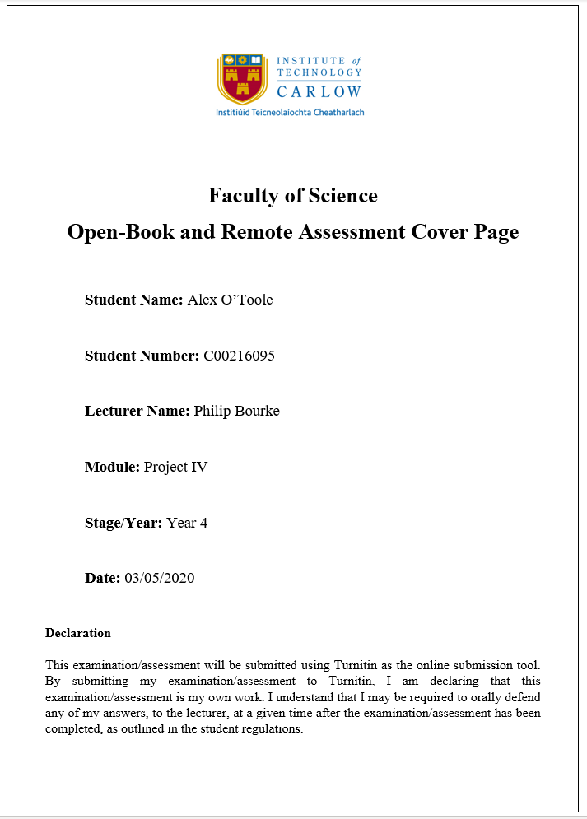

Contents

Features **2**

Feature: LocalAvatar 3

Feature: Room 3

Feature:Box 3

Feature:Cube 3

Feature: Shape 3

Feature: Spawn Point 4

Feature: Button 4

Feature: Basketball Hoop 4

Feature: Basketball 4

Feature: Flashlight 4

CRC Cards **5**

Class Name : Cube 6

Class Name : Box 6

Class Name : gameController 6

Class Name : Basketball 6

Class Name : Floor 7

Class Name : gameController 7

Class Name : Flashlight 7

Class Name : Shape 7

Class Name : Box 8

Class Name : FinalLevelController 8

# **Features**

## Feature: LocalAvatar

Tasks:

1. Add the Oculus Integration toolkit to the project.
2. Add the local avatar prefab to the scene.
3. Remove the default camera from the scene (avatar has it own OVR camera)
4. Replace controller models with custom hand models.
5. Set tracking to floor level so that all tracking is based on the users height.

## Feature: Room

Tasks:

1. Add in five planes to the scene.
2. place them to form a room (floor, 4 walls)
3. resize planes so that room is 25m^2 in the real world.

## ***Feature:***Box

Tasks:

1. Create a box model in Unity.
2. Add a collider to the box
3. Create a script that adds an object to a list when it enters the box.
4. Make the finished object a prefab for reuse.

## Feature:Cube

Tasks:

1. Add a cube to the scene.
2. Create a script that changes the material on the cube to grey when the level starts
3. add to the script so that it can also reapply the previous material for when the level ends.
4. add to the script so it positions the cube at a random spawn point.
5. Add the OVR Grabbable script so that the object can be interacted with
6. Make the finished object a prefab for reuse.

## Feature: Shape

Tasks:

1. Create a script
2. Add to the script so that it randomises the shape from a possible of 4 shapes.
3. Add to the script so that it randomises the colour of the shape.
4. Add to the script so that it places the shape at a random spawn point.
5. Make the finished object a prefab for reuse.

## Feature: Spawn Point

Tasks:

1. Create a series of empty gameobjects that can be placed around the scene and used in a list so that any script can access them and spawn objects at their positions.

## Feature: Button

Tasks:

1. Create a button model.
2. Add a spring joint to the model.
3. Add to the script so that when the button hits the a collider just above to spring joint it does something. (eg.start level, go to level, quit, etc)
4. Make the finished object a prefab for reuse.

## Feature: Basketball Hoop

Tasks:

1. Create a basketball hoop model in unity using the available shape in unity.
2. Add colliders to the rim.
3. Add script to check when an object(basketball) collides with that collider.
4. Add ui elements to the backboard to keep track of time and score.

## Feature: Basketball

Tasks:

1. Create a sphere object.
2. Add OVR grabble script so that it is interactable.
3. Add script that destroys the ball after a time delay triggered by a bool. (Bool can be changed in other scripts)
4. Make the finished object a prefab for reuse.

## Feature: Flashlight

Tasks:

1. Add script to flashlight model.
2. Add colliders to the flashlight model.
3. In Script check if the light is in either the right or left hand.
4. Add on off functionality based on if it's in the user's hand and the trigger is pressed.

# **CRC Cards**

*Level One*

|  |  |
| --- | --- |
| ***Class Name :*** Cube | |
| Responsibilities | Collaborators |
| Position cube at random spawn point on table. |  |
| hide and reveal materials |  |

# 

|  |  |
| --- | --- |
| ***Class Name :*** Box | |
| Responsibilities | Collaborators |
| Detect what cube has entered the box. | gameController |

|  |  |
| --- | --- |
| Class Name : gameController | |
| Responsibilities | Collaborators |
| start and stop level timer. | Box |
| generate a correct answer |  |
| check anwer once boxes are full |  |

*Level Two*

|  |  |
| --- | --- |
| Class Name : Basketball | |
| Responsibilities | Collaborators |
| destroy the ball after a time delay |  |

|  |  |
| --- | --- |
| Class Name : Floor | |
| Responsibilities | Collaborators |
| instantiate new ball when a ball hits the floor | Basketball |
| start the ball destroy timer |  |

|  |  |
| --- | --- |
| Class Name : gameController | |
| Responsibilities | Collaborators |
| start and stop level timer. |  |
| track the score |  |
| update level text |  |

*Level Three*

|  |  |
| --- | --- |
| Class Name : Flashlight | |
| Responsibilities | Collaborators |
| light up the room |  |
| activate and deactivate via user input |  |

|  |  |
| --- | --- |
| Class Name : Shape | |
| Responsibilities | Collaborators |
| create a random of 4 possible shapes | Box |
| randomly colour the shape |  |
| randomly position shape in the room |  |
| destroy shape after time delay |  |

|  |  |
| --- | --- |
| Class Name : Box | |
| Responsibilities | Collaborators |
| detect what shape entered the box | Shape |
| start shape destroy timer |  |
|  |  |
|  |  |

|  |  |
| --- | --- |
| Class Name : FinalLevelController | |
| Responsibilities | Collaborators |
| start and stop level timer. |  |
| update level text |  |
| generate a correct answer |  |
| check answer when box is full |  |