1. Install far manager <https://farmanager.com/download.php?l=ru>
2. Start it
3. Press alt+F2 to move to NetBox screen in the second far part  
   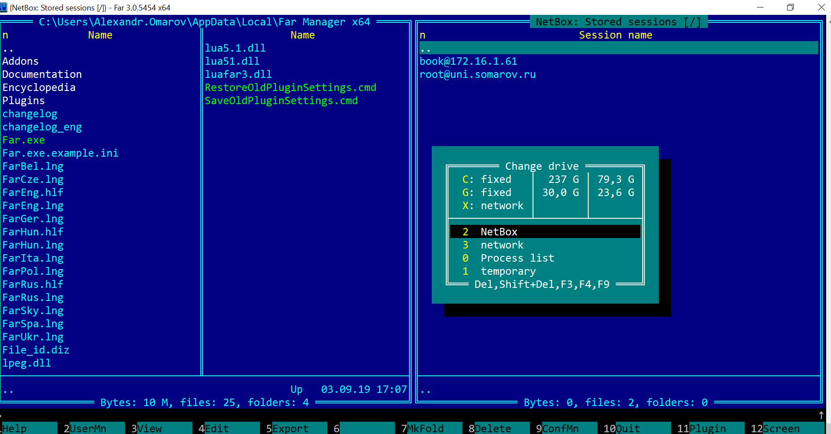
4. Press shift+F4 to create a new SSH session (don’t fill password!) AND USER WILL BE ROOT  
   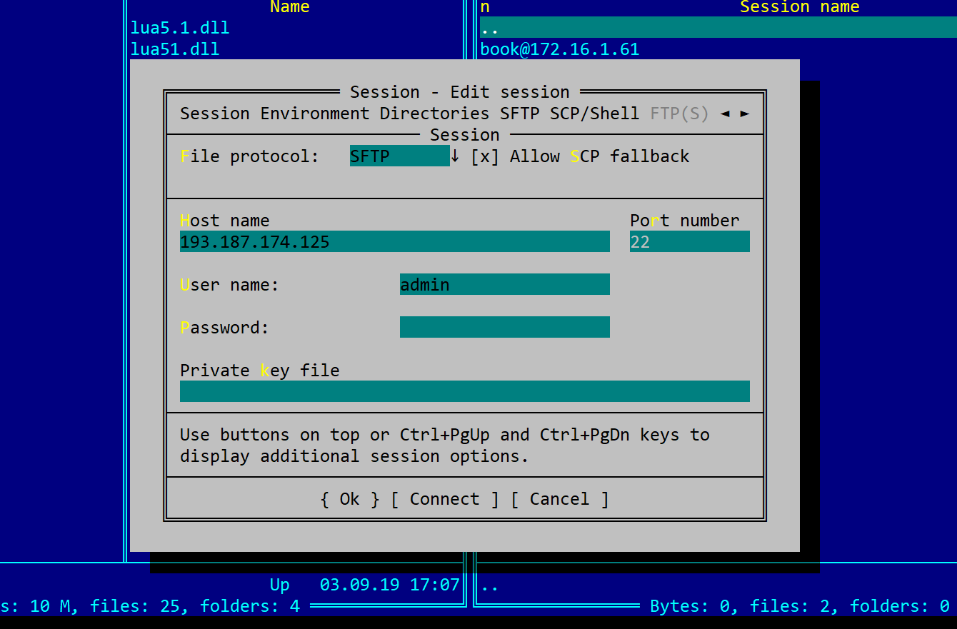
5. Press OK and click on the new row in the list
6. Add new fingerprint to your hosts  
   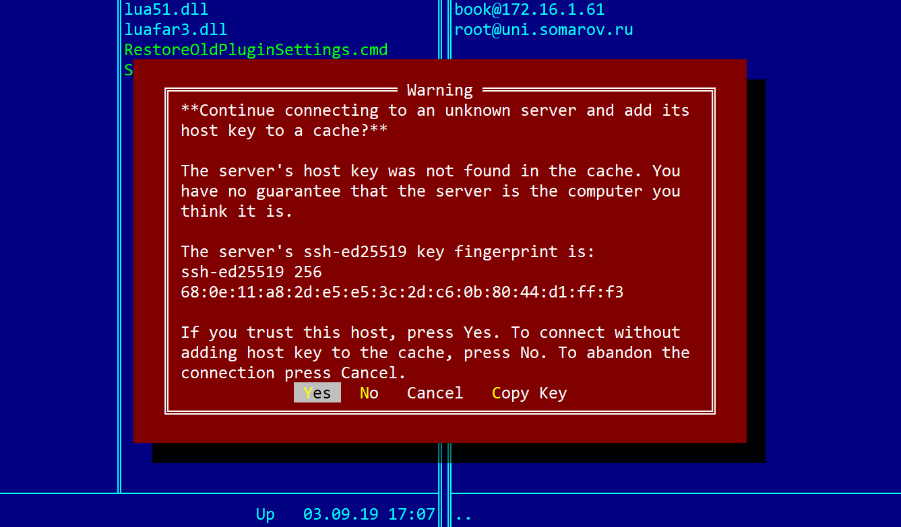
7. Enter password
8. Congratz, you are inside of our server! Now it’s working just like putty, but it’s much more comfortable  
   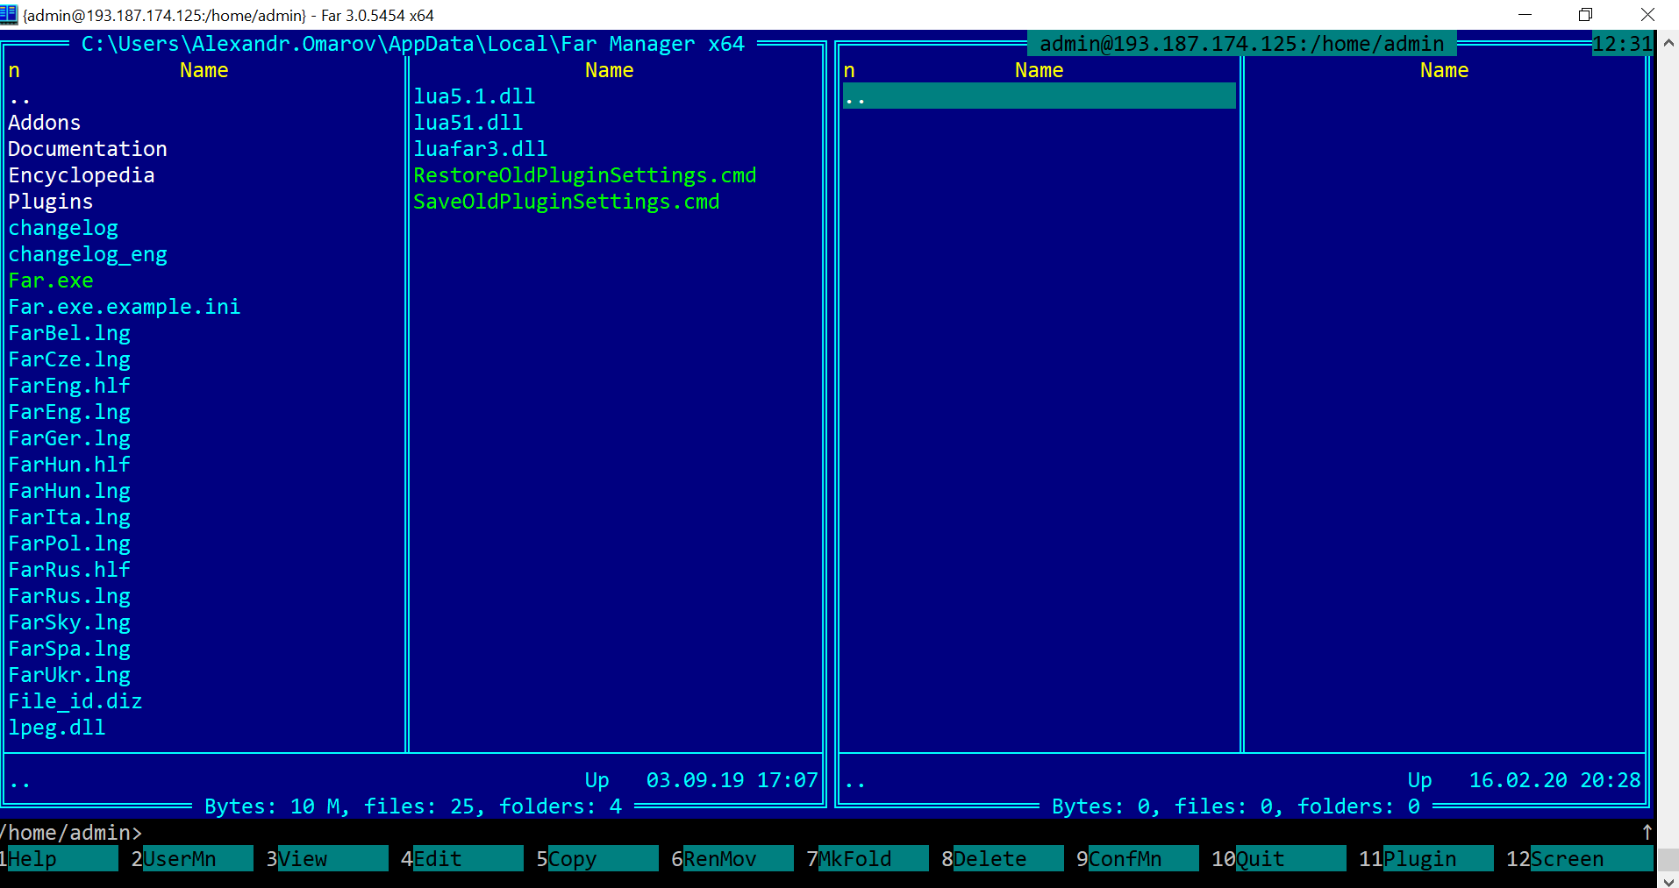

As an alternative there is midnight commander inside of putty as a plugin. Do what you like