Logistic Regression Stats: Using Selection Methods (Backward, Forward and Stepwise)



backward

Forward



CART MODEL

Entropy

Gini

Neural Network



Logistic Backward Selection:

* Variables Removed

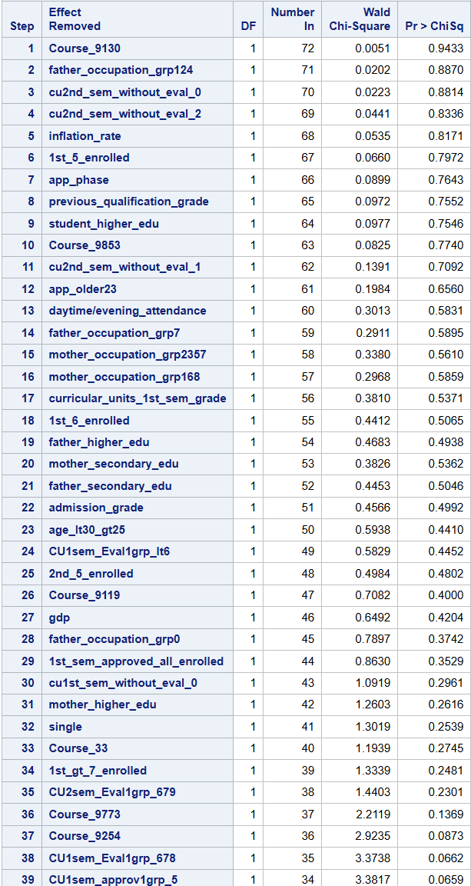

Final model:

proc logistic data=data;

model target_bin(event="1")= displaced debtor tuition_fees_up_to_date gender

scholarship_holder age_lt20 age_lt25_gt20 age_lt30_gt25

student_secondary_edu student_higher_edu

mother_occupation_grp168 mother_occupation_grp2357 mother_occupation_grp4910

father_occupation_grp124 father_occupation_grp3568 father_occupation_grp7 father_occupation_grp910

app_phase app_older23 app_inter curricular_units_2nd_sem_grade

"2nd_sem_approved_all_enrolled"n

"1st_5_enrolled"n "1st_6_enrolled"n "1st_7_enrolled"n "1st_gt_7_enrolled"n

"2nd_5_enrolled"n "2nd_6_enrolled"n

"2nd_7_enrolled"n "2nd_8_enrolled"n "2nd_gt_8_enrolled"n CU1sem_approv1grp_5

CU1sem_approv1grp_lt5 CU2sem_Eval1grp_679 CU2sem_Eval1grp_8 CU2sem_Eval1grp_lt6 CU2sem_approv1grp_5 CU2sem_approv1grp_0 CU2sem_approv1grp_1234

cu1sem_credit Course_33 Course_171 Course_9003 Course_9070 Course_9085 Course_9119 Course_9130 Course_9147_9670 Course_9238_8014

Course_9254 Course_9500 Course_9556 Course_9773 Course_9853 unemployment_rate cu1st_sem_without_eval_1_2 cu1st_sem_without_eval_0;

run;

Logistic Forward Selection:

* Variables Entered

* Interpreting variables, adding all the categories so it makes sense:

Variables to keep: curricular_units_2nd_sem_grade, tuition_fees_up_to_date, 2nd_sem_approved_all_enrolled, CU1sem_approv1grp_5, CU1sem_approv1grp_lt5, app_phase, app_older23, app_inter, scholarship_holder, Course_33, Course_171, Course_9003, Course_9070, Course_9085, Course_9119, Course_9130, Course_9147_9670, Course_9238_8014, Course_9254, Course_9500, Course_9556, Course_9773, Course_9853, gender, CU2sem_Eval1grp_679, CU2sem_Eval1grp_8, CU2sem_Eval1grp_lt6, CU2sem_approv1grp_5, CU2sem_approv1grp_0, CU2sem_approv1grp_1234, 2nd_5_enrolled, 2nd_6_enrolled, 2nd_7_enrolled, 2nd_8_enrolled, 2nd_gt_8_enrolled, age_lt20, age_lt25_gt20, age_lt30_gt25, father_occupation_grp124, father_occupation_grp3568, father_occupation_grp7, father_occupation_grp910, unemployment_rate, displaced, debtor, mother_occupation_grp168 mother_occupation_grp2357 mother_occupation_grp4910, cu1st_sem_without_eval_1_2 cu1st_sem_without_eval_0;

Final Model:

proc logistic data=data;

model target_bin(event="1")=curricular_units_2nd_sem_grade tuition_fees_up_to_date "2nd_sem_approved_all_enrolled"n CU1sem_approv1grp_5

CU1sem_approv1grp_lt5 app_phase app_older23 app_inter scholarship_holder Course_33 Course_171 Course_9003 Course_9070 Course_9085

Course_9119 Course_9130 Course_9147_9670 Course_9238_8014 Course_9254 Course_9500 Course_9556 Course_9773 Course_9853 gender

CU2sem_Eval1grp_679 CU2sem_Eval1grp_8 CU2sem_Eval1grp_lt6 CU2sem_approv1grp_5 CU2sem_approv1grp_0 CU2sem_approv1grp_1234 "2nd_5_enrolled"n "2nd_6_enrolled"n

"2nd_7_enrolled"n "2nd_8_enrolled"n "2nd_gt_8_enrolled"n age_lt20 age_lt25_gt20 age_lt30_gt25 father_occupation_grp124

father_occupation_grp3568 father_occupation_grp7 father_occupation_grp910 unemployment_rate displaced debtor cu1st_sem_without_eval_1_2 cu1st_sem_without_eval_0;

run;

Logistic Stepwise Selection:

* Interpreting variables, adding all the categories so it makes sense:

Variables to keep: tuition_fees_up_to_date, 2nd_sem_approved_all_enrolled, CU1sem_approv1grp_5, CU1sem_approv1grp_lt5, app_phase, app_older23, app_inter, scholarship_holder, Course_33, Course_171, Course_9003, Course_9070, Course_9085, Course_9119, Course_9130, Course_9147_9670, Course_9238_8014, Course_9254, Course_9500, Course_9556, Course_9773, Course_9853, gender, CU2sem_Eval1grp_679, CU2sem_Eval1grp_8, CU2sem_Eval1grp_lt6, CU2sem_approv1grp_5, CU2sem_approv1grp_0, CU2sem_approv1grp_1234, 2nd_5_enrolled, 2nd_6_enrolled, 2nd_7_enrolled, 2nd_8_enrolled, 2nd_gt_8_enrolled, age_lt20, age_lt25_gt20, age_lt30_gt25, father_occupation_grp124, father_occupation_grp3568, father_occupation_grp7, father_occupation_grp910, unemployment_rate, displaced, debtor, mother_occupation_grp168 mother_occupation_grp2357 mother_occupation_grp4910, cu1st_sem_without_eval_1_2 cu1st_sem_without_eval_0;

Final Model:

proc logistic data=data;

model target_bin(event="1")=tuition_fees_up_to_date "2nd_sem_approved_all_enrolled"n CU1sem_approv1grp_5

CU1sem_approv1grp_lt5 app_phase app_older23 app_inter scholarship_holder Course_33 Course_171 Course_9003 Course_9070 Course_9085

Course_9119 Course_9130 Course_9147_9670 Course_9238_8014 Course_9254 Course_9500 Course_9556 Course_9773 Course_9853 gender

CU2sem_Eval1grp_679 CU2sem_Eval1grp_8 CU2sem_Eval1grp_lt6 CU2sem_approv1grp_5 CU2sem_approv1grp_0 CU2sem_approv1grp_1234 "2nd_5_enrolled"n "2nd_6_enrolled"n

"2nd_7_enrolled"n "2nd_8_enrolled"n "2nd_gt_8_enrolled"n age_lt20 age_lt25_gt20 age_lt30_gt25 father_occupation_grp124

father_occupation_grp3568 father_occupation_grp7 father_occupation_grp910 unemployment_rate displaced debtor cu1st_sem_without_eval_1_2 cu1st_sem_without_eval_0;

run;

CART Model Entropy:

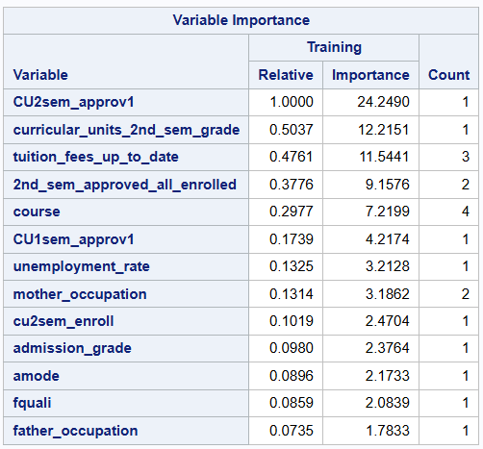

We nee to take in consideration that if we remove a variable the output is probably going to change, I used only those variables in the table, and it gave me a completely different table after:

CU2_approve1 curricular_units_2nd_sem_grade tuition_fees_up_to_date 2nd_sem_approved_all_enrolled course CU1sem_approv1 unemployment_rate mother_occupation cu2sem_enroll admission_grade amode fquali father_occupation;

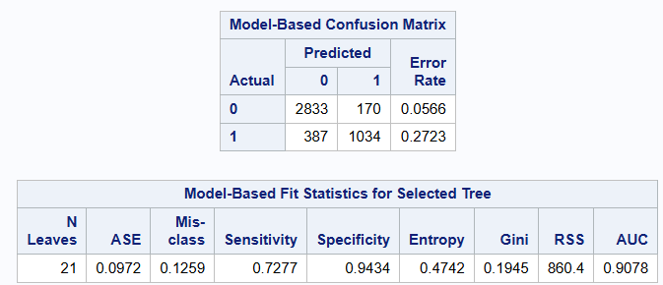

Also, some measures like sensitivity and AUC decreased.

CART Model Gini:

With the Gini after I used only the model performed better (more nodes though)

Curricular_units_2nd_sem_grade tuition_fees_up_to_date course CU2sem_approv1 unemployment_rate debtor cu1sem_approv1 cu2sem_enroll admission_grade father_occupation cu2sem_eval1

Here is the SAS code so you can try (Will also send a .sas file):

/* Importing, remember to change the path*/

proc import out= data datafile="/home/u64008123/CombineData_1stestAttempt.csv"

dbms=csv replace;

run;

/* Utilizing diferent models to measure the importance of our input variables */

/*Backward*/

proc logistic data=data;

model target_bin(event="1")=previous_qualification_grade admission_grade displaced debtor tuition_fees_up_to_date gender

scholarship_holder curricular_units_1st_sem_grade curricular_units_2nd_sem_grade age_lt20 age_lt25_gt20 age_lt30_gt25

mother_occupation_grp168 mother_occupation_grp2357 mother_occupation_grp4910

father_occupation_grp124 father_occupation_grp3568 father_occupation_grp7 father_occupation_grp910

single app_phase app_older23 app_inter student_secondary_edu student_higher_edu mother_secondary_edu

mother_higher_edu father_secondary_edu father_higher_edu "1st_sem_approved_all_enrolled"n "2nd_sem_approved_all_enrolled"n

"1st_5_enrolled"n "1st_6_enrolled"n "1st_7_enrolled"n "1st_gt_7_enrolled"n "2nd_5_enrolled"n "2nd_6_enrolled"n

"2nd_7_enrolled"n "2nd_8_enrolled"n "2nd_gt_8_enrolled"n CU1sem_Eval1grp_678 CU1sem_Eval1grp_lt6 CU1sem_approv1grp_5

CU1sem_approv1grp_lt5 CU2sem_Eval1grp_679 CU2sem_Eval1grp_8 CU2sem_Eval1grp_lt6 CU2sem_approv1grp_5 CU2sem_approv1grp_0 CU2sem_approv1grp_1234

cu1sem_credit cu2sem_credit Course_33 Course_171 Course_9003 Course_9070 Course_9085 Course_9119 Course_9130 Course_9147_9670 Course_9238_8014

Course_9254 Course_9500 Course_9556 Course_9773 Course_9853 unemployment_rate inflation_rate gdp / selection=backward;

run;

/* After selection method */

proc logistic data=data;

model target_bin(event="1")= displaced debtor tuition_fees_up_to_date gender scholarship_holder age_lt20 age_lt25_gt20 age_lt30_gt25

mother_occupation_grp168 mother_occupation_grp2357 mother_occupation_grp4910 father_occupation_grp124

father_occupation_grp3568 father_occupation_grp7 father_occupation_grp910 app_phase app_older23 app_inter

"1st_sem_approved_all_enrolled"n "2nd_sem_approved_all_enrolled"n "2nd_5_enrolled"n "2nd_6_enrolled"n

"2nd_7_enrolled"n "2nd_8_enrolled"n "2nd_gt_8_enrolled"n CU1sem_Eval1grp_678 CU1sem_Eval1grp_lt6 CU1sem_approv1grp_5

CU1sem_approv1grp_lt5 CU2sem_Eval1grp_679 CU2sem_Eval1grp_8 CU2sem_Eval1grp_lt6 CU2sem_approv1grp_5 CU2sem_approv1grp_0 CU2sem_approv1grp_1234

cu1sem_credit Course_33 Course_171 Course_9003 Course_9070 Course_9085 Course_9119 Course_9130 Course_9147_9670 Course_9238_8014

Course_9254 Course_9500 Course_9556 Course_9773 Course_9853 unemployment_rate;

run;

/*Foward*/

proc logistic data=data;

model target_bin(event="1")=previous_qualification_grade admission_grade displaced debtor tuition_fees_up_to_date gender

scholarship_holder curricular_units_1st_sem_grade curricular_units_2nd_sem_grade age_lt20 age_lt25_gt20 age_lt30_gt25

mother_occupation_grp168 mother_occupation_grp2357 mother_occupation_grp4910

father_occupation_grp124 father_occupation_grp3568 father_occupation_grp7 father_occupation_grp910

single app_phase app_older23 app_inter student_secondary_edu student_higher_edu mother_secondary_edu

mother_higher_edu father_secondary_edu father_higher_edu "1st_sem_approved_all_enrolled"n "2nd_sem_approved_all_enrolled"n

"1st_5_enrolled"n "1st_6_enrolled"n "1st_7_enrolled"n "1st_gt_7_enrolled"n "2nd_5_enrolled"n "2nd_6_enrolled"n

"2nd_7_enrolled"n "2nd_8_enrolled"n "2nd_gt_8_enrolled"n CU1sem_Eval1grp_678 CU1sem_Eval1grp_lt6 CU1sem_approv1grp_5

CU1sem_approv1grp_lt5 CU2sem_Eval1grp_679 CU2sem_Eval1grp_8 CU2sem_Eval1grp_lt6 CU2sem_approv1grp_5 CU2sem_approv1grp_0 CU2sem_approv1grp_1234

cu1sem_credit cu2sem_credit Course_33 Course_171 Course_9003 Course_9070 Course_9085 Course_9119 Course_9130 Course_9147_9670 Course_9238_8014

Course_9254 Course_9500 Course_9556 Course_9773 Course_9853 unemployment_rate inflation_rate gdp / selection=forward;

run;

/* After selection method */

proc logistic data=data;

model target_bin(event="1")=curricular_units_2nd_sem_grade tuition_fees_up_to_date "2nd_sem_approved_all_enrolled"n CU1sem_approv1grp_5

CU1sem_approv1grp_lt5 app_phase app_older23 app_inter scholarship_holder Course_33 Course_171 Course_9003 Course_9070 Course_9085

Course_9119 Course_9130 Course_9147_9670 Course_9238_8014 Course_9254 Course_9500 Course_9556 Course_9773 Course_9853 gender

CU2sem_Eval1grp_679 CU2sem_Eval1grp_8 CU2sem_Eval1grp_lt6 CU2sem_approv1grp_5 CU2sem_approv1grp_0 CU2sem_approv1grp_1234 "2nd_5_enrolled"n "2nd_6_enrolled"n

"2nd_7_enrolled"n "2nd_8_enrolled"n "2nd_gt_8_enrolled"n age_lt20 age_lt25_gt20 age_lt30_gt25 father_occupation_grp124

father_occupation_grp3568 father_occupation_grp7 father_occupation_grp910 unemployment_rate displaced debtor;

run;

/*Stepwise*/

proc logistic data=data;

model target_bin(event="1")=previous_qualification_grade admission_grade displaced debtor tuition_fees_up_to_date gender

scholarship_holder curricular_units_1st_sem_grade curricular_units_2nd_sem_grade age_lt20 age_lt25_gt20 age_lt30_gt25

mother_occupation_grp168 mother_occupation_grp2357 mother_occupation_grp4910

father_occupation_grp124 father_occupation_grp3568 father_occupation_grp7 father_occupation_grp910

single app_phase app_older23 app_inter student_secondary_edu student_higher_edu mother_secondary_edu

mother_higher_edu father_secondary_edu father_higher_edu "1st_sem_approved_all_enrolled"n "2nd_sem_approved_all_enrolled"n

"1st_5_enrolled"n "1st_6_enrolled"n "1st_7_enrolled"n "1st_gt_7_enrolled"n "2nd_5_enrolled"n "2nd_6_enrolled"n

"2nd_7_enrolled"n "2nd_8_enrolled"n "2nd_gt_8_enrolled"n CU1sem_Eval1grp_678 CU1sem_Eval1grp_lt6 CU1sem_approv1grp_5

CU1sem_approv1grp_lt5 CU2sem_Eval1grp_679 CU2sem_Eval1grp_8 CU2sem_Eval1grp_lt6 CU2sem_approv1grp_5 CU2sem_approv1grp_0 CU2sem_approv1grp_1234

cu1sem_credit cu2sem_credit Course_33 Course_171 Course_9003 Course_9070 Course_9085 Course_9119 Course_9130 Course_9147_9670 Course_9238_8014

Course_9254 Course_9500 Course_9556 Course_9773 Course_9853 unemployment_rate inflation_rate gdp / selection=stepwise;

run;

/* After selection method */

proc logistic data=data;

model target_bin(event="1")=curricular_units_2nd_sem_grade tuition_fees_up_to_date "2nd_sem_approved_all_enrolled"n CU1sem_approv1grp_5

CU1sem_approv1grp_lt5 app_phase app_older23 app_inter scholarship_holder Course_33 Course_171 Course_9003 Course_9070 Course_9085

Course_9119 Course_9130 Course_9147_9670 Course_9238_8014 Course_9254 Course_9500 Course_9556 Course_9773 Course_9853 gender

CU2sem_Eval1grp_679 CU2sem_Eval1grp_8 CU2sem_Eval1grp_lt6 CU2sem_approv1grp_5 CU2sem_approv1grp_0 CU2sem_approv1grp_1234 "2nd_5_enrolled"n "2nd_6_enrolled"n

"2nd_7_enrolled"n "2nd_8_enrolled"n "2nd_gt_8_enrolled"n age_lt20 age_lt25_gt20 age_lt30_gt25 father_occupation_grp124

father_occupation_grp3568 father_occupation_grp7 father_occupation_grp910 unemployment_rate displaced debtor;

run;

/*Score*/

proc logistic data=data;

model target_bin(event="1")=previous_qualification_grade admission_grade displaced debtor tuition_fees_up_to_date gender

scholarship_holder curricular_units_1st_sem_grade curricular_units_2nd_sem_grade age_lt20 age_lt25_gt20 age_lt30_gt25

mother_occupation_grp168 mother_occupation_grp2357 mother_occupation_grp4910

father_occupation_grp124 father_occupation_grp3568 father_occupation_grp7 father_occupation_grp910

single app_phase app_older23 app_inter student_secondary_edu student_higher_edu mother_secondary_edu

mother_higher_edu father_secondary_edu father_higher_edu "1st_sem_approved_all_enrolled"n "2nd_sem_approved_all_enrolled"n

"1st_5_enrolled"n "1st_6_enrolled"n "1st_7_enrolled"n "1st_gt_7_enrolled"n "2nd_5_enrolled"n "2nd_6_enrolled"n

"2nd_7_enrolled"n "2nd_8_enrolled"n "2nd_gt_8_enrolled"n CU1sem_Eval1grp_678 CU1sem_Eval1grp_lt6 CU1sem_approv1grp_5

CU1sem_approv1grp_lt5 CU2sem_Eval1grp_679 CU2sem_Eval1grp_8 CU2sem_Eval1grp_lt6 CU2sem_approv1grp_5 CU2sem_approv1grp_0 CU2sem_approv1grp_1234

cu1sem_credit cu2sem_credit Course_33 Course_171 Course_9003 Course_9070 Course_9085 Course_9119 Course_9130 Course_9147_9670 Course_9238_8014

Course_9254 Course_9500 Course_9556 Course_9773 Course_9853 unemployment_rate inflation_rate gdp/ selection=score;

run;

/*

Disclaimer, We cannot use this selection method because we have to many variables and the way it works is that it provides

the full conbination of the variables (incrementally adding variables) with the Chi Score for each one of them so it eould be basically calculating the Score

for( i=1; i++; i<=total_number_variables ) {C = i Combinations total_number_variables; calculate Chi Score for each C}

That for our copious variables, is a lot and the SAS server will not run it.

*/

/* CART Entropy */

proc hpsplit data=data;

class target_bin course displaced debtor tuition_fees_up_to_date gender scholarship_holder father_occupation mother_occupation

single amode pquali fquali mquali "1st_sem_approved_all_enrolled"n "2nd_sem_approved_all_enrolled"n

cu1sem_enroll cu1sem_credit cu2sem_credit cu2sem_enroll age CU1sem_Eval1 CU1sem_approv1 CU2sem_Eval1 CU2sem_approv1;

model target_bin(event="1")=previous_qualification_grade admission_grade curricular_units_1st_sem_grade

curricular_units_2nd_sem_grade unemployment_rate inflation_rate gdp course displaced debtor

tuition_fees_up_to_date gender scholarship_holder father_occupation mother_occupation

single amode pquali fquali mquali "1st_sem_approved_all_enrolled"n "2nd_sem_approved_all_enrolled"n

cu1sem_enroll cu1sem_credit cu2sem_credit cu2sem_enroll age CU1sem_Eval1 CU1sem_approv1 CU2sem_Eval1 CU2sem_approv1;

grow entropy;

prune cc;

run;

/* Using only the variables of the importance table */

proc hpsplit data=data;

class target_bin course tuition_fees_up_to_date gender scholarship_holder father_occupation mother_occupation fquali

"2nd_sem_approved_all_enrolled"n cu1sem_enroll cu2sem_credit cu2sem_enroll age CU1sem_approv1 CU2sem_approv1;

model target_bin(event="1")=previous_qualification_grade admission_grade curricular_units_2nd_sem_grade unemployment_rate

inflation_rate gdp course tuition_fees_up_to_date gender scholarship_holder father_occupation mother_occupation fquali

"2nd_sem_approved_all_enrolled"n cu1sem_enroll cu2sem_credit cu2sem_enroll age CU1sem_approv1 CU2sem_approv1;

grow entropy;

prune cc;

run;

/* CART Gini */

proc hpsplit data=data;

class target_bin course displaced debtor tuition_fees_up_to_date gender scholarship_holder father_occupation mother_occupation

single amode pquali fquali mquali "1st_sem_approved_all_enrolled"n "2nd_sem_approved_all_enrolled"n

cu1sem_enroll cu1sem_credit cu2sem_credit cu2sem_enroll age CU1sem_Eval1 CU1sem_approv1 CU2sem_Eval1 CU2sem_approv1;

model target_bin(event="1")=previous_qualification_grade admission_grade curricular_units_1st_sem_grade

curricular_units_2nd_sem_grade unemployment_rate inflation_rate gdp course displaced debtor

tuition_fees_up_to_date gender scholarship_holder father_occupation mother_occupation

single amode pquali fquali mquali "1st_sem_approved_all_enrolled"n "2nd_sem_approved_all_enrolled"n

cu1sem_enroll cu1sem_credit cu2sem_credit cu2sem_enroll age CU1sem_Eval1 CU1sem_approv1 CU2sem_Eval1 CU2sem_approv1;

grow gini;

prune cc;

run;

/* Using only the variables of the importance table */

proc hpsplit data=data;

class target_bin course tuition_fees_up_to_date father_occupation mother_occupation amode "1st_sem_approved_all_enrolled"n

"2nd_sem_approved_all_enrolled"n cu2sem_enroll age CU1sem_approv1 CU2sem_approv1;

model target_bin(event="1")=previous_qualification_grade admission_grade curricular_units_2nd_sem_grade unemployment_rate gdp course

tuition_fees_up_to_date father_occupation mother_occupation amode "1st_sem_approved_all_enrolled"n "2nd_sem_approved_all_enrolled"n

cu2sem_enroll age CU1sem_approv1 CU2sem_approv1;

grow gini;

prune cc;

run;

CART Model

CART Entropy full vars

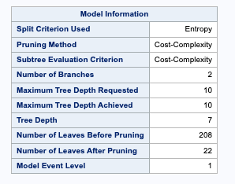

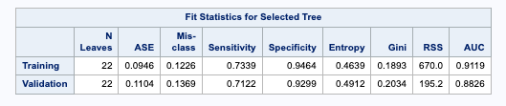

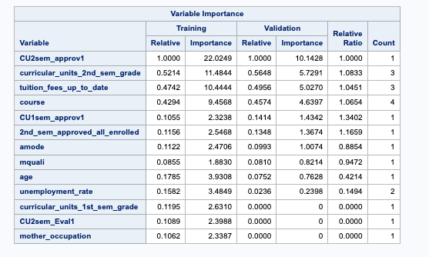

reduced list of vars: CU2sem_approv1 curricular_units_2nd_sem_grade tuition_fees_up_to_date course CU1sem_approv1 2nd_sem_approved_all_enrolled amode mquali age unemployment_rate