**TASK1**

1. CREATE DATABASE ALEX_OREHVO

GO

USE ALEX_OREHVO

GO

CREATE SCHEMA sales;

GO

CREATE TABLE sales.Orders

(

OrderNum INT NULL

);

GO

RESULT

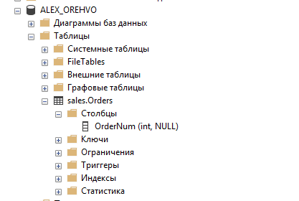

1. BACKUP DATABASE ALEX_OREHVO

TO DISK='ALEX_OREHVO.bak';

GO

USE master;

GO

DROP DATABASE ALEX_OREHVO

GO

RESULT

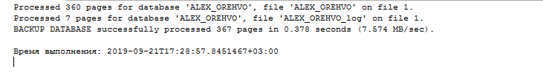

1. RESTORE DATABASE ALEX_OREHVO

FROM DISK = 'ALEX_OREHVO.bak'

GO

RESULT

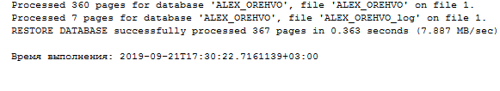

**TASK 2**

1.

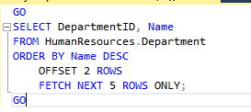

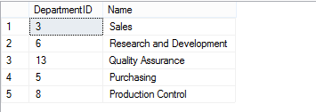

2.



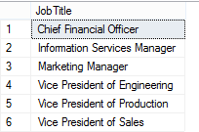

3.



