EXPANSION: MINESWEEPER VERSUS
BASE GAME: MINESWEEPER
MAIN IDEA / DESIGN GOAL (max. 2 lines)
. The game is now a multiplayer.
CORE GAMEPLAY from BASE GAME (max. 7 lines)
. “Board”: field of tiles, with a hidden item behind each tile
. A tile may be hiding: a bomb; a number, indicating how many bombs are in the spots directly adjacent to it; or an empty spot, in case there is no bomb adjacent
. The Player can click on a tile to clear it, revealing the hidden item (extra: the Player may also place a marker on an uncleared tyle, to help identify possible bombs)
. The Player uses the numbered spots to strategically deduce the position of the bombs
. The game automatically clears some non-bomb tiles away, when there are not enough numbered tiles for the Player to deduce bomb position
. The Player wins once they clear all tiles without bombs
. The Player loses if they clear a tile with a bomb behind it
KEY FEATURES for EXPANSION (max. 9 lines)
. 2 or more Players clear the tiles away in the same “Board”
. The more tiles a Player clears, the higher their final score; this score is computed at the end of the game, and suffers a penalty if a Player clicks on a bomb
. If any Player clicks on a bomb, the game enters the Final Stage
. In the Final Stage, the Player who clicked on the bomb tile cannot clear tiles any longer, and a Timer starts counting down for the remaining Players to make their final plays (the game ends when the Final Stage Timer reaches 0)

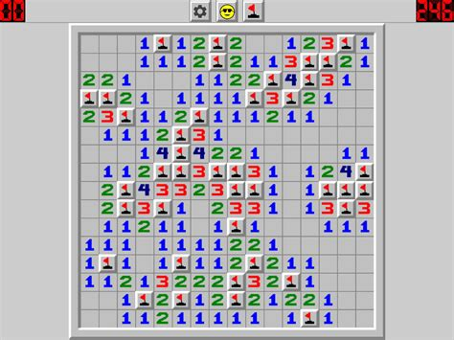
OUR MINESWEEPER

