Q.1

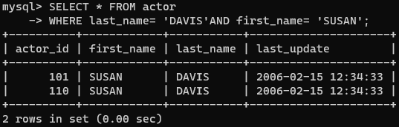Q.2

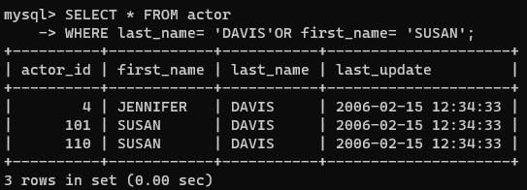Q.3

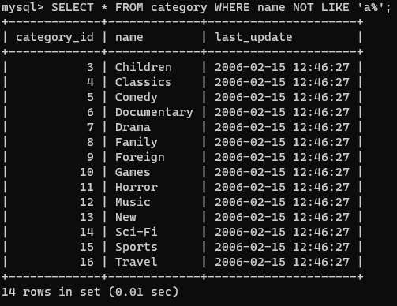Q4.

Q.5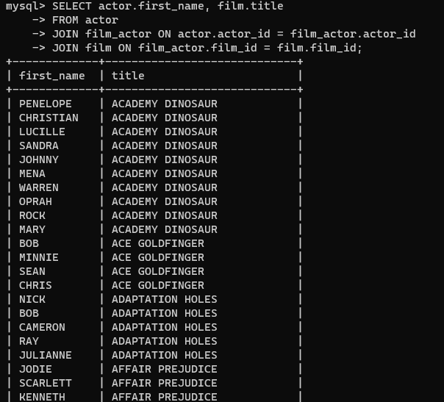

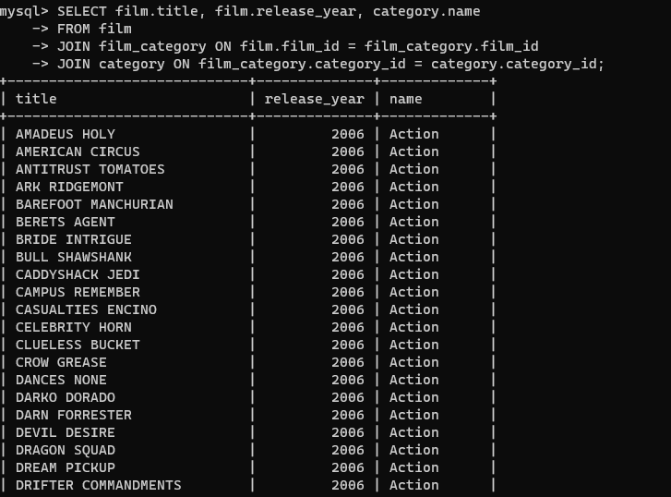Q.6

Q.7

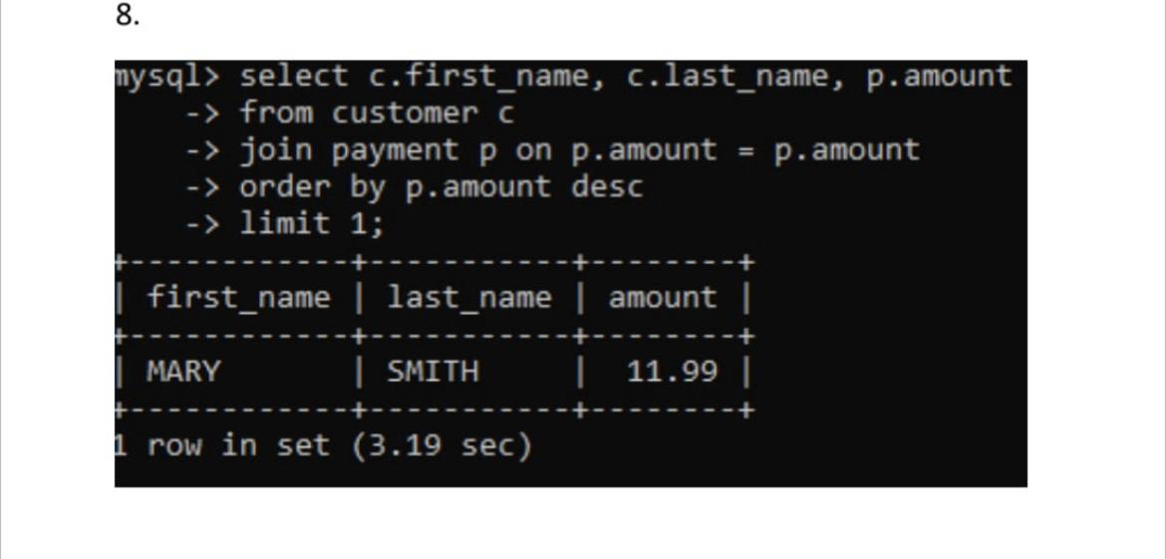Q.8

Q.9

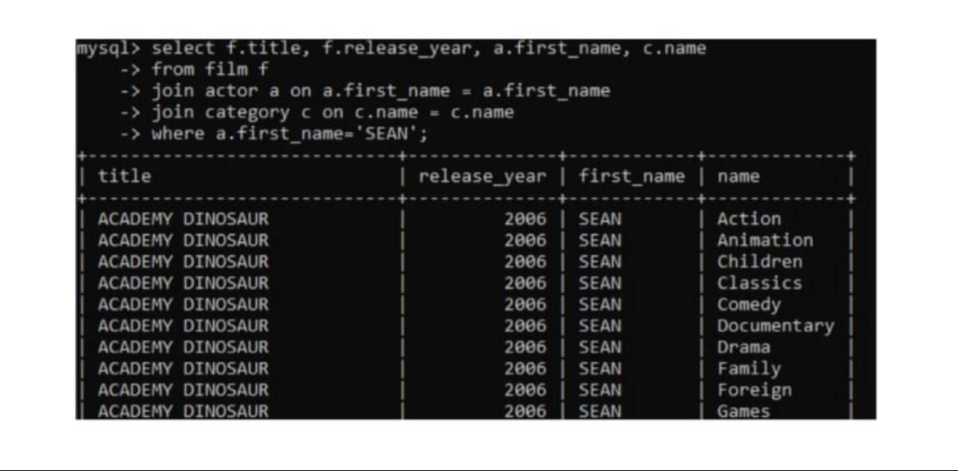

Q.10

1. Return all actors name with Address and city iD

2. Return actors last name starting with A and payment date

3. Return film category with language English

4. Return Customer last name not starting with S

5. Return all Customer with City and last update

6. Return all Inventory iD with Store iD

7. Return all staff Username with managing staff iD

8. Return all Customer iD with rental iD

9. Return all Customer iD with Payment date

10. Return release year with language