MINISTRY OF EDUCATION AND SCIENCE OF UKRAINE

NATIONAL TECHNICAL UNIVERSITY

“KHARKOV POLYTECHNICAL INSTITUTE”

LABORATORY WORK № 2

“C++ Operators and Statements"

Created by student of 1.КН201.8г

Pasichnuy O.S.

Checked by

Melnik K.V.

KHARKIV 2018

Topic: Report on laboratory work #2

Goal: Learning basic principles of C++

Tasks:

1. Individual Assignment

According to the task in Table 1 student should analyze computational algorithms and write a program which should calculate sequence of results on interval.

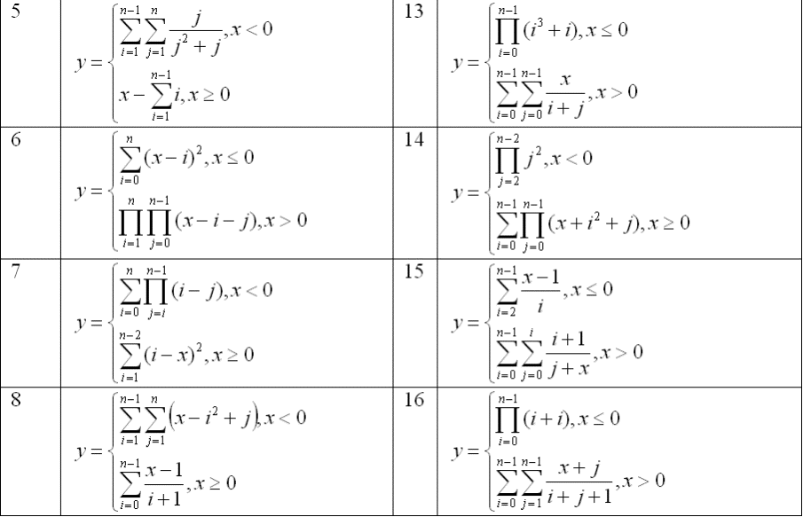

#include <iostream>

#include <string>

#include <vector>

#include "Lab1.h"

#include "tools.h"

class Lab2

{

private:

double n;

double stepSize;

double x;

double maxX;

double sum;

std::vector<double> results;

bool isExit = false;

public:

void getData();

void useLab2();

void getFromFile();

void returnToFile();

void positiveX();

void negativeX();

};

void Lab2::useLab2()

{

while (isExit == false)

{

getData(); //input

if (stepSize <= 0 || (maxX - x) <= 0)

{

std::cout << "Incorrect input!!!" << std::endl;

system("pause");

return;

}

for (x; x <= maxX; x += stepSize)

{

if (x >= 0)

positiveX();

else

negativeX();

std::cout << "x = " << x << "; sum = " << sum << std::endl;

results.push_back(sum);

}

returnToFile();

system("cls");

std::cout << "Do you want to use the program again?\n";

switch (Menu::getInstance().menuOrgan({ "Yes", "No" }))

{

case 0:

break;

case 1:

isExit = true;

std::cout << "Thanks for using my product)\n"

<< "With love, Alex Pasechnuy\n";

break;

}

}

}

void Lab2::getData()

{

std::cout << "Select data input way please:\n";

std::vector<std::string> giveMenu = { "Give from file", "Give from keyboard" };

switch (Menu::getInstance().menuOrgan(giveMenu))

{

case 0:

getFromFile();

break;

case 1:

input("n = ", n);

input("step = ", stepSize);

input("start value of your x :", x);

input("maximum value of your x :", maxX);

break;

}

system("cls");

}

void Lab2::getFromFile()

{

std::ifstream fin;

fin.open("InputLab2.txt");

std::vector<std::vector<double>> data;

std::vector<std::string> strVec;

int memb;

while (!fin.eof())

{

std::string str;

std::vector<double> vecDob;

for (int i = 0; i < 4; i++)

{

fin >> memb;

vecDob.push_back(memb);

str += std::to_string(memb) + " ";

}

strVec.push_back(str);

data.push_back(vecDob);

}

std::cout << "Select your start and maximum value of x ,n and step size:\n";

int choise = Menu::getInstance().menuOrgan(strVec);

std::vector<double> vecDob = data[choise];

x = vecDob[0]; //interval start

maxX = vecDob[1]; //interval end

n = vecDob[2];

stepSize = vecDob[3];

fin.close();

}

void Lab2::positiveX()

{

sum = 0;

for (int i = 0; i < n; i++)

{

sum += (x - 1) / (i + 1);

}

}

void Lab2::negativeX()

{

sum = 0;

for (int i = 1; i < n; i++)

{

for (int j = 1; j <= n; j++)

{

sum += x - (i*i) + j;

}

}

}

void Lab2::returnToFile()

{

std::ofstream fout;

fout.open("OutputLab2.txt", std::ios_base::app);

std::cout << std::endl << "Do you want to save your results to file?" << std::endl;

switch (Menu::getInstance().menuOrgan({ "Yes", "No" }))

{

case 0:

for (int i = 0; i < results.size(); i++)

{

fout << results[i] << " ";

}

fout << std::endl;

fout.close();

break;

case 1:

break;

}

}

Screenshots of program outputs:

