CS 340 README Template

About the Project/Project Title
AACCrud is a Python module designed to help simplify CRUD operations in the Austin Animal Center MongoDB collection. It provides a clean user-friendly interface that is abstracted from the lowest levels of database management. AACCrud helps cut back on the repetitive backend work of database management and provide a quicker and more convenient experience for those who may be managing a MongoDB system. This module serves as the backend foundation for the Grazioso Salvare Dashboard, a data-driven application that helps identify dogs suitable for specialized rescue operations. The dashboard integrates:
- Dynamic Queries
- Interactive data tables
- A live map that updates
- Breed distribution pie chart
- Intuitive UI

Dashboard Features
The Grazioso Salvare Dashboard includes:
- Water, Mountain/Wilderness, and Disaster/individual dynamic filters for type of rescue
- Sortable, Filterable, and selectable interactive tables for each animal
- Live map updates based on row or animal selected
- Popup on map for breed/name
- Pie chart with smart animal grouping

Motivation
AACCrud was created to centralize Create, Read, Update, and Delete operations into a single maintainable Python module. The goal is to offer a foundation that makes MongoDB interactions straightforward, reusable, and easy to integrate with future client-side applications such as the Grazioso Salvare dashboard

Getting Started
Follow these steps to set up AACCrud locally.
Prerequisites

- Python

- MongoDB (local instance in Codio or remote)

- A database user with read/write permissions

- PyMongo installed in your environment

- Jupyter Notebook (for testing)

Installation
1) Ensure MongoDB is running and accessible.
2) Import the AAC dataset using mongoimport.
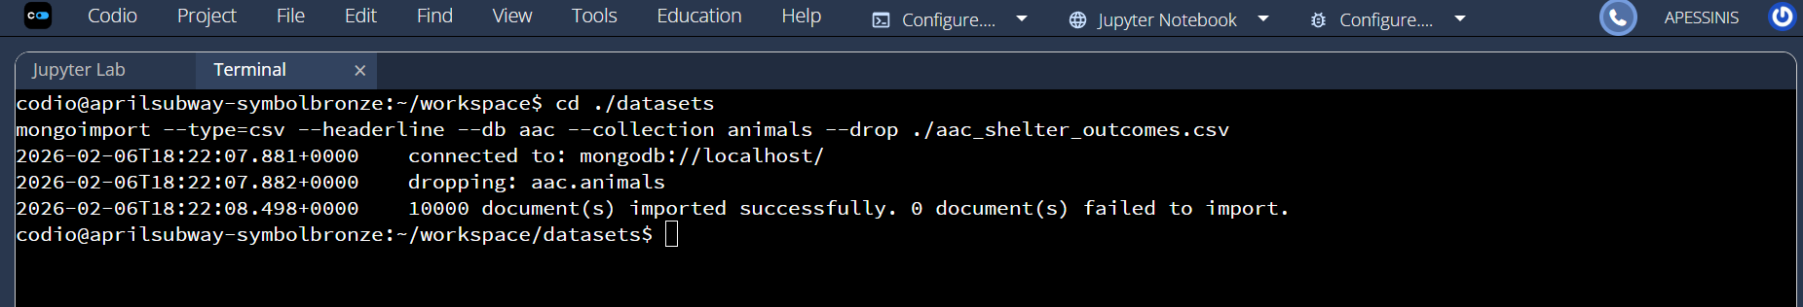
3) Create a database user with read/write permissions.
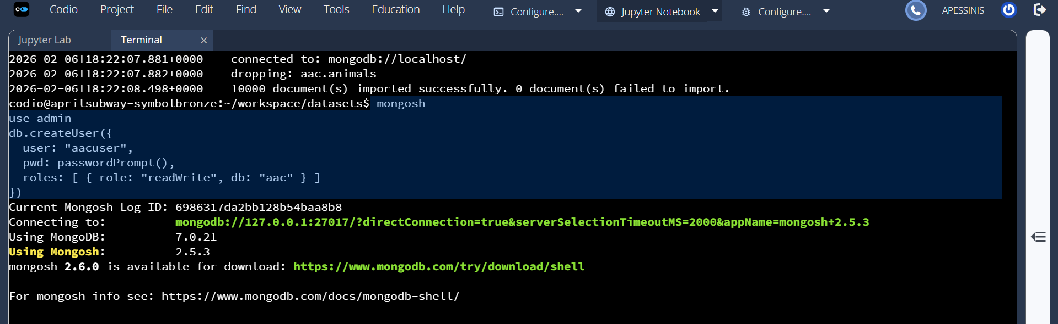
- Install required Python dependencies (pymongo).
- Use Python, MongoDB, PyMongo, and Jupyter Notebook to interact with the module.
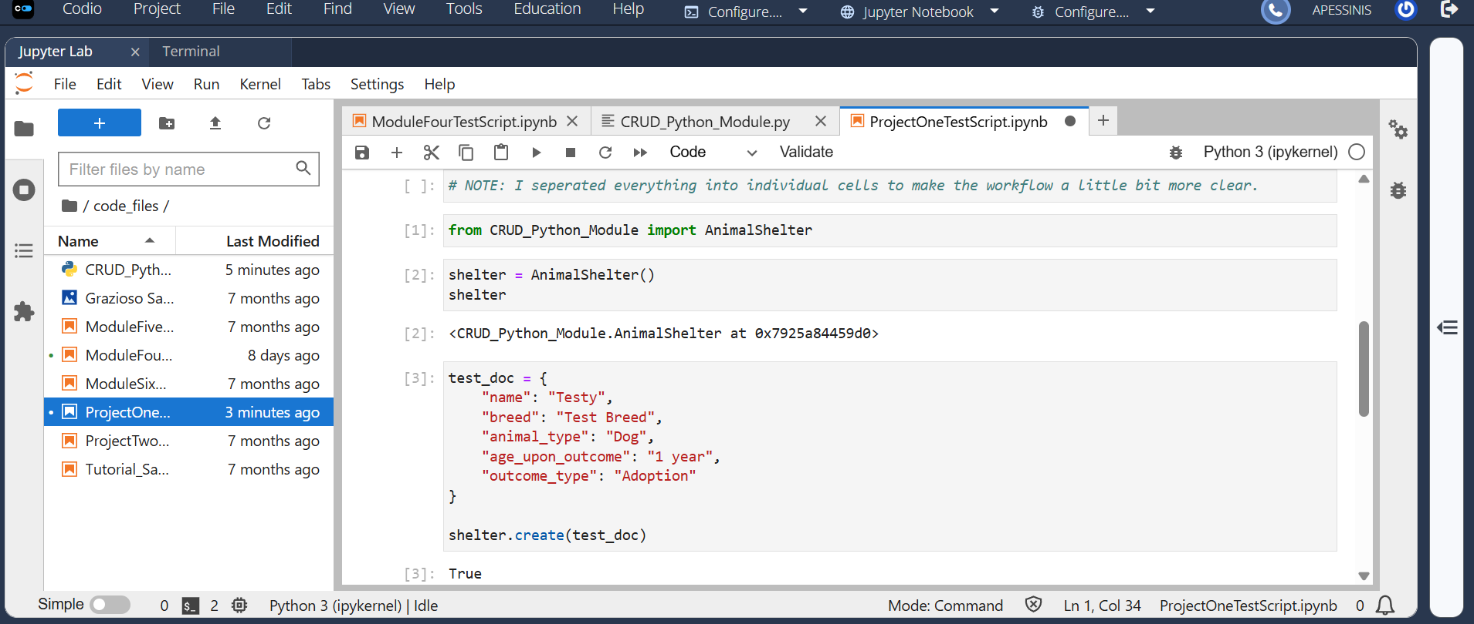

Usage
Import AACCrud into your Python environment and instantiate the client with your database credentials.

Code Example
from CRUD_Python_Module import AnimalShelter

# Initialize the client
client = AnimalShelter()

# CREATE example
new_document = {
"name": "Shadow",
"type": "Dog",
"age": 2,
"color": "Black"
}
client.create(new_document)

# READ example
query = {"type": "Dog"}
results = client.read(query)
for item in results:
print(item)

Tests
Testing can be completed in any python environment.
test_query = {"color": "Black"}
results = client.read(test_query)
print(len(results))

Other important tests include update and delete.
client.update({"name": "Shadow"}, {"color": "Brown"})
client.delete({"name": "Shadow"})

Screenshots
MongoDB Import Command and Output

Mongo Shell Login Using aacuser


CREATE Operation Test in Jupyter Notebook
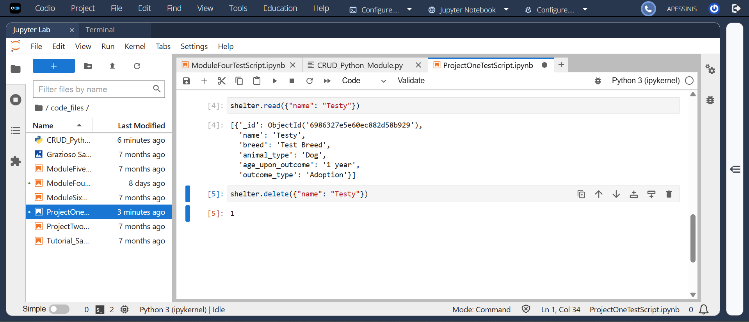
READ/UPDATE/DELETE Operation Test in Jupyter Notebook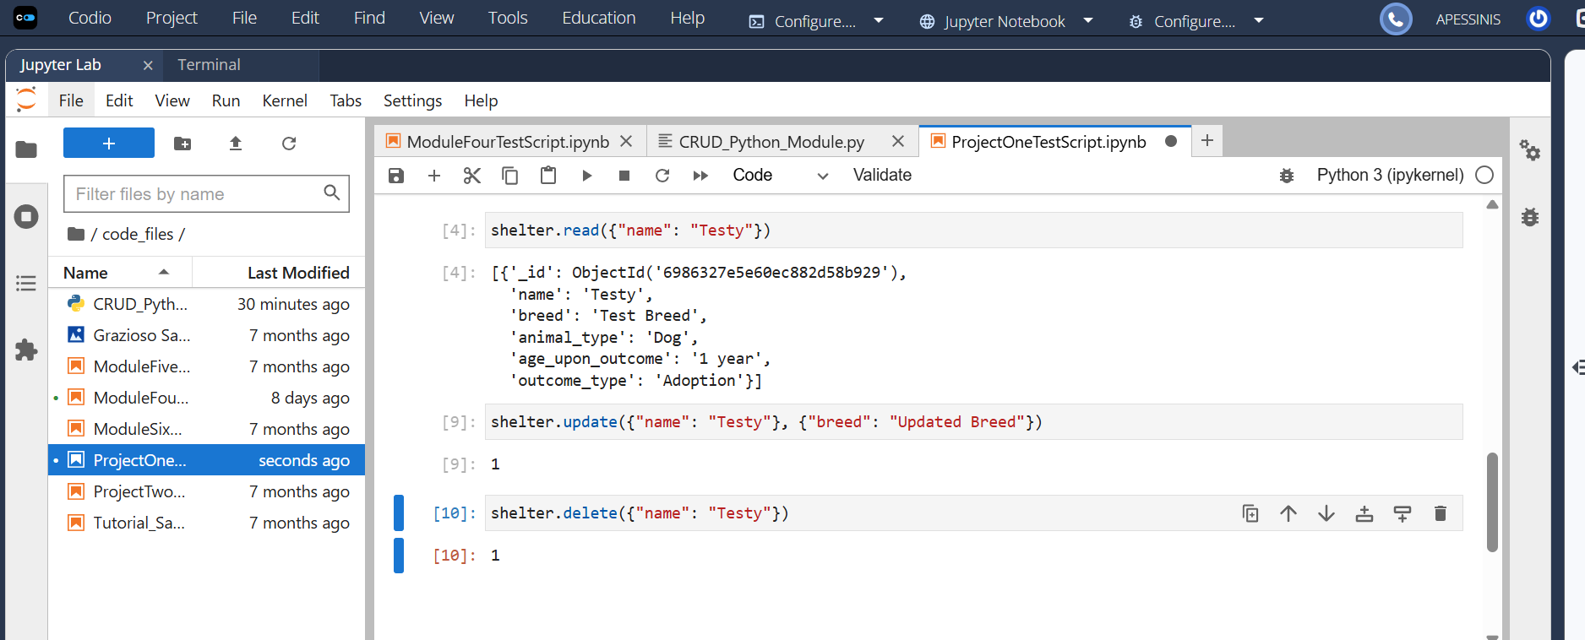

Dashboard Features running
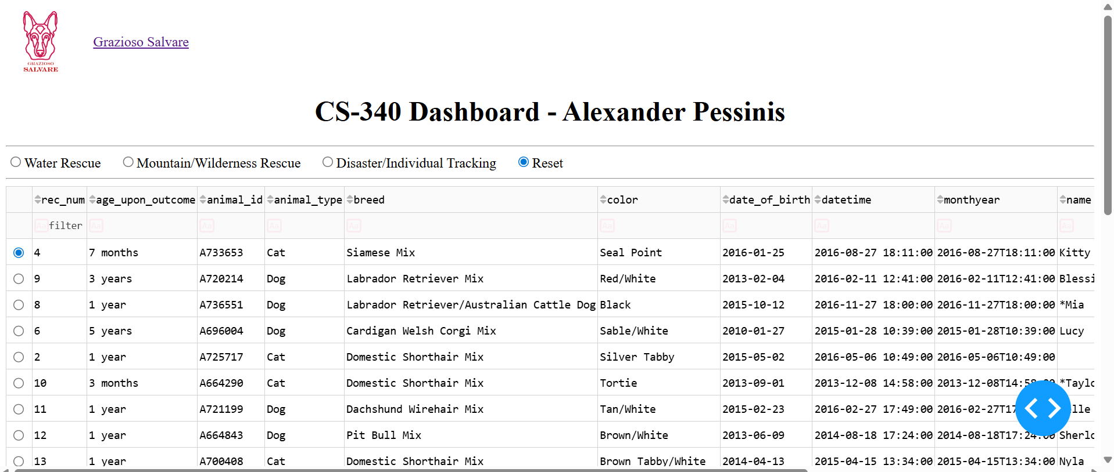
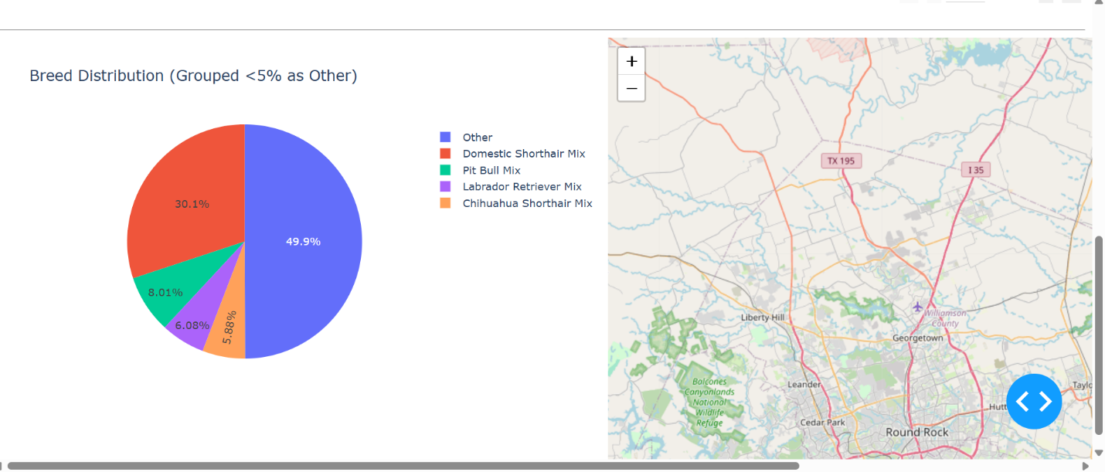

Water, Mountain/Wilderness, and Disaster/Individual Tracking Filter
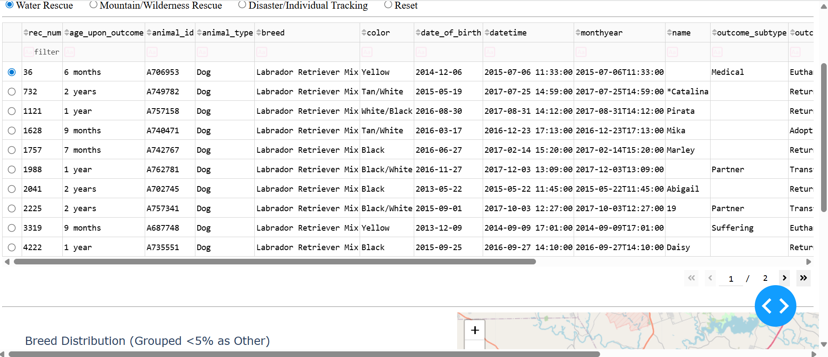
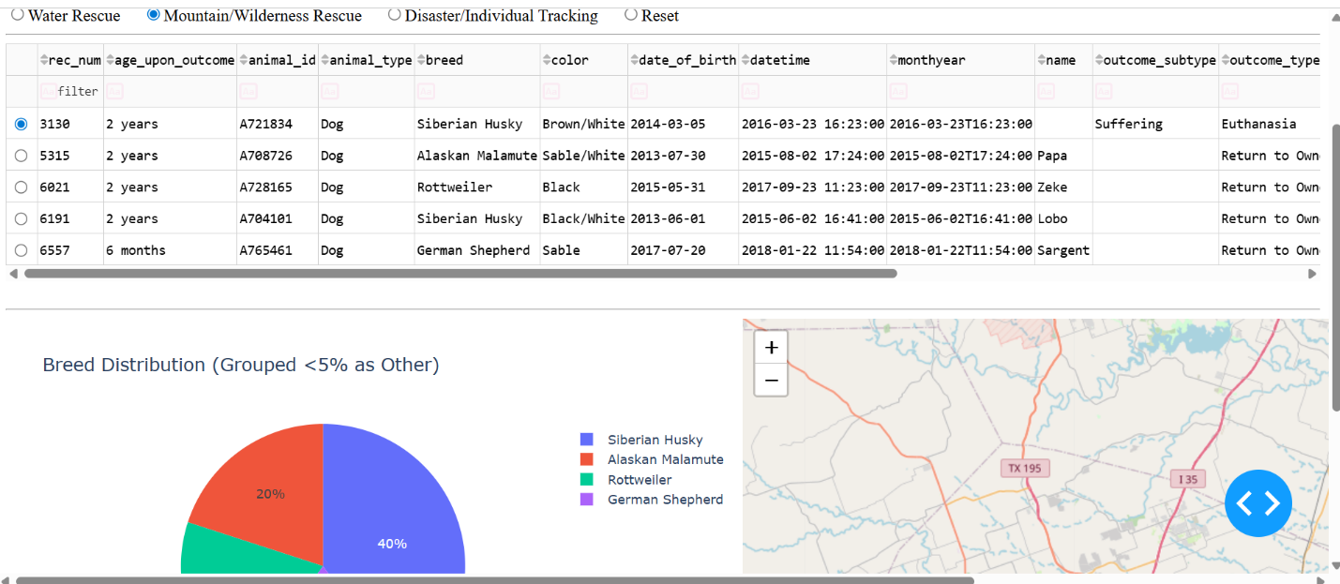
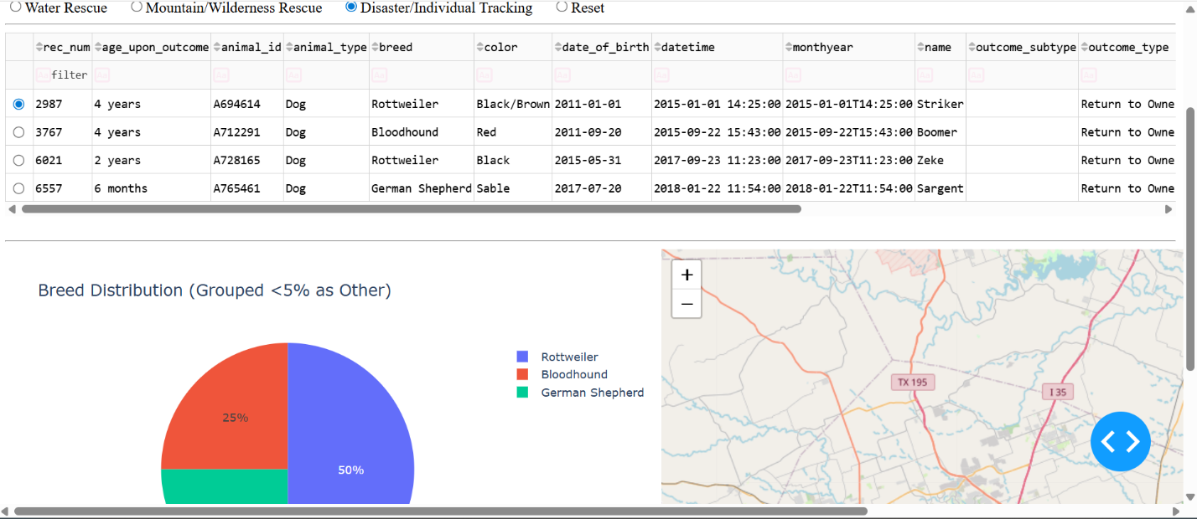
Reset Filter
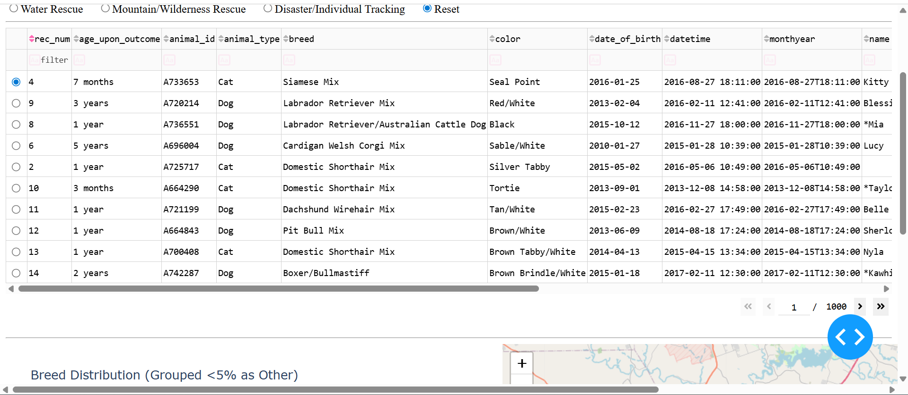

Map Update w/ Row Selection
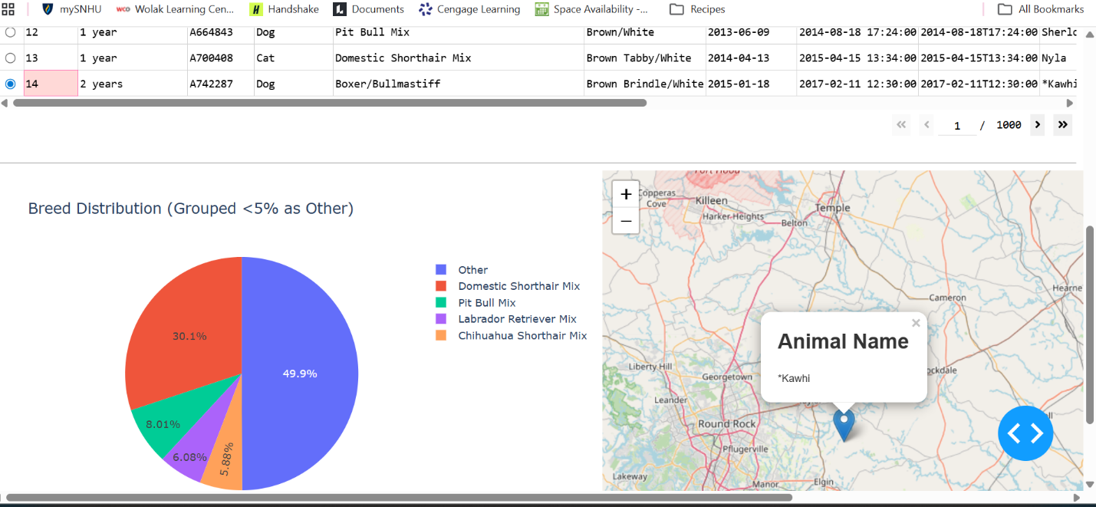
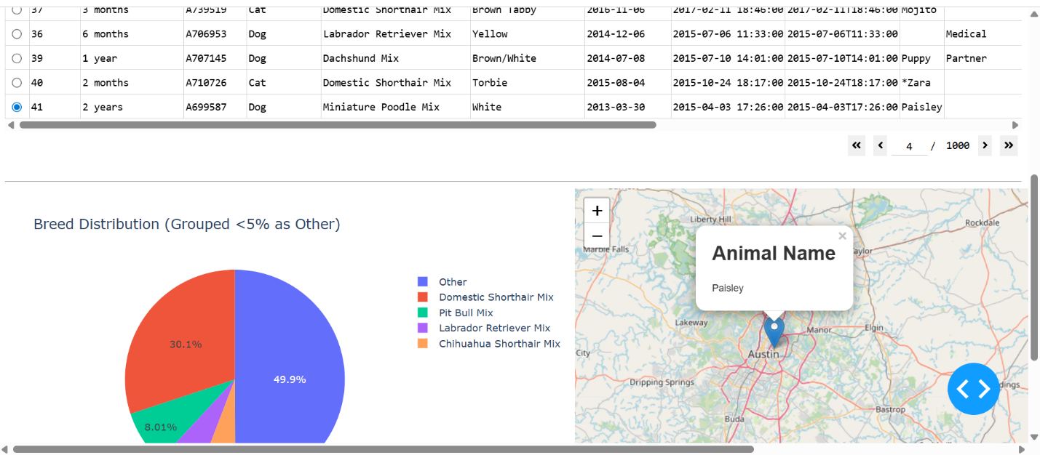Contact:
Alexander Pessinis

