|  |
| --- |
| *29/06/2021*  Изготвил: Александър Пилафов (F91104) Преподавател: З.Узунова |

|  |  |
| --- | --- |
| Project Design Document |  |

|  |  |  |  |
| --- | --- | --- | --- |
| Project Concept | | | |
| 1 **Player Control** |  | You control a   |  | | --- | | *2D ninja frog named*  *Frogo Gogo* | | in this   |  |  | | --- | --- | | *2D side view platformer* | game | |
|  | where   |  | | --- | | *We use keyboard and mouse* | | To make the player   |  | | --- | | *Move, shoot and navigate through the menus.* | |

|  |  |  |  |  |  |
| --- | --- | --- | --- | --- | --- |
| 2 **Basic**  **Gameplay** |  | During the game,   |  | | --- | | *You will encounter many enemies and traps* | | including   |  | | --- | | *Ghosts, Fire traps & more* | |
|  | the goal of the game is to   |  | | --- | | *Reach the end of the level without dying and score as many points as you can.* | | |

|  |  |  |  |  |  |
| --- | --- | --- | --- | --- | --- |
| 3 **Sound**  **& Effects** |  | There will be   |  | | --- | | *Background music* | | and particle effects   |  | | --- | | *Portal particle effects, OnDeath particle effects and more* | |
|  |  | |

|  |  |  |  |  |  |
| --- | --- | --- | --- | --- | --- |
| 4 **Gameplay**  **Mechanics** |  | As the game progresses,   |  | | --- | | *The character will increase in straight and find new ways to fight with his enemies.* | | making it   |  | | --- | | *Able to shoot, grapple with thong, regenerate grappling ammo while swimming in water.* | |
|  | [*optional*] There will also be   |  | | --- | | *Fire traps, Patroling Enemies, Chasing Enemies, Moving Platforms, Collectibles, Boosts and Pickups* | | |

|  |  |  |  |  |  |  |  |
| --- | --- | --- | --- | --- | --- | --- | --- |
| 5 **User**  **Interface** |  | The   |  | | --- | | *Score* | | will   |  | | --- | | *increase*  decrease | | whenever   |  | | --- | | *You collect a coin or kill and enemy.*  *You die by an enemy or a trap.* | |
|  | At the start of the game, the title   |  |  | | --- | --- | | *The adventures of Frogo Gogo* | will appear | | | and the game will end when   |  | | --- | | *The player hits the exit game button in the menu* | |

|  |  |  |  |
| --- | --- | --- | --- |
| 6 **Other Features** |  | |  | | --- | | *Pause Menu, Score Counter and more* | |

# Flow Chart, Functions and diagrams

# Project Sketch

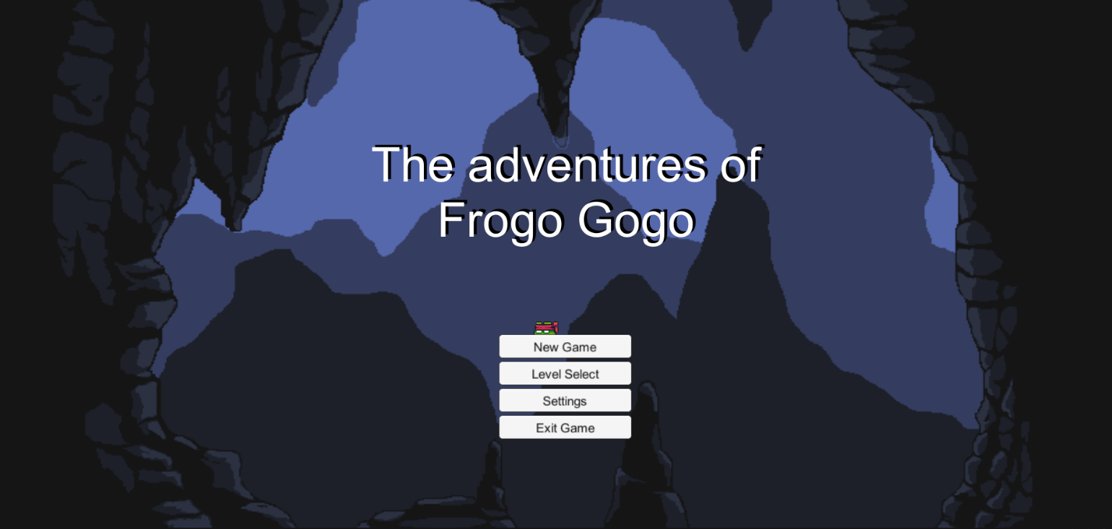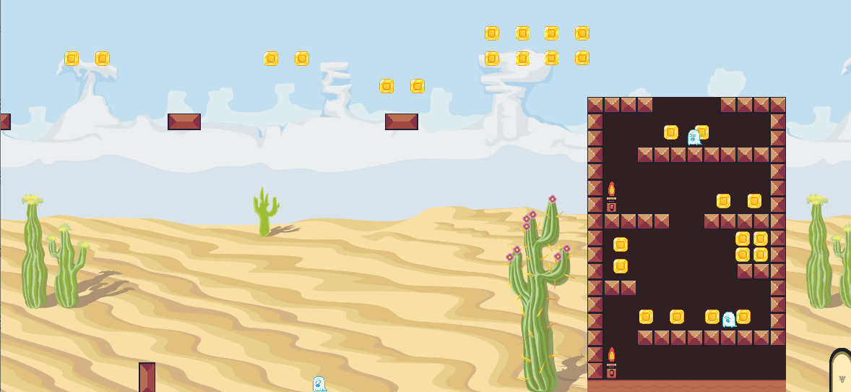

|  |
| --- |
| *29/06/2021*  Изготвил: Александър Пилафов (F91104) Преподавател: З.Узунова |