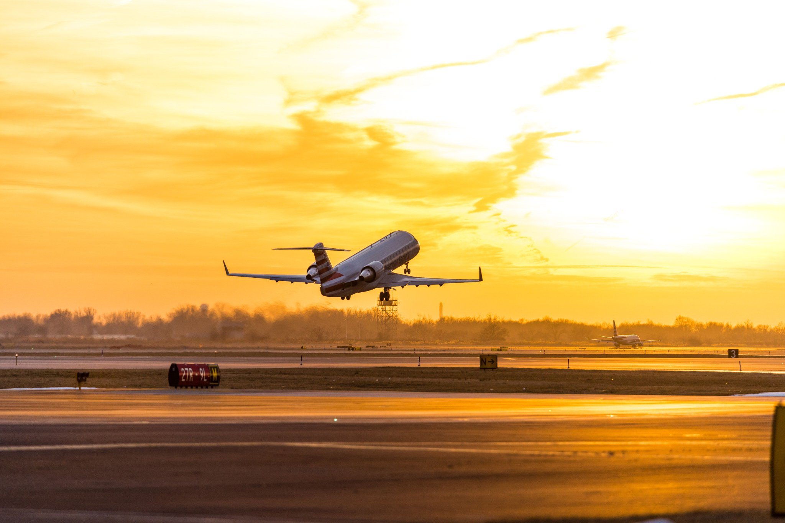

**Create a Tableau Project**

***Flights delay and cancellation 2015***

Aleksandr Plotnitskiy

data analyst nanodegree

2018

Contents

**Story 1** – Southwest Airlines - 2 -

**Story 2** – Weather Delays - 7 -

**Story 3** – Philadelphia International Airport - 9 -

**Story 4 –** Alaska Airlines dashboard - 12 -

# **Story 1** – Southwest Airlines

**Link for the old** version of story in Tableau Public:

<https://public.tableau.com/profile/alex8163#!/vizhome/most_worst_airline_storyOLD/worst_delay_airline_story>

**Link for the final** version of story in Tableau Public:

<https://public.tableau.com/profile/alex8163#!/vizhome/most_worst_airline_storyNEW/worst_delay_airline_story>

**Summary:** First look which airline has the most delay in total delays (Figure 1)?

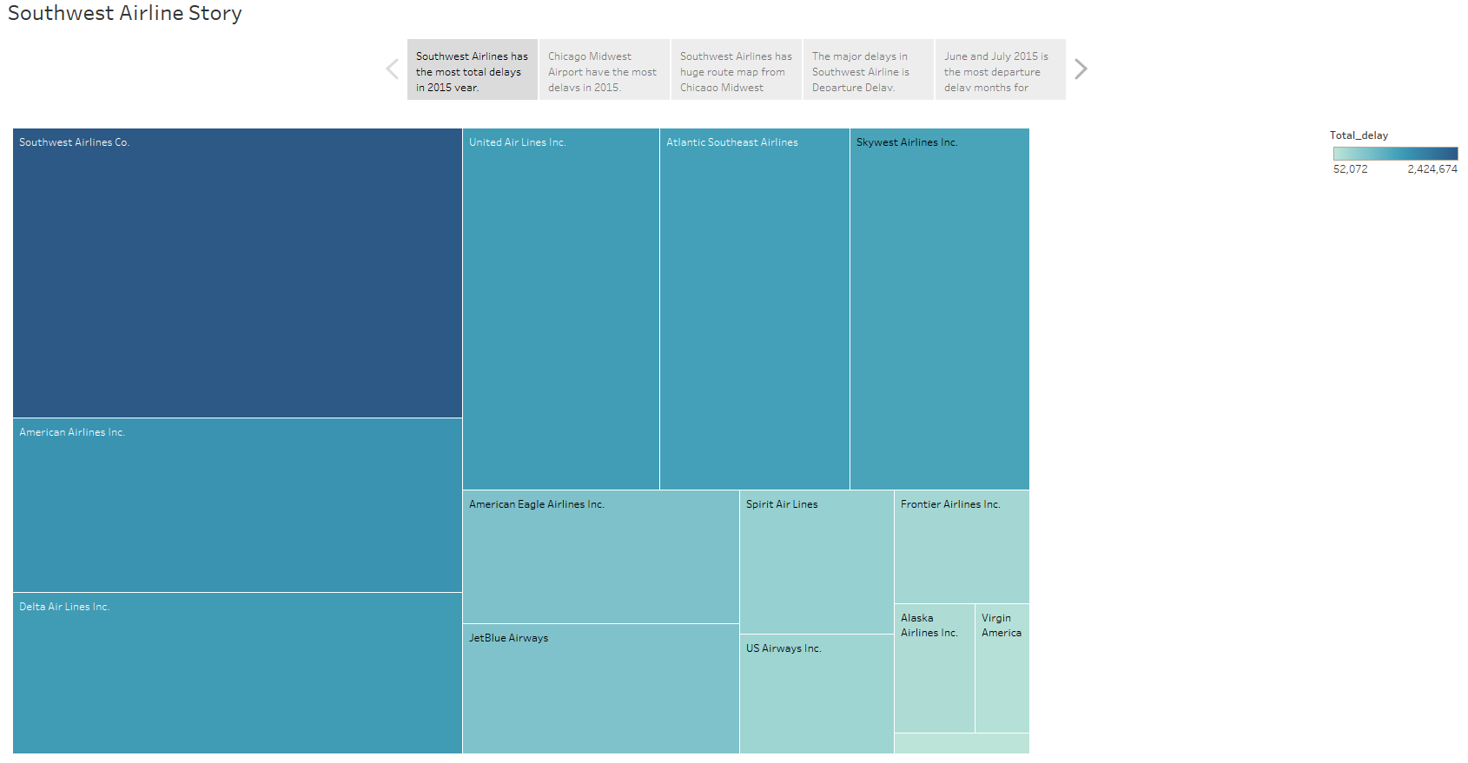

Figure 1

To calculate delays the new field “Total Delays” was created. A calculation scheme for this field is simple – just add all summarized types of delays. Southwest Airlines has 2,424,674 minutes of delays. This is the top result of total delays. Second major delay airline is American Airline. They have 1,461,272 minutes of delays.

On the other hand, we have Hawaiian Airlines. This is the best on time airline – 52,072 minutes.

Where and what causes delays for Southwest Airline? To answer a first question let’s see the map (Figure 2):

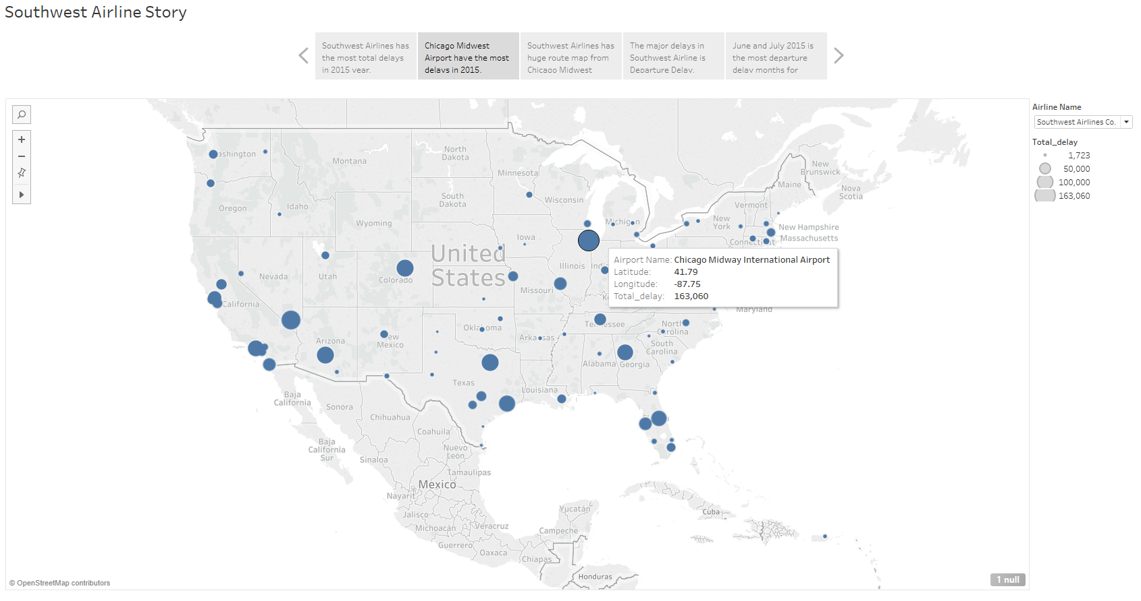

Figure 2

Chicago Midway is the most delay airport in US. It has 163,060 delays total in minutes. The second most delay airport is Baltimore – Washington International. BWI has 145,643 minutes of delays.

Portland International Jetport is the most less delays across the country – 1,723 min.

As we saw in previous picture, Chicago Midway Airport experiencing a high level of delays. Is there a main reason for those delays amount? Let’s see the routes map for airport and airline (Figure 3):

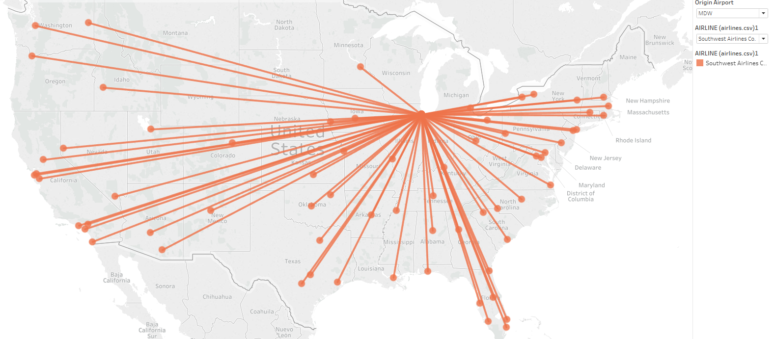

Figure 3

Southwest Airlines has a huge flights or route map from Chicago Midway! Looks like the airline has a hub there. Airline hub are used by one or more airlines to concentrate passenger traffic and flight operations at a given airport.

What part of Southwest Airline flights has the most delays? Arrival or departure, or due the weather condition? Let’s look on Figure 4:

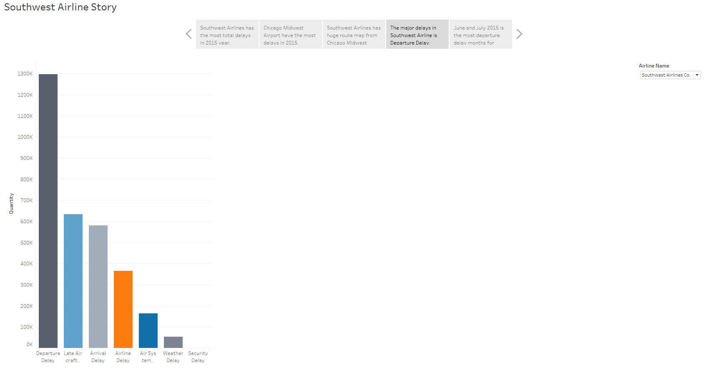

Figure 4

By the diagram above, Southwest has a lot of departure delays. It’s 1,296,838 delays are happening during departure process. It’s a huge delay amount!

What month the airline has most delays (Figure 5):

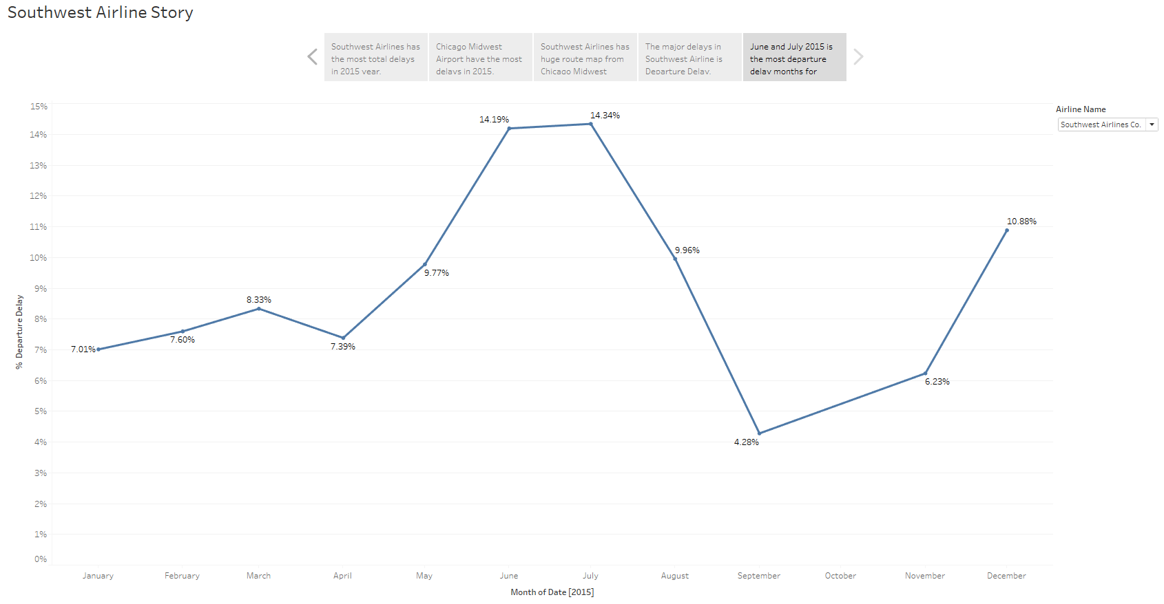

Figure 5

June and July have 14.19% and 14.34% percentage of total departure delays. June and July is a summer months.

September has the less percentage of departure delays – 4.2%.

**Design** for this story I choose blue and warm green colors to prevent destructing or destroying from the red, yellow or green colors. On the flights root map, I choose little bit orange color for better displaying.

**Feedback:** In **Figure 1** you want to show which airport has the highest delay. So, you should only color airport, and NOT the whole state. Remember, that state might have more than one airport. Use dot to represent the airport and marker size to encode extent of delay.

**Recourses** which I used for this story was [www.google.com](http://www.google.com), Tableau online help.

# **Story 2** – Weather Delays

**Link for the old** version of story in Tableau Public:

<https://public.tableau.com/profile/alex8163#!/vizhome/weather_delays_storyOLD/Weather_delays_story>

**Link to the final** version of story in Tableau Public:

<https://public.tableau.com/profile/alex8163#!/vizhome/weather_delays_storyNEW/Weather_delays_story>

Are there any delay problems due the weather condition? How often airlines cancelling the flights?

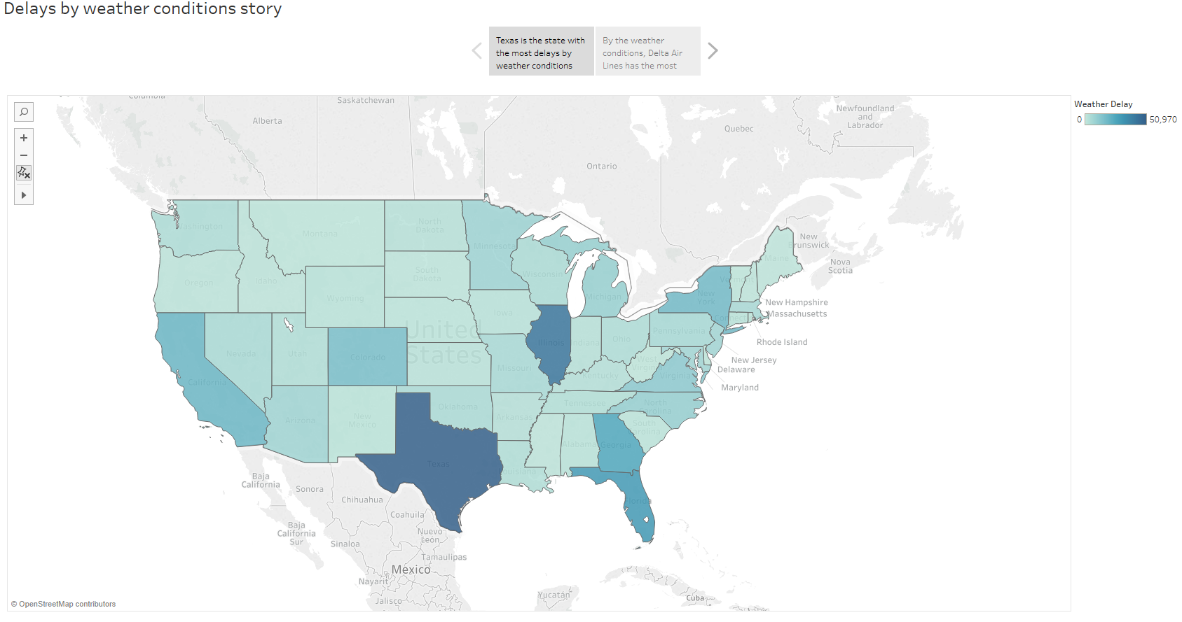

Figure 6

Texas has the most delays in US due the weather conditions – 50,970. Second state with a lot of delays due the weather conditions is Illinois. This state has 42,600 delays.

On the other side West Virginia state has the lowest amount of weather delays – only 24.

Which airline has the most amount of delays due the weather condition? How delays depend on time of year of month (Figure 7)?

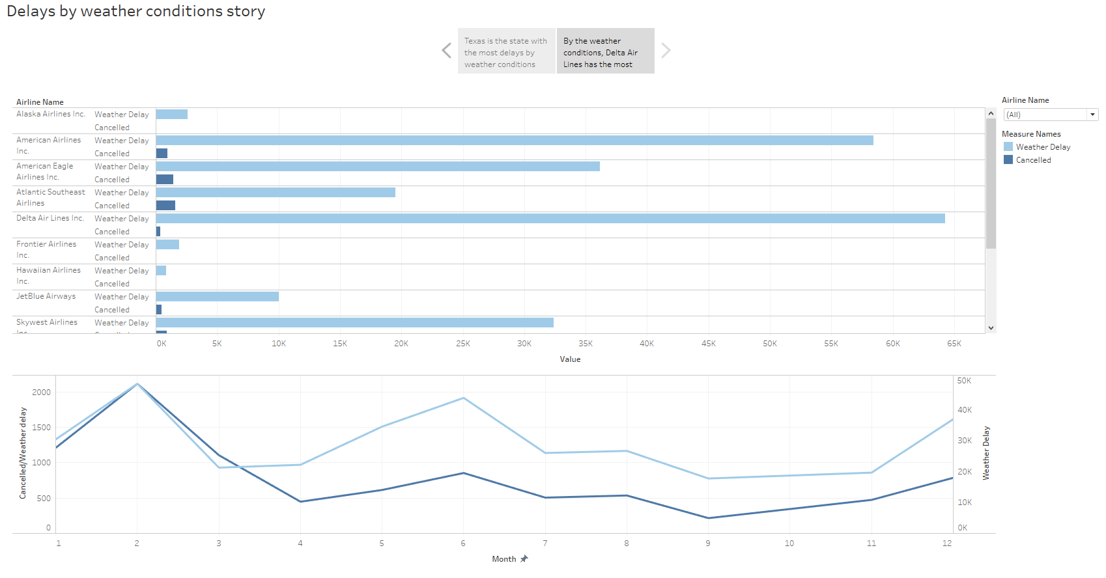

Figure 7

Delta Air lines has the most amount of weather delays – 64,276 flights. American Airlines has the second range – they delayed 58,434 flights due the weather conditions.

Let’s look onto Alaska Airlines: they delayed only 2,614 flights by the weather.

In February 2015 airlines has the most delays by weather and cancellations: weather delays 48, 406 and cancellations 2,116. February is the winter month, so delays may be cause by snowy or windy weather condition.

**Design** for this story I choose blue and warm green colors to prevent destructing or destroying from the red, yellow or green colors.

**Feedback:** Please avoid using labels that block visualization. You can remove the labels as the insights in the label and clearly visible on chart. Please remove month 0 and 13 from the line graph, as these numbers do not make sense in the context of month.

**Recourses** which I used for this story was [www.google.com](http://www.google.com), Tableau online help.

# **Story 3** – Philadelphia International Airport

**Link for the old** for the story in Tableau Public:

<https://public.tableau.com/profile/alex8163#!/vizhome/PHL_storyOLD/PHL_story?publish=yes>

**Link for the final** for the story in Tableau Public:

<https://public.tableau.com/profile/alex8163#!/vizhome/PHL_story_newNEW/PHL_story>

Based in Figure 1 American Airlines is the second most delay airline. Let’s see how they are operating in one of their hub – Philadelphia International Airport (PHL)

This is a story about Philadelphia International Airport(PHL) and American Airlines. How many flights departed and arrived from/to PHL in 2015? What is the average delays?

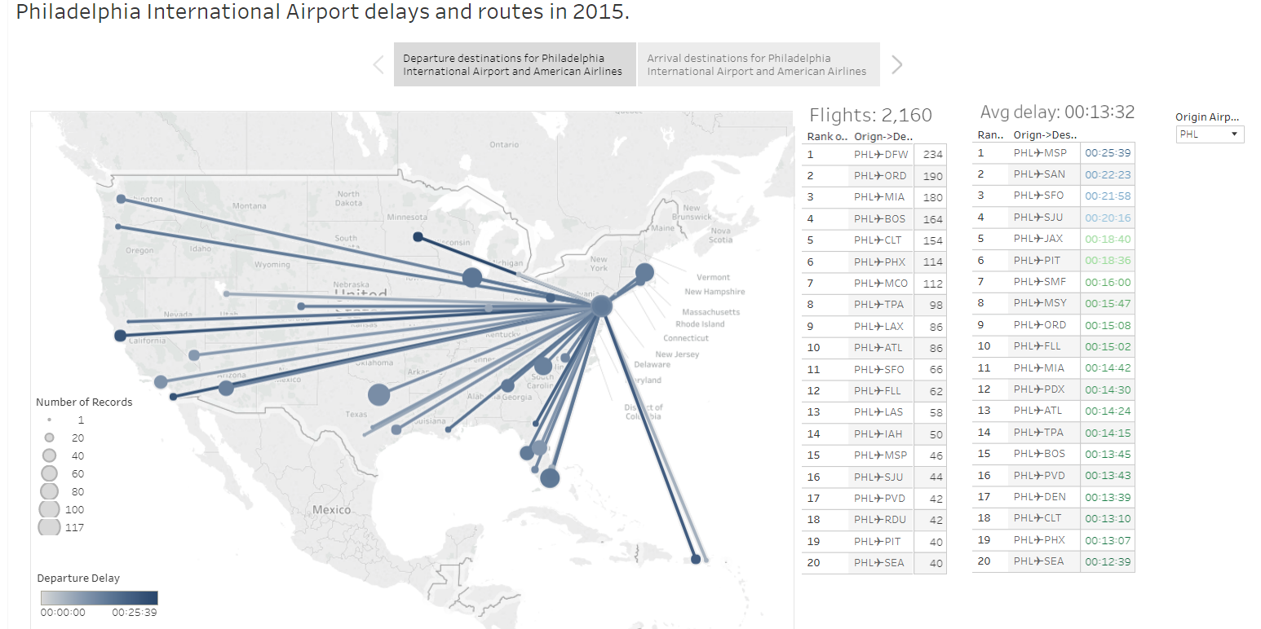

Figure 8

First, investigate departure section. Flights map shoes us a big flights route from PHL across the country. There are 2,160 flights departed from PHL in 2015. Let’s rank the amount of departure flights to different airports.

First rank is the flight from PHL to Dallas/Fort Worth(DFW) International Airport. American did 234 flights in 2015 to the airport. Second rank is the flights to Chicago O’Hare International Airport(ORD). American Airliners did 190 flights to this airport.

On the other side, rank number 36 is the flight to Richmond International Airport (RIC) and only 2 flights in whole 2015 year.

Investigating departure delays part. Average delays from PHL with American Airlines is 13:32 min. Let’s rank delayed flights: rank number one for the flight to Minneapolis St. Paul International (MSP). Total delay for this flight in 2015 was 25:39 min.

All other ranks have departure delay less than 23 min.

Now investigate arrival section (figure 9):

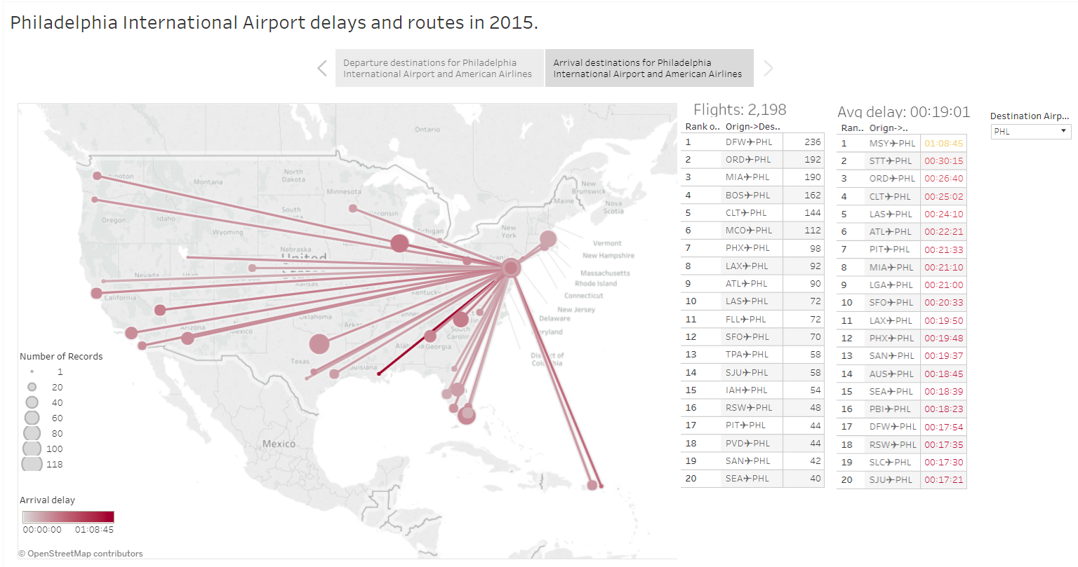

Figure 9

Average arrival delays 19:01 min. Ranking arrival flights by delay time: rank 1 is the flight from Louise Armstrong New Orleans International Airport (MSY). This flight delayed for 1 hr 08 min 45 sec. What a delay!!

Another big arrival delay flight from Cyril E. King Airport (STT). The flight was delayed for 30 min 15 sec in whole 2015 year.

All other flights were delayed by arrival for less than 30 min.

The difference between total departure and arrival flights is 38 flights. It’s can be caused by delays or diversion, or any technical problems with aircrafts.

**Design** for this story I choose blue and warm green colors to prevent destructing or destroying from the red, yellow or green colors. On the flights root map, I choose little bit red color for better displaying.

**Feedback:** Please pay attention to layout of the visualizations. Some of the elements are partially hidden.

**Recourses** which I used for this story was [www.google.com](http://www.google.com), Tableau online help.

# **Story 4 –** Alaska Airlines dashboard

**Link for the old** story in Tableau Public:

<https://public.tableau.com/profile/alex8163#!/vizhome/Airlinedelaysbytypeandmonth_DashboardOLD/AA_dashboard?publish=yes>

**Link for the final** story in Tableau Public:

<https://public.tableau.com/profile/alex8163#!/vizhome/Airlinedelaysbytypeandmonth_Dashboard/AA_dashboard>

Based in Figure 1 – Alaska Airlines is in the group with less total delays. Let’s look inside the airline and take Seattle-Tacoma International Airport (SEA) as an example.

The dashboard about Alaska Airlines (Figure 10):

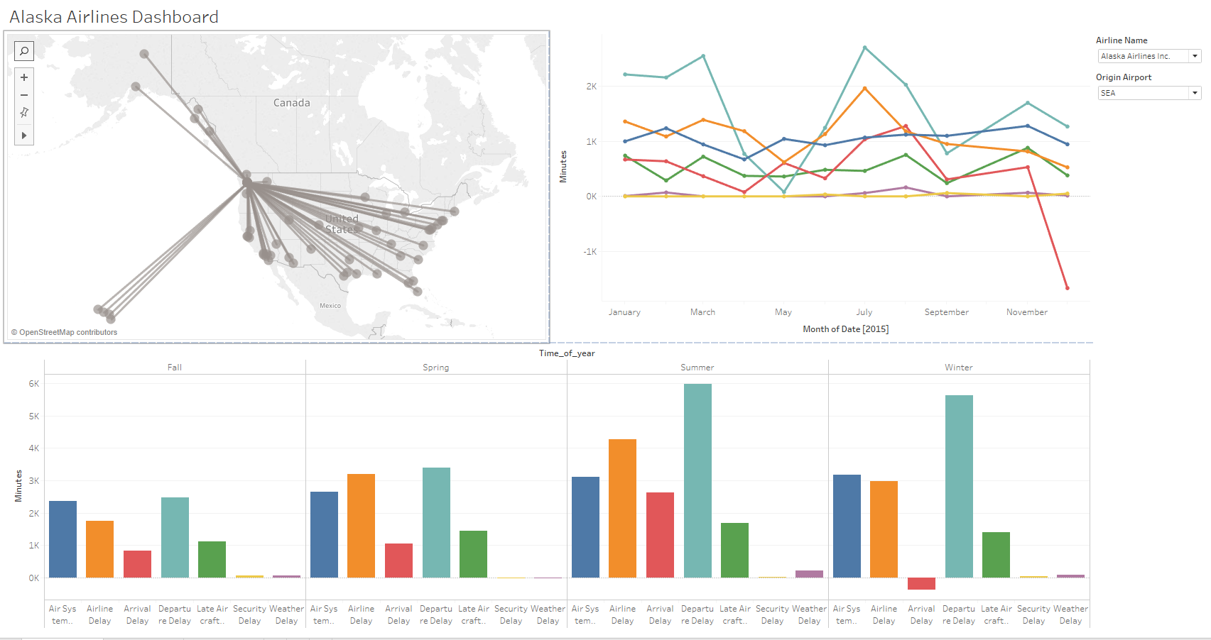

Figure 10

From this picture we can see a size of airline routes from Seattle-Tacoma International Airport (SEA).

The bottom part of screenshot displays different type of delay by period of year. Major delays happening during departure, arrival procedures and due the air system delay. On Summer amount of departure delays is 5,968, on Winter – 5,634.

Another big delay happening in Summer is Arrival delay – 4,270. Assume, that it’s happened due the high travelling season.

One interesting thing – if we look to Arrival delay in Winter it goes under the zero axis. This fact can be interpreted as early arrival.

This fact easy to understand while analyze many types of delays on months view (Figure 11):

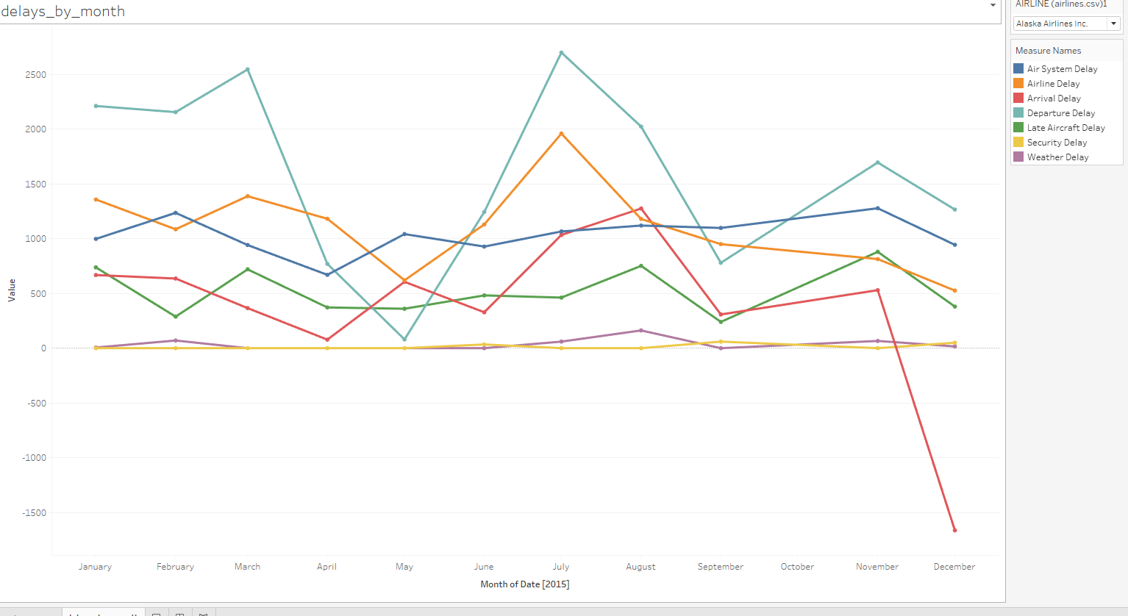

Figure 11

Here we can see the “arrival effect” in December.

**Design** for this dashboard I choose standard Tableau and grey color scheme to better display flights map.

**Feedback:** On Figure 10 Clustered Bar Chart a color legend is provided, so it is no necessary to label the bars repeatedly, which is redundant and makes the visualization cluttered.

**Recourses** which I used for this story was [www.google.com](http://www.google.com), Tableau online help.