Real Complex Diagrams Export
This file verifies that Prism preview and export reuse the same rendered diagram output.

Mermaid Flowchart
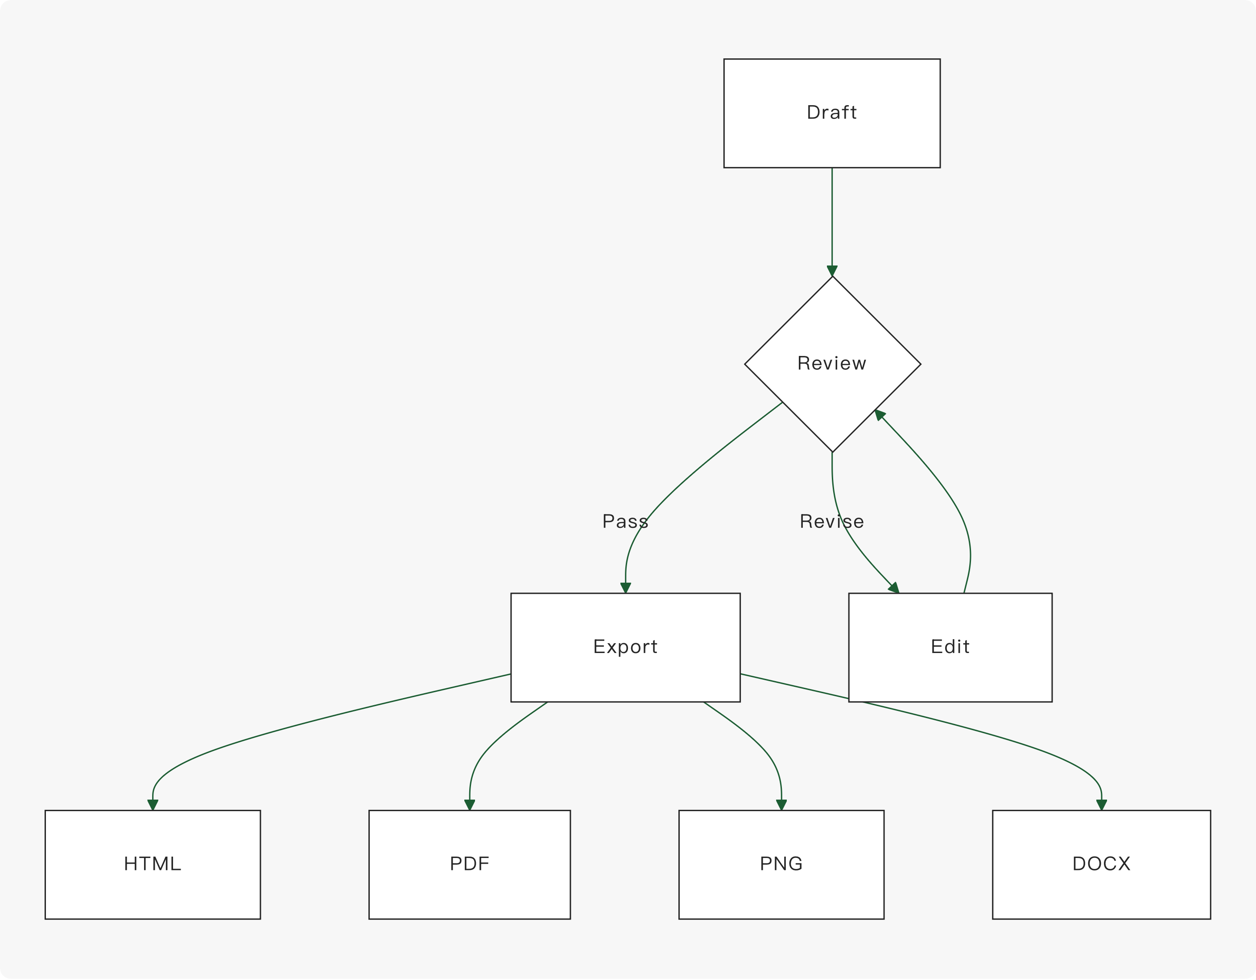

PlantUML Relationship
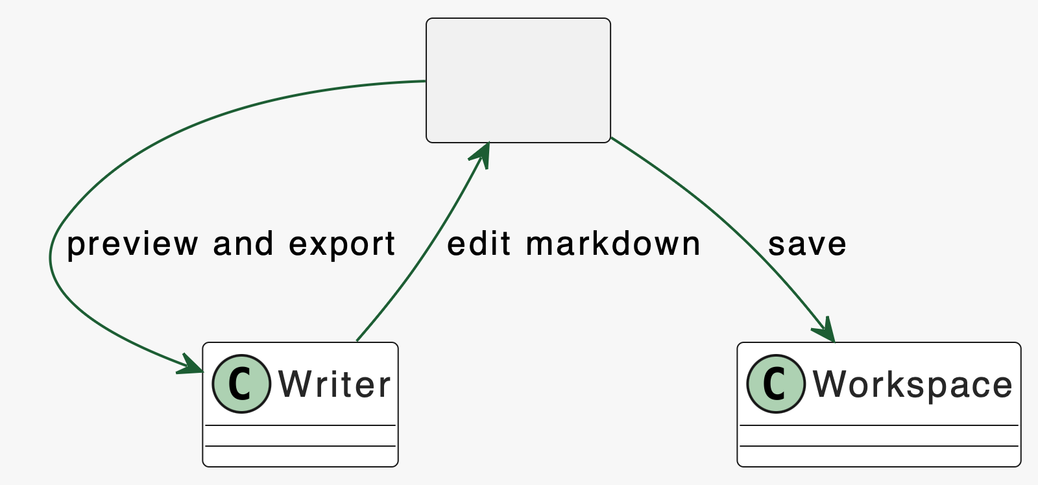

Markmap Mind Map
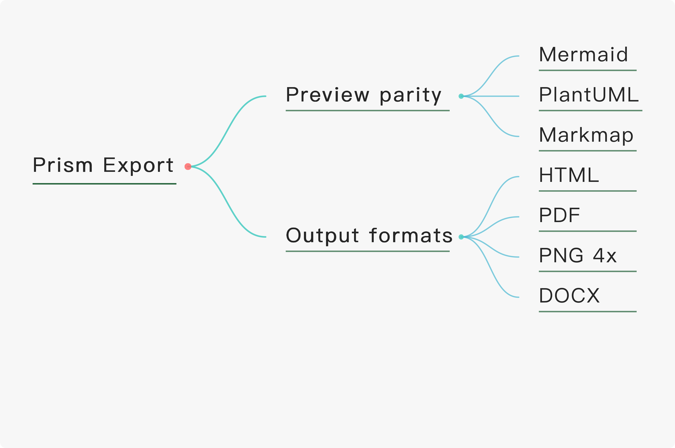

Local Resource


Table And Math
Format | Expected
HTML | self-contained preview output
PDF | no missing diagram nodes
PNG | keeps selected 4x scale
DOCX | readable in office suites
Inline math: 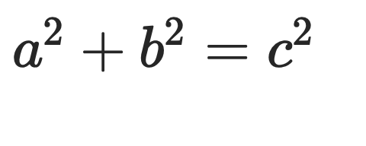.
Block math:


