Implementation -Sample database file in

IBM UDeploy

Contents

A. Create Resource 2

➢ Map Agent 3

B. Create component 4

➢ Map component 4

➢ Create component level process 5

C. Create Application 8

➢ Map component to application 9

➢ Create Application level process 10

➢ Create environment 11

➢ Add resources 12

# Create Resource

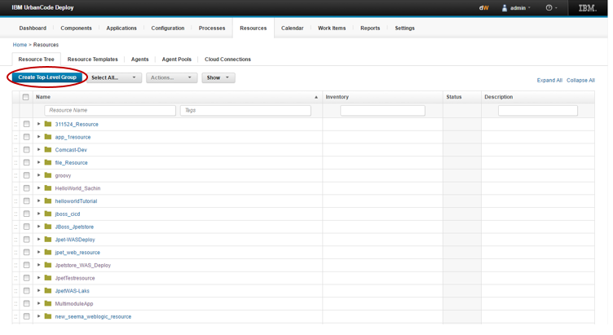

Create top level resource.

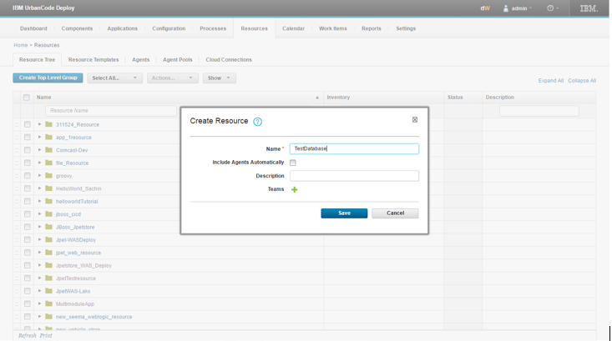

## Map Agent

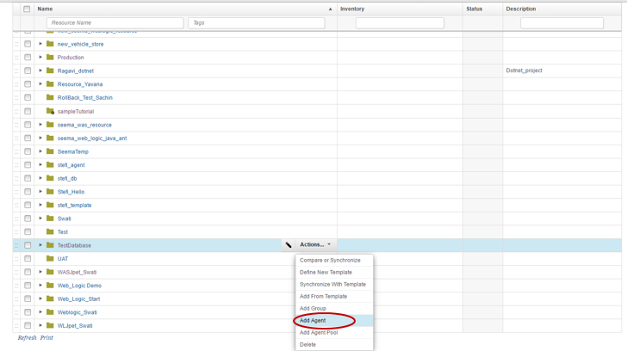

Add the agent to resource. Choose the agent which is present on same machine where the MYSQL database is running and the .sql file of database should present there.

# Create component

Go to component tab and create new component.

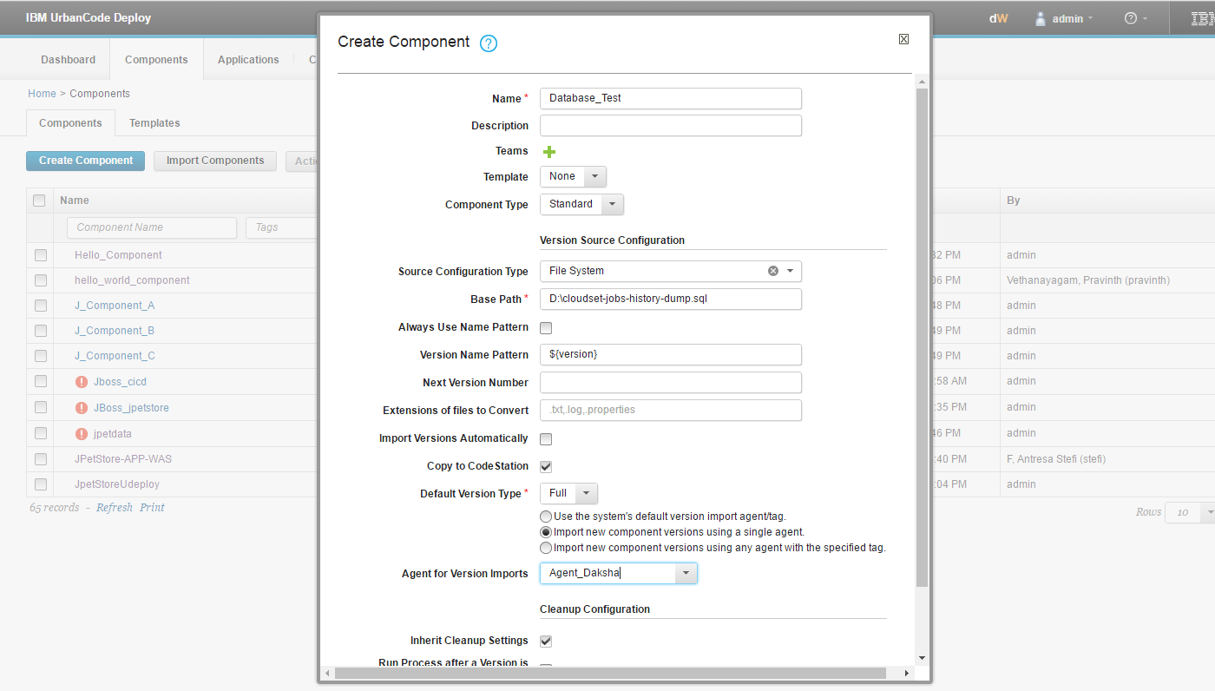

In base path add the path of file you want to execute

Choose the agent.

## Map component

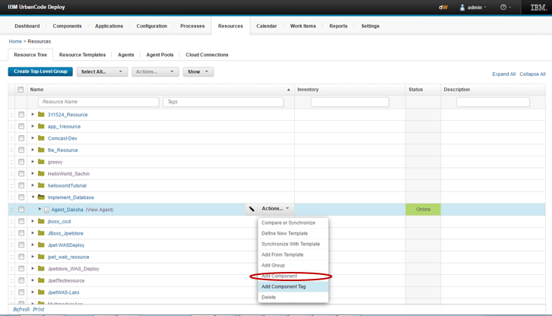

You will get the mapped component in your resource tree field.

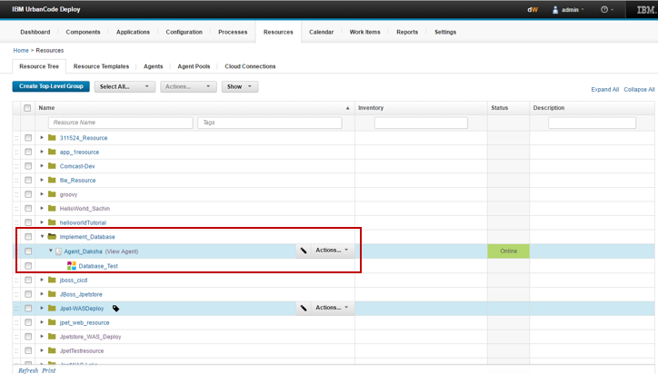

## Create component level process

Go to component tab 🡪 click on your component 🡪 select process 🡪 create component

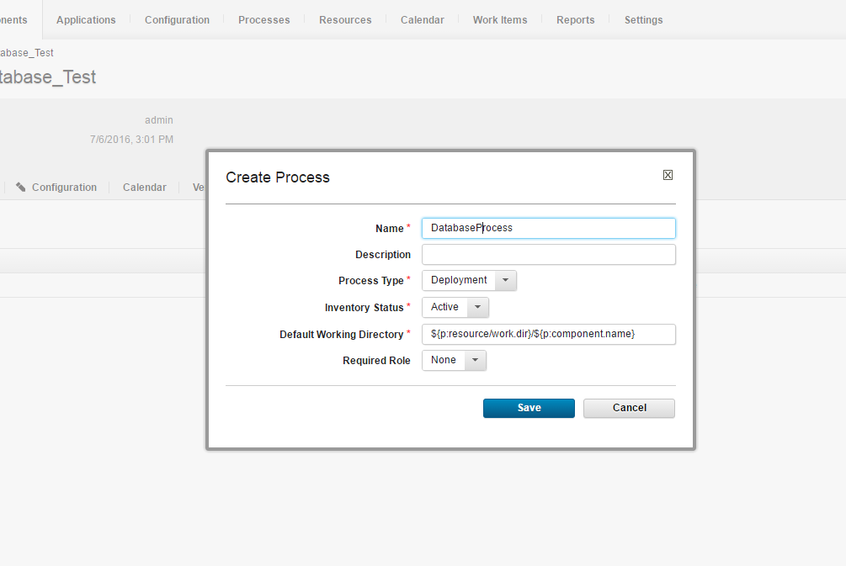

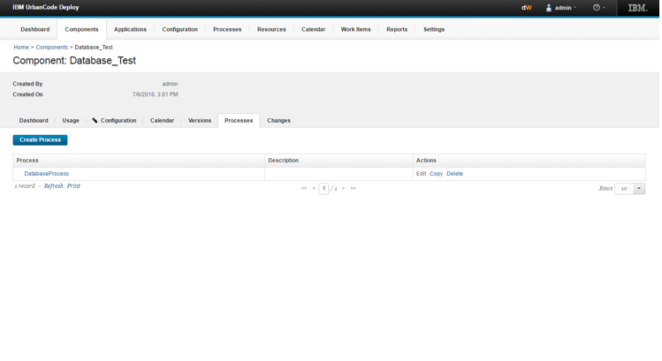

Click on that component and edit the design.

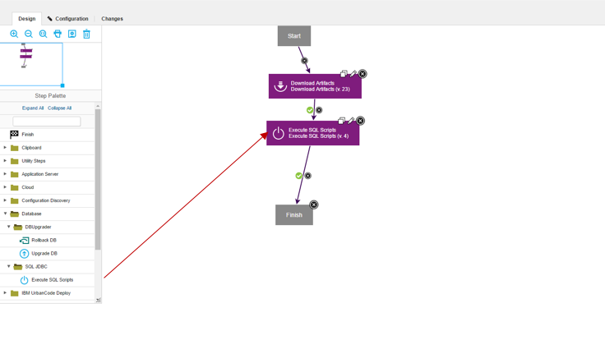

1. Download artifact –

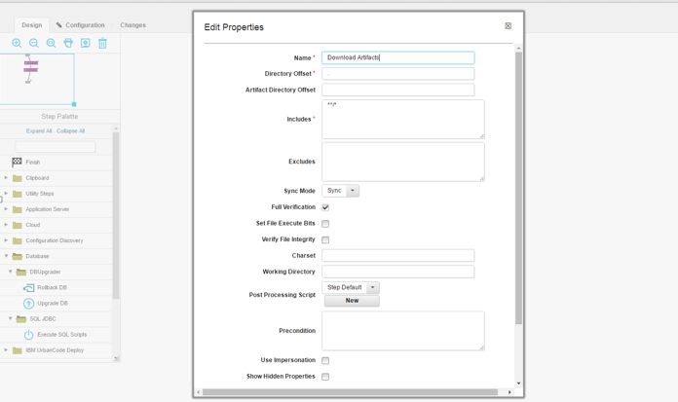

Properties –

Keep all the field as it is and save it.

1. Execute sql script -

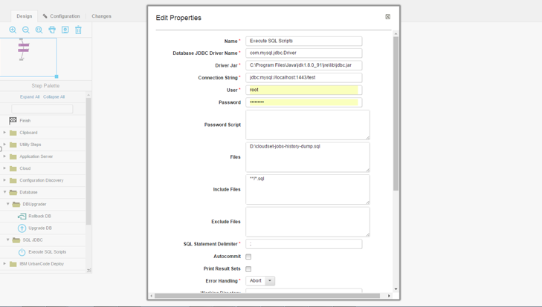

Properties –

1. Name – Name of step.
2. Database JDBC driver name – Provide the name of jdbc driver

(for eg. Com.mysql.jdbc.Driver for mysql)

1. Driver jar – Provide the full path of jdbc jar which is present in the system.
2. Connection string –Provide the connection string foe sql database connection.

(for eg. jdbc:mysql://localhost:portnumber/databasename)

1. Files – Provide the file of database with root directory path.

# Create Application

Go to application tab 🡪 create application.

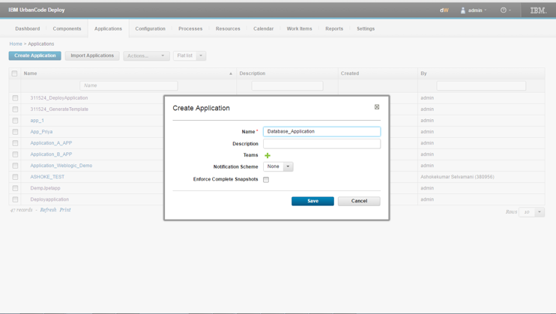

## Map component to application

Go to Application🡪 select the application 🡪 Component 🡪 add component

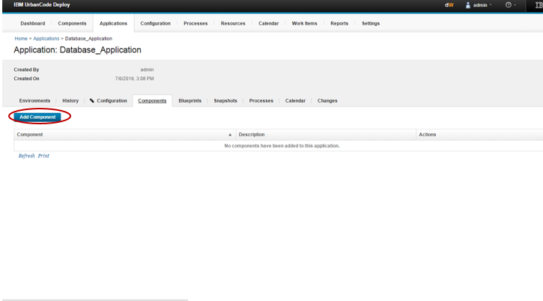

Select the component which you have created.

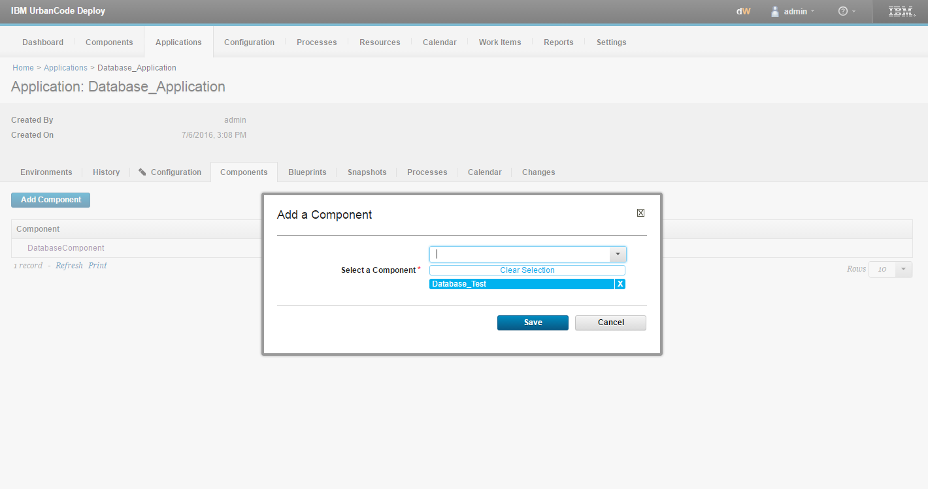

## Create Application level process

Go to 🡪 Application🡪 choose your application 🡪 process 🡪create process

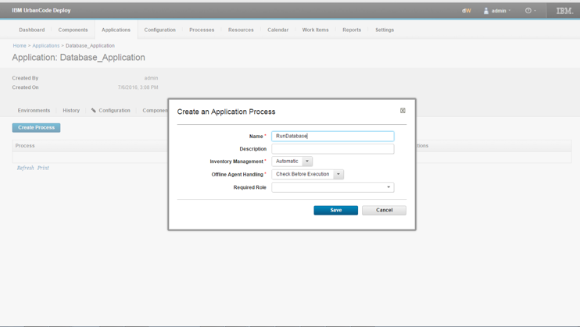

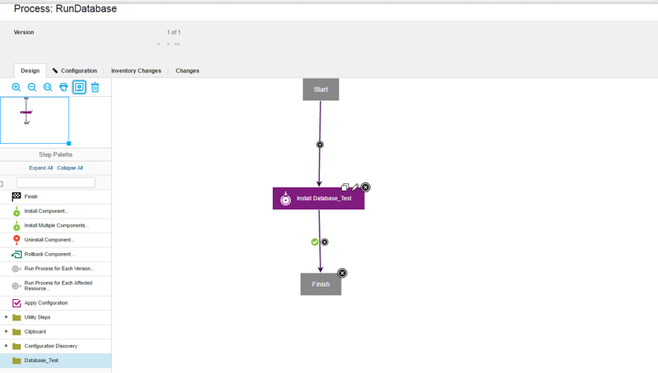

Check given properties.

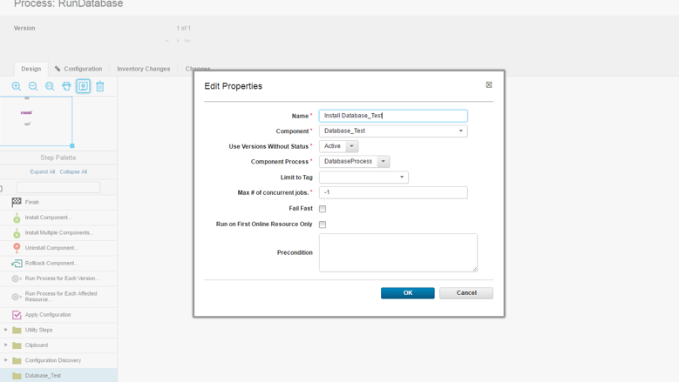

## Create environment

Go to 🡪application tab 🡪select your application 🡪Environment tab 🡪create environment

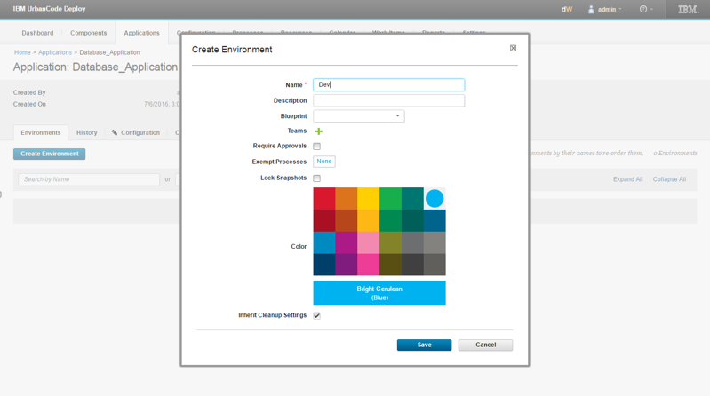

## Add resources

Go to application🡪 choose your application 🡪 click on environment🡪add base resource

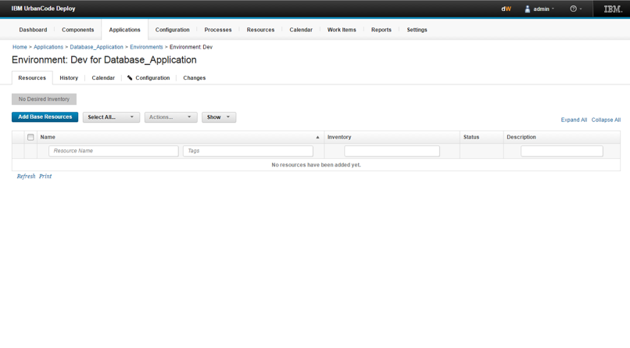

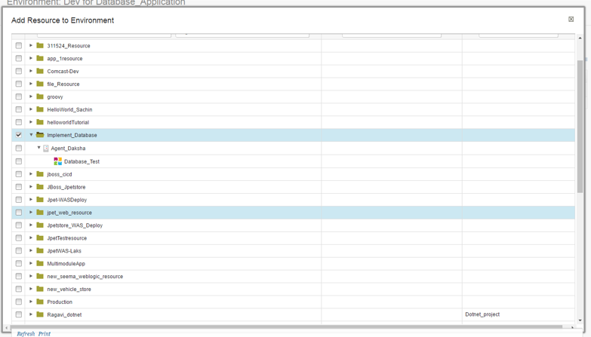

Click on run symbol and run it.

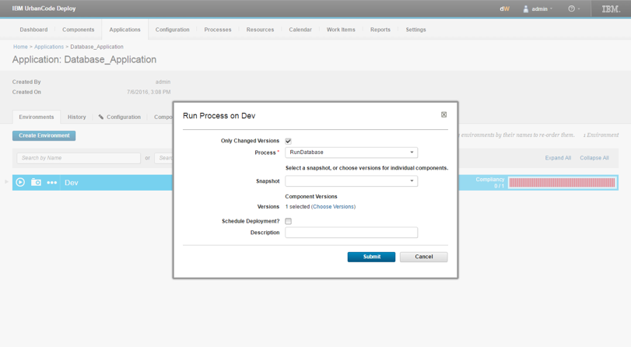

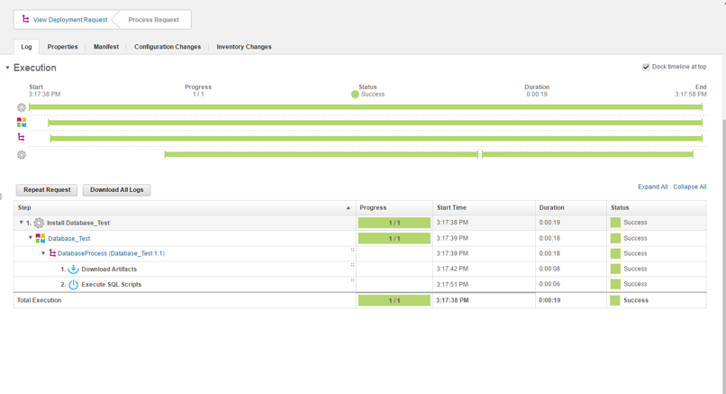

To check the successful execution of sql script open the MySQL in your machine .choose the database in which you are working. And run select query for any table then you can see the data here.

