Linked List
Sprint Report
Team: Partigiano

Introduction
The following article is the report of a Software Engineering project, that took place in 2025. The source code and file files can also be found in Github,

Purpose
The purpose of the project is to develop a robust Linked List. Other than the different functionalities of this application, the project should be designed in such a way that it is maintainable and extendable, as well fully documented. This shall result in fast and correct development and deployment of new features in the future. Another target of the project was to implement agile methods to develop software. In our case, I used scrum.

Document Structure
The rest of this document is structured as follows:
- Section 2 specifies the technologies used during the development of the project.
- Section 3 describes our Scrum team and specifies this Sprint's backlog.
- Section 4 dives into the Use Cases, which derive from User Stories.
- Section 5 explains the project’s Architecture and Design.

Tools and Technologies
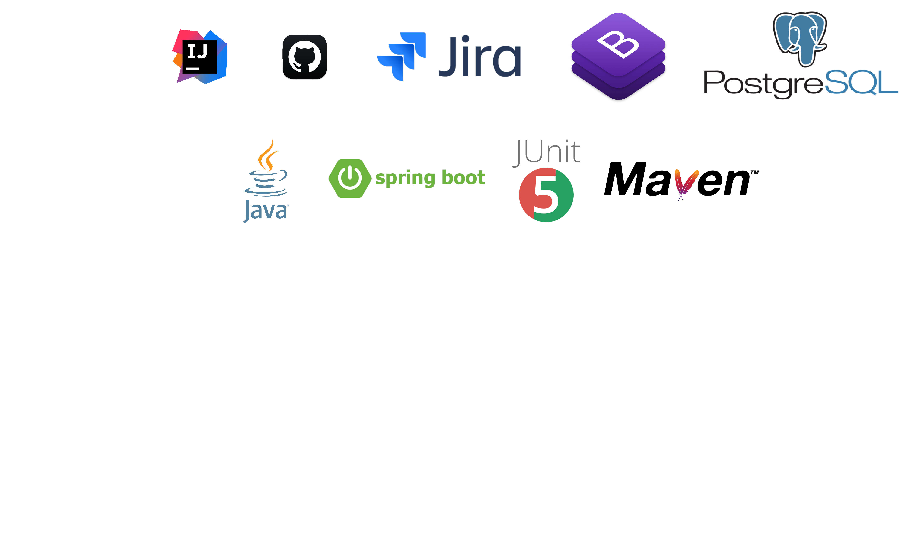

- Java: A high-level, class-based, object-oriented programming language. Widely used and famously quoted as “write once, run anywhere” as she has very few dependencies.
- Spring Boot: An open-source Java framework used for programming standalone, production-grade Spring-based applications.
- Bootstrap: An open-source CSS framework directed at responsive front-end web applications.
- GitHub: A developer platform that allows development teams to create, store and manage their code. It uses and extends the Git software.
- Junit: A unit testing framework for java.
- PostgreSQL: A free and open-source relational database management system (RDBMS) emphasizing extensibility and SQL compliance.
- Jira: A product development tool that allows bug tracking, issue tracking and agile project management.
- IntelliJ: An IDE for developing computer software written in Java and other JVM-based languages.
- Maven: A build automation tool used for, among others, java projects.

Scrum team and Sprint Backlog

Scrum team
Product Owner | Alex Pournaras
Scrum Master | Alex Pournaras
Development Team | Alex Pournaras

Sprints
Sprint No | Begin Date | End Date | Number of weeks | User stories | Description
1 | 9/3/2024 | 22/3/2024 | 2 | None | Determine the tools and technologies to be used to build the project. Create use cases, domain classes and UML diagrams.
2 | 24/3/2024 | 07/04/2024 | 2 | US1, US2, US3 | Implement basic user functionalities such as creating and logging in/out of an account.
3 | 07/04/2024 | 21/04/2024 | 2 | US5, US6, US7, US8, US9 | Complete book offer functionalities:  Add, remove book offers with info for them.  Browse book request list. Browse interested users list for each book.  Select a user to hand each book
4 | 24/04/2024 | 05/05/2024 | 2 | US4, US10, US11 | Add User Profile editing and book search functionalities
5 | 06/05/2024 | 19/05/2024 | 2 | None | Create separate database for testing and test each class.

Use Cases

Create Linked List
Use case ID | UC1
Actors | User
Preconditions | -
Main flow of events | - The use case starts when the user calls the create() function.
Post conditions | - A new Linked List has been created with empty contents.
Alternative flow 1 | - There is no space in the heap to allocate memory.
Post conditions | The programs exits, throwing an error message.

Add Node
Use case ID | UC2
Actors | User
Pre conditions | The user has created a Linked List.
Main flow of events | - The use case starts when the user calls an add_node function.  - add_at_head()  - add_at_tail()  - add_at_index()  - The user will define the index of the insertion, default: head.
Post conditions | - A new node has been inserted to the Linked List.
Alternative flow 1 | - There is no space in the heap to allocate memory .
Post conditions | - The programs exits, throwing an error message.
Alternative flow 2 | - The user-provided index is out of bounds.  - The software asks the user to dictate its next action  - Ignore and do nothing.  - Insert at head.  - Insert at tail.
Post conditions | - The software throws out of bounds message.  - The node is inserted or not, depending on user’s choice.

Delete Node
Use case ID | UC3
Actors | User
Pre conditions | The user has created a Linked List. For the sake of the main flow, it will have to be non-empty.
Main flow of events | - The use case starts when the user calls a delete function.  - delete_at_head().  - delete_at_tail().  - delete_at_index().  - It’s matter mandatory for the user to define the index.
Post conditions | - The corresponding node has been deleted.
Alternative flow 1 | - The user-provided index is out of bounds.
Post conditions | - No effect to the data structure, a message is thrown, informing the user about that.

Get Node
Use case ID | UC4
Actors | User
Pre conditions | The user has created a Linked List. For the sake of the main flow, it will have to be non-empty.
Main flow of events | - The user calls the get_node() function. It is mandatory for the user to define the index.
Post conditions | - The corresponding node is being returned.
Alternative flow 1 | - The user-provided index is out of bounds.
Post conditions | - Void is being returned. A message is thrown, informing the user about that

Design

Architecture
The project consists of 5 packages.
- Entity : The entity package contains the domain classes of the project. Those classes represent real world objects (user, book, etc.).
- Repository: The repository package contains the classes that extend the JpaRepository Interface. The allow Spring to map Entity classes into SQL tables. They also provide query methods to save, delete and update java object data into the SQL schema of the project.
- Service: The Service package contains classes responsible for transferring between the backend and the front-end. The classes apply domain login to determine whether the incoming data requests are valid.
- Controller: The controller package contains classes that take care of HTTP requests made on the projects front-end. Each class is responsible for calling the appropriate Service class based on incoming CRUD operations and loading the view of each endpoint if needed.
- Security: The security package contains the configurations needed to securely authorize user access. It determines which endpoints should be public and/or accessible for a specific type of user.

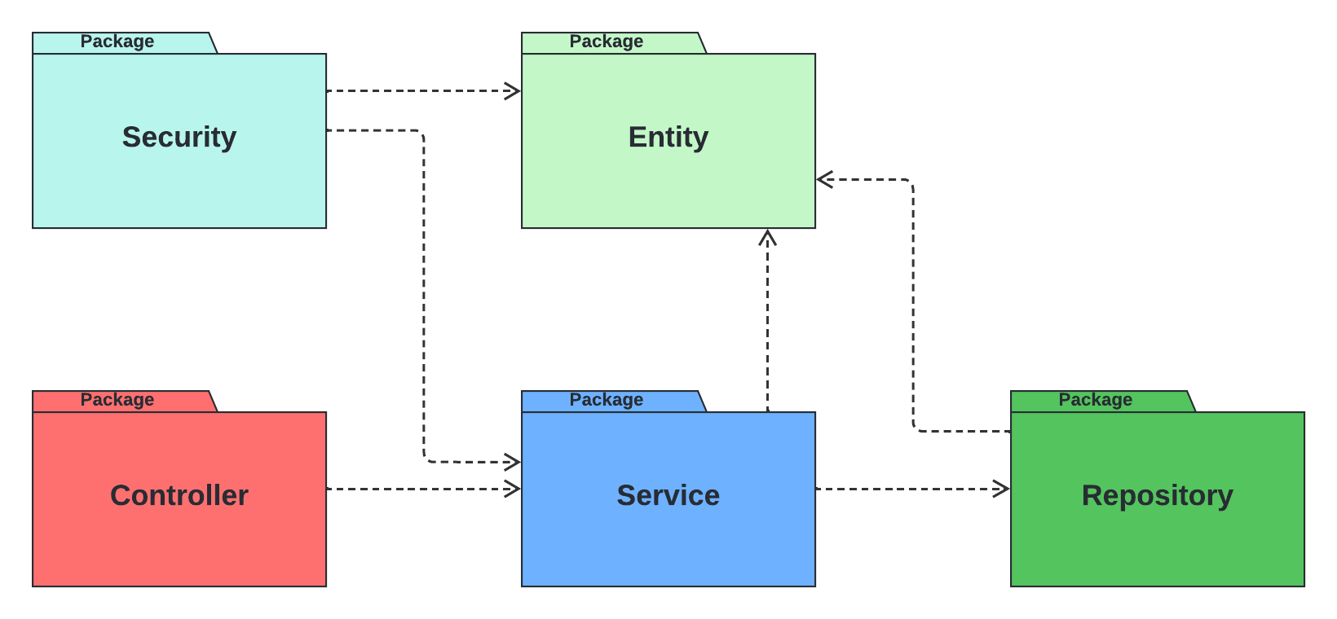

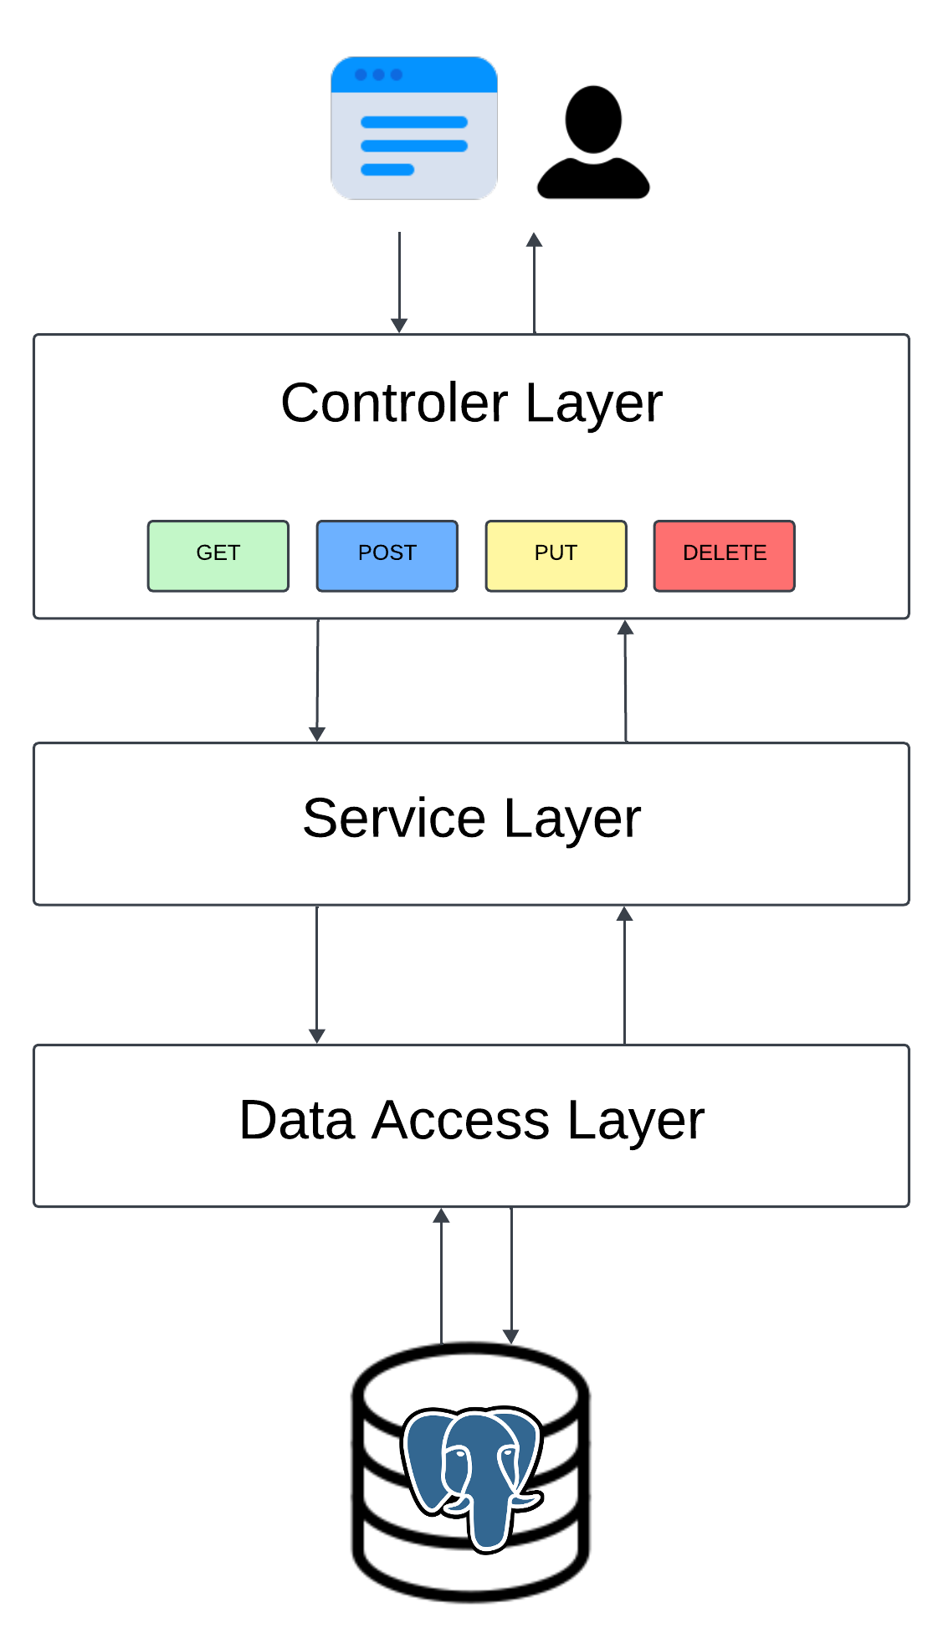
The project uses the 3-Tier architecture which means that the controller requests data from the service layer. The service layer determines if the controller should have access to the requested data given the user credentials. Finally, the service queries the data from the repository and sends it back to the controller.

Design
The Entity package consists of 4 subpackages:
- Book
- Recommend
- Search
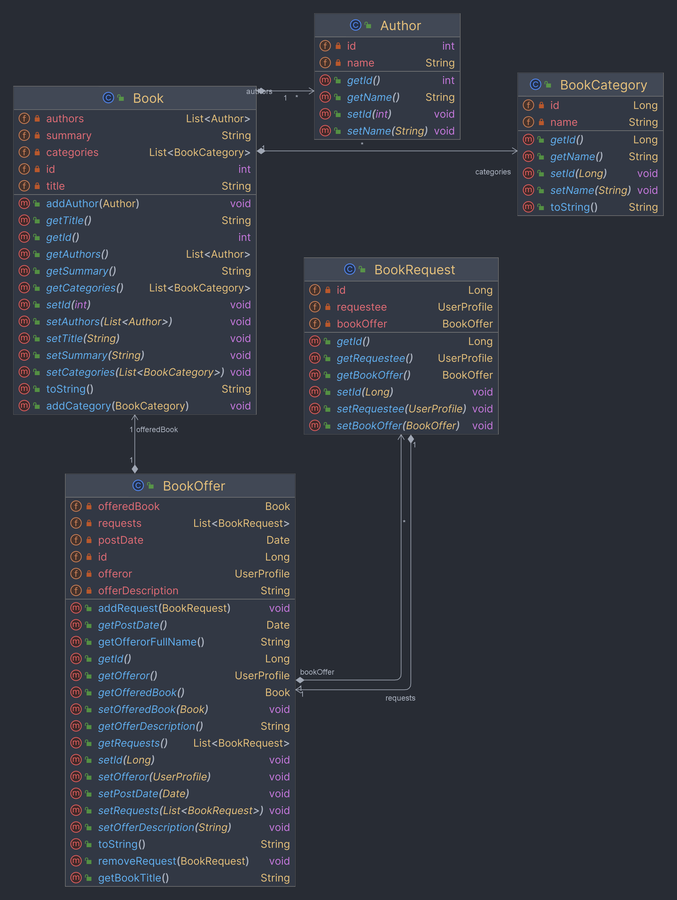
- User

