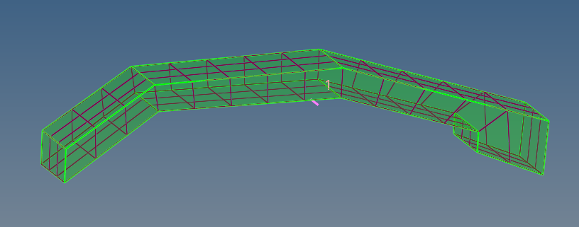
Had to modify the input file to have all the element-nodes on a single line

