**How to use the scheduler:**

1. Put the two input files in the same directory as the executable. The input files must be named "STUDENTS.csv" and "TEACHERS.csv". They must be formatted as specified in the Input_Specification.xlsx file. There are example rows in this file. Furthermore, in the executable directory, STUDENTS.csv and TEACHERS.csv are last semester's data reformatted according to this specification (with some filler info thrown in where necessary). Use these as a reference when creating new input files for the scheduler.

2. Open a Terminal on a Mac, 'cd' into the directory with the executable and the two input files. Type ".\process_input" to run the executable. Runtime is about 45 seconds. The result will be stored in an excel file called Schedule.xlsx. If Schedule.xlsx already exists, it will be overwritten by the new result.

Example:

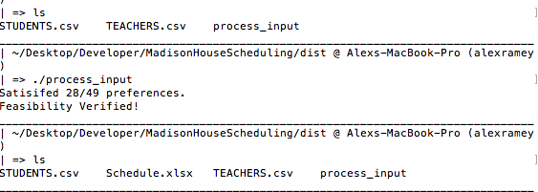

Notes:

1. Python files are included. If you are on Windows and/or want to run scheduler with python, feel free. You may need to 'pip install' some packages, but it's not hard to do this. Scripts are coded in python 3.4, and may be run with command 'python3 process_input.py' (make sure read_input.py is in same directory along with input files).

2. For the same input, results may vary slightly. It is recommended to run the scheduler a few times until you get a result you like the best.