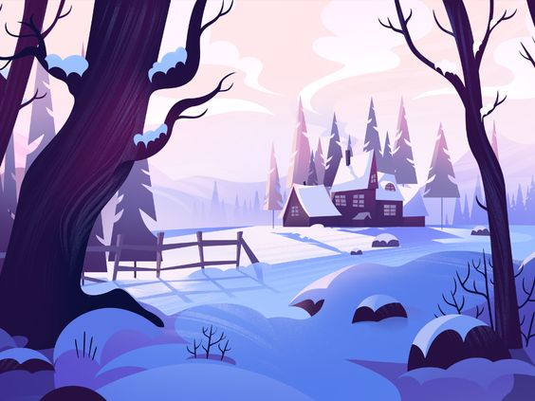

**Lines**

* Lines used for the wood texture.
* No outlines
* Far away more thinner. Close, more thick

**Shapes**

* Reinforcement of the sizes of the shapes depending on the distance they are from the viewer point of view
* A lot of curving. Specially in the front. At the back is more straight but not full straight
* The shapes that are more straight indicates that are create by the humans and there are not part of the nature (this one are more curved).

**Colour**

* There is a high value contrast. (Colours in front are more dark, like the trees, that ones in the back, like the sky). Helps to put it in black and white.
* The farer away the things are the less saturated they are. (Use colour pick to see the saturation)
* A lot of gradients (Snow (blue))

**Composition**

* Use ruler with percent to see the exact centre of the image
* High contrast
* Guiding lines to the main element = the house (mountains lines, sky clouds etc)