**HOW TO ANALYZE**

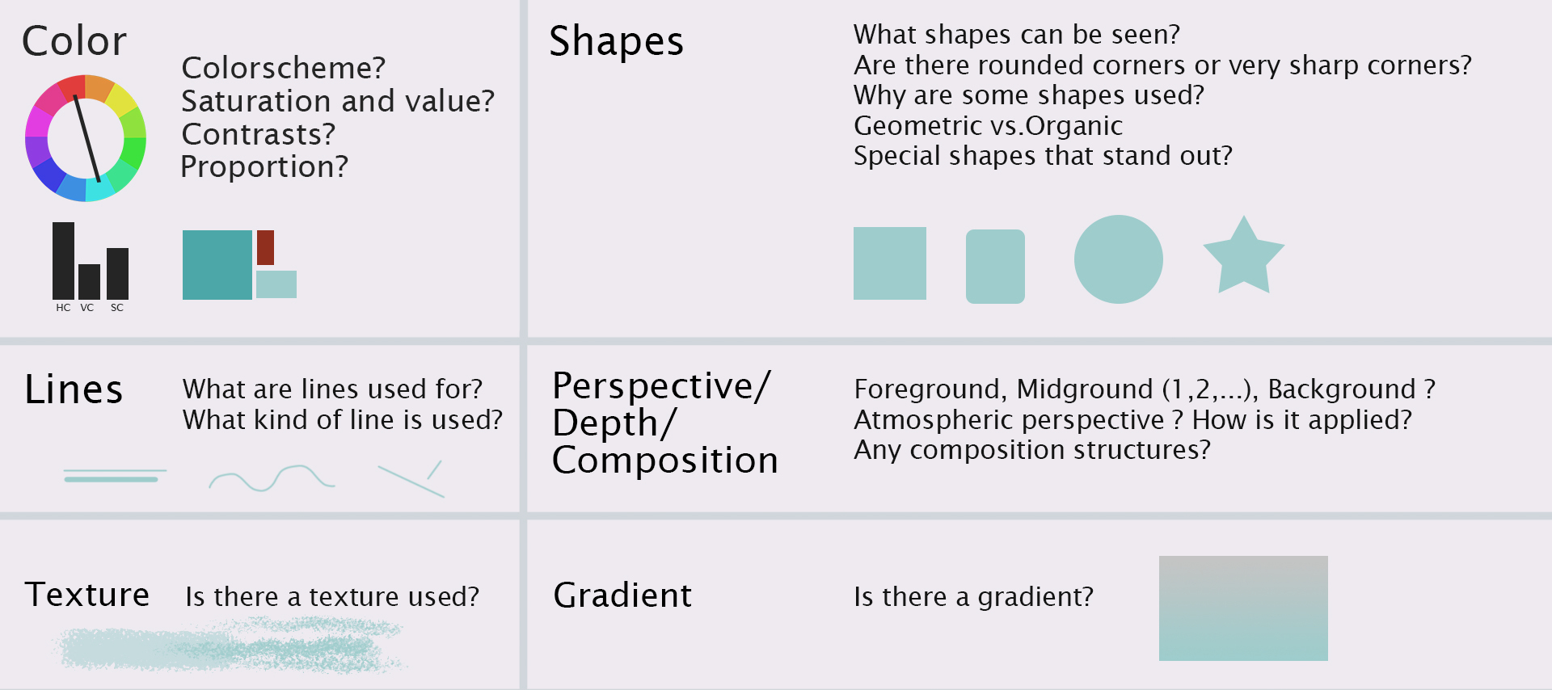

**Lines**

* **What is the purpose of the line?**
  + Emphasize objects
  + Texture
  + Create movement
  + Hatching (a set of lines, straight or curved, used for indicate shading, modeling, and light and shades. If the lines are crossed, is know as cross-hatching)

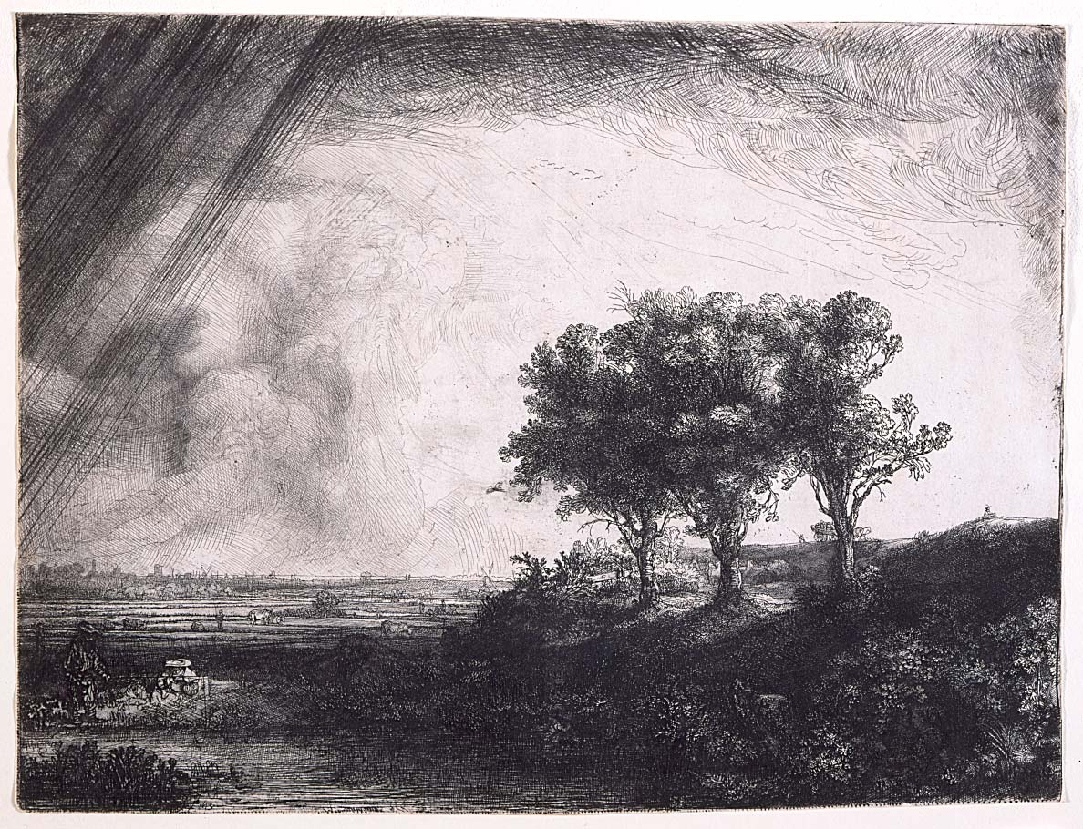

**Example of Hatching**

* **What is the weight and style of the line?**
  + Thin or thick
  + Straight or wavy
  + Curly
  + ZigZag
* **What is the color and/or texture of the line?**
  + For example “rough brush” lines

**Shapes**

* **Which shapes are used?**
  + Rectangles, circles, triangles,
  + Are they rounded or skewed (sesgado)
  + Geometric
  + Organic (Irregular and imperfect, all of these shapes will be slightly different from each other)
* **Why are these shapes used?**
  + Do the shapes express danger?
  + Are round shapes used to express friendliness?
  + Are there a lot of organic shapes because it’s a nature scene?
  + Are there a lot of rectangles because its men made?
* **Is there contrast between the shapes?**
  + For example, a trap has a more triangular shape to express danger, compared to the rounded environment

**Color**

* **Which HUE’s is used?**
  + Hue’s is the color himself
* **What color scheme is used?**
  + This means the choice of colors used
  + Monochromatic. Consists of one hue and a number of corresponding tints and shades.
  + Complementary. Colors which are directly across from each other on the color wheel.
  + Analogous. Groups of three colors that are next to each other on the color wheel.
  + Triadic. Three colors that are evenly spaced on the colorwheel.
  + Tetradic. 4 colors evenly spaced on the colorwheel.
  + Split complementary. Similar to complementary, but, instead of using a complementary color, two colors placed symetrically around it on the color wheel are used.
* **What is the contrast?**
  + Hue contrast
    - To get the biggest contrast, we choose complementary colors. Those are colors who are opposite of each other on the color wheel

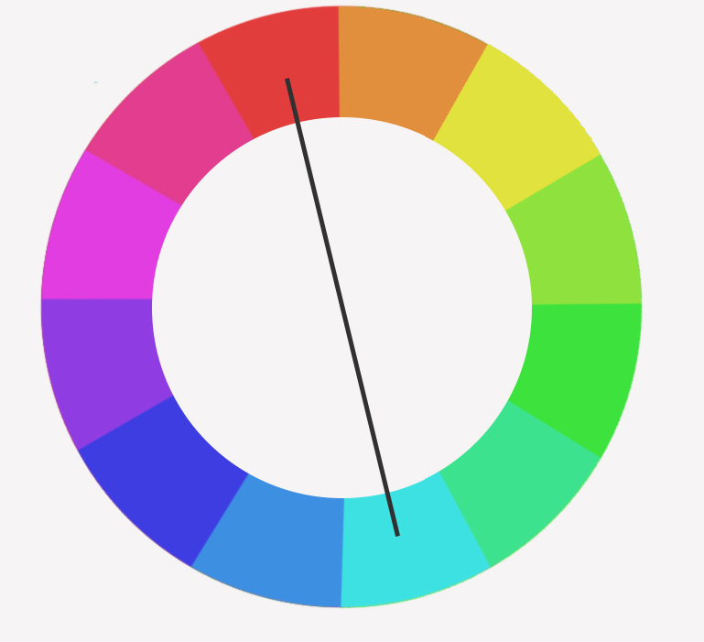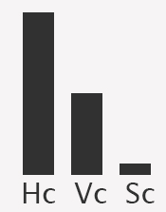

**Color wheel**

* + Value contrast
    - Difference between the lightest and darkest part of the image
    - If we have few greys between black and white, we call it “High value contrast”
  + Saturation contrast
    - Saturation is the intensity of the color. The higher it is, the more vivid the color is. The lower, the closer it is to gray.
* **What are the proportions?**
  + For example, 20% blue and 80% green
* **Is there a gradient?**
* **Why are these colors used?**
  + For example, lots of orange colors give a warm feeling. Or more contrast between character and background so the characters stands out.

**Texture**

* **What kind of texture is used?**
  + Paper grain
  + Watercolor
  + Roughness
* **It could be that you already discussed this in the lines and shapes part, as it these can also be used as textures**

**Step 1 – Analyse**

* Dont use really bright colors for background.
* I could use a background color similar to the gradient of the background of the picture and put some shapes of the background buildings in the bottom of the style file
* Background color options →
  + H: 310, S: 65, B: 45
  + H: 315, S: 50, B: 47
  + H: 315, S: 41, B: 57
  + H: 163, S: 54, B: 59 (favourite)