AMP(1)-Lab01 – Arithmetic Refresher

# Content

# Learning objectives

## Exam objectives

By the end of this lab you should be able to (pen and paper):

* Perform basic arithmetics including powers and fractions
* Understand and apply the distributive law (of one operation over another)
* Perform polynomial algebra including addition, multiplication, division (by a monomial) and exponentiation
* Solve linear equations for one unknown
* Solve quadratic equations for one unknown via the discriminant
* Understand and convert between the angular units radian and degree
* Understand and apply the trigonometric ratios in a right triangle: sine, cosine and tangent
* Understand and apply the Pythagorean Theorem in a right triangle

We advise you to **make your own summary of topics** which are new to you.

## Supportive objectives

### GeoGebra 6.0

By the end of this lab you should be able to:

* Setup GeoGebra Classic **6.0**, and configure its language, interface, defaults
* Enter various input either via its View/Algebra or View/Input Bar
* Display various graphs in its View/Graphics
* Draw angles and triangles in its View/Graphics

### Self-support by GeoGebra

More specifically related to the above you should in GeoGebra:

* Perform basic arithmetics including powers and fractions
* Expand and simplify expressions
* Perform polynomial algebra including addition, multiplication, division (by a monomial) and exponentiation
* Solve and graph linear equations for one unknown
* Solve and graph quadratic equations for one unknown
* Convert between the angular units radian and degree
* Calculate the trigonometric ratios in a right triangle: sine, cosine and tangent
* Calculate the Pythagorean Theorem in a right triangle

We therefore provide AMP(1)-Lab01-ArithmeticRefresher-GEOGEBRA(quickstart)

# Exercises

Dependent of the lab session you may work individually or teamed (organized by the lab attendant). In either case make sure that throughout the course of this lab, you re-save sufficiently your solution file on your local machine as

**1DAExx-0y-name1**(+name2+name3).GGB given **xx**=groupcode, **0y**=labindex

If not already on your machine, get **GeoGebra Classic 5.0 or 6.0** via <https://www.geogebra.org/download>

## Basic exercises

For all underneath exercises do at least one pen and paper attempt in your own workbook, before checking your results in GeoGebra. In case of mismatches between your handwritten results and GeoGebra’s output, do not hesitate to seek assistance by your Lab attendant, as you are owner of your own learning.

### Arithmetics

Exercise 1: Simplify the following expressions (GeoGebra/View/CAS only)

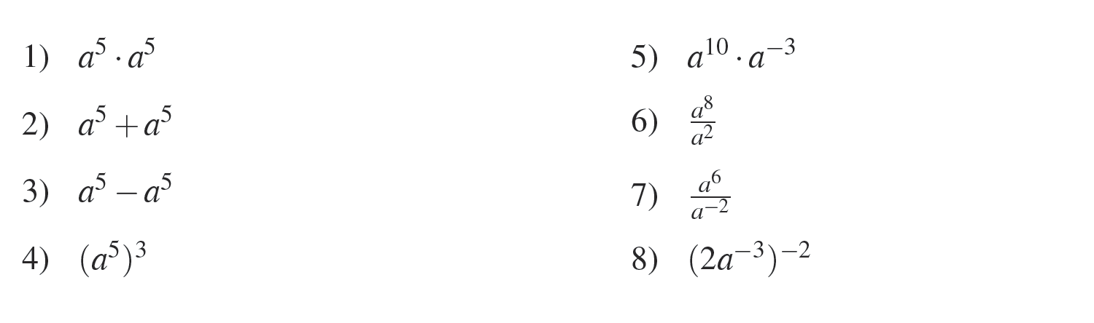

Exercise 2: Tick every correct answer (GeoGebra/View/CAS, Simplify)

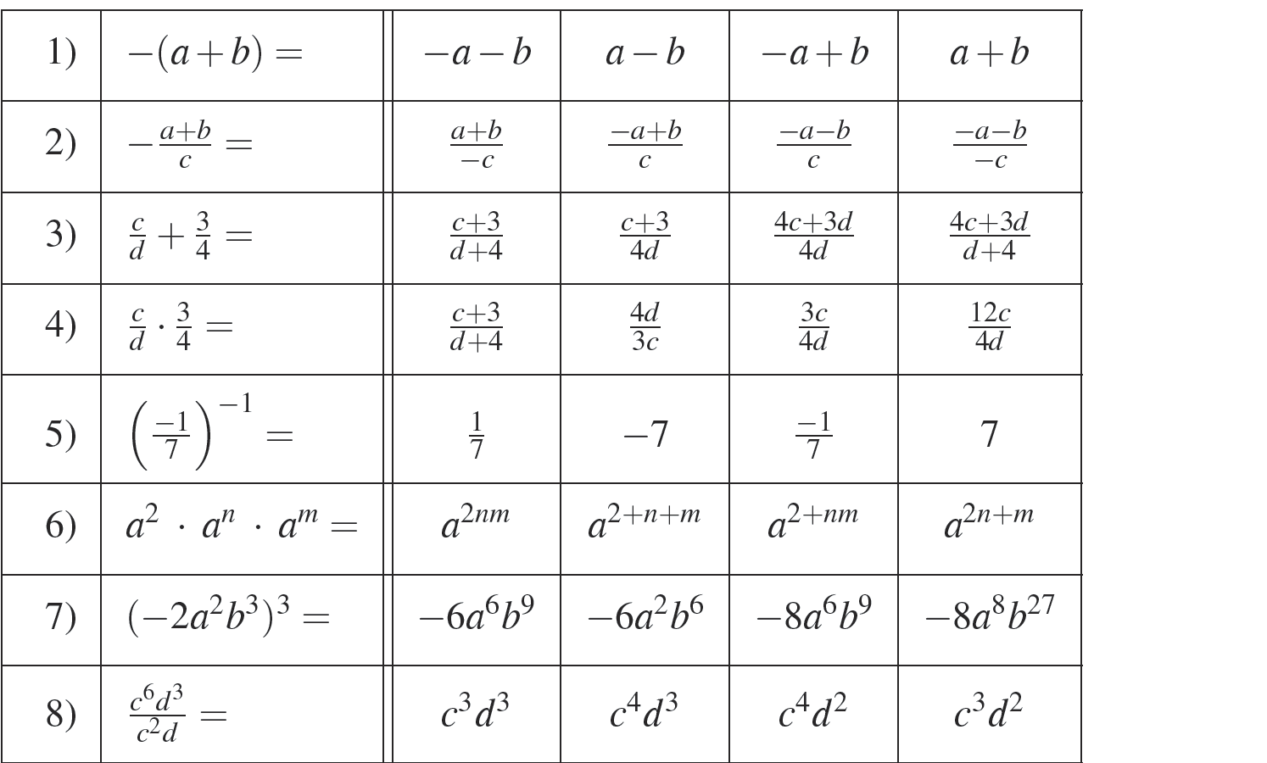1) 1º 2)

### Polynomial algebra

Exercise 3: Simplify as much as possible (GeoGebra/View/CAS, Simplify)

In GeoGebra the product *x y* is different from the string *xy* – mind you.

In GeoGebra the division operator to insert is / (slash) instead of : (colon).

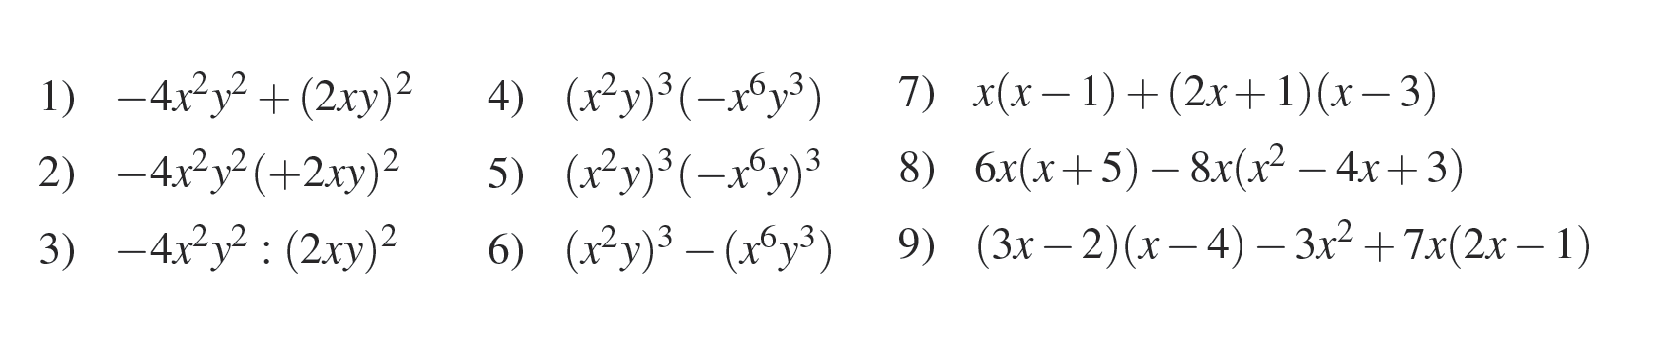

### Equation solving

Exercise 4: Solve only the *linear* equations in the unknown *x* from underneath list (GeoGebra/View/CAS, Solve(button))

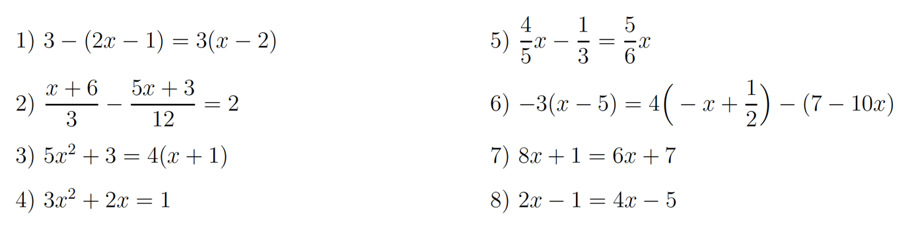

Exercise 5: Solve these quadratic equations for their unknown, applying the abc-formulas aka discriminant (GeoGebra/View/CAS, Solve(button), alpha(button))

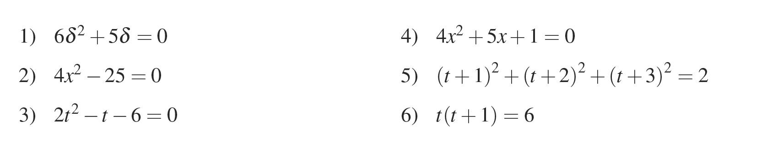

### Trigonometric fundamentals: angular units

Exercise 6: Convert accordingly to radians, or to degrees and simplify the result.

To radians is default but to degrees postfix the input by \° (GeoGebra/View/CAS)

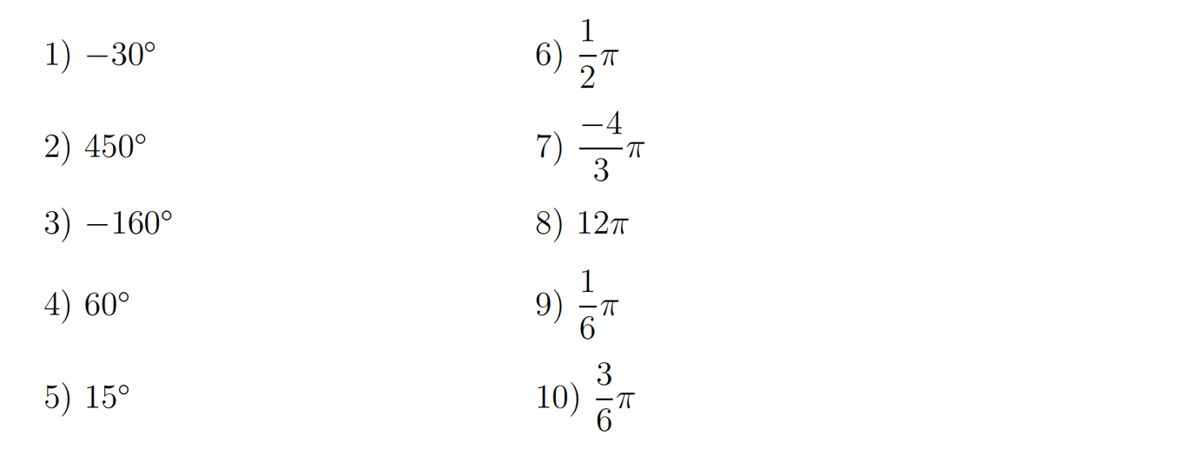

## Bridging exercises

### Exploring polynomials

Exercise 7: Calculate the polynomial’s return value given its input value (GeoGebra/View/CAS, Substitute(button) )

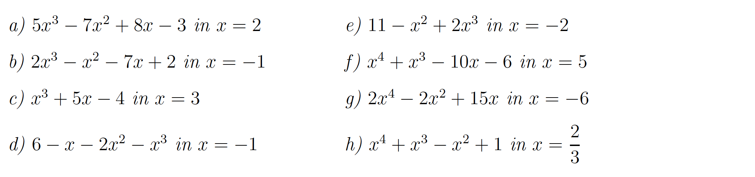

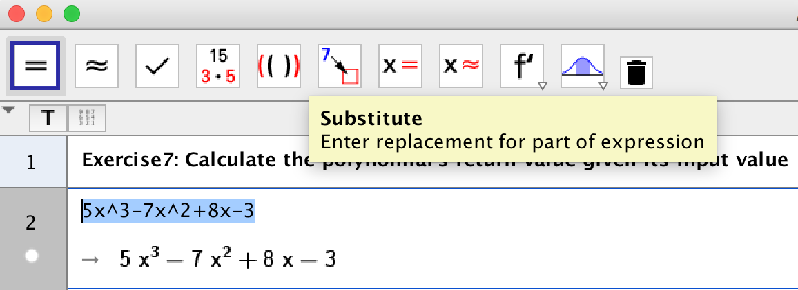

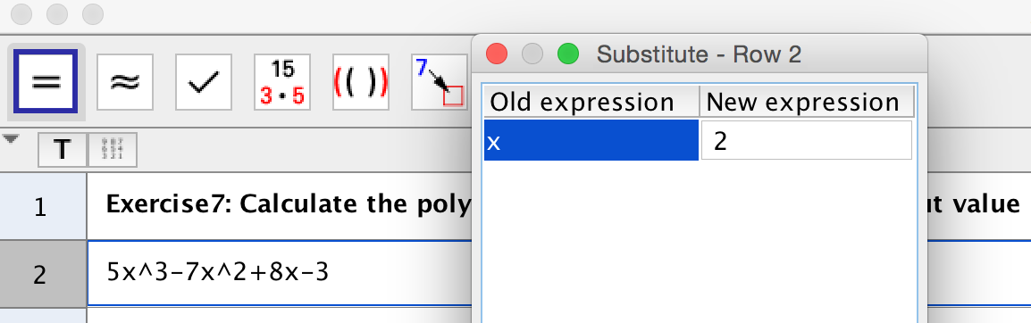

### Visualize the solution sets of equations

Exercise 8: Linear expressions in *x* simplified to the standard form *mx+c* draw straight lines.

The final coefficient *m* of variable *x* denotes **the slope** of this line: for each *k* steps (to the right) the line rises *mk* steps up (m>0) or down (m<0).

The **intercept** c simply shows on which height this line is intersecting the y-axis.

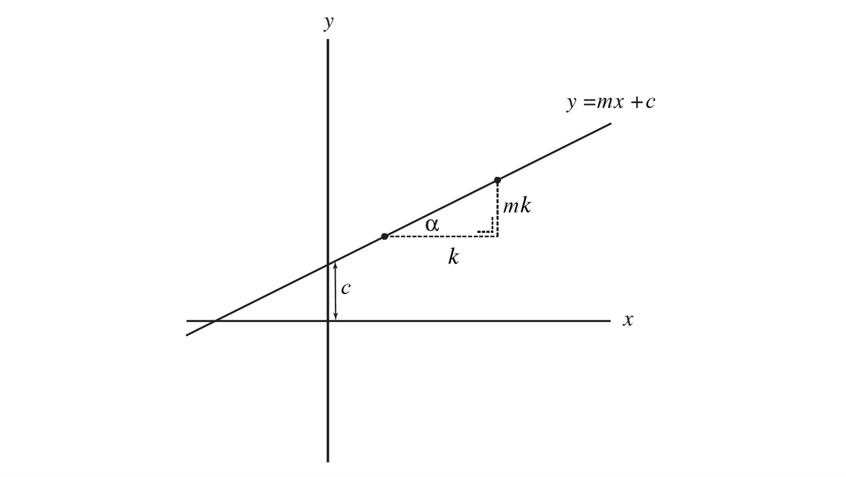

Graph (pen and paper) the **simplified** left hand and right hand **sides** of only the *linear* equations over a horizontal running *x-*axis, as their intersection shows the solution set of their equation. (GeoGebra/View/CAS + /Algebra + /Graphics)



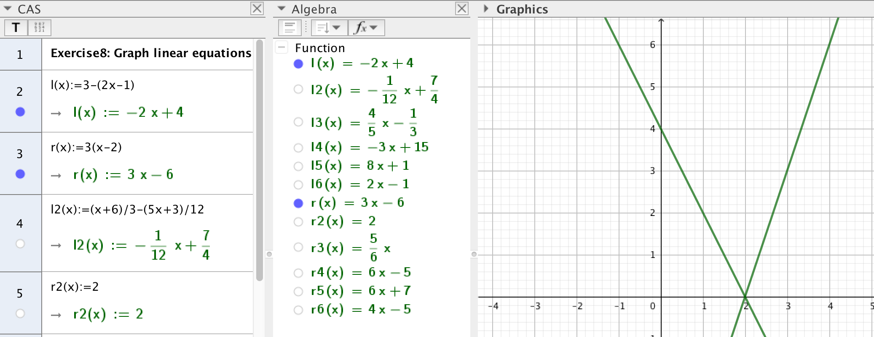

Exercise 9: As linear expressions in *x* simplified to the standard form *mx+c* draw straight lines which slope by coefficient *m* and intercept by the constant *c*, explore this line(graph) in GeoGebra by varying both *m* and *c* by using sliders. (GeoGebra/View/Algebra + /Graphics + /Input Bar)

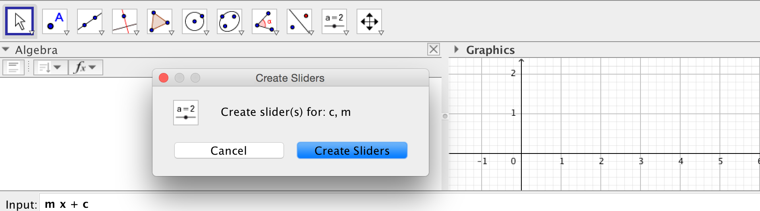

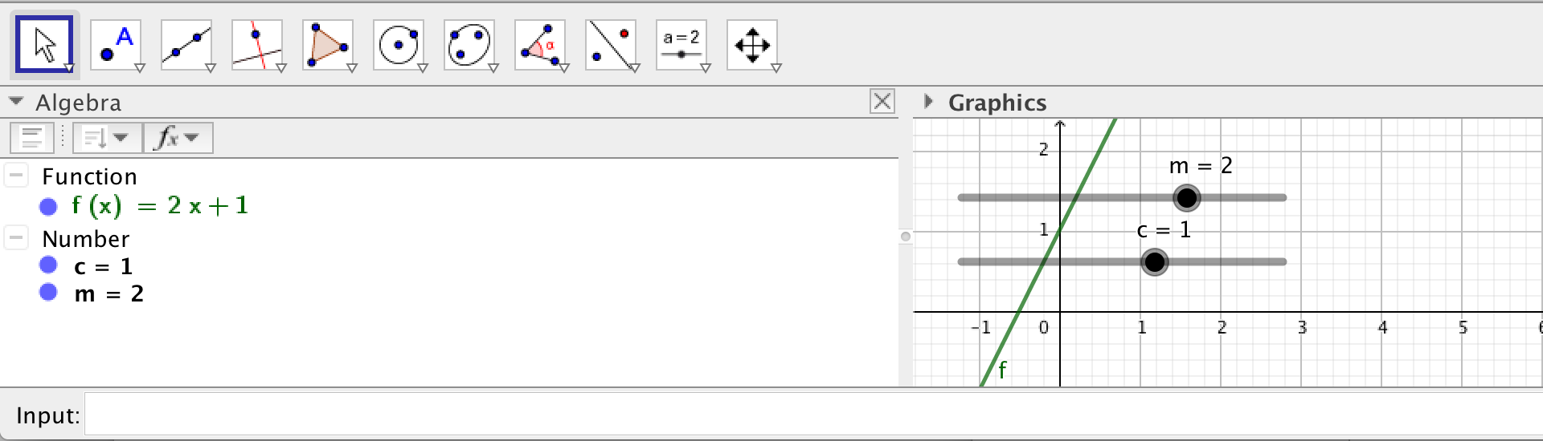

### Trigonometric fundamentals: right triangles

Exercise 10: Solve each of the six underneath right triangles given, only for its side *a* whilst applying the shortest strategy. An expression suffices to answer *a*.

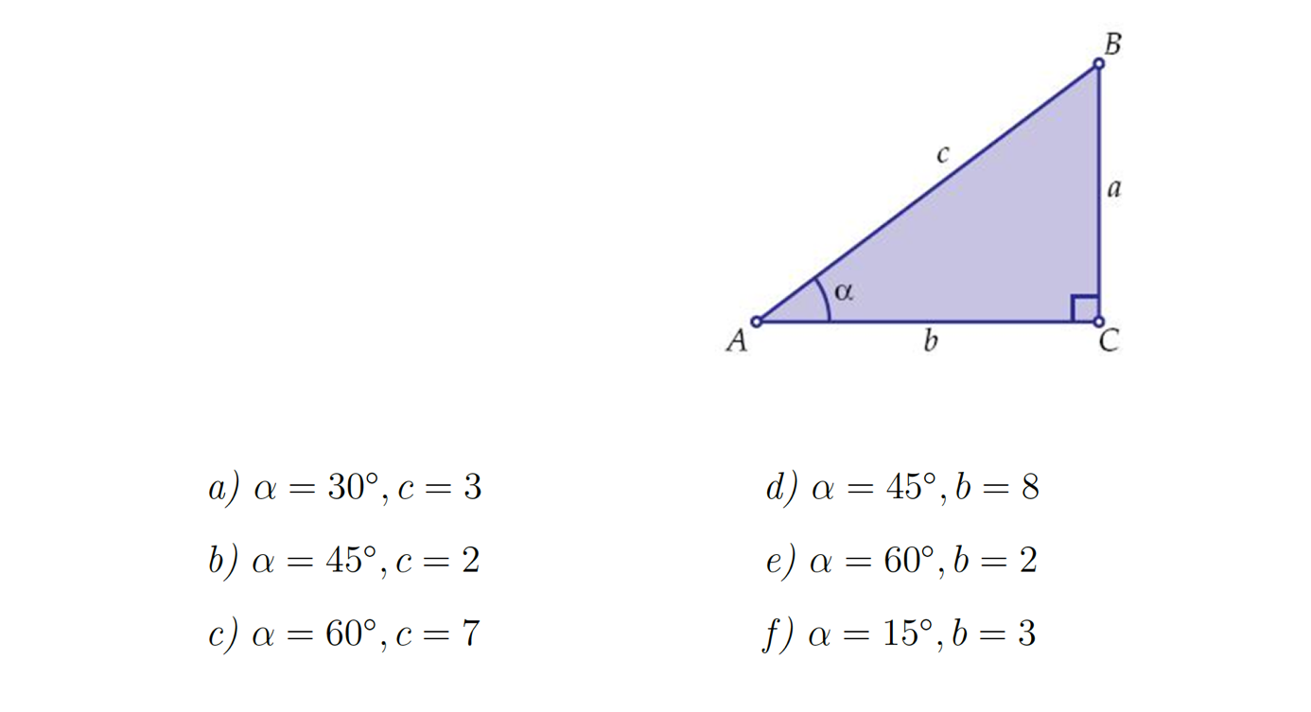

(GeoGebra/View/CAS, Symbolic Evaluation(button) )

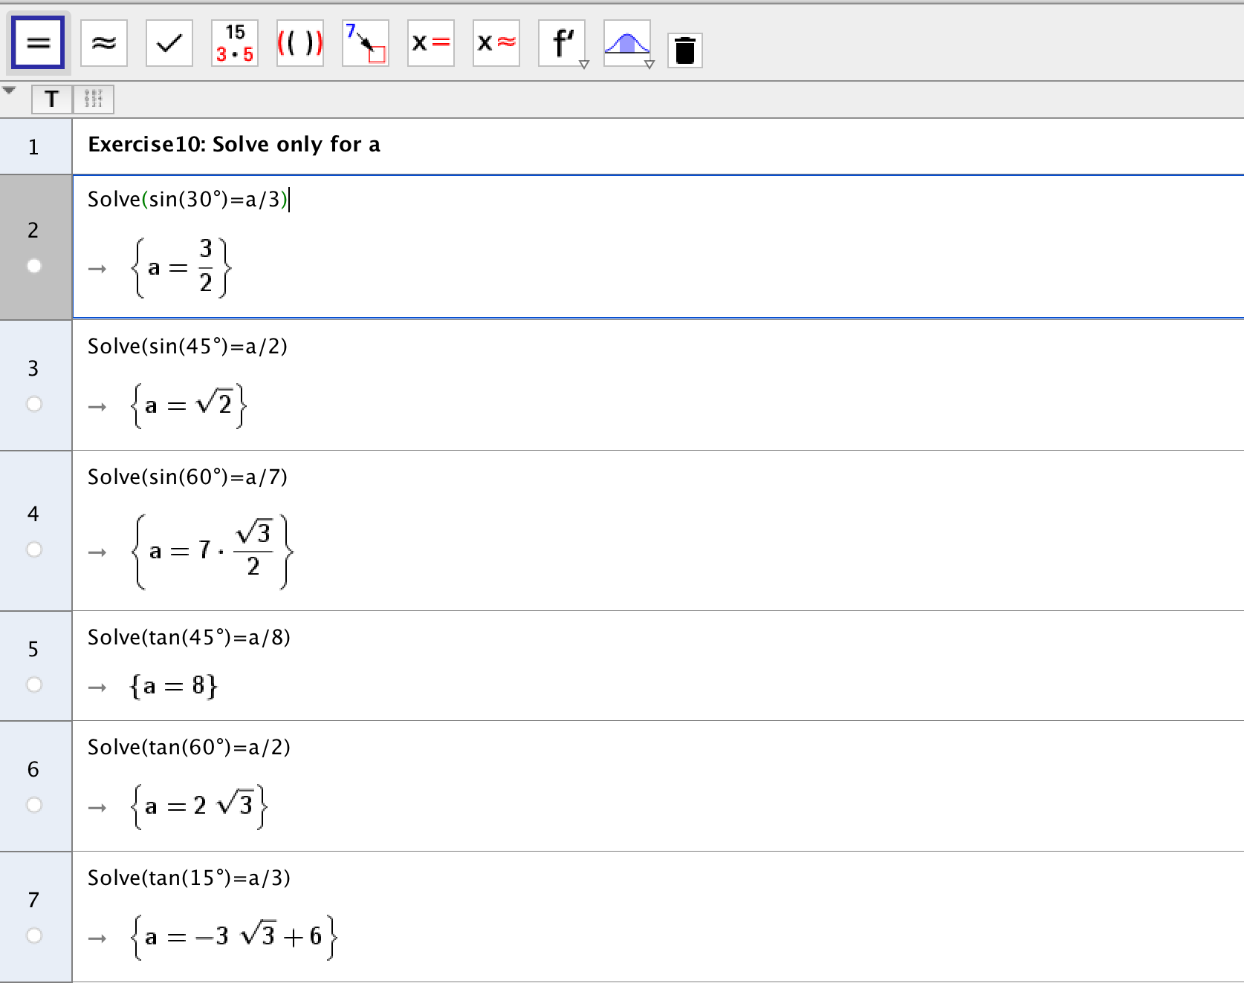

Experience GeoGebra by displaying the previous answers numerically up to 5 significant digits. (GeoGebra/View/CAS, Numeric Evaluation (button) )

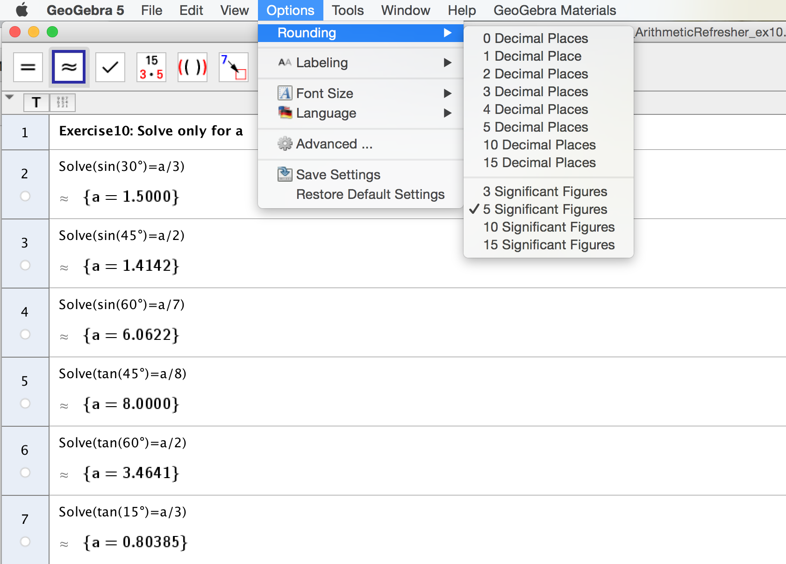

Exercise 11: As right triangles feature their constant angle of 90° opposite the hypotenuse, we create this polygon in GeoGebra stepwise like underneath. (GeoGebra/View/Algebra + /Graphics2, Polygon(button)) Click its three vertices subsequently in the Graphics2-screen putting the right angle in the origin (0,0).

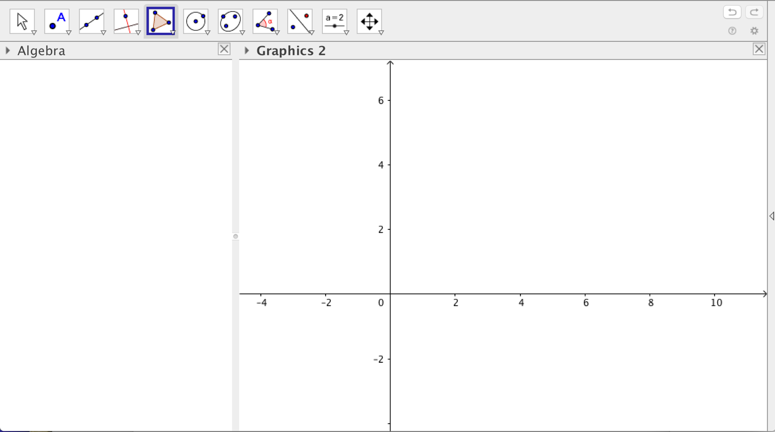

GeoGebra applies the naming convention (side a laying opposite vertex A, etc).

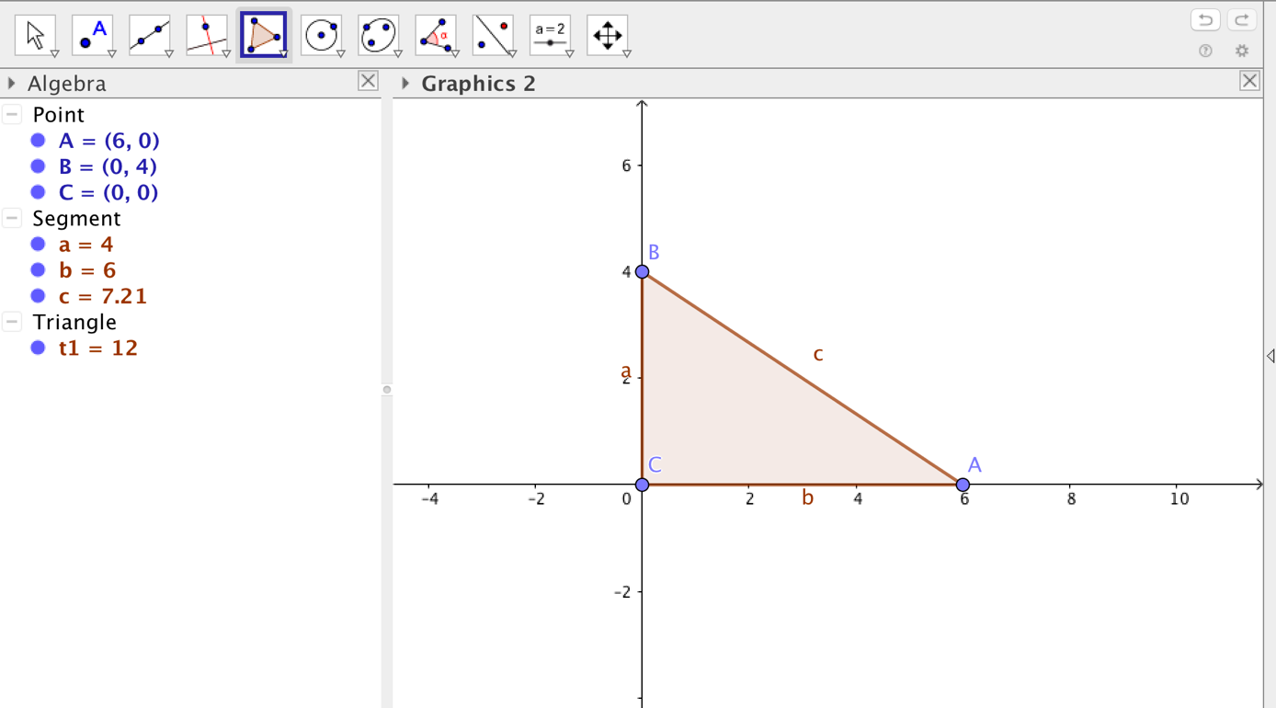

Nextly we overlay in this polygon only **interior angle**  by clicking appropriately three points with the Angle(button) in the Graphics2-screen.

(GeoGebra/View/Algebra + /Graphics2, Angle(button))

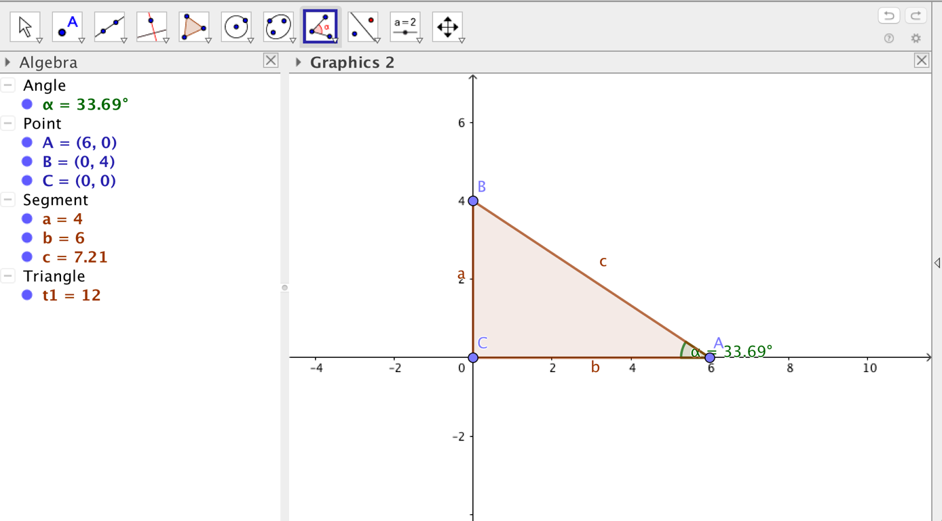

Finally we can explore and visualize some cases, for instance of the previous exercise answers by dragging either vertex A horizontally or vertex B vertically using the Move(button) in the Graphics2-screen.

(GeoGebra/View/Algebra + /Graphics2, Move(button))

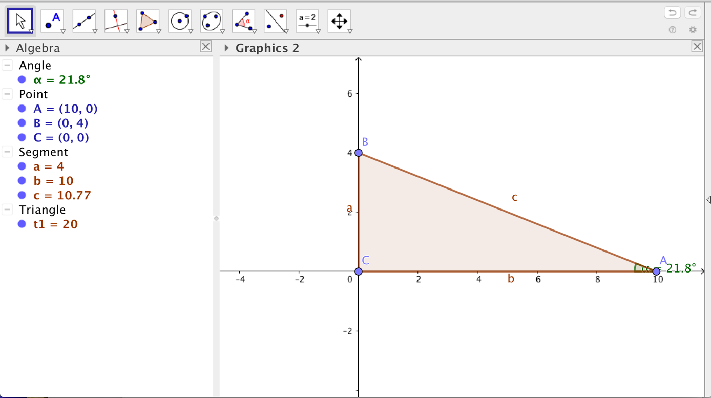

## Contextual practice

### Polynomial landscapes

Exercise 12: We create these polynomial landscapes in GeoGebra

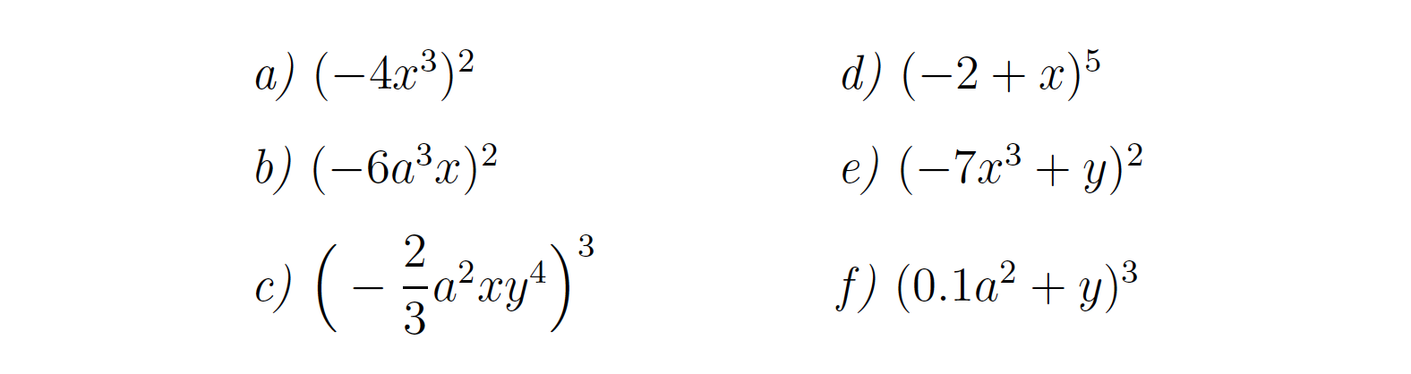

**Firstly in 2D** based on one variable *x*, see items **a) b) d)** and by putting the slider to vary coefficient *a* if there is any in the polynomial.

(GeoGebra/View/Algebra + /Graphics2 + /Input Bar)

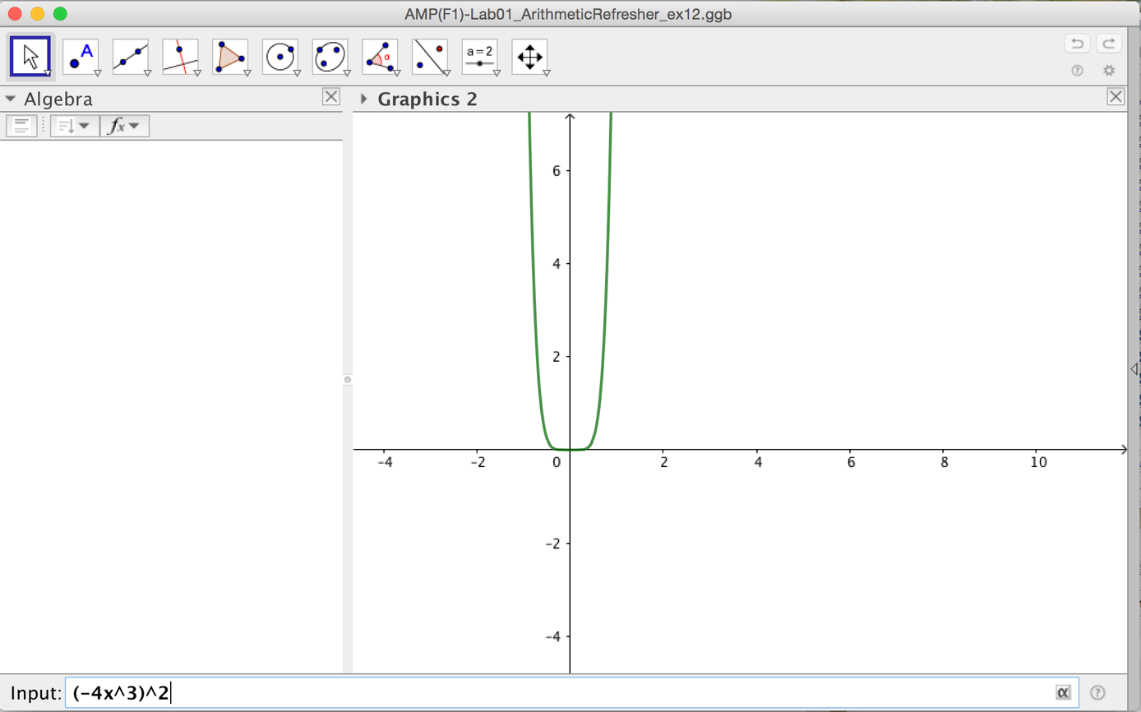

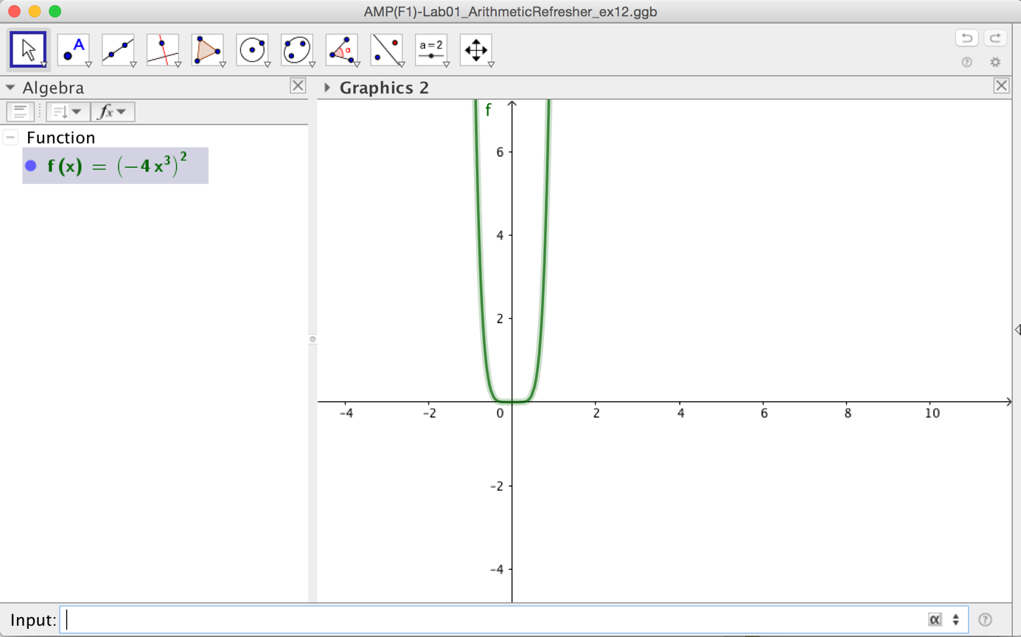

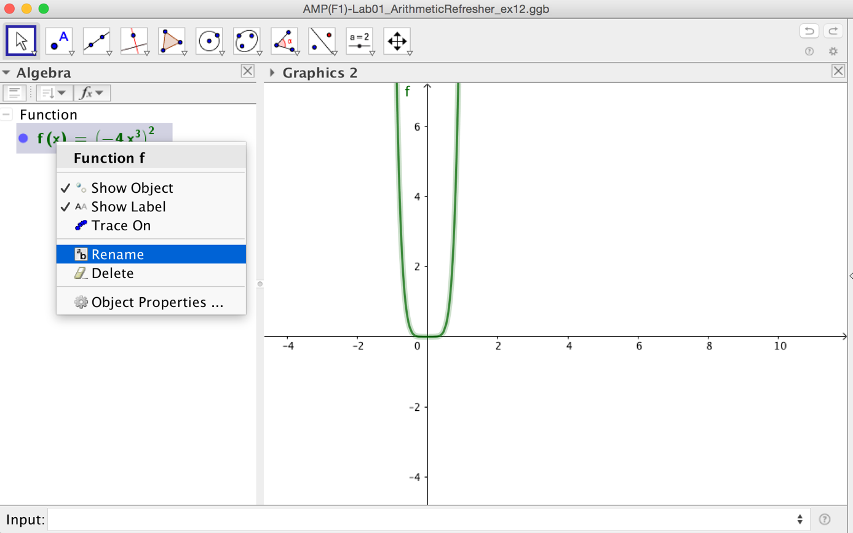

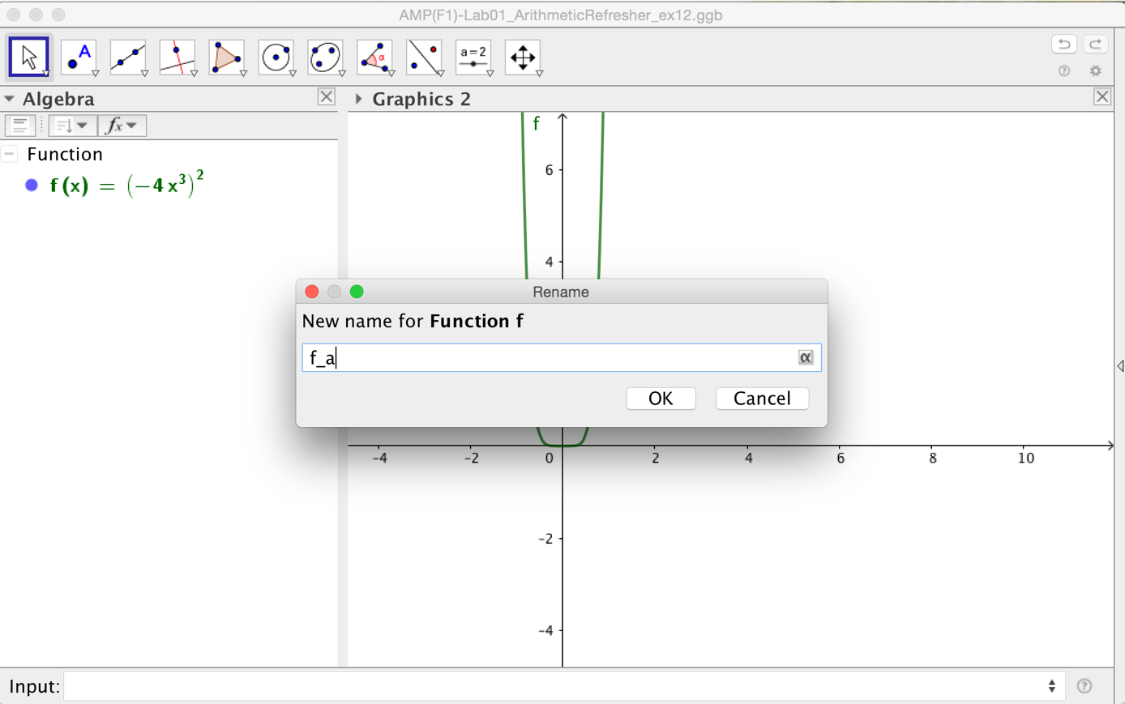

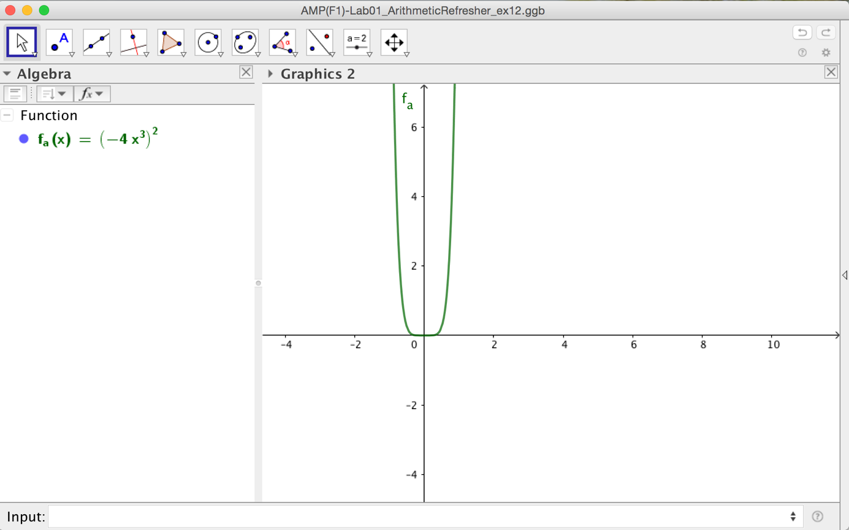

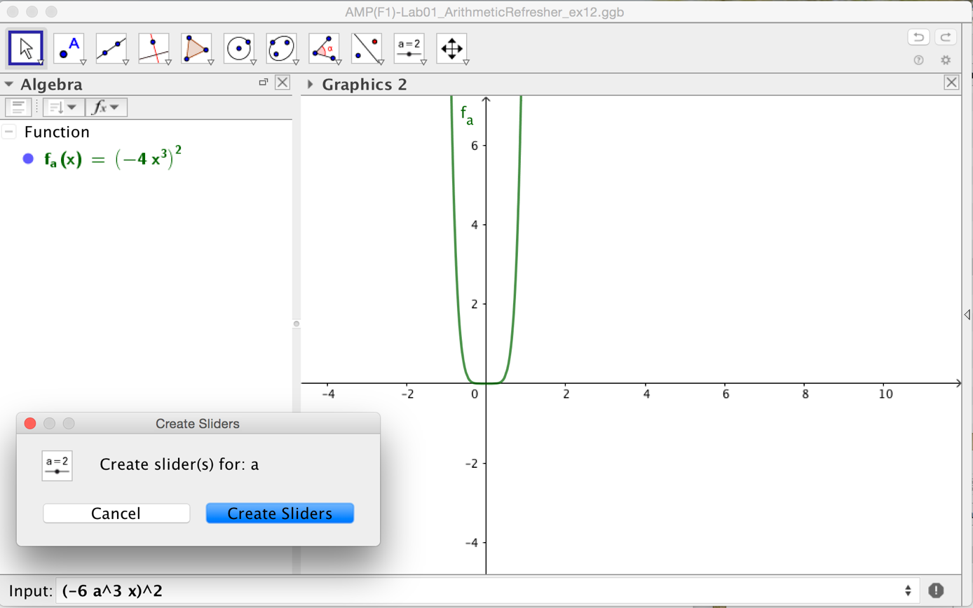

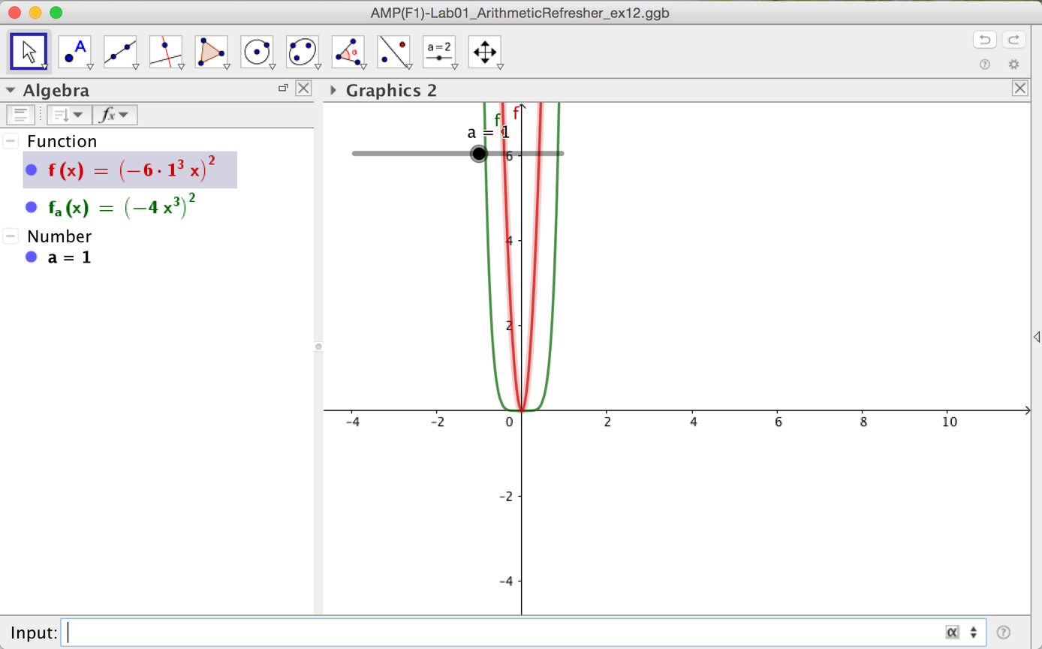

**Secondly in 3D** based on two variables *(x,y)* see items **c) e) f)** and by putting the slider to vary coefficient *a* if there is any in the polynomial.

In GeoGebra the product *x y* is different from the string *xy* – mind you.

(GeoGebra/View/Algebra + /3D Graphics +/Input Bar)

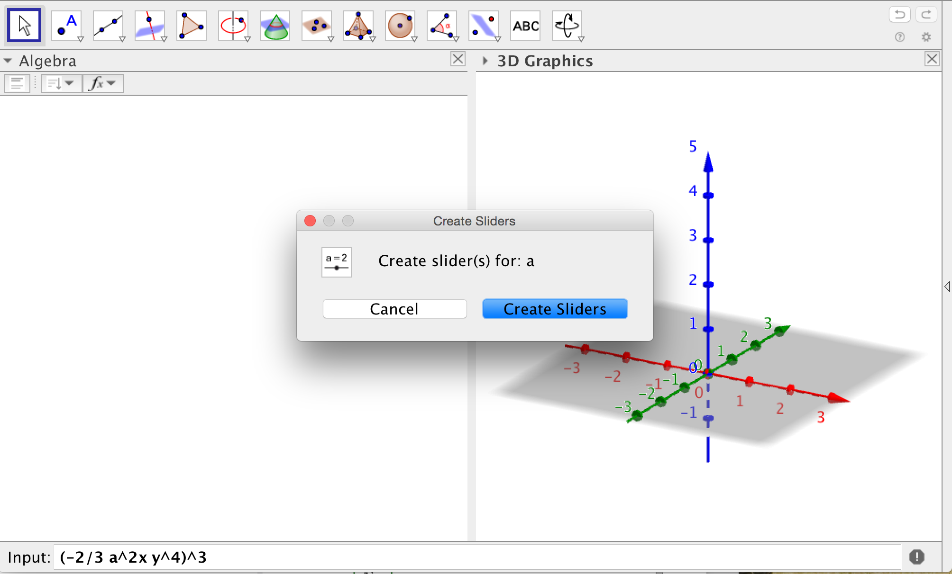

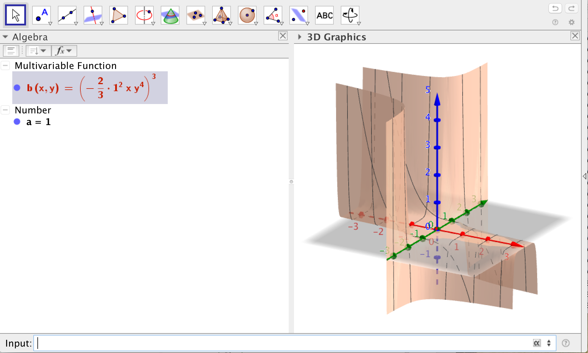

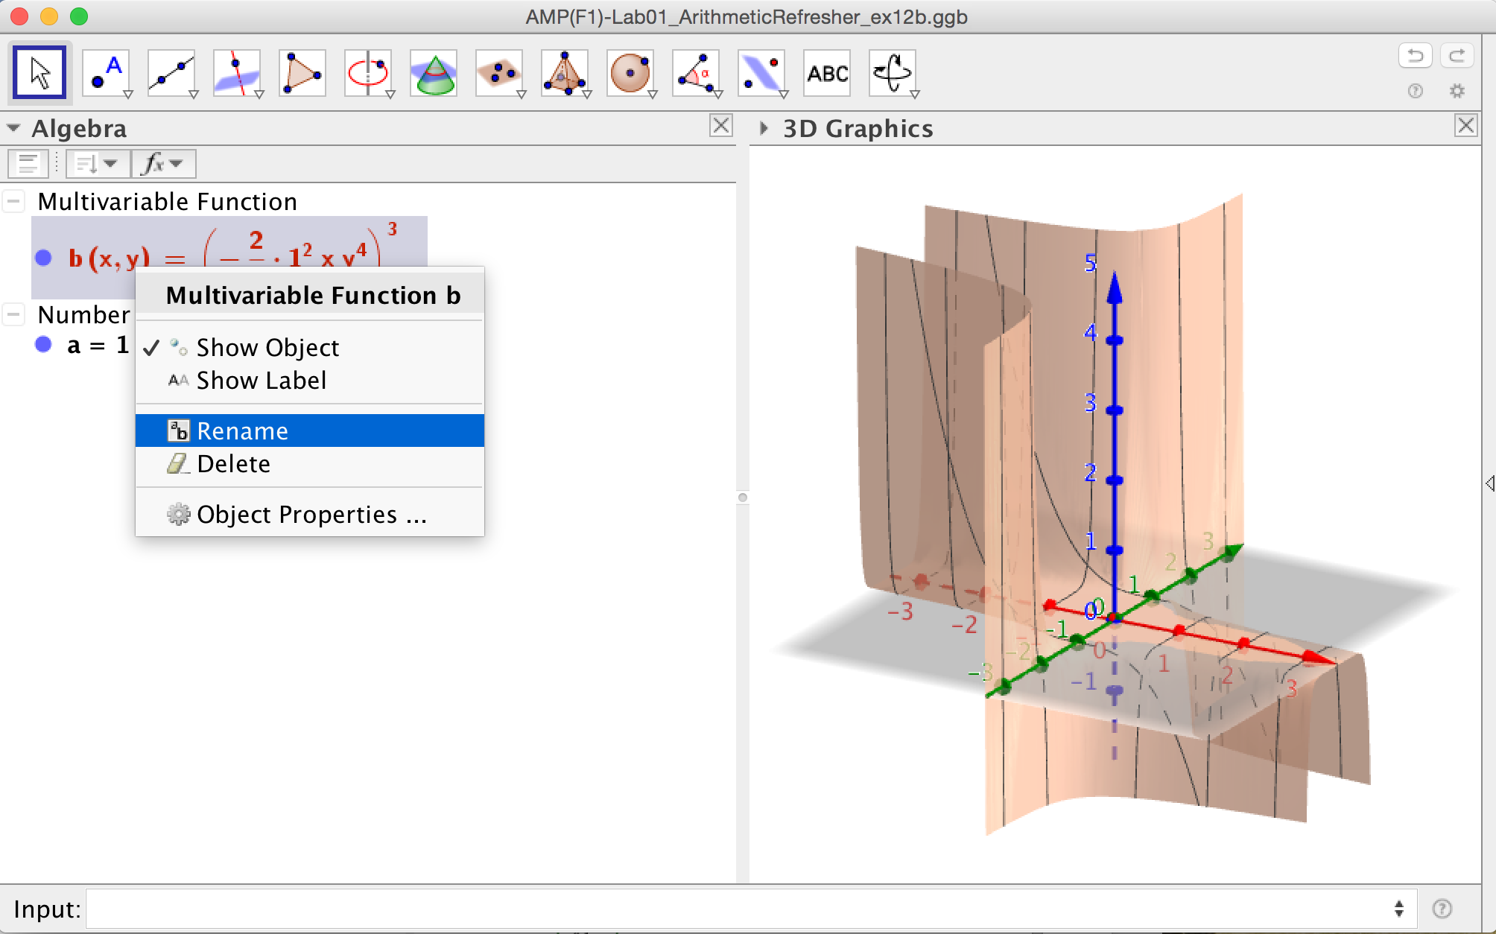

GeoGebra may vary the coefficient *a (default set to 1)* only by ‘Animation On’.

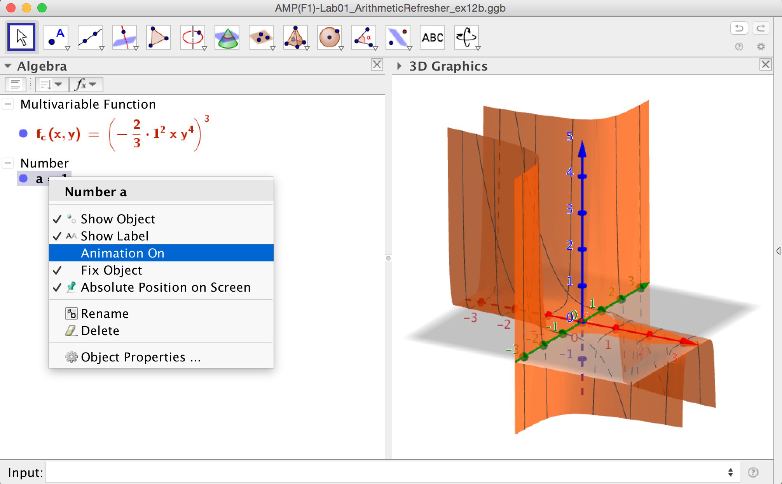

In GeoGebra different 3D views are enabled by toggling the `Style Bar’ and opting for instance for `rotating the view’.

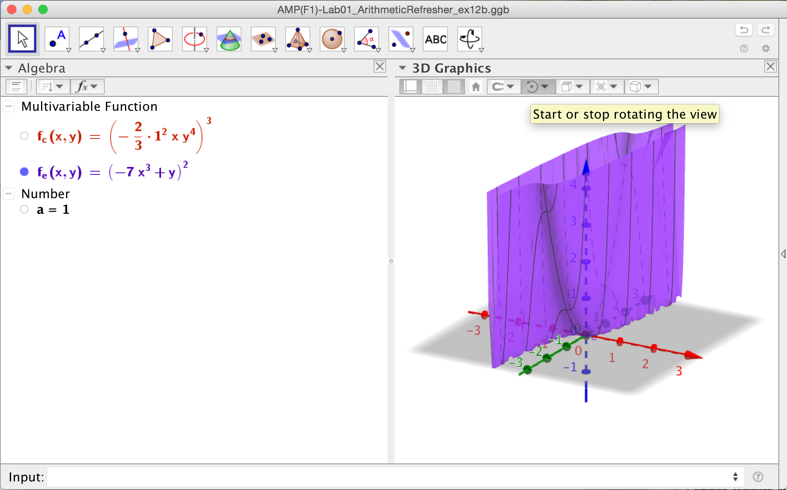

In GeoGebra/View/3D Graphics - in case the expression lacks an *x* - you need to insert somewhere a harmless `times 1’ technically to input as *\*x^0*.

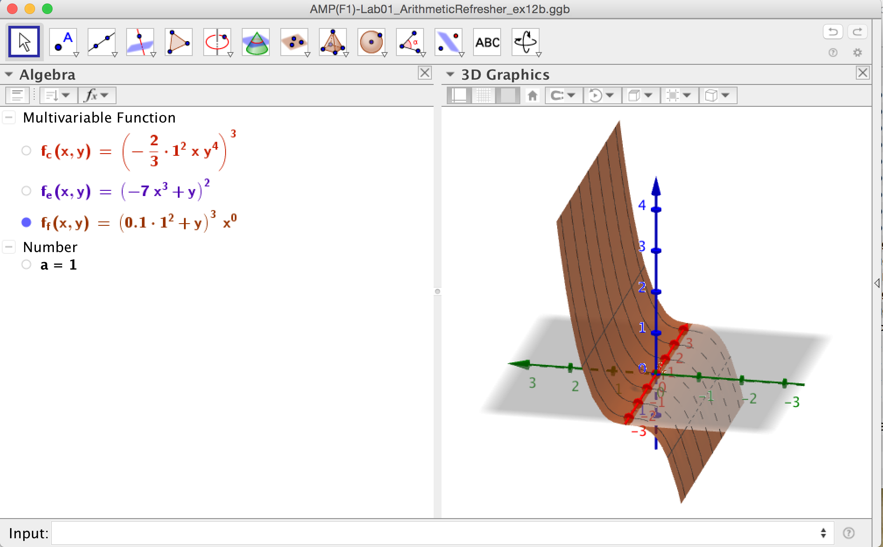

### Intersection problem

Exercise 13: Underneath graphs the heights *h* of both the descending straight line *-2t+100* and the curved line *–t^2+3t+106* and shows their intersection for a positive *t.*

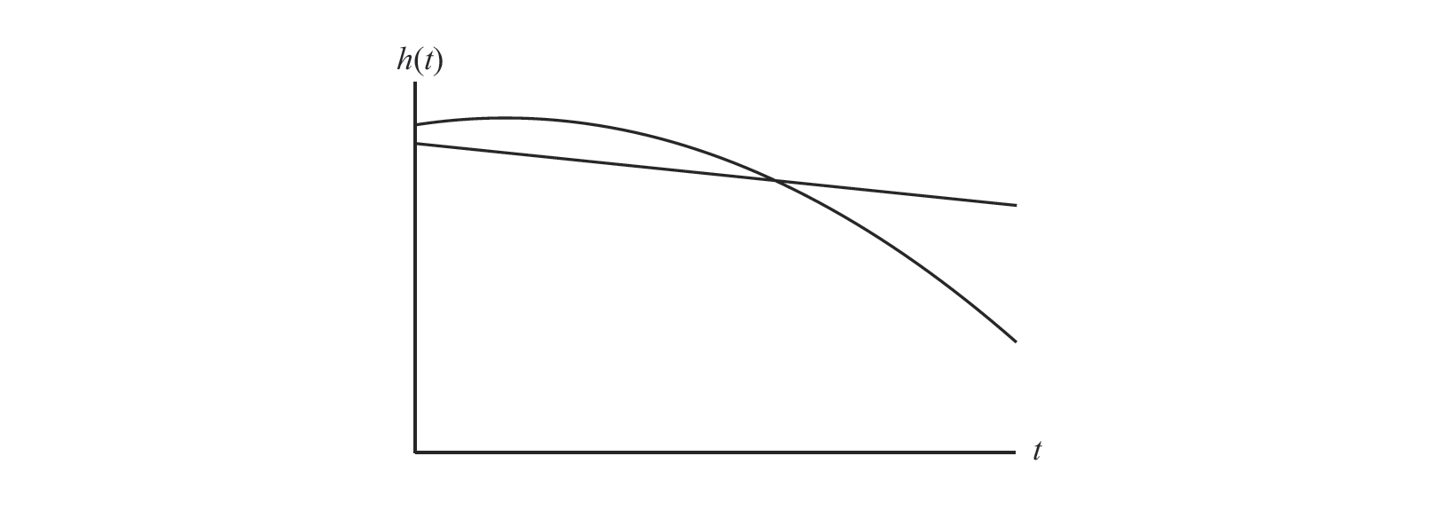

1. Solve their equal heights for *t* by pen and paper
2. Verify the previous labour by GeoGebra (GeoGebra/View/CAS)
3. Determine their corresponding equal height (for the positive solution *t*)
4. Reveal the positive solution *t* graphically (GeoGebra/View/CAS+Graphics)

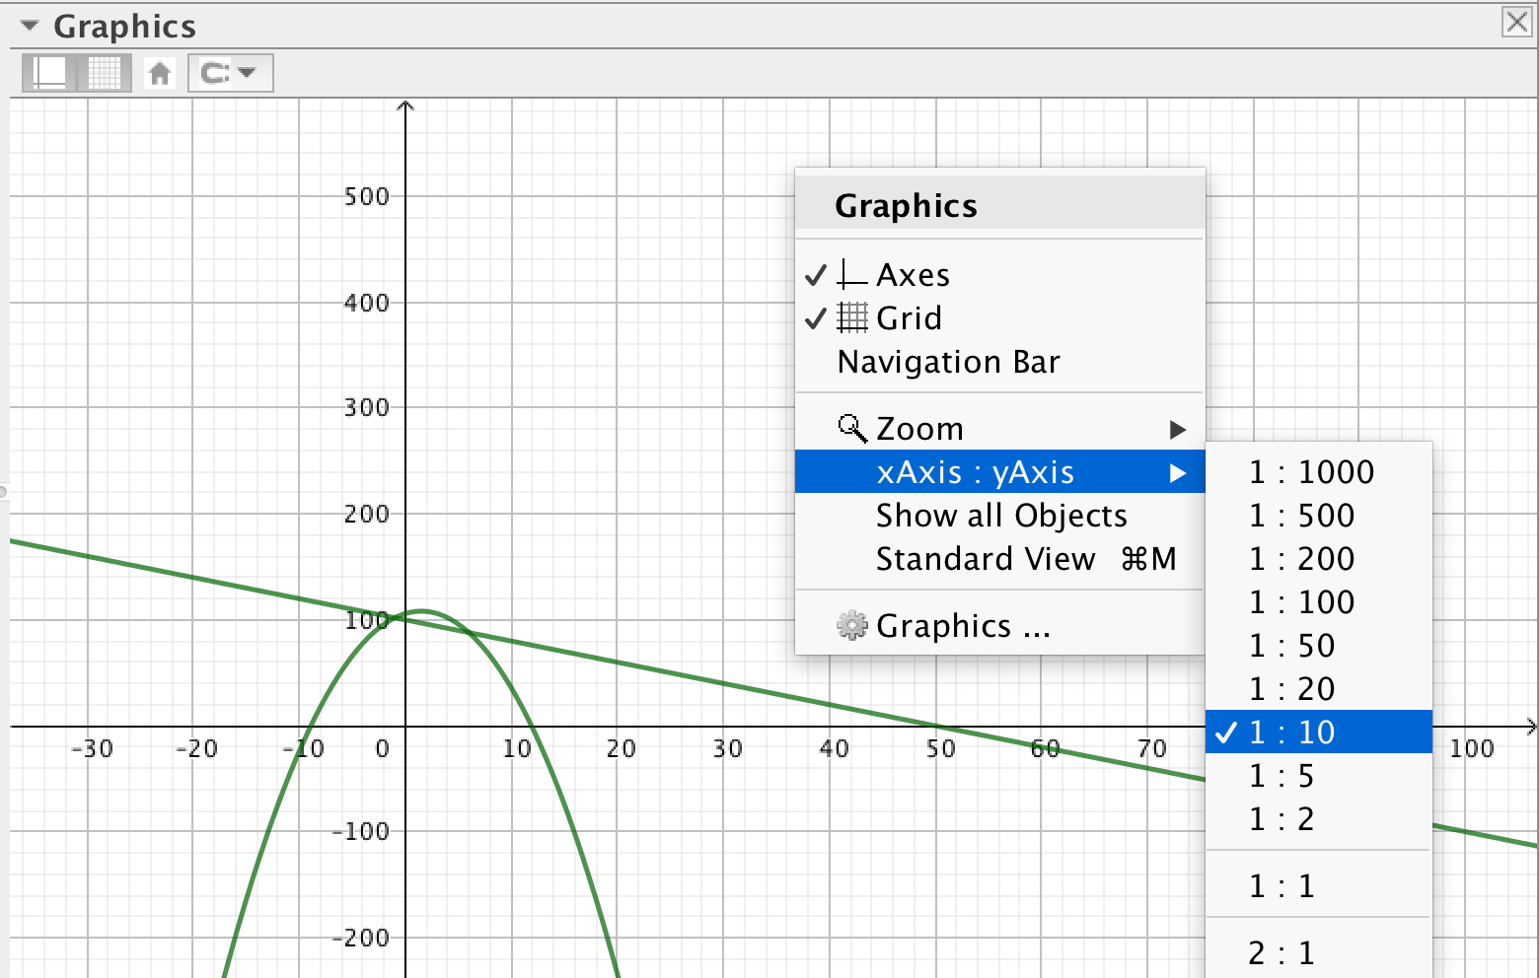

# References

## Basics

### GeoGebra installs

<https://www.geogebra.org/download>

### Computational Intelligence engine

[http://www.wolframalpha.com](http://www.wolframalpha.com/)

### English maths dictionary

[http://www.mathwords.com](http://www.mathwords.com/)