AMP(1)-Lab02–Trigonometry Fundamentals

# Content

Lab02 – Trigonometry Fundamentals 1

1. Content 1

2. Learning objectives 1

3. Exercises 2

3.1. Basic exercises 2

3.1.1. Exploring the triangle in Geogebra 2

3.1.2. Exploring trigonometric ratios in the unit circle 3

3.1.3. Angles 4

3.1.4. Your summary of the trigonometric formulas 5

3.1.5. Applying these formulas in some basic situations 6

3.2. Contextual practice 9

3.2.1. Sonic the hedgehog loop 9

3.2.2. Frog 10

3.2.3. Through a tube to the next level 11

3.2.4. Pool 12

3.2.5. Clock 13

3.2.6. Advanced clock 14

3.2.7. Tank wars 15

3.2.8. Air balloon 15

# Learning objectives

# Exercises

## Basic exercises

### Exploring the triangle in Geogebra

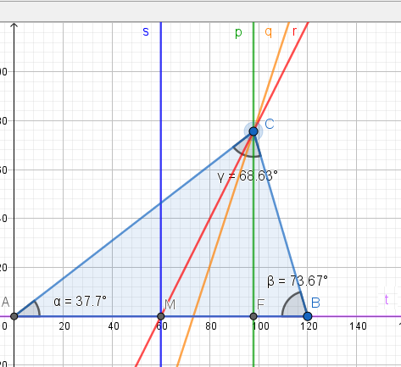

Now move vertex C around and have a look at the sum of the 3 angles, what do you notice?

Sum is always 180°

Move point C until the sides CA and CB get the same length (isosceles triangle). What do you notice about the special lines and the angles ?

They coincide.

What is the apex of the isosceles triangle?

The apex is the vertex where the two sides of equal length meet, thus C.

Move point C until all the sides have the same length value 120 (equilateral triangle). What do you notice about the angles ?

They all have the same value 60°

### Angles

#### Recognize relationships

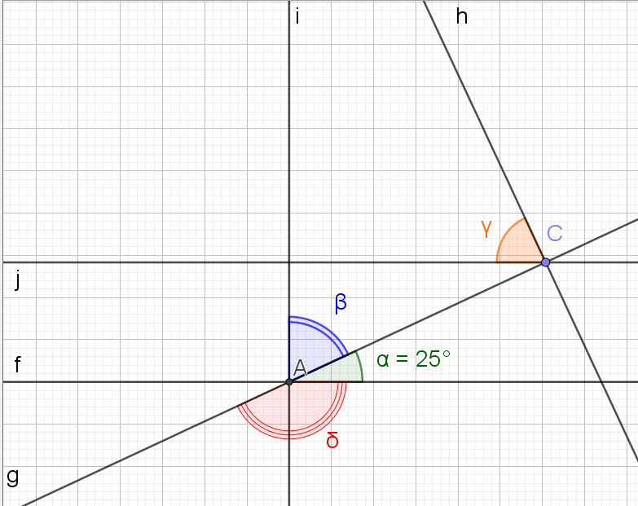

|  |  |
| --- | --- |
| Angle | Size in degrees |
| β | 65° |
| δ | 155° |
| γ | 65° |

### Your summary of some trigonometric formulas

Before making the following exercises you should know very well which formulas are at your disposal. Write in the second column the formulas requested in the left column.

|  |  |
| --- | --- |
| 1. Definition of an angle | angle = length of circular arc / radius |
| 1. Conversion from radians to degrees | degrees = radians * 180 / pi |
| 1. Conversion from degrees to radians | radians = degrees * pi / 180 |
| 1. The Pythagorean theorem | c2= a2 + b2 |
| 1. The formula of the sine, cosine and tangent of the acute angle in a right triangle | sin α = opposite side/ hypotenuse (SOH)  cos α = adjacent side / hypotenuse(CAH)  tg α = opposite / adjacent side (TOA) |
| 1. The law of sines | a/sin α = b/sin β = c /sin γ |
| 1. The law of cosines | c2= a2 + b2– 2ab cos γ  a2= c2 + b2– 2cb cos α  b2= c2 + a2– 2ca cos β |
| 1. The area of a triangle | area = a * b * sin(γ) / 2 |

### Applying these formulas in some basic situations

|  |  |
| --- | --- |
| Given | Questions |
| 1. Given is this right triangle. | 1. What is the length of the hypotenuse? sqrt(40 2 + 60 2)= 72.11 2. What is the tangent of angle α? tan (α) = 40/60 3. What is the tangent of angle β? tan( β) = 60/40 4. How many degrees is the angle α? α = arctan (40/60) = 33.69° 5. How many radians is the angle α? α = 33.69° * ϖ / 180° = 0.59 6. How many degrees is the angle β? β = arctan (60/40) = 56.31° 7. How many radians is the angle β? β = 56.31° * ϖ / 180° = 0.98 |
| 1. Vertices B and C are on a circle with center A and radius 50 cm. The length of the arc between B and C is 60 cm. | 1. What is the angle α in radians? α = l/r = 60/50 = 1.2 radians 2. What is the angle β in radians? α + β + γ = ϖ It is an isosceles triangle, then β and γ have the same size, so α + β + **β** = ϖ α + 2*β = ϖ β = (ϖ – α) / 2 = (ϖ – 1.2) / 2 = 0.97 3. What is the angle γ in radians? 0.97 4. What is the length of the line segment [BC] Using the rule of cosines: |BC|2=502 + 502 -2*50*50*cos γ |BC| = 56.5 or  Dividing the triangle ABC in 2 right triangles AMB and ACM: |BC| = |CM| + |MB| |BC| = 50 * cos(γ) + 50 * cos(β) |BC| = 56.5 |
| 1. Vertex B is on a unit circle with center A. | 1. What is the length of line segment [AC]? ACB is a right triangle.   adjacent side/hypotenuse = cos β |AC|/|AB|= cos β |AC| = |AB| * cos β    β = α - 180°  β = 210° - 180°   β = 30°   |AB| = 1  |AC| = 1 * cos 30° **|AC| = 0.87**   1. What is the length of the line segment [CB]? |CB| = |AB| * sin β |CB| = 1 * sin 30° **|CB|=0.5** |
| 1. Given are these 2 similar right triangles JIH and LKH. Knowing the size of following sides:  * |HI|= 100 units * |HK|= 60 units * |IJ|= 40 units | 1. What is the length of [LK]? Triangles LHK and JHL are both right triangles and they have a common angle $\hat{H}$  tan = |LK| / |HK| tan = |JI| / |HI| =>  |LK| / |HK| = |JI| / |HI| |LK| = |JI| / |HI| * |HK|  |LK| = 40 / 100 * 60 |LK| = 24   1. How many degrees are the angles at the triangle vertices H, J and L ? $\hat{H}$? tan = |JI| / |HI| = 40 / 100 $\hat{H}$ = arctan(40 / 100) = 21.8° $\hat{J}$  ? $\hat{H}$ + $\hat{J}$ + $\hat{I}$ = 180° $\hat{J}$ = 180° - $\hat{H}$- $\hat{I}$ $\hat{J}$ = 180° - 21.8° - 90° = 68.2° $$\hat{L}?$$ $\hat{H}$ + $\hat{L}$ + $\hat{K}$ = 180° $\hat{L}$ = 180° - $\hat{H}$- $\hat{K}$ $\hat{J}$ = 180° - 21.8° - 90° = 68.2° 2. Complete: These triangles are similar because …? 2 of their corresponding angles measure the same size |
| 1. Given is this scalene triangle ABC with known length of 2 sides and known angle between those 2 sides | 1. Is this a right, isosceles, equilateral or scalene triangle? scalene 2. What is the length of the other side a and what formula(s) did you use? a = 101.99 The law of cosines 3. How many degrees is the angle β and what formula(s) did you use? β = 29.74° law of sines 4. How many degrees is the angle γ, and what formula(s) did you use? γ = 33.69°   Sum of angles is 180°   1. What is the area of this triangle? area = c * b * sin(α) / 2 1600 |
| 1. Given is this scalene triangle and the length of the 3 sides. | 1. What size in degrees do the 3 angles have and what formula(s) did you use to solve each question   α: 85.6° (law of cosines)  β: 55.3° (law of cosines)  γ: 39.1° (sum of angles is 180°) |

## Contextual practice

Now solving following real world examples should be a piece of cake.

### Sonic the hedgehog loop

The radius of the loop is 100 cm. Sonic starts the loop in point A which is located on a line starting in point C and perpendicular on a horizontal line. After having done a distance of 52,36 cm on the loop Sonic has reached point B.

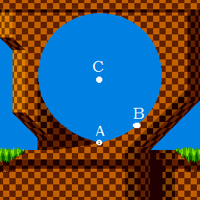

Answer these 4 questions.

1. What is the angle in radians between the lines CA and CB?  
   angle = l/r = 52.36/100 = 0.52 radians
2. What is this angle in degrees?  
   angle = 0.52 * 180 / pi = 30°
3. What is the horizontal distance between the points A and B?  
   dx = 100 * sin(30°) = 100 *1/2 = 50 cm
4. What is the vertical distance between the points A and B?  
   dy = 100 – 100*cos(30°) = 100 (1 - √(3)/2) = 13.40

### Frog

Given is this start situation:



The frog wants to jump on the grass block to get extra strength. Knowing that:

* The distance between the horizontal centers of the frog and the grass block is 240 cm when the frog starts its jump.
* The height of the grass block is 80 cm
* It jumps in a straight line
* After the jump the horizontal centers of the frog and grass block coincide

Answer these 3 questions.

1. What was the jumped distance ?   
   distance = √(802 + 2402) = 252.98 cm
2. At what angle (in radians) did the frog jump ?  
   0.32 radians
3. At what angle (in degrees) did the frog jump ?  
   18.43°

Following images should clarify some things.

|  |  |
| --- | --- |
| Before the jump |  |
| After the jump |  |

### Through a tube to the next level

The player can only get to the next level via a narrow tube. Therefor it needs to transform into a ball with the same diameter as the tube. This transformation costs a lot of energy that is greater as it shrinks more. So in order not to waste more energy than necessary, it should shrink until it reaches the same diameter as the tube and not more. To know this diameter the player uses a device that allows measuring the angle between the line from the device up to a point in the level and a horizontal reference line.

What is this diameter (d) when you know:

* The vertical position of the device (h) and
* The values of 2 angles (α and β ) as indicated on the picture below.
* That the terrain in front of the tube is horizontal
* That the entrance of the tube is perpendicular to the terrain.

h = 5

α = 36.87°

β = 51.34°

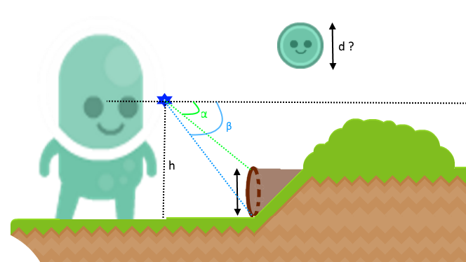

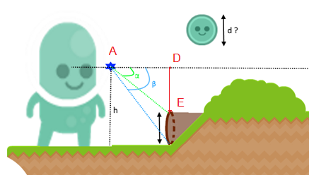d = h - |DE|

d = 5 - |DE|

|DE|?

|DE| = |AD| * tan α = |AD| * tan (36.87°) = |AD| * 0.75

|AD|?

|AD| = h / tan β = 5 / tan 51.34° = 5 / 1.25 = 4

=>

|DE| = 4 * 0.75 = 3

=>

d = 5 – 3 = 2

### Pool

In a game there is a medal at the bottom of a pool. The pool has the shape of a triangular right prism. The player needs this medal to get more power. It swims in a straight line to the medal as indicated by the black dotted line. The medal is located in the middle of that bottom side. the lengths of the sides of the base triangle are given as well as the height of the prism. How far swims the player before reaching the medal?

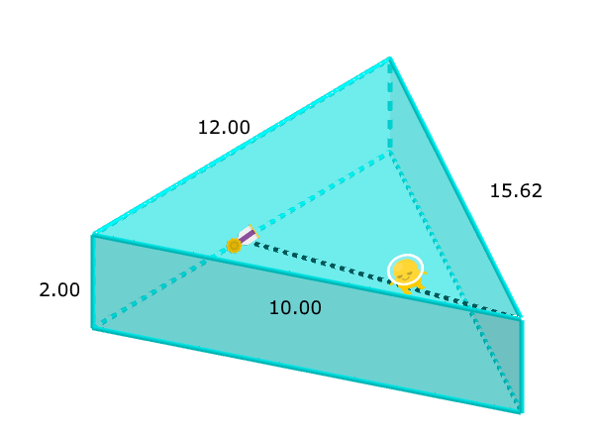

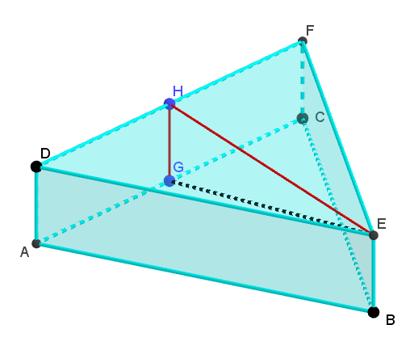

Triangle EGH is a right triangle because $\hat{H}$ is 90° as it is a right prism, thus

|GE|2 = |HE|2 + |GH|2 = |HE|2 + 22 = = |HE|2 + 4

|HE|2?

|HE|2 = |HF|2 + |FE|2 – 2 * |HF| * |FE| * cos

|HE|2 = 62 + 15.622 - 2 * 6 * 15.62 * cos

cos ?  
|DE|2 = |FE|2 + |FD|2 – 2 * |FE| * |FD| * cos

(|DE|2 - |FE|2 - |FD|2)/( – 2 * |FE| * |FD| ) = cos

(102 – 15.622 - 122 )/(-2 * 15.62 * 12 ) = cos

|HE|2 = 62 + 15.622 - 2 * 6 * 15.62 * (102 – 15.622 - 122 )/(-2 * 15.62 * 12 )

|HE|2 = 135.99

|GE|2 = 135.99 + 4

**|GE| = 11.83**