AMP(1)-Lab03– Trigonometric Formulas

# Content

AMP(1)-Lab03– Trigonometric Formulas 1

1. Content 1

2. Learning objectives 1

2.1. Exam objectives 1

2.2. Supportive objectives 2

3. Exercises 2

3.1. Basic exercises 3

3.1.1. Exploring trigonometric ratios in the unit circle 3

3.1.2. Angles 4

3.2. Contextual practice 5

3.2.1. Clock 5

3.2.2. Advanced clock 5

3.2.3. Tank wars 7

3.2.4. Rotation 7

3.2.5. Belt 8

4. References 8

4.1. Trigonometry 8

4.2. Geogebra tutorials 8

4.2.1. The basics 8

4.2.2. Sine and Cosine in a Unit Circle 8

# Learning objectives

## Exam objectives

By the end of this lab you should be able to (pen and paper):

* Understand and retrieve sine, cosine and tangent values in the unit circle
* Master these pairs of angles: complementary angles, opposite angles
* Master the inverse trigonometric functions like arcsine, arccosine and arctangent.

We advise you to **make your own summary of topics** which are new to you.

More info is available in Trigonometry

## Supportive objectives

More specifically related to the above you should in GeoGebra () be able to:

* Visualize angles, triangles and circles

More information is available on the Web Geogebra tutorials

# Exercises

Dependent of the lab session you may work individually or teamed (organized by the lab attendant). In either case make sure that throughout the course of this lab, you re-save sufficiently your solution file on your local machine as

**1DAExx-0y-name1**(+name2+name3).GGB given **xx**=groupcode, **0y**=labindex

## Basic exercises

### Exploring trigonometric ratios in the unit circle

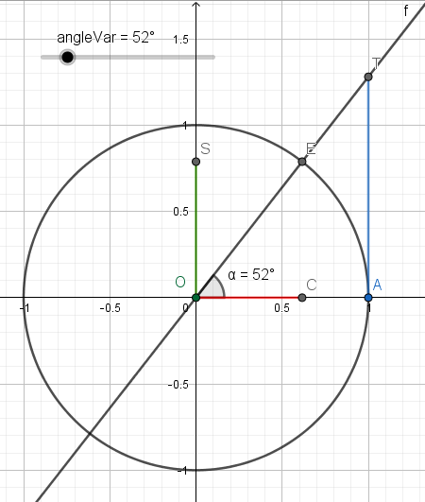

Open the given AMP(1)-Lab03_TrigonometricFormulas21-22_v3(UnitCircle).ggb file. The graphics view shows a unit circle and a line that forms an angle *α* with the positive x. The angle has the same value as the slider value, so it changes when you move the slider. The Algebra view shows the values of the cosine, sine and tangents of this angle. The points C, S and T also correspond with these values.

You can achieve the same result by performing the following steps using the Graphics buttons:

* Draw a unit circle with center O.
* Draw a slider *angleVar* of type angle, interval is [0°,360°].
* Draw an angle *α* with size equals the value of the slider *angleVar*.
* E is the intersection point of the angle leg and the circle,
* A is the intersection point of the circle and the x-axis.
* Draw a line through O and E.

And by defining these 3 variables in the input bar:

* cosAlpha = cos(α)
* sinAlpha = sin(α)
* tanAlpha = tan(α)

And by defining these 3 points in the input bar:

* C =( cosAlpha, 0 )
* S =( 0, sinAlpha )
* T =(1, tanAlpha )

The length of the segments [OC], [OS] and [AT] represent alpha’s cosine, sine and tangent respectively. Create these segments yourselves using the Segment button 

Move the slider indicator or activate the slider animation and have a look at these segments. Now you should be able to answer following questions:

1. For which angle values is the tangent undetermined? **For alpha = 90º and alpha = 270º**
2. Give the angle interval(s) that results in negative cosine values? **]90º, 270º[**
3. Give the angle interval(s) that results in negative sine values? **[180º, 360º[**
4. Give the angle interval(s) that results in negative tangent values? **]360º,27[ ]180º, 90º[**
5. What is the maximum and minimum value of the cosine and sine? **Max = 1, Min = -1**
6. Which angles have the same cosine and sine value? **225º and 45º**

When you know the cosine, sine or tangent value of an angle, you can obtain the angle itself using the inverse functions arccosine, arcsine or arctangent.

Define the angle β as the result of inverse cosine function applied on cosAlpha.



This should result in an angle that has the same value as α.

### Angles

#### Special angles

1. Prove solely by pen and paper the three trigonometric ratios (sine, cosine and tangent) for **at least one** of these special angles: 30° or 45° or 60°
2. Scaffold each geometric reasoning step by a situation sketch within the unit circle.
3. Prove pure calculations by providing each intermediate calculation step.

#### Opposite and complementary angles

A drawing will help you to solve these questions:

1. What is the result of sin(α) + sin(β) when α and β are opposite angles?

alpha + beta = 0 → alpha = - beta

sin(alpha) + sin(beta)

sin(-Beta) + sin(beta)

-sin(beta) + sin(beta) → 0

1. What is the result of sin2(α)+ sin2(β)when α and β are complementary angles? A drawing helps to find the solution.
2. What is the result of cos2(α)+ cos2(β)when α and β are complementary angles?

## Contextual practice

Now solving following real world examples should be a piece of cake.

### Clock

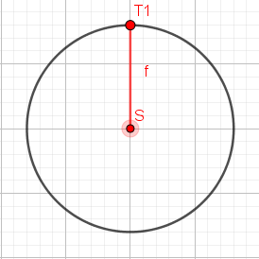A game shows a chronometer that measures the time an attack takes.

The arm starts upwardly as indicated by [ST1].

And it makes a whole tour in 1 minute.

It has a diameter of 16 units.

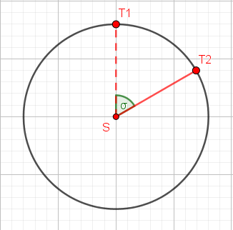T2 indicates the position of the arm after 10 seconds. Answer the questions mentioned in the table below.

|  |  |  |
| --- | --- | --- |
|  | Formula | Result |
| 1. Size in degrees of angle σ | 60 sec = 360 degrees  1 sec = 360 / 60  10 sec = x → x = (360 / 60 ) * 10 | 60 degrees |
| 1. Horizontal distance between S and T2 | r = diameter / 2 = 8  8 * sin(60) | 6.93 |
| 1. Vertical distance between S and T2 | 8 * cos(60) |  |

Check your results in Geogebra.

### Advanced clock

The project leader wants you to draw a more advanced arm.

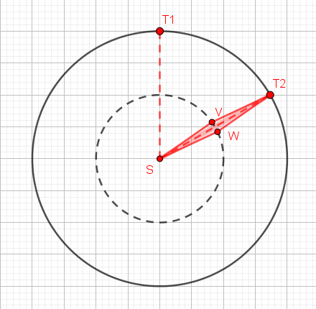 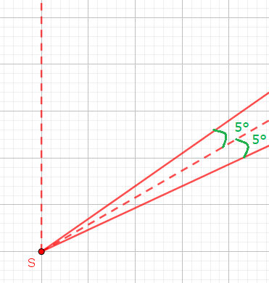

The vertices V and W of the arm are on a circle with diameter half the value (8 units) of the outer circle (16 units) and the line segments [SV] and [SW] form an angle of 5° to ST2.

What is the horizontal and vertical distance between S and V and S and W after 10 seconds?

|  |  |  |
| --- | --- | --- |
|  | Formula | Result |
| 1. Horizontal distance between S and V |  |  |
| 1. Vertical distance between S and V |  |  |
| 1. Horizontal distance between S and W |  |  |
| 1. Vertical distance between S and W |  |  |

### Tank wars

We are developing a tank wars game.

The image below shows the top view of one of the tanks. It has a rectangular form. The coordinates of vertex A are (3,2).

[AD] and [BC] measure 1 unit each. [AB] and [DC] both measure 1.5 units. The tank its gun is aligned with the tank and pointing in the direction determined by the dashed line with angle α. The slope (=tan(α)) of this direction is +0.6.

Calculate the coordinates of the vertices B, C and D of the tank.

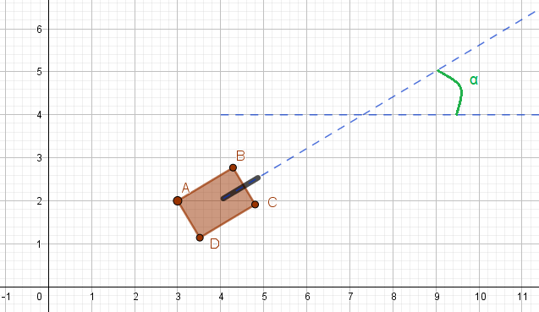

|  |  |  |
| --- | --- | --- |
|  | Formula | Result |
| 1. x of B |  |  |
| 1. y of B |  |  |
| 1. x of D |  |  |
| 1. y of D |  |  |
| 1. x of C |  |  |
| 1. y of C |  |  |

### Rotation

Position a plane point P(x,y) at a fixed distance *r* to the origin O. Now, rotate this point around the origin O over an angle $β$ along a circular arc (i.e.: keeping its distance *r* to the origin).

**Determine** the rotated point P’(x’,y’) **coordinates** in terms of the initial coordinates x and y.

*Hint: consider the initial point P(x,y) subtending an angle $α$ to the horizontal x-axis.*

### Belt

The red belt keeps together two wheels of radii R and r respectively, looping all the way around them both. We logically assume R > r >0.

**Determine** the entire **length** of this looped belt.

*Hint 1. Distinguish the four parts of this belt: two external tangent stretches, the left circular arc and the right circular arc. Calculating each of these partial lengths relies on properties of the tangent to a circle, right triangles and (inverse) trigonometry.*

*Hint 2. You will need to solve a certain right triangle, and will need to apply the definition of an angle in radian.*

# References

## Trigonometry

ISBN 9789401474955 (Animation Maths NE/2021), **pars 3.4 – 3.8**

## Geogebra tutorials

### The basics

<https://www.youtube.com/watch?v=1cBXWi66-tY>

### Sine and Cosine in a Unit Circle

<https://www.youtube.com/watch?v=H-MTLHRkcn8>