AMP(1)-Lab05 – Vectors(2D)

# Content

Lab07 – Vectors(2D) 1

1. Content 1

2. Learning objectives 2

2.1. Exam objectives 2

2.2. Supportive objectives 2

3. Exercises 2

3.1. Basic exercises 2

3.1.1. Vectors as arrows 3

3.1.2. Addition 4

3.1.3. Scalar multiplication 5

3.1.4. Subtraction 6

3.2. Bridging exercises 7

3.2.1. Decompose a 2D vector trigonometrically 7

3.2.2. Orthogonal vector 8

3.2.3. A vector as linear combination of 2 other vectors 8

3.2.4. Distance between 2 points 9

3.3. Contextual practice 9

3.3.1. Vectors as forces 9

3.3.2. Vectors as displacements 10

3.3.3. Point in triangle 11

3.3.4. Linearly interpolation between two vectors (lerp) 11

3.3.5. Vertex normal 12

4. References 13

4.1. Linear combination of vectors 13

4.1.1. Point in triangle 13

4.2. Vertex normal 13

4.3. Vertices, faces and edges 13

4.3.1. Smooth shading 13

4.4. Lerp 13

4.4.1. Lerp function in unity 13

# Learning objectives

## Exam objectives

By the end of this lab you should be able to (pen and paper):

* Master 2D vector vocabulary like the norm (length) and direction (meaning orientation plus sense), zero vector, unit vector, base vector, location vector, free vector, (anti)parallel,
* Apply the addition of 2D vectors
* Apply the scalar multiplication of 2D vectors: uniform scaling
* Apply the subtraction of vectors: 2D point-to-vector formula, distance, …
* Decompose a 2D vector trigonometrically

We advise you to **make your own summary of topics** which are new to you.

## Supportive objectives

Specifically related to the above you should in GeoGebra Classic**5.0 or** <https://geogebra.org/classic> be able to:

* Apply the addition of vectors and visualize it in the View/Graphics
* Apply the scalar multiplication of vectors and visualize it in the View/Graphics
* Apply the subtraction of vectors and visualize it in the View/Graphics

# Exercises

Dependent of the lab session you may work individually or teamed (organized by the lab attendant). In either case make sure that throughout the course of this lab, you re-save sufficiently your solution file on your local machine as

**1DAExx-0y-name1**(+name2+name3).GGB given **xx**=groupcode, **0y**=labindex

## Basic exercises

Make these exercises on paper and then verify your results in Geogebra.

Some Geogebra tips:

* Creating a vector (Input bar/Vector command)  
  
* Drawing a vector (Graphics toolbar/Vector button)  
  
* Length of a vector (Input bar/Length command)



* Components of a vector (automatically in Algebra view)  
  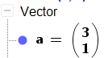

### Vectors as arrows

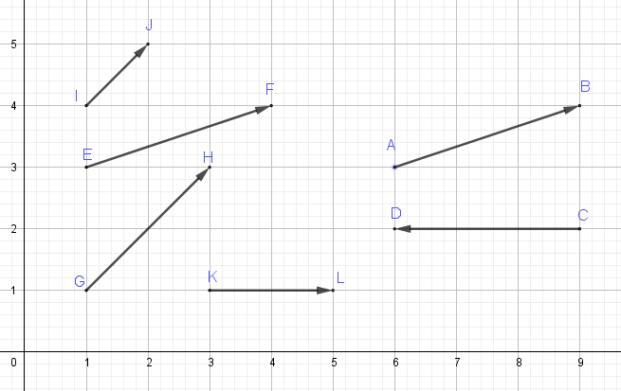

|  |  |  |  |  |  |  |  |  |  |  |  |  |
| --- | --- | --- | --- | --- | --- | --- | --- | --- | --- | --- | --- | --- |
| 1. Calculate the length of the above free vectors  |  |  | | --- | --- | |  |  | |  |  | |  |  | |  |  | |  |  | |  |  | |
| 1. Which vectors are equal? |
| 1. Which vectors are not equal however are parallel? |
| 1. Which vectors are antiparallel? |
| 1. Determine the column components of the location vectors that are equal to these free vectors  |  |  | | --- | --- | |  |  | |  |  | |  |  | |  |  | |  |  | |  |  | |

### Addition

Add the given vectors in 2 ways.

|  |  |
| --- | --- |
| Head-to-tail method | Adding components |
| (1) | A = (3, 1) B = (-2, 1)  A + B = (1, 2)  graphically can do it with the parallelogram method |
| (2) | A = (1, 2). B = (1, -1)  A + B = (2, 1) |
| (3) | A = (1,2) B = (-1, 1)  A + B = (0, 1) |
| (4) | A = (2, 4) B = (-1, -2)  A + B = (1, 2) |
|  |  |

### Scalar multiplication

1. Given are the vectors $\vec{a}$ and $\vec{b}$. Multiply these vectors with a scalar and give the components of the resulting vectors and draw them.  
   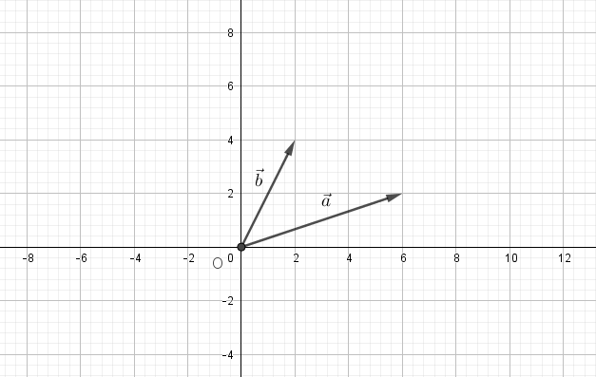

|  |  |
| --- | --- |
| 2 $\vec{a}$* = | A = (6, 2). → (2*6, 2*2) = (12, 4) |
| 2 $\vec{b}$* = | B = (2, 4). → (2*2, 2*4) = (4, 8) |
| -1 $\vec{a}$* = | (-1 * 6, -1*2) = (-6, -2) |
| -1 $\vec{b}$* = | (-1 * 2, -1*2) = (-2, -2) |

Consider the same vectors $\vec{a}$ and $\vec{b}$, compute the components of the vectors with the same direction however with a length equals 1.

|  |  |  |
| --- | --- | --- |
|  | length | Components of vector = vector/length |
| $\vec{a}$ | A = |  |
| $$\vec{b}$$ |  |  |

How do we call these vectors ? Unit Vectors

1. In geogebra:
   * Create a slider with the name **scale**
   * Define 3 vectors in the input bar, like this: $\vec{a}$ 
     : scale * Vector((6, 2)) $\vec{b}$ 
     : scale * Vector((8,4)) $\vec{c}$ 
     : scale * Vector((2,4))
   * Select the Polygon button  and draw a triangle that connects the 3 endpoints of these vectors.
   * Then change the scale value using the slider, what do you notice?

### Subtraction

The subtraction of $\vec{a}$ and $\vec{b}$ can be written as the addition of $\vec{a}$ and $−\vec{b}$

$\vec{a}−\vec{b}=\vec{a}+$)

Subtract the vectors $\vec{a}$ and $\vec{b}$ in 2 ways.

|  |  |
| --- | --- |
| Head-to-tail method | Subtracting components |
|  | A = (3,1). B = (-2, 1)  A + (-B) = (5, 0) |
|  |  |
|  |  |

## Bridging exercises

### Decompose a 2D vector trigonometrically

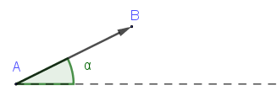Give the formulas for the x and y components of the vector $\vec{AB}$ when the angle $α$ with the positive x-axis and the length l are given.

|  |
| --- |
| x = length * cos alpha |
| y = length * sin alpha |

Apply these formulas. Calculate the components of the vectors for the given lengths and angles.

|  |  |  |  |  |
| --- | --- | --- | --- | --- |
| Vector | Length l | Angle α | x component | y component |
| $$\vec{a}$$ | 1 | 0° | 1*cos 0 = 1 * 1 = 1 | 1*sin0 = 0 |
| $$\vec{b}$$ | 2 | 30° | 1 * cos 30 = 1 * sqrt(3) / 2 = sqrt(3) / 2 | 1 * sin 30 =  = 1 * ½ = 1/2 |
| $$\vec{c}$$ | 3 | 45° | 1 * cos 45 = 1 * sqrt(2) / 2 =  = sqrt (2) / 2 | 1 * sin 45 =  = 1 * sqrt(2) / 2 = sqrt(2) / 2 |
| $$\vec{d}$$ | 4 | 90° | 4 * cos 90 = 4 * 0 = 0 | 4 * sin 90 = 4 * 1 = 4 |

### Orthogonal vector

Calculate the x and y components of the vectors that are orthogonal to and have the same length as the vectors in previous exercise.

|  |  |  |  |  |  |
| --- | --- | --- | --- | --- | --- |
| Given vector | | | Orthogonal vector | | |
| Vector | Length l | Angle α | Angle | x component | y component |
| $$\vec{a}$$ | 1 | 0° | 90° | Same formula as previous one |  |
| $$\vec{b}$$ | 2 | 30° | 120° |  |  |
| $$\vec{c}$$ | 3 | 45° | 135° |  |  |
| $$\vec{d}$$ | 4 | 90° | 180° |  |  |

**What do you notice?** Write a general formula to find the orthogonal vector to a vector given in 2D space, when you require the orthogonal vector of the same length as the given vector.

The x and y values swap, and x values convert to negative.

### A vector as linear combination of 2 other vectors

Given are the vectors $\vec{a}$, $\vec{b}$ and $\vec{c}$.

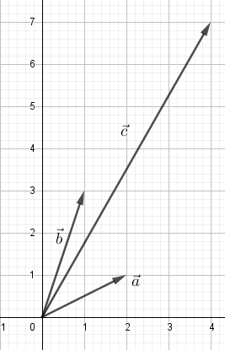

You can write the vector $\vec{c}$ as a linear combination of the vectors $\vec{a}$ and $\vec{b}$, like this

$$\vec{c}=s∗\vec{a}+t∗\vec{b}$$

Compute the values of s and t?

S = 1, t = 2

Verify your result in Geogebra.

### Distance between 2 points

|  |  |
| --- | --- |
|  | Given are 2 points A(3,1) and B(1,6). Calculate the distance between those 2 points (tip use vector subtraction and length of resulting vector) |

## Contextual practice

### Vectors as forces

#### Pulling a box towards a target

Two teams are pulling a box located in a point S towards a target point T, the vectors $\vec{a}$ and $\vec{b}$ are the forces applied by team A and B respectively.

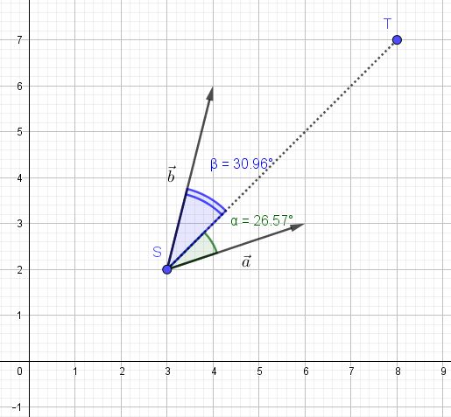

Calculate the resulting force vector applied on the box

How much force does each team apply on the box?

How much is each of the team’s force going into the direction of the target?

#### Which team wins

Three teams A, B and C are trying to pull a treasure into their own area. The treasure is located in point O (4,2)

The forces (vectors) of each team start in point O, the end points are:

End point of force $\vec{a}$ of team A : (8, 2)

End point of force $\vec{b}$ of team B : (-2, 3)

End point of force $\vec{c}$ of team C : (1, -1)

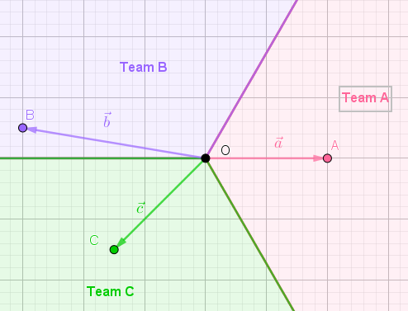

Give the components of the location vectors corresponding with $\vec{a}$, $\vec{b}$ and $\vec{c}$

What is the magnitude of the resulting force $\vec{r}$ acting on the treasure?

Draw the resulting force that starts in point O. In which camp is the treasure getting pulled?

### Vectors as displacements

In a top-down game the hero moves through the level looking for some extra armour. Hestarts at a location S with coordinates (2, 1). The displacements (distance and direction) of the hero through the level are described by the following vectors:

$$\vec{d1}\left(\begin{aligned}−5 \\ 1\end{aligned}\right)$$

$$\vec{d2}\left(\begin{aligned}0 \\ 3\end{aligned}\right)$$

$$\vec{d3}\left(\begin{aligned}2 \\ 0\end{aligned}\right)$$

$$\vec{d4}\left(\begin{aligned}5 \\ 1\end{aligned}\right)$$

Compute the coordinates of the end point E the hero reached at the end of this expedition?

Compute the total length l of the travelled distance?

At what distance d is the hero from its starting location?

### Point in triangle

Have a look at the given file *3_3_3_PointInTriangle.ggb* file. The vectors $\vec{a}\left(\begin{aligned}4 \\ 2\end{aligned}\right)$ and $\vec{b}\left(\begin{aligned}1 \\ 4\end{aligned}\right)$ coincide with 2 sides of triangle *tri*. Point P of the vector $\left\|\vec{OP}\right\|$ is defined as a linear combination of these 2 triangle vectors, like this $\left(\begin{aligned}4∗s+1∗t \\ 2∗s+4∗t\end{aligned}\right)$. The values s and t are controlled by 2 sliders. Move the point P using the sliders and indicate in the third column the location of P

|  |  |  |
| --- | --- | --- |
| s | t | P |
| 0 | 0 |  |
| 1 | 0 |  |
| 0 | 1 |  |
| Any value in [0, 1] | 0 |  |
| 0 | Any value in [0,1] |  |
| s and t are positive and sum is 1 | |  |
| At least one is negative | |  |
| Both are positive and the sum is < 1 | |  |

A video is available at Point in triangle

### Linearly interpolation between two vectors (lerp)

Lerp means linear interpolation between 2 values. It is commonly used to find a point some fraction of the way along a line between 2 points, e.g. to move an object gradually between those points.

It is one of the Unity functions: Lerp function in unity

With the given endpoints S and E of the vectors $\vec{s}$ and $\vec{e}$ calculate the vector $\vec{p}$ for different values for the fraction of the distance between S and E

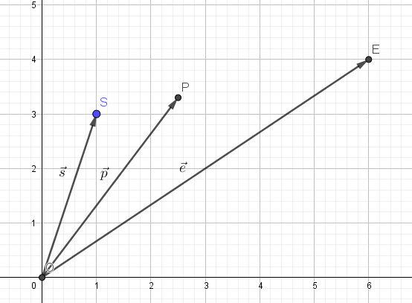

What are the components of the vector $\vec{SE}$?

|  |  |
| --- | --- |
| Fraction | Components of $\vec{p}$ |
| 0 |  |
| 0.1 |  |
| 0.2 |  |
| 0.5 |  |
| 0.8 |  |
| 1 |  |

Give the general formula of vector $\vec{p}$:

### Vertex normal

In 3D computer graphics objects are often described as a collection of vertices, edges and faces. One of the properties of a vertex is its normal. A vertex normal describes the orientation of the neighboring faces of that vertex and it used by the lighting and shading techniques in 3D applications (Vertex normal). Commonly, a vertex normal is computed as the normalized average of the normals of the neighboring faces of that vertex.

With the vector knowledge you have acquired, you can compute a vertex normal. Consider a vertex B with 2 neighboring faces perpendicular to the xy plane and described by the vectors $\vec{a}$ and $\vec{b}$

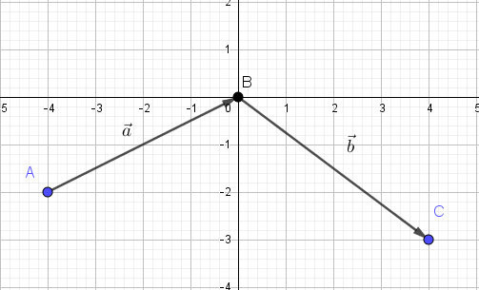

Create this starting situation in Geogebra and then compute the normal in the vertex B, like this:

* Create the orthogonal vectors $\vec{n1}$ and $\vec{n2}$ on $\vec{a}$ and $\vec{b}$ in Geogebra
* Create the vector $\vec{n}$ of vertex B, it is the vector : ${\vec{n1}}/{\left\|\vec{n1}\right\|}+{\vec{n2}}/{\left\|\vec{n2}\right\|}$ in Geogebra  
  This is the result in Geogebra.

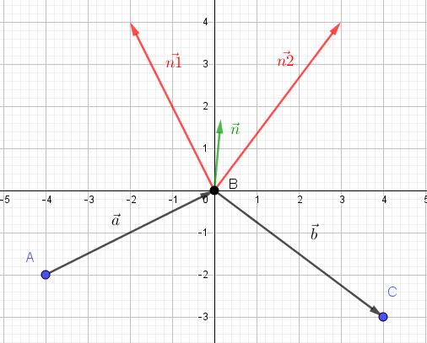

* Then normalize the vector $\vec{n}$ (in Geogebra). What are the components of this normalized vector?

# References

## Linear combination of vectors

### Point in triangle

<https://www.youtube.com/watch?v=HYAgJN3x4GA>

## Vertex normal

## Vertices, faces and edges

<https://www.mathsisfun.com/geometry/vertices-faces-edges.html>

<https://revisionmaths.com/gcse-maths/geometry-and-measures/3d-shapes>

### Smooth shading

<https://www.youtube.com/watch?v=PMgjVJogIbc>

## Lerp

### Lerp function in unity

<https://docs.unity3d.com/ScriptReference/Vector3.html>