Lab09 – Cross Product

# Content

Lab08 – Cross Product 1

1. Content 1

2. Learning objectives 1

2.1. Exam objectives 1

2.2. Supportive objectives 1

3. Exercises 2

3.1. Basic exercises 2

3.1.1. Calculate & visualize Cross product using unit vectors 2

3.1.2. Calculate & Visualize Cross product using other vectors 2

3.2. Bridging exercises 3

3.2.1. Determine a surface normal via the cross product 3

3.2.2. Area of parallelogram via the cross product 3

3.2.3. Distance from point to a plane 4

3.3. Contextual practice 5

3.3.1. Backface culling 5

3.3.2. Relative Right and Left 5

3.3.3. Moving along the wall 6

4. References 6

# Learning objectives

## Exam objectives

By the end of this lab you should be able to (pen and paper):

* Apply the cross product of vectors
* Be mindful of the cross product’s anticommutativity
* Apply the cross product’s geometric properties to determine surface normal (inwards or outwards) and area of its subtended triangle (or parallelogram)
* Apply the cross product’s criterion for (anti)parallelism

We advise you to **make your own summary of topics** which are new to you.

## Supportive objectives

Specifically related to the above you should in GeoGebra Classic**5.0** be able to:

* Apply the cross product of vectors
* Apply the cross product to determine and visualize a surface normal in the View/Graphics

# Exercises

## Basic exercises

### Calculate & visualize Cross product using unit vectors

* Given vector $\vec{u}=\left(\begin{aligned}\begin{aligned}1 \\ 0\end{aligned} \\ 0\end{aligned}\right)$ and the vector $\vec{v}=\left(\begin{aligned}\begin{aligned}0 \\ 1\end{aligned} \\ 0\end{aligned}\right)$
* Calculate the cross product $\vec{w}1=\vec{u}X\vec{v}$

w1 = uxv = Matrix (ex ey ez, 1 0 0, 0 1 0) = ex (00 10) – ey (10 00) + ez (10 01) = (0 0 1)

* Visualize $\vec{u}$ and $\vec{v}$ in GeoGebra (View – Graphics3D)
* Visualize $\vec{w}1$ using the Cross-command
* Calculate the cross product $\vec{w}2=\vec{v}X\vec{u}$

w2 = Matrix (ex ey ez, 0 1 0, 1 0 0) = (0 0 -1)

* Visualize $\vec{w}2$ using the Cross-command
* Check the directions of $\vec{w}1$ and $\vec{w}2$ with the right hand-rule. Make use of one of the mnemonics visualized below

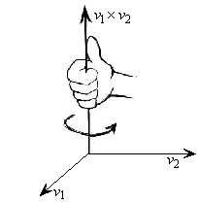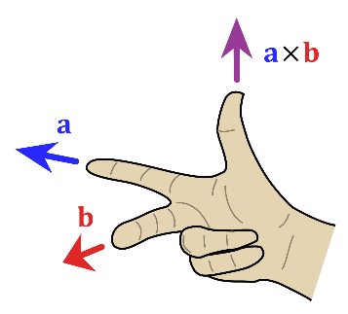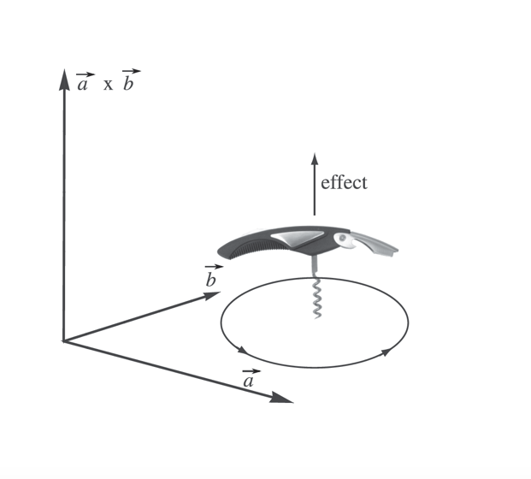

### Calculating Cross products

### Given the vector $\vec{d}=\left(\begin{aligned}\begin{aligned}2 \\ −2\end{aligned} \\ 2\end{aligned}\right)$ and the vector $\vec{e}=\left(\begin{aligned}\begin{aligned}2 \\ 2\end{aligned} \\ 2\end{aligned}\right)$

* Calculate their cross product $\vec{f}=\vec{d}×\vec{e}$
* Verify the vector $\vec{f}$ indeed is perpendicular to both $\vec{d}$ and $\vec{e}$ (see dot product!)
* Repeat Calculate the alternative cross product
* VeriVerify the anticommutative property of the cross product via $\vec{f}$ and $\vec{g}$
* Normalize the cross products $\vec{f}$ and $\vec{g}$ to their respective unit vectors $\hat{f}$ and $\hat{g}$

## Bridging exercises

### Determine a surface normal via the cross product

* Visualize the triangle determined by the vertices $A=\left(−3,0,2\right)B=\left(2,0,3\right)∧C=\left(2,−4,3\right)$
* Calculate and visualize the normalized normal in $A$

Hint :

* + Determine vector $\vec{AB}$ AB = B – A = (2 - (-3), 0 – 0, 3 -2) = (5, 0, 1)
  + Determine vector $\vec{AC}$ AC = C -A = (2 - (-3), -4 – 0, 3 -2) = (5, -4, 1)
  + Visualize the vectors $\vec{AB}$ and $\vec{AC}$
  + Calculate $\vec{AB}$ x $\vec{AC}$ and $\vec{AC}$ x $\vec{AB}$ + visualize in GeoGebra

AB X AC = (4, 0, -20)

AC X AB = (-4, 0, -20)

* What is your conclusion?

Calculate and visualize the normalized normal in $B$

Hint :

* + Determine vector $\vec{BA}$
  + Determine vector $\vec{BC}$
  + Visualize the vectors $\vec{BA}$ and BC
  + Calculate $\vec{BA}$ x $\vec{BC}$ and $\vec{BC}$ x $\vec{BA}$ + visualize in GeoGebra
* Compare with the normal in vertex $A$. Wat is your conclusion?

### Area of parallelogram via the cross product

The *length* of the cross product-vector is a measure of the Area of the parallelogram determined by the 2 side-vectors of the parallelogram.

Find the area of the parallelogram spanned by the location vectors

$\vec{a}\left(\begin{aligned}\begin{aligned}4 \\ −10\end{aligned} \\ 5\end{aligned}\right)$ and $\vec{b}\left(\begin{aligned}\begin{aligned}−3 \\ −1\end{aligned} \\ −3\end{aligned}\right)$

Check your answer in GeoGebra.

a x b = ||a|| ||b|| sin θ

a x b = (35, -3, -34)

|| a ||= sqrt (42 + (-10)2 + 52) = sqrt(131) = 11.87

|| b ||= sqrt ((-3)2 + (-1)2 + (-3)2) = sqrt(19) = 4.36

θ = arcsin( || a x b || / ||a|| * ||b|| ) = 70.83

areaPallelogram = 2 x areaTriangle = 2 x (1 / 2 * a * b sin θ) = 2 x (½ * ||a|| ||b|| * sin θ) = 48.89

### Distance from point to a plane

Given a point P (2,2,4) and a plane defined by A (-6, 10, 0), B (7, 13, 0) and C (-1, 15, 14). Calculate the perpendicular distance from the point P tot the plane ABC.

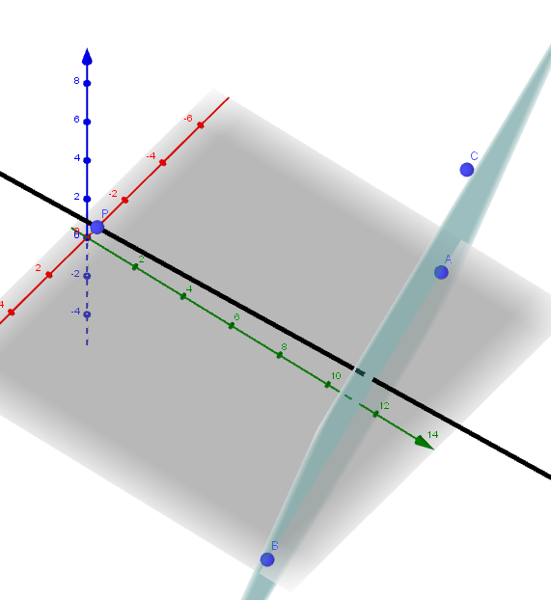

## Contextual practice

### Backface culling

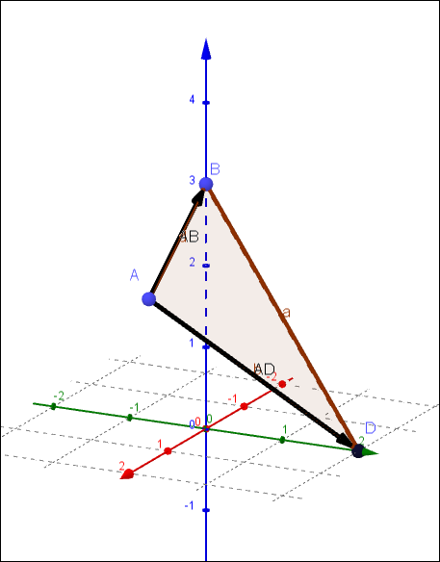

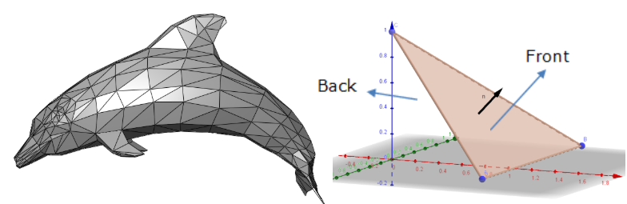

Assume a face determined by the vertices $A=\left(1.5,0,2\right),B=\left(0,0,3\right)∧C=\left(0,2,0\right)$. The frontside of the triangle is determined by the counterclockwise normal (in $A,B$ or $C$).

The camera is positioned in (1,4,3) and point towards the target in (5,2,1). Use the cross-product to calculate the normal and the dot-product to determine if the camera is looking at the frontside of the plane or not.

### Relative Right and Left

In a top-down game, the movement is often relative to the front facing direction of the avatar. The avatar is in position (2,2,0). The front vector is described by $\vec{f}$ = $\left(\begin{aligned}\begin{aligned}1 \\ 0.75\end{aligned} \\ 0\end{aligned}\right)$. It’s up direction is the same as that of the z-axis.

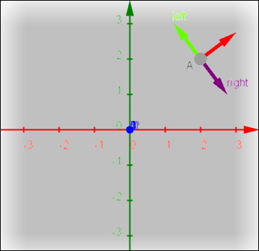

* Calculate the vector that indicates the direction 90 degrees to the right and 90 degrees to the left using a cross-product with the z-axis.
* When the player clicks in (2,4,0), how can you calculate that is to the avatars left side or right side?

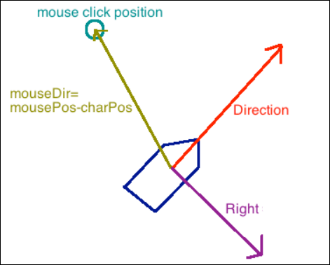

### Moving along the wall

A player is directing his avatar into a wall. The direction in which the avatar moves is $\vec{f}\left(\begin{aligned}\begin{aligned}−5 \\ −1\end{aligned} \\ −1\end{aligned}\right)$. The wall is determined by the vertices $W1=\left(−4,3,0\right),W2=\left(−4,3,2\right)∧W3=\left(4,−3,0\right)$.

Like any decent game, the player will not be able to traverse the wall, but the character will start sliding along the wall. Determine the direction in which the character will move along the wall

# References

**Backface culling**

<https://en.wikipedia.org/wiki/Back-face_culling>