AMP(1) – Lab10 – Matrices

# Content

Contents

AMP(1)Lab09 – Matrices 1

1. Content 1

2. Learning objectives 1

2.1. Exam objectives 1

2.2. Supportive objectives 2

3. Exercises 2

3.1. Matrices and Geogebra 3

3.2. Basic exercises 3

3.2.1. Matrix addition and scalar multiplication 3

3.2.2. Dot product and (natural) matrix powers 4

3.2.3. Understanding the dot- product 5

3.3. Bridging exercises 5

3.3.1. Inverse matrices 5

3.3.2. Noncommutative dot product of matrices 6

3.4. Terminology 6

3.5. Contextual practice 7

3.5.1. Matrix operations to perform colour transformations 7

3.5.2. Adjacency matrix 8

3.5.3. Population models and matrices 9

4. References 9

4.1. Demos in art and programming 9

# Learning objectives

## Exam objectives

By the end of this lab you should be able to (pen and paper):

* Master specific vocabulary about matrices like row matrix, column matrix, square matrix, zero matrix and identity matrix
* Given its conditions are met, apply the addition of matrices
* Apply the scalar multiplication of matrices
* Given its conditions are met, apply the subtraction of matrices
* Apply the transpose of matrices and understand symmetric matrices
* Given its conditions are met, apply the dot product of matrices
* Given its conditions are met, apply the matrix powers with natural exponents
* Understand and **use** the inverse of regular matrices
* Understand and apply the transpose or inverse of a matrix product (Socks ‘n Boots rule)

We advise you to **make your own summary of topics** which are new to you.

## Supportive objectives

Specifically related to the above you should in GeoGebra Classic**5.0** be able to:

* Create specific matrices like row matrix, column matrix, square matrix, zero matrix and identity matrix
* Perform the addition, scalar multiplication and substraction of matrices
* Perform the transpose of matrices
* Perform the dot product of matrices and matrix powers with natural exponent
* Distinguish between invertible and singular matrices via their determinant
* Calculate the inverse of an invertible square matrix

# Exercises

Dependent of the lab session you may work individually or teamed (organized by the lab attendant). In either case make sure that throughout the course of this lab, you re-save sufficiently your solution file on your local machine as

**1DAExx-0y-name1**(+name2+name3).GGB given **xx**=groupcode, **0y**=labindex

## Matrices and Geogebra

Defining matrices in GeoGebra can be done in different ways. The easiest way is the following:

* Open the spreadsheet view
* Type in a matrix in the spreadsheet view
* Select the matrix element (use the shift key to allow multiple selection)
* Right click the selected matrix, choose create.Matrix

The generated matrix can be manipulated by double clicking (eg: change its name)

You can use this procedure when working on the exercises below, to check your calculated results.

## Basic exercises

### Matrix addition and scalar multiplication

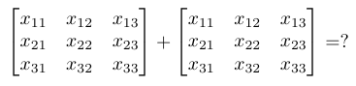

What conditions must be met to be able to add 2 matrices?

Sizes of both matrices have to be equal

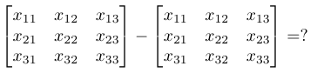

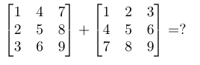

m3 = {{2, 6, 10}, {6, 10, 14}, {10, 14, 18}}

What conditions must be met to perform the scalar multiplication?

No condition

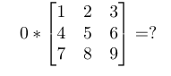

0 0 0

0 0 0

0 0 0

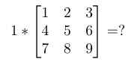

same matrix

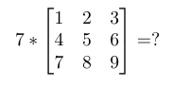7 14 21

28 35 42

49 56 63

### Dot product and (natural) matrix powers

Write down the dimensions of both matrices. Indicate whether the multiplication is compatible, and if so, do the calculation:

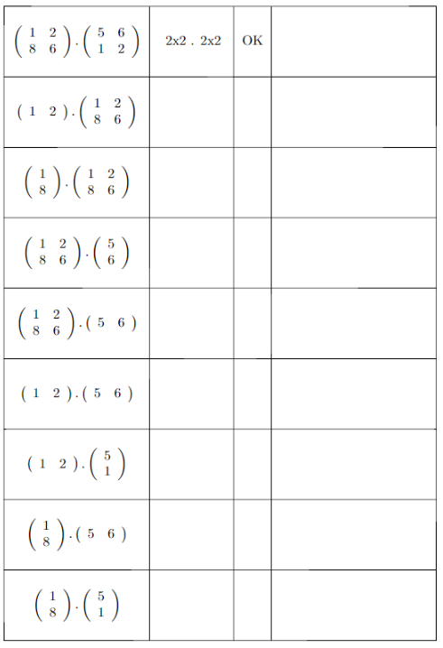

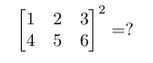

Can’t do it because the power of a matrix can only be applied to square matrices

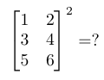

Can’t do it because the power of a matrix can only be applied to square matrices



m6 = {{7, 10}, {15, 22}}

What condition must be met if you want to calculate the power of a matrix?

### Understanding the dot- product

Given are the integer matrices A1 and A2:

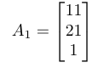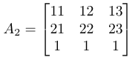

Find the **integer** matrix **B** such that

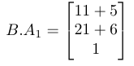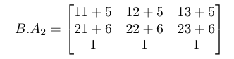

and

**B*A1**

A1 size is 3×1, so B need to have 3 columns in order to do the dot product. The result matrix is 3×1, this is the rows from B x columns of A, so B is 3×1 size.

We fill the 3×1 B matrix with B elements (B11, B12, B13 etc) and we calculate te dot product with it and we equal to the result. Then we check with values for B will return us the result indicated.

B11 * 11 + B12 * 21 + B13 * 1 = 11 + 5 → So B11 = 1, B12 = 0 and B13 = 5 in order to get 16 for the first row.

We do the same for the other 2 rows and we get as matrix B = {{1, 0, 5}, {0, 1, 6}, {0, 0, 1}}

**B*A2**

Find the matrix C such that

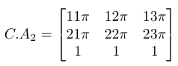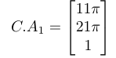

and

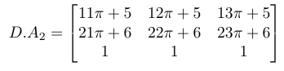Find the matrix D such that

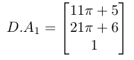and

What is the relationship between **B**, C and D? Prove this relationship

## Bridging exercises

### Inverse matrices

Calculate the determinant of the following matrices if any:

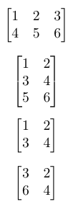 1º Not posible because is not squared.

2 º Same problem

3 º Det(3º) = -2

4º Det(4º) = 0

For the above matrices, which of the matrices below is its inverse?

Inverse matrix can only exits for square matrix, so the first two matrices dont have inverse matrix.

For the other 2 matrices, if the determinant of a square matrix is = 0, then there is no inverse for that matrix. So for the 4º matrix there isn’t an inverse matrix either.

For the 3º matrix there is an inverse matrix and in order to check wich one it is, the result of the dot product of both matrices should be equal to the Identity matrix In.

So, (-2 1, 3/2 -1/2) because the dot product with the 3º give us the Identity matrix (1 0, 0 1).

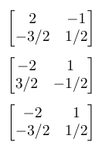

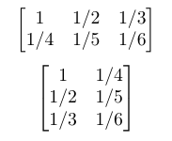

### Noncommutative dot product of matrices

Calculate the following matrix (dot) products:

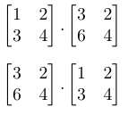

## Terminology

* What is a square matrix? A matrix which have same number of columns and rows.
* What is a zero matrix? What is the notation of a zero matrix? A zero matrix is a matrix which all his elements are 0. 0mxn
* What is an identity matrix? What is the notation of an identity matrix? Square matrix for which all elements are zero, except the diagonal ones which are 1. In , where n is the size of the square matrix
* What is the minor of the element ai,j in a matrix? When we delete the row and the column of a square matrix element aij and calculate the determinant of its underlying submatrix
* What is the cofactor of the element ai,j in a matrix? Is the multiplication of its minor with (-1)i+j
* Write down the definition of the determinant of a matrix
* Why is it important to know the determinant of a matrix? Because with the determinant of a matrix you can determine whether the matrix has an inverse or not (if det(M) != 0)
* What is an opposite matrix?
* What is the transpose of a matrix?
* What is the notation of a transposed matrix?
* What is a zero divisor?
* What is the inverse of a matrix?
* What is a singular matrix?
* What is an invertible matrix?
* Explain the ‘Socks-and-Boots’ formulation

For the above definitions, which apply to square matrices only?

## Contextual practice

### Matrix operations to perform colour transformations

The following matrix represents RGB colours using floats, a very common format in 3D environments:

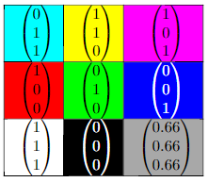

Apply the following matrixes to all the colours and write down the new colour. The matrices that are given are all 4x4 matrices which allows for some special operations (for example the negative operation). To be able to perform the matrix multiplications it is necessary to add an extra row with value 1 to each color:

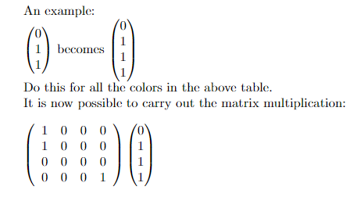

#### Monochrome – ‘yellowish’

Apply the following matrix to the above colours and explain what is happening and how it is happening. Try to look up the colours

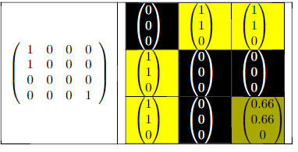

#### Saturation

Start by calculating the following matrix and apply it to the colours. What are the new colours you get?

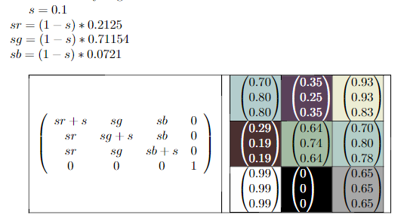

#### Negative

Apply the matrix to the starting colours above and explain what is happening

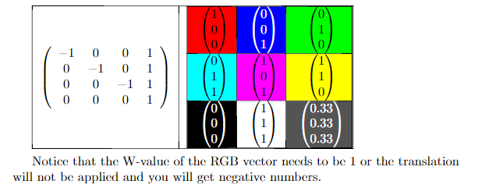

### Adjacency matrix

Look up the definition of a directed adjacency matrix. Create the adjacency matrix for the following graph describing waypoint navigation in a game

Use powers of this matrix to find how many steps it takes to

* move from A to D
* move from A to H

What’s the maximum exponent for any given graph, which (the exponent) adds information concerning the number of steps it takes to move from 1 vertex in the graph to another one

Hint: define a matrix which is the power of the adjacency matrix, in which the power is a slider variable

### Population models and matrices

Matrices can be used to describe how a population evolves. Look at the video found at [population models and matrices](https://www.youtube.com/watch?v=2rWr2QlQm4k).

Consider an initial population of 100 immature, 0 mature and 0 post mature elements:

|  |  |  |
| --- | --- | --- |
| **I** | **M** | **P** |
| 100 | 0 | 0 |

We can describe the population evolution from this current situation to the next (let’s say a breeding cycle) with a 3x3 matrix:

|  |  |  |  |
| --- | --- | --- | --- |
|  | **I** | **M** | **P** |
| **I** | 0.5 | 0.3 | 0 |
| **M** | 0.8 | 0.6 | 0.2 |
| **P** | 0 | 0 | 0.4 |

* Pen and paper: calculate the population after 1 step
* Geogebra: define a power matrix for the breeding matrix, in which the power is a slider variable. Allow this slider to take value in [1,500].
* Will this population flourish or perish?
* Whatever the result, change the breeding factor of the mature individuals such that the result (perish of flourish) changes. Change the factor in steps of 0.1, and find at which new value the change occurs (if any).
* Put that number to 0.8 again and change the number specifying the evolution from mature to mature such that you switch the result again. Move in steps of 0.1. What’s the first number causing the change?
* What would this 3x3 matrix look like when all individuals were female?

# References

## Demos in art and programming

* If you want to program some advanced graphical matrix operations, have a look at [Kernel (image processing)](https://en.wikipedia.org/wiki/Kernel_(image_processing)). These matrix operations allow you to enhance digital material.
* The population matrix is a simplified version of [Markov chains](https://en.wikipedia.org/wiki/Markov_chain). A different population approach can be found at [Lotka–Volterra_equations (predator-prey)](https://en.wikipedia.org/wiki/Lotka–Volterra_equations)