Let`s draw histograms by all of fields of data

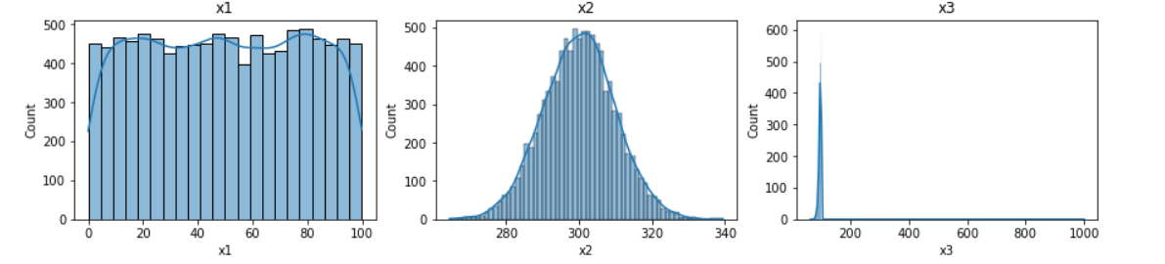

The outlier prevents us from evaluating the graph ‘x3’. So we will clear our data from outliers and rebuild graphs again.

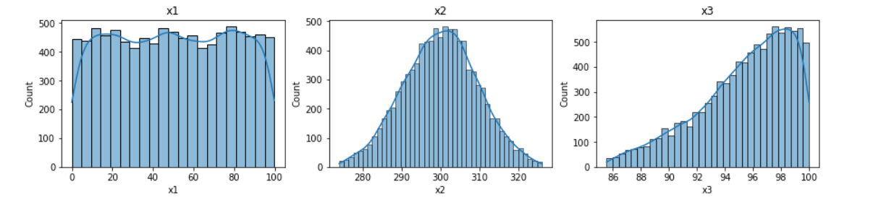

As we can see, first graph corresponds to a uniform distribution, second graph is a normal distribution, and the last one not similar to any kind of distributions but looks like reverse geometrical distribution.

Also let`s scale our data for better work of our future model. We get:

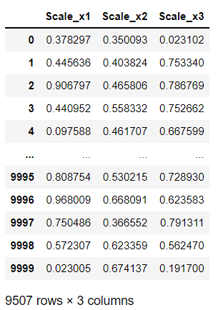

Now, we can build multiple linear regression by our cleared and scaled data.

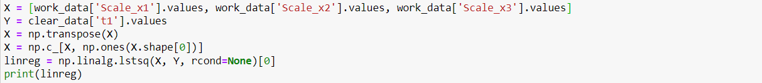

We get next coefficients:



Let`s compare values of predictable “t1” and real “t1” field:

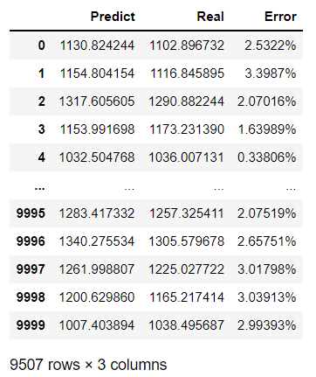

We need some common indicators of received column to evaluate accuracy:

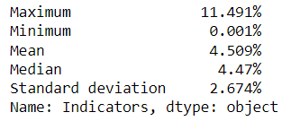

Let`s compare this with indicators of our previous model (simple linear regression from first version of Report):

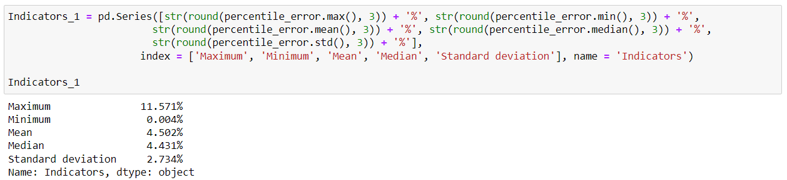

As we can see, accuracy of both models are very similar.