Clearing Redistribution Server

Version history

1.0 build (0)
TO DO

What you should to run…

- TO DO

Files needed to run

TO DO

Source code

All the source files located in Source Safe under $/MainLine/Clearing. SS Database -\\crocodile\ag\vss

Project description

Clearing Redistribution Server is the application that retransmits information about real-time trades and positions got from RTTF server to another persons concerned (normally traders). Another responsibility is to store this information is database.
Figure 1 shows business use-case model. As shown clearing firm clearing firm enter a trade into Real Time Trade Feed server and the latter sends this information to all applications those are subscribed to get it. Our application (CDRS) is exactly of this kind. After receiving trades and positions from RTTF system it stores them in database and sends to traders using a transport provider layer (currently supposed that this layer will be implemented using IP multicast).
One of the strict requirements to CDRS is reliability. This means that all the trades those come from RTTF server must be surely delivered to traders. Because of unreliable nature of multicast protocol (which in turn provides much more scalability, performance and decreases traffic intensity) from the developer’s point of view CDRS must provide an ability to resend trades those are lost during network transfer.
Figure 2 shows another use-case model that is more detailed and includes use-cases described above. This model is for developers.
Another aspects of application involve considerations of threading model, trades flow, connection to RTTF server management, recovery ability, decision taken to maximize speed of interaction with SQL server.
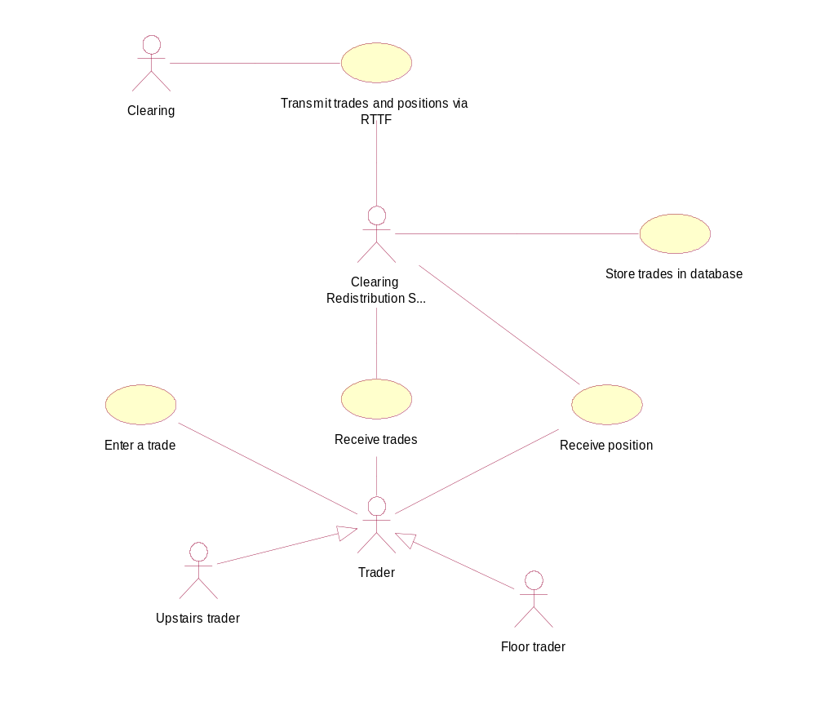
Figure 1. Business use-case model
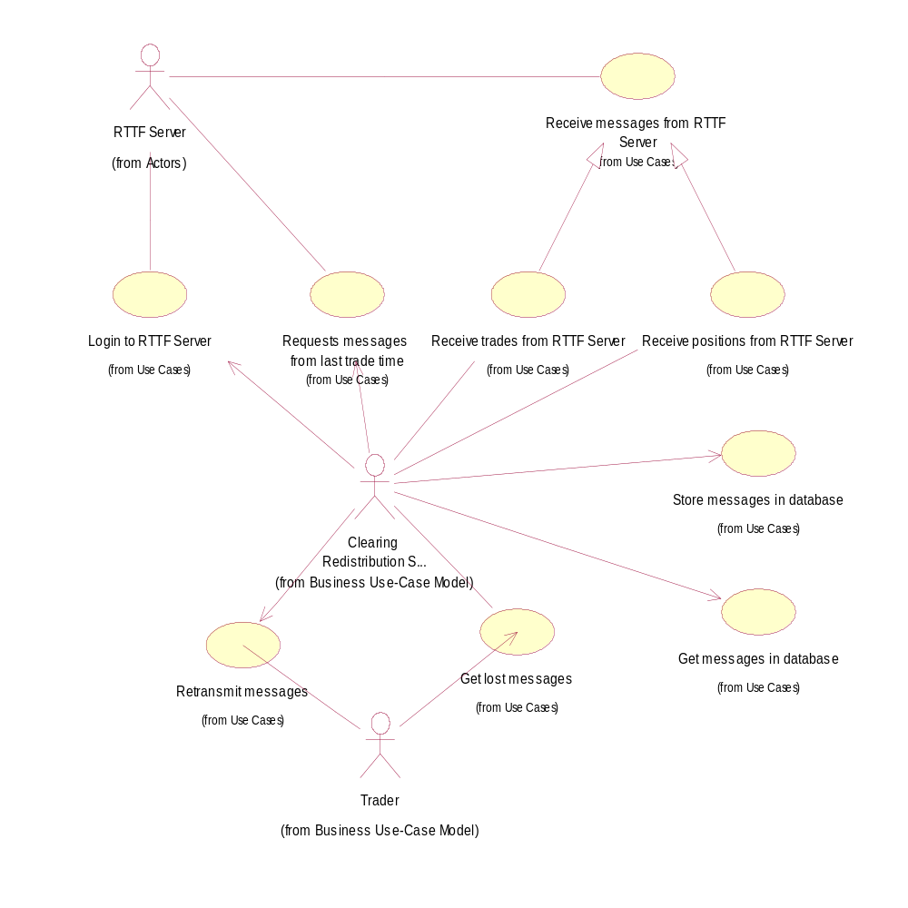
Figure 2. Use-case model
Threading model.
To maximize performance of application and to make it responsible to user requests (such as stop server and others) CDRS has several threads.
Figure 3 shows all the threads of control running in CDRS process.
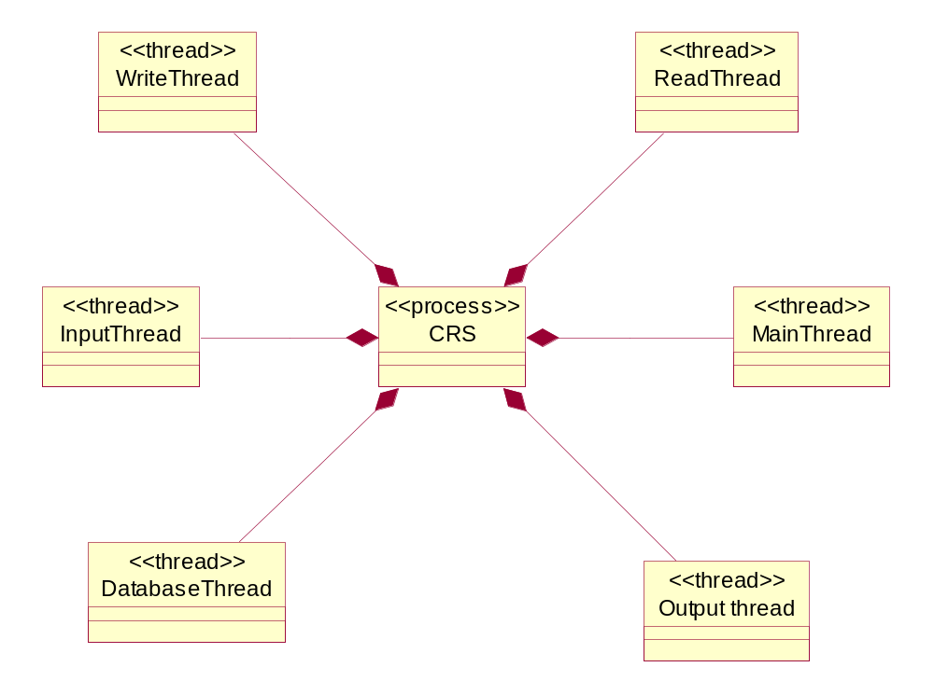
Figure 3. Threads in CDRS process

As recommended in FOC documentation, client of RTTF server should have 4 threads.
Here is a part of FOC specification:
...
A recommended way to process messages is to have four threads:
Thread One takes the message from the Comm Server and
places it in the In Queue
Thread Two takes the message out of the In Queue for
processing by the client application
Thread Three takes the message from the client application and
places it in the Out Queue
Thread Four takes the message from the Out Queue and sends
it to the Comm Server for processing
...
In CDRS these threads are named ReadThread, InputThread, OutputThread and WriteThread correspondingly.
In addition OutputThread watch the connection status and reconnect to FOC server if socket connection is lost.
MainThread is the primary thread of application and, while running, just wait for stop event from user. Another functionality could be placed here to respond on other events from users (for example run-time setup of parameters). After all this thread is for interaction with user.
Database thread is for background flushing of cached data to database server and will be discussed later in this document. This architecture lifts up overall performance of application when intensive interaction with SQL server is needed (this occurs when there are a lot of trades and traders whereas network is overloaded and multicast packets

Trades flow.
Figure 5 shows work of application under normal conditions.
During initialization application gets from database last trade time. This value will be used in request to RTTF server to get trades and position from the beginning of the day (if application is started for the first time of the day) or from the time of getting last trade (in case when the application is started at the same day twice or more times). This value is cached in CdbCache class.
The next step is connection to FOC server and login to FOC and RTTF server. This answer of login request is asynchronous operation.
After successful login CDRS gets value of cached value of last trade and issues request to RTTF server to get trades (and positions if application is run for first time of the day) that could be made while application was not running.
Each trade (and position) then is stored in database (really in database cache that is flushed to database from time to time - see below in this document) and sent to traders using retransmission class (currently realized on IP multicasting).
After sending all the previous trades and positions (they could be send out-of-order) RTTF server sends packet containing original request of CDRS. This indicates that all the trades that fit the request is sent and other real-time trades will be sent in order. For CDRS it is signal to save time of next trades that will come. This will be accomplished by calling ClastTrade::SetDate which in turn will store this value in database cache.
Collaboration between retransmission class, trader and database cache is shown in figure4. This shows the ability of trader to request additional information from CDRS which will be extracted from database cache. This mechanism is needed based on nature of IP mulicast.

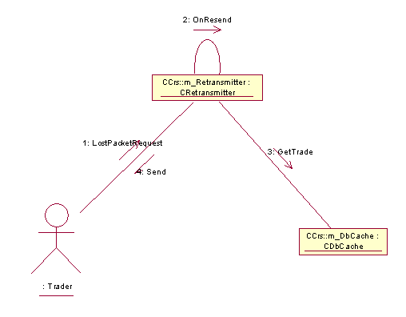

Figure 4. Collaboration between retransmission class, trader and database
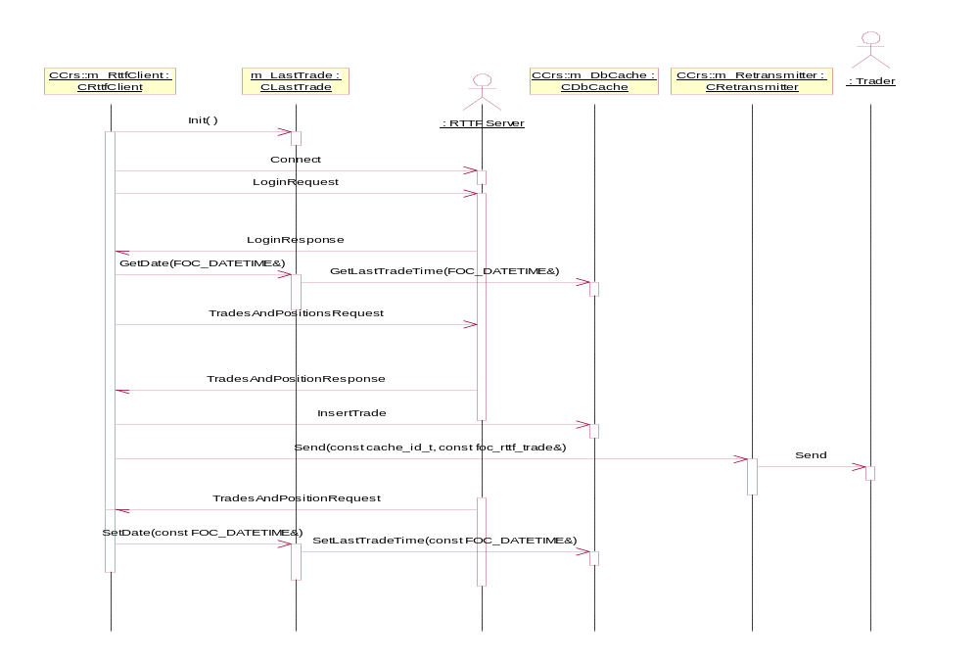

Figure 5. Normal flow
Connection handling.
During normal work of the application several network events can occur that put CDRS into one of states. Normally the application is connected to FOC server that in turn connected to RTTF server and is retransmitting messages from the latter.
Connection errors can occur in CDRS socket that is directly connected to FOC server and between FOC and RTTF server. In the latter case FOC server notifies CDRS with special message.
States of CDRS according to connections are shown in figure 6.
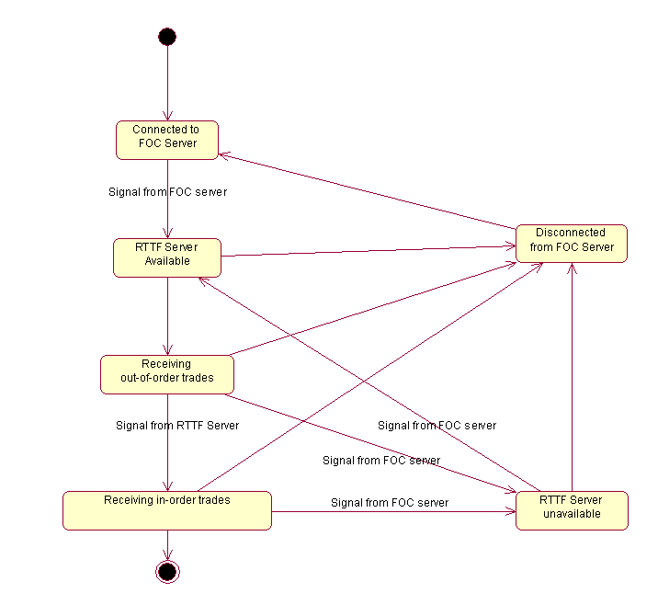
Figure 6. States of CDRS according to connections.
Normal flow of CDRS work is shown at the left of the picture. Application sequentially passes states of connection to FOC server, receiving signal from ROC server that RTTF is available, receiving out-of-order trades and after signal from RTTF server receiving in-order trades.
If a disconnection occurs application finds itself in one of states shown at the right and after reconnection is done repeats states of normal flow.
Database cache.
Database cache is shown in activity diagram in figure 7.
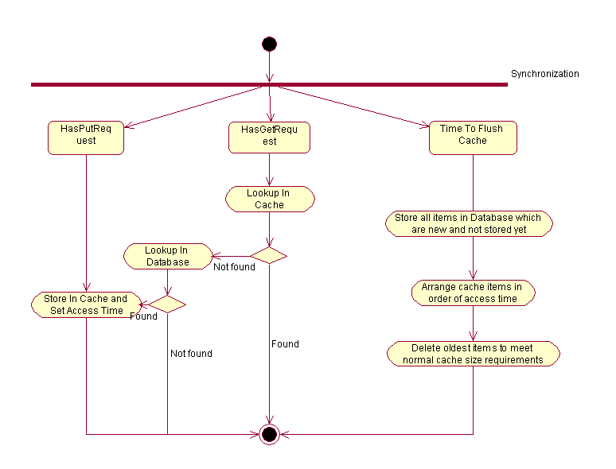Figure 7. Cache control.

Access operation (put and get) is trivial and is not discussed. The only thing to mention is saving last access time for cache item when the letter is put or got from cache.
CDRS has one thread that is responsible for controlling cache size. From time to time it gets processor time and flushes all items that is in memory only to SQL server. After this it deletes oldest items in memory cache until cache is of reasonable size (currently of 90% of max cache size).

