Price providers

Introduction
Different companies produce and sell services which allow clients to receive real-time information about stocks, options, quotes and financial news.

Price feeds give market information in different forms. But application that receives this information should work the same good independently of which price feed it uses. This problem can be solved by means of price providers.

The price providers have the request/response interfaces that allow an application program to query the real-time and fundamental databases maintained by the price feed system.

This document describes the following price providers
- MyTrack
- ATF
- HyperFeed (PCQoute)
- PriceSimulator

All these providers have the same COM interfaces. Thus switching between them can be done easily. Moreover application can be switched from one to another provider in run-time.

At this moment ATF provider is more than other adapted and tested for ETS. Unfortunately, MyTrack has a big restriction (in real-time stuff) for active using in production version of ETS and should be used for the functionality test or Market structure updates

Price Provider’s Structure
Each Price Provider supports the following components:
1) PriceProvider component
2) PriceInfo component
3) StructureProvider component
4) StructureInfo component
also each provider have to support ProviderInfo component, which enable to get provider’s parameters.

Each component has its own set of interfaces. All components with its interfaces are described in the Price Provider components and Interfaces sections. In the section Structure you can find description of the structures which are used for the request forming and getting information. Farther, each price provider is described individually.

The following scheme describes the connection between the components and interfaces.

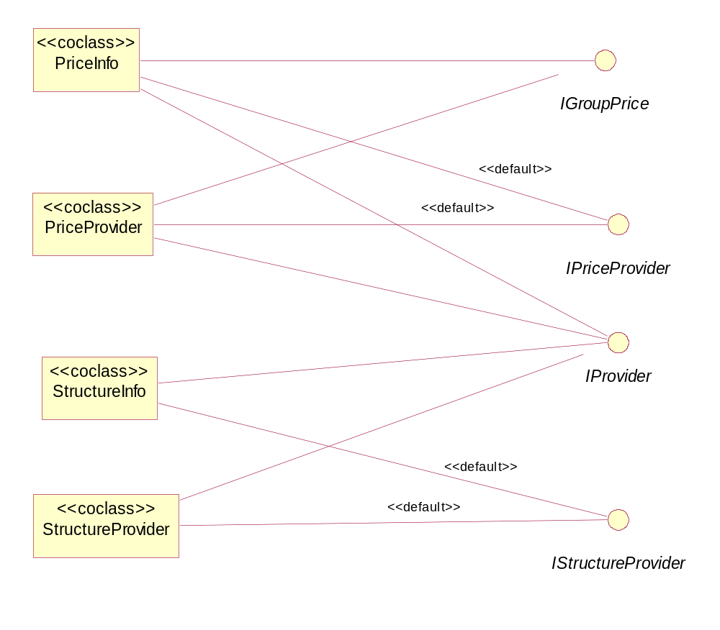

How to initialize the Price Provider
You must register each type of the provider you want to use.
To register the provider you have to add implementation of RegisterServer and UnRegisterServer functions to the ExeModul class.

^^^^^^^^^^^^^^^^^^^^^^^^^^^^^^^^^^^^^^^^^^^^^^^^^^^^^^^^^^^^^^^^^^^^^^^^^^^
HRESULT CExeModule::RegisterServer(BOOL bRegTypeLib, const CLSID* pCLSID)
{
HRESULT hr = CComModule::RegisterServer(bRegTypeLib, pCLSID);
if(SUCCEEDED(hr))
{
CComPtr<ICatRegister> spcr;
hr = spcr.CoCreateInstance(CLSID_StdComponentCategoriesMgr, NULL, CLSCTX_INPROC);
if(SUCCEEDED(hr) && spcr!=NULL)
{
CATEGORYINFO catinfo;
catinfo.catid = CATID_PiceProviders;
catinfo.lcid = 0x0409; // locale=english

USES_CONVERSION; // uses A2W
wcscpy(catinfo.szDescription, A2W("EGAR Price Providers"));
hr = spcr->RegisterCategories(1, &catinfo);
if(SUCCEEDED(hr))
{
CATID catid = CATID_PiceProviders;
LPOLESTR pDaya ;

StringFromCLSID(CLSID_ProviderInfo, &pDaya);
hr = spcr->RegisterClassImplCategories( CLSID_ProviderInfo, 1, &catid);
if(SUCCEEDED(hr))
{
_bstr_t str(_T("SOFTWARE\\Egar\\Providers\\"));
str += pDaya;
eg_reg::CEgRegKey reg;
if(ERROR_SUCCESS==reg.Create(HKEY_LOCAL_MACHINE,(LPCTSTR)str))
{
reg.SetDWORDValue(_T(""),DEF_PROVIDER_ID);
reg.SetStringValue(_T("Name"),W2T(DEF_PROVIDER_NAME));
}
}
::CoTaskMemFree(pDaya);
}
}
}

return hr;
}
^^^^^^^^^^^^^^^^^^^^^^^^^^^^^^^^^^^^^^^^^^^^^^^^^^^^^^^^^^^^^^^^^^^^^^^^^^^^^^^^^^^^^^^^^

HRESULT CExeModule::UnregisterServer(BOOL bUnRegTypeLib, const CLSID* pCLSID)
{
CComPtr<ICatRegister> spcr;
HRESULT hr = spcr.CoCreateInstance(CLSID_StdComponentCategoriesMgr, NULL, CLSCTX_INPROC);
if(SUCCEEDED(hr) && spcr!=NULL)
{
CATID catid = CATID_PiceProviders;
spcr->UnRegisterClassImplCategories( CLSID_ProviderInfo, 1, &catid);
}
return CComModule::UnregisterServer(bUnRegTypeLib, pCLSID);
}

Note: The DEF_PROVIDER_ID and DEF_PROVIDER_NAME constants are defined in the StdAfx.h file and they must be unique for each provider. The constants 0,1,2,3 are already used.

Provider | DEF_PROVIDERR_ID | DEF_PROVIDER_NAME
MyTrack | 0 | ProTrack Price Provider
HyperFeed | 1 | HyperFeed Price Provider
Price Simulator | 2 | TrackData Price Provider (Sim)
ATF | 3 | AT Financial Price

Price Provider components

ProviderInfo

ProviderInfo component supports only one interface –IProviderInfo. IProviderInfo interface includes the methods, which allow to put/get the provider’s properties :
- ProviderID([out, retval] long *pVal);
- Provider([in] ProviderRole type, [out] BSTR* pProgID);
- Description([out, retval] BSTR *pVal);
- IsGroup([out, retval] VARIANT_BOOL *pVal);
- NeedLogin([out, retval] VARIANT_BOOL *pVal);
- UseProxy([out, retval] ProviderUseProxyType* pVal);
- UseProxy([in] ProviderUseProxyType newVal);
- ProxyName([out, retval] BSTR* pVal);
- ProxyName([in] BSTR newVal);
- ProxyPort([out, retval] LONG* pVal);
- ProxyPort([in] LONG newVal);
- UserAccount([out, retval] BSTR* pVal);
- UserAccount([in] BSTR newVal);
- UserPassword([out, retval] BSTR* pVal);
- UserPassword([in] BSTR newVal);
- ProxyAuthorization([out, retval] ProviderProxyAuthType* pVal);
- ProxyAuthorization([in] ProviderProxyAuthType newVal);
- ProxyLogin([out, retval] BSTR* pVal);
- ProxyLogin([in] BSTR newVal);
- ProxyPassword([out, retval] BSTR* pVal);
- ProxyPassword([in] BSTR newVal);

Price Provider component
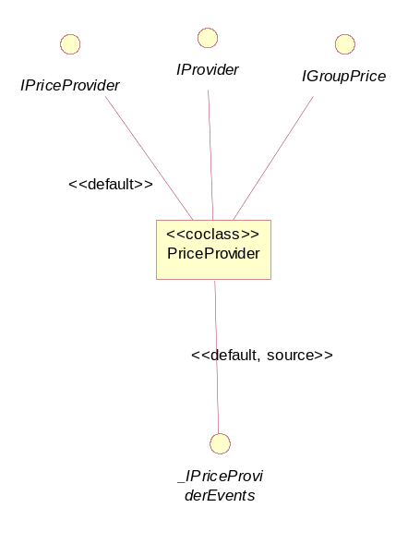
PriceProvider component supports the following interfaces
- IPriceProvider
- IProvider
- IGroupPrice

And source interface
- _IPriceProviderEvents

Note: MyTrack and PriceSimulator
providers don’t support the IGroupPrice interface.

Interface |  | Methods
IPriceProvider |  | - RequestLastQuote  - CancelLastQuote  - SubscribeQuote  - UnSubscribeQuote  - Connect  - Disconnect
IProvider

IGroupPrice |  | - RequestGroup  - CancelGroup  - Connect  - Disconnect
_IPriceProviderEvents |  | - OnLastQuote  - OnQuoteUpdate  - OnError

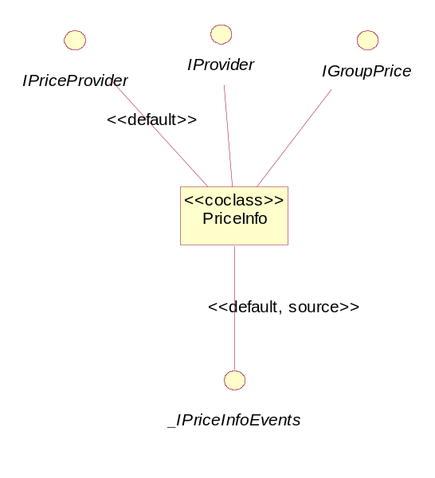
PriceInfo component
The PriceInfo component supports the following interfaces
- IPriceProvider
- IProvider
- IGroupPrice

And Source Interface
- _IPriceInfoEvents

PriceInfo component has request structure equal with PriceProvider component. The difference is in
the Response data. PriceInfo component provides more information for requested symbol.

Note: MyTrack and PriceSimulator
providers don’t support IGroupPrice interface.

Interface |  | Methods
IPriceProvider |  | - RequestLastQuote  - CancelLastQuote  - SubscribeQuote  - UnSubscribeQuote  - Connect  - Disconnect
IProvider

IGroupPrice |  | - RequestGroup  - CancelGroup  - Connect  - Disconnect
_IPriceInfoEvents |  | - OnLastQuote  - OnQuoteUpdate  - OnError

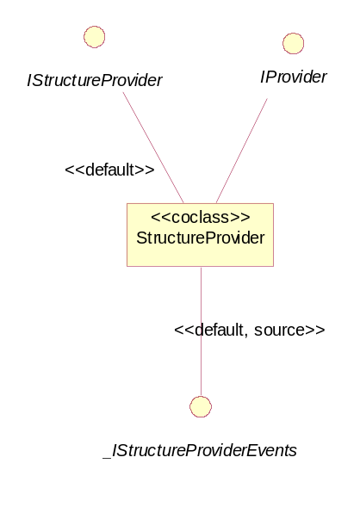
StructureProvider component
The StructureProvider component supports the following interfaces:
- IStructureProvider
- IProvider
- IStructureProvider2

and source Interface
- _IStructureProviderEvents

Interface |  | Methods
IStructureProvider |  | - RequestStock  - CancelStock  - RequestOptions  - CancelOptions  - Connect  - Disconnect
IProvider

_IStructureProviderEvents |  | - OnLastQuote  - OnQuoteUpdate  - OnError  - OnFuture  - OnFutureByRoot  - OnFuturesOption
IStructureProvider2 |  | - RequestFuture  - CancelFuture  - RequestFutures  - CancelFutures  - RequestFuturesOptions  - CancelFuturesOptions

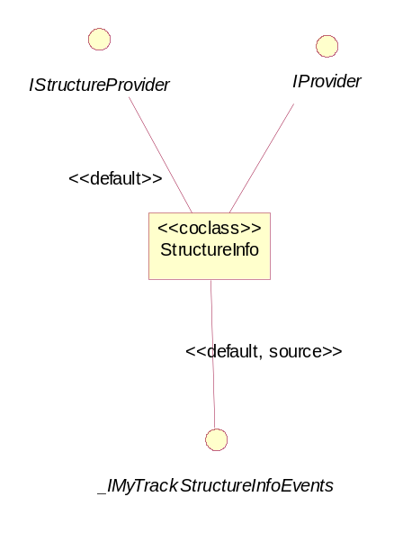

StructureInfo
The StructureInfo component supports the following interfaces

- IStructureProvider
- IProvider

and Source Interface
- _IMyTrackStructureInfoEvents

The PriceInfo component allows to receive more information about stocks and options than the PriceStructure component.
Interface |  | Methods
IStructureProvider |  | - RequestStock  - CancelStock  - RequestOptions  - CancelOptions  - Connect  - Disconnect
IProvider

_IMyTrackStructureInfoEvents |  | - OnStock  - OnOption  - OnError

Interfaces.

IProvider
[object,uuid(16F0F27D-BF1C-4d86-8246-40B2B106A67D),dual,
helpstring("IProvider Interface"),pointer_default(unique)]
interface IProvider : IDispatch
{ [propget, id(1), helpstring("property Type")] HRESULT Type([out, retval] long *pVal);
[propput, id(1), helpstring("property Type")] HRESULT Type([in] long newVal);
};

The methods of the IProvider interface is used to put/get the provider type (DEF_PROVIDER_ID)

IStructureProvider interface
StructureProvider interface is supported by StructureProvider and StructureInfo components. This interface includes following methods
- RequestStock
- CancelStock
- RequestOptions
- CancelOptions
- Connect
- Disconnect

RequestStock
HRESULT RequestStock([in] struct StockParams *Params);

The StockParams structure includes
- Stock name
- Exchange code.

RequestStock method is used for request stock market structure from the exchange. OnStock method returns the market structure for RequestStock query.

For the StructureProvider component OnStock method returns StockResults structure, which includes following information:
- Stock Type
- Dividends frequency
- Dividends last date
- Dividends amount
- Currency (now only USD)
- Description
- Lot size
- Exchange

For the StructureInfo component OnStock method returns StockInfo structure, which includes the same set of fields as in StockResult strucrure and also additional fields in response data:
- Name
- Stock Type
- Dividends frequency
- Dividends amount
- Currency (now only USD)
- Description
- Lot size
- Exchange
- Ask
- Bid
- OpenPrice
- ClosePrice
- High
- Low
- Volume
- CompositeVolume
- CurrentVolume
- LastTradeVolume

CancelStock
HRESULT CancelStock([in,optional] VARIANT Params);

CancelStock method has one optional parameter. The function accepts StockParams structure as input parameter or this parameter could be empty. If CancelStock method has a parameter then it cancels the request of stock market structure for the RequestStock method with the same parameter .If the parameter is missing then this method cancels requests for all stocks.

RequestOptions
HRESULT RequestOptions([in] struct OptionParams *Params);

OptionParams structure includes the Underlying Symbol and the Exchange code.

RequestOption method requests the market structure for the correspondent options from the Exchange. OnOption method is used to return the market structure.

For the StructureProvider component the OnOption method returns the OptionResults structure, which includes the following information:
- Strike price
- Expiration date
- Series
- Option Type
- Currency (now only USD)")
- Lot size
- Exchange

For the StructureInfo component the OnOption method returns the OptionInfo structure, which includes OptionResults information and additional information as:
- Ask
- Bid
- Last
- Open Interest
- Volume
- Yesterday Volume

CancelOptions
HRESULT CancelOptions([in,optional] VARIANT Params);

CancelOptions method has one optional parameter. The function accepts OptionParams structure as input parameter or this parameter could be empty. If the method has a parameter then it cancels the request of the options last quote for RequestOption method with the same parameter.If the parameter is missing then the method cancels the option requests for all symbols and exchanges.

Connect
HRESULT Connect();

This method allows to connect to the provider This method has to be called before any request to price provider

Disconnect
HRESULT Disconnect();

This method is used to disconnect from the provider. This method cancels all open requests and closes price feed connection.

IStructureProvider2 interface

IStructureProvider2 interface is supported by StructureProvider component. This interface includes following methods:
- RequestFuture
- CancelFuture
- RequestFutures
- CancelFutures
- RequestFuturesOptions
- CancelFuturesOptions

RequestFuture
HRESULT RequestFuture([in] struct FutureParams *Params);

FutureParams stucture includes Future symbol.

RequestFuture method requests the market structure for the correspondent futures from the Exchange. OnFuture method is used to return the market structure.

For the StructureProvider component the OnFuture method returns FutureResults structure, which includes:
- Symbol
- Description
- Futures contract size
- Futures option contract size
- Futures expiration date

CancelFuture
HRESULT CancelFuture([in,optional] VARIANT Params);

CancelFuture method has one optional parameter. The function accepts FutureParams structure as input parameter or this parameter could be empty. If CancelFuture method has a parameter then it cancels the request of future market structure for the RequestFuture method with the same parameter .If the parameter is missing then this method cancels requests for all futures

RequestFutures
HRESULT RequestFutures([in] struct FutureRootParams *Params);

FutureRootParams structure includes Base Future Symbol

The RequestFutures method requests market structure for all futures with base future symbol from the Exchange. OnFutureByRoot method is used to return the market structure.

For the StructureProvider component method OnFutureByRoot returns FutureResults structure which includes:
- Symbol
- Description
- Futures contract size
- Futures option contract size
- Futures expiration date

CancelFutures
HRESULT CancelFutures([in,optional] VARIANT Params);

CancelFutures method has one optional parameter. The function accepts FutureRootParams structure as input parameter or this parameter could be empty. If CancelFutures method has a parameter then it cancels the request of all futures with base future symbol last quote for the RequestFutures method with the same parameter. If the parameter is missing then this method cancels requests for all futures with all base future symbols.

RequestFuturesOptions
HRESULT RequestFuturesOptions([in] struct FuturesOptionParams *Params);

FuturesOptionParams structure includes:
- Futures Symbol
- Exchange code

RequestFuturesOptions method requests market structure for the corresponding futures options from the Exchange. OnFuturesOption method is used to return this market structure.

For the StructureProvider component method OnFuturesOption returns structure which includes:
- Strike price
- Expiration date
- Series
- Type
- Lot size

CancelFuturesOptions
HRESULT CancelFuturesOptions([in,optional] VARIANT Params);

CancelFuturesOptions method has one optional parameter. The function accepts FuturesOptionParams structure as input parameter or this parameter could be empty. If the method has a parameter then it cancels the request of the futures option last quote for RequestFuturesOptions method with the same parameter. If the parameter is missing then the method cancels requests for all futures options

IPriceProvider interface
The IPriceProvider interface is supported by the PriceProvider and PriceInfo components.

This interface includes the following methods:
- RequestLastQuote
- CancelLastQuote
- SubscribeQuote
- UnSubscribeQuote
- Connect
- Disconnect

RequestLastQuote
HRESULT RequestLastQuote([in] struct QuoteUpdateParams *Params);

The parameter of this method specifies
- the Symbol name
- the Instrument type
- the Exchange code

The RequestLastQuote method is used for getting last quote from the exchange. The OnLastQuote method returns the market structure for the RequestLastQuote query.

For the PriceProvider component the OnLastQuote method returns the QuoteUpdateResults structure, which provides the following information:
- UpdateDateTime
- SeqNu
- BidPrice
- AskPrice
- BidSize
- AskSize
- Currency
- LotSize
- LastPrice
- OpenInterest
- Volume
- Exchange

For the PriceInfo component the OnLastQuote method returns the QuoteUpdateInfo structure, which provides the following information:
- UpdateDateTime
- SeqNum
- BidPrice
- AskPrice
- BidSize
- AskSize
- Currency
- LotSize
- LastPrice
- OpenInterest
- Volume
- Exchange
- Open Price
- Yesterday Close Price
- day High Price
- day Low Price
- Skipped Items Number
- Total Requests in queue
- Wait time in mSecs
- Net Change

CancelLastQuote
HRESULT CancelLastQuote([in,optional] VARIANT Params);

CancelLastQuote method has one optional parameter. The function accepts StockParams structure as input parameter or this parameter could be empty.
If the CancelLastQuote method has a parameter then it cancels the request of stock market structure for the RequestLastQuote method with the same parameters .

If the parameter is missing then this method cancels all RequestLastQuote query.

SubscribeQuote
HRESULT SubscribeQuote([in] struct QuoteUpdateParams *Params);

The parameter of this method specifies
- the Symbol name
- the Instrument type
- the Exchange code

The SubscribeQuote method is used to subscribe for quotes update from the exchange. The OnQuoteUpdate method returns the market structure for the subscribed symbol.
The OnQuoteUpdate and OnLastQuote methods has equal response data structure

UnSubscribeQuote
HRESULT UnSubscribeQuote([in,optional] VARIANT Params);

If the UnSubscribeQuote method has a parameter then it cancels the subscription for the corresponding symbol. If the parameter is missing then this method cancels subscription for all symbols.

Connect
HRESULT Connect()

This method allows to connect to the provider. This method has to be called before any request to price provider

Disconect
HRESULT Disconnect();

This method is used to disconnect from the provider This method cancels all open requests and closes price feed connection.

IGroupPrice interface
Only the HyperFeed and the ATF providers support the IGroupPrice interface. The MyTrack provider doesn’t support it.

This interface includes the following methods:
- RequestGroup
- CancelGroup
- Connect
- Disconnect

RequestGroup
HRESULT RequestGroup([in] struct QuoteUpdateParams *Params,
[in] GroupRequestType enOperationType);

The RequestGroup method allows to receive Last quotes for options for the individual underlying symbol and/or subscribe to receiving these quotes for the future.

The first parameter specifies the underlying symbol, its type and the exchange code. The second parameter defines one of three possibilities:
- request Last Quote and Subscribe (= -1)
- request Last Quote only (= 0 )
- subscribe Quotes only (= 1)

This method runs as group of the RequestLastQuote and/or the SubscribeQuote queries for each option with correspondent underlying symbol.

CancelGroup
HRESULT CancelGroup([in,optional] VARIANT Params);

If CancelGroup method has a parameter then it cancels the request of the market structure for the group of options with the same parameters. If the parameter is missing then this method cancels requests for all groups.

Connect
HRESULT Connect();

This method opens connection to the provider. This method has to be called before any request to price provider

Disconnect
HRESULT Disconnect();

This method closes price provider connection. This method cancels all open requests and closes price feed connection.

_IPriceProviderEvents interface
This interface is source interface for PriceProvider component. The PriceProvider component’s client should implement it to receive any response data for its requests. The set of functions declared for this interface is described below.
- OnLastQuote
- OnQuoteUpdate
- OnError

OnLastQuote
HRESULT OnLastQuote([in] struct QuoteUpdateParams *Params, [in] struct QuoteUpdateResult *Results);

This method is called by the price provider as a response for RequestLastQuote method request. This methods returns two elements.

Params –pointer to QuoteUpdateParams structure. This structure repeats request data from RequestLastQuote method
Results – pointer to QuoteUpdateResult structure with response for Params request.

If the second parameter for the RequestLastQuote is -1 or 0 then the several OnLastQuote methods are called as a response for RequestLastQuote method. (each OnLastQuote corresponds the one option for the symbol, and last OnLastQuote pointer only Params and has nothing in the results field )

OnQuoteUpdate
HRESULT OnQuoteUpdate([in] struct QuoteUpdateParams *Params, [in] struct QuoteUpdateResult *Results);

This method provides real-time quote updates subscribed by the SubscribeQuote() method. It returns the same information as the OnLastQuote method.

OnError
HRESULT OnError([in] ErrorNumberEnum ErrorNumber, [in] BSTR Description, [in] RequestsTypeEnum ReqType, [in] VARIANT Request);

_IPriceInfoEvents interface

This interface is source interface for PriceInfo component. The PriceInfo component’s client should implement it to receive any response data for its requests.There are three methods in this interface:
- OnLastQuote
- OnQuoteUpdate
- OnError

OnLastQuote

HRESULT OnLastQuote([in] struct QuoteUpdateParams *Params, [in] struct QuoteUpdateInfo *Results);

This method provides the QuoteUpdateInfo requested by the RequestLastQuote()
method. To get more information about the QuoteUpdateInfo structure click here -> QuotesUpdateInfo This methods returns two elements.

Params –pointer to QuoteUpdateParams structure. This structure repeats request data from RequestLastQuote method
Results – pointer to QuoteUpdateInfo structure with response for Params request.

If the second parameter for the RequestLastQuote is -1 or 0 then the several OnLastQuote methods are called as a response for RequestLastQuote method. (each OnLastQuote corresponds the one option for the symbol, and last OnLastQuote pointer only Params and has nothing in the results field )

OnQuoteUpdate

HRESULT OnQuoteUpdate([in] struct QuoteUpdateParams *Params, [in] struct QuoteUpdateInfo *Results);

This method provides the real-time quotes subscribed by the SubscribeQuote() method. It returns the same information as the OnLastQuote method.

OnError

HRESULT OnError([in] ErrorNumberEnum ErrorNumber, [in] BSTR Description, [in] RequestsTypeEnum ReqType, [in] VARIANT Request);

_IStructureProviderEvents interface
This interface is source interface for StructureProvider component. The StructureProvider component’s client should implement it to receive any response data for its requests. The set of functions declared for this interface is described below:
- OnStock
- OnOption
- OnError
- OnFuture
- OnFutureByRoot
- OnFuturesOption

OnStock
HRESULT OnStock([in] struct StockParams *Params, [in] struct StockResults *Results);

This method is called by the price provider as a response for RequestStock query. This methods returns two elements.

Params –pointer to StockParams structure. This structure repeats request data from RequestLastQuote method
Results – pointer to StockResults structure with response for Params request.

OnOption
HRESULT OnOption([in] struct OptionParams *Params, [in] struct OptionResults *Results, [in] VARIANT_BOOL IsLastOption);

The OnOption method provides the OptionResult structure requested by the RequestOptions query.

OnError

HRESULT OnError([in] ErrorNumberEnum ErrorNumber, [in] BSTR Description, [in] RequestsTypeEnum ReqType, [in] VARIANT Request);

OnFuture
HRESULT OnFuture([in] struct FutureParams *Params, [in] struct FutureResults *Results);

The OnFuture method provides the FutureResults structure requested by the RequestFuture method.

OnFutureByRoot
HRESULT OnFutureByRoot([in] struct FutureRootParams *Params, [in] struct FutureResults *Results, [in] VARIANT_BOOL IsLastFutures);

This method is called by the price provider as a response for the RequestFutures method calling. This method returns FutureResults structure. After calling this method value IsLastFuture is checked. In case of false value method is called again.

OnFuturesOption
HRESULT OnFuturesOption([in] struct FuturesOptionParams *Params, [in] struct FuturesOptionResults *Results, [in] VARIANT_BOOL IsLastOption);

This method is called by the price provider as a response on RequestFuturesOptions method calling. Method returns FuturesOptionResults structure. After calling this method value IsLastFuture is checked. In case of false value method is called again.

_IMyTrackStructureInfoEvents interface
This interface is source interface for StructInfo component. The StructInfo component’s client should implement it to receive any response data for its requests. The set of functions declared for this interface is described below:
- OnStock
- OnOption
- OnError

OnStock
HRESULT OnStock([in] struct StockParams *Params, [in] struct StockInfo *Results);

This method provides the information about stock requested by the RequestStock method

OnOption

HRESULT OnOption([in] struct OptionParams *Params, [in] struct OptionInfo *Results, [in] VARIANT_BOOL IsLastOption);

This method provides the information about stock requested by the RequestStock method

OnError

HRESULT OnError([in] ErrorNumberEnum ErrorNumber, [in] BSTR Description, [in] RequestsTypeEnum ReqType, [in] VARIANT Request);

The OnError method is called when an error has occurred accessing the Price database.
It produces code numbers, which correspond to the error and to the type of the request.

Valid values for ErrorNumber and ReqType you can see in the section RequestTypeEnum

Structures

StockParams
[uuid(7F841DD2-C284-4a52-9048-8D8DD0EF5A0A)]
struct StockParams
{
[helpstring("Stock")] BSTR Stock;
[helpstring("Exchange code")] BSTR Exchange;
};

StockInfo
[uuid(E4B58341-79A1-41fd-AE31-8674B997422F)]
struct StockInfo
{
[helpstring("Name")] BSTR Name;
[helpstring("Type")] StockTypeEnum StockType;
[helpstring("Dividends frequency")] long DivFreq;
[helpstring("Dividends last date")] DATE DivLastDate;
[helpstring("Dividends amount")] double DivAmount;
[helpstring("Currency (now only USD)")] BSTR Currency;
[helpstring("Description")] BSTR Description;
[helpstring("Lot size")] long LotSize;
[helpstring("Exchange")] BSTR Exchange;
[helpstring("Ask")] double Ask;
[helpstring("Bid")] double Bid;
[helpstring("OpenPrice")] double OpenPrice;
[helpstring("ClosePrice")] double ClosePrice;
[helpstring("High")] double High;
[helpstring("Low")] double Low;
[helpstring("Volume")] double Volume;
[helpstring("CompositeVolume")] double CompositeVolume;
[helpstring("CurrentVolume")] double CurrentVolume;
[helpstring("LastTradeVolume")] double LastTradeVolume;
};

StockResults

[uuid(3473AAAC-ED10-4737-95BF-CAC4005BFF36)]
struct StockResults
{
[helpstring("Type")] StockTypeEnum StockType;
[helpstring("Dividends frequency")] long DivFreq;
[helpstring("Dividends last date")] DATE DivLastDate;
[helpstring("Dividends amount")] double DivAmount;
[helpstring("Currency (now only USD)")] BSTR Currency;
[helpstring("Description")] BSTR Description;
[helpstring("Lot size")] long LotSize;
[helpstring("Exchange")] BSTR Exchange;
};

OptionParams

[uuid(D761FEFC-BC8A-4c2f-ADFA-938F3C6012F5)]
struct OptionParams
{
[helpstring("Underlying Symbol")] BSTR UnderlyingSymbol;
[helpstring("Exchange code")] BSTR Exchange;
};

OptionInfo

[uuid(8969FCBE-0C47-4678-81D9-2D5823C303E6)]
struct OptionInfo
{
[helpstring("Strike price")] double StrikePrice;
[helpstring("Expiration date")] DATE ExpirationDate;
[helpstring("Series")] BSTR Series;
[helpstring("Type")] OptionTypeEnum OptionType;
[helpstring("Currency (now only USD)")]BSTR Currency;
[helpstring("Lot size")] long LotSize;
[helpstring("Exchange")] BSTR Exchange;
[helpstring("Ask")] double Ask;
[helpstring("Bid")] double Bid;
[helpstring("Last")] double Last;
[helpstring("Open Interest")] long OpenInterest;
[helpstring("Volume")] long Volume;
[helpstring("Yesterday Volume")] long YVolume;

};

OptionResult
[uuid(C330E48F-75D5-4418-A64B-9A559D675589)]
struct OptionResults
{
[helpstring("Strike price")] double StrikePrice;
[helpstring("Expiration date")] DATE ExpirationDate;
[helpstring("Series")] BSTR Series;
[helpstring("Type")] OptionTypeEnum OptionType;
[helpstring("Currency (now only USD)")]BSTR Currency;
[helpstring("Lot size")] long LotSize;
[helpstring("Exchange")] BSTR Exchange;
};

QuoteUpdateParams

[uuid(2BB28A0D-D1EC-4fec-92C5-D3F2D740600D)]
struct QuoteUpdateParams
{
[helpstring("Symbol")] BSTR Symbol;
[helpstring("Instrument type")] InstrumentTypeEnum Type;
[helpstring("Exchange code")] BSTR Exchange;
};

typedef
[uuid(75131B2C-2F08-4bc9-A47E-C93FC5AD4A51),helpstring("Instrument types enum"),v1_enum]
enum InstrumentTypeEnum
{
[helpstring("Stock")] enSTK = 0,
[helpstring("Futures")] enFUT = 1,
enOST = 2,
enOFT = 3,
[helpstring("Index")] enIDX = 4,
[helpstring("Option")] enOPT = 5,
[helpstring("Stock for Group Request")] enGrSTK = 6,
[helpstring("Index for Group Request")] enGrIDX = 7,
[helpstring("Futures Option")] enFOP = 8
} InstrumentTypeEnum;

QuotesUpdateInfo
struct QuoteUpdateInfo
{
[helpstring("UpdateDateTime")] DATE UpdateDateTime;
[helpstring("SeqNum")] long SeqNum;
[helpstring("BidPrice")] double BidPrice;
[helpstring("AskPrice")] double AskPrice;
[helpstring("BidSize")] long BidSize;
[helpstring("AskSize")] long AskSize;
[helpstring("Currency")] BSTR Currency;
[helpstring("LotSize")] long LotSize;
[helpstring("LastPrice")] double LastPrice;
[helpstring("OpenInterest")] double OpenInterest;
[helpstring("Volume")] long Volume;
[helpstring("Exchange")] BSTR Exchange;
[helpstring("Open Price")] double OpenPrice;
[helpstring("Yesterday Close Price")] double ClosePrice;
[helpstring("day High Price")] double HighPrice;
[helpstring("day Low Price")] double LowPrice;
[helpstring("Skipped Items Number")] long Skipped;
[helpstring("Total Requests in queue")] long TotalRequests;
[helpstring("Wait time in mSecs")] long WaitTime;
[helpstring("Net Change")] double NetChange;

};

QuoteUpdateResult
[uuid(11786B12-35BB-4525-914C-41F08D22195D)]
struct QuoteUpdateResult
{
[helpstring("UpdateDateTime")] DATE UpdateDateTime;
[helpstring("SeqNum")] long SeqNum;
[helpstring("BidPrice")] double BidPrice;
[helpstring("AskPrice")] double AskPrice;
[helpstring("BidSize")] long BidSize;
[helpstring("AskSize")] long AskSize;
[helpstring("Currency")] BSTR Currency;
[helpstring("LotSize")] long LotSize;
[helpstring("LastPrice")] double LastPrice;
[helpstring("OpenInterest")] double OpenInterest;
[helpstring("Volume")] long Volume;
[helpstring("Exchange")] BSTR Exchange;
}

ErrorNumberEnum
typedef
[uuid(24C78375-FB1F-4a2c-BC8D-76C834948D63),
helpstring("Error number enum"),v1_enum]

enum ErrorNumberEnum
{
enUnknown = 0,
enNoError = 1,
enSymbolNotSupported = 2,
enNoDataAvailableForSymbol = 3,
enNoAccessForData = 4,
enCouldNotConnectToProvider = 5,
enNotConnected = 6,
enConnectionWasDisconnected = 7,
enInvalidAccount = 8,
enVersionIsNoLongerSupport = 9,
enInternalError = 10,
enProviderInternalError = 11
} ErrorNumberEnum;

RequestTypeEnum
typedef
[uuid(41C621A9-835D-4f0b-A945-4C95AB157967),
helpstring("Request types enum"), v1_enum]
enum RequestsTypeEnum
{
enNoRequest = 0,
enRequestLastQuote = 1,
enSubscribeQuote = 2,
enRequestStock = 3,
enRequestOptions = 4,
enRequestFuture = 5,
enRequestFutures = 6,
enRequestFuturesOptions = 7
} RequestsTypeEnum;

FutureResults
[uuid(A2E9CB47-ED34-4858-A6EB-09B612185F2A)]
struct FutureResults
{
[helpstring("Symbol")] BSTR Symbol;
[helpstring("Description")] BSTR Description;
[helpstring("Futures contract size")] long ContractSize;
[helpstring("Futures option contract size")] long OptionContractSize;
[helpstring("Futures Expiration date")] DATE ExpirationDate;
};

FuturesOptionResults
[uuid(C559CD76-3959-4b70-9EDC-32D827FA35A5)]
struct FuturesOptionResults
{
[helpstring("Strike price")] double StrikePrice;
[helpstring("Expiration date")] DATE ExpirationDate;
[helpstring("Series")] BSTR Series;
[helpstring("Type")] OptionTypeEnum OptionType;
[helpstring("Lot size")] long LotSize;
}

FutureParams
[uuid(C8D7B416-14EB-4749-B7E3-A84BC799843D)]
struct FutureParams
{
[helpstring("Futures Symbol")] BSTR FutureSymbol;
}

FuturesOptionParams
[uuid(F9B7EC70-DEFB-4c41-BE1D-9818F42E8F75)]
struct FuturesOptionParams
{
[helpstring("Futures Symbol")] BSTR FutureSymbol;
[helpstring("Exchange code")] BSTR Exchange;
}

FutureRootParams
[uuid(DD3F6C64-F08A-4c74-B047-9BF300C8C8A6)]
struct
{
[helpstring("Base Futures Symbol")] BSTR FuturesRootSymbol;
}

We considered the common structure for all price providers in the previous section. Farther, we will view each provider separately and examine its differences from other providers.

MyTrack provider
The MyTrack provider allows to subscribe for the real-time quotes no more than for 700 symbols.
The 4 components, which are supported by the MyTrack provider, are named
- IMyTrackPriceProvider
- MyTrackPriceInfo
- MyTrackStructureProvider
- MyTrackStructureInfo

IMyTrackPriceProvider
The IMyTrackPriceProvider component supports the following interfaces
- IPriceProvider
- IMyTrackInfo
- _IPriceProviderEvents

Thus, the IGroupProvider interface isn’t supported .

MyTrackPriceInfo component

The MyTrackPriceInfo component supports two interfaces:
- IPriceProvider
- _IPriceInfoEvents

Thus, the IMyTrackInfo and IGroupProvider interfaces aren’t supported .

MyTrackStructureProvider component

The StructureProvider component supports the following interfaces
- IStructureProvider
- IStructureProvider
- IMyTrackInfo
- _IStructureProviderEvents

MyTrackStructureInfo component
The MyTrackStructureInfo component supports the following interfaces
- IStructureProvider
- IMytrackInfo
- _IMyTrackStructureInfoEvents

ATF provider
ATF provider uses A-T Financial Workstation API to get market data.

Bid/Ask values, Volume and other parameters (except Last Price and Open Interest ) are zero in off-hours (when market is closed) and nonzero when trade day in progress.

The 4 components, which are supported by the ATF provider, are named as
- ATFPriceProvider
- ATFPriceInfo
- ATFStructureProvider
- ATFStructureInfo

ATFPriceProvider component
The ATFPriceProvider component supports the following interfaces
- IPriceProvider
- IGroupPrice
- _IPriceProviderEvents

ATPriceInfo component

The ATFPriceInfo component supports two interfaces:
- IPriceProvider
- IGroupPrice
- _IPriceInfoEvents

ATFStructureProvider component

The ATFStructureProvider component supports the following interfaces
- IStructureProvider
- IStructureProvider2
- _IStructureProviderEvents

ATFStructureInfo
The ATFStructureInfo component supports the following interfaces
- IStructureProvider
- _IMyTrackStructureInfoEvents

Hyper Feed
Market Guide’s extensive fundamental data on approximately 6800 companies is available through Hyper Feed Technologies. The information is both current and historical.

The HyperFeed provider supports the following components:
  - HyperFeedPriceProvider
  - HyperFeedPriceInfo
  - HyperFeedStructureProvider
  - HyperFeedStructureInfo

HyperFeedPriceProvider
The HyperFeedPriceProvider component supports the following interfaces
- IPriceProvider
- IGroupPrice
- _IPriceProviderEvents

HyperFeedPriceInfo component

The HyperFeedPriceInfo component supports three interfaces:
- IPriceProvider
- IGroupPrice
- _IPriceInfoEvents

HyperFeedStructureProvider component

The HyperFeedStructureProvider component supports the following interfaces
- IStructureProvider
- IStructureProvider2
- _IStructureProviderEvents

HyperFeedStructureInfo component
The HyperFeedStructureInfo component supports the following interfaces
- IStructureProvider
- _IMyTrackStructureInfoEvents

ATF and MyTrack performance
This data is approximately data for internal use

Procedure | MyTrack | ATF
Market structure load | 9 stock/min | 9 stock/min
Load Stock Close Prices | 2500 stock/min | 186 stock/min
Load Options Close Prices | 7080 options/min | 840 options/min
Calculate theoretical options close prices | 2160 options/min | 2160 options/min

