**Script usage:**

You’ll have the following files:

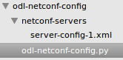

You can add as many server config XMLs as you want, in case you want to configure all NE from centralized location.

You can modify the and of course add additional if needed:

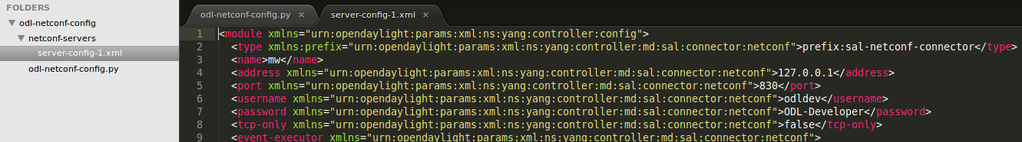

To configure the ODL server credentials, open odl-netconf-config.py and edit the following parameters at the beginning of the file:

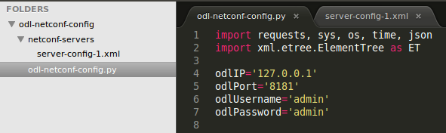

Following are execution examples:

**Add an NE:**

Succeesfully:

cid:image004.png@01D17F9C.0F4A7A60

Failure:

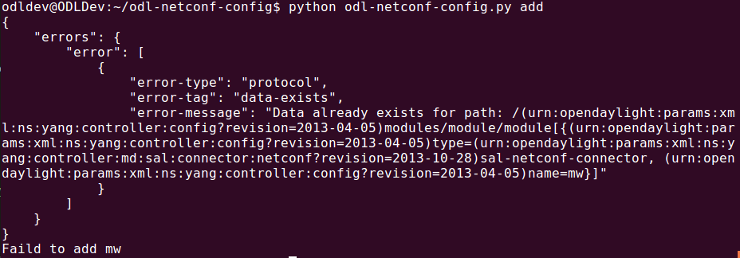

**Delete NE:**

                Successfully:

cid:image006.png@01D17F9C.0F4A7A60

                Failure:

