1. **INTRODUCTION**

**Ising model**

The Ising model is one of the most extensively studied lattice model in physics. It has a lattice of N sites i with a single, two-state dgree of freedom $s_{i}$ on each site with values +1, -1. The Hamiltonian for the Ising model is

$H= -\sum_{<i, j>}{Js_{i}s_{j}}-μH\sum_{i}{s_{i}}$ (1)

The sum <i, j> is over pairs of nearest neighbor sites, and J is coupling between these neighboring sites.

**Monte carlo algorithm**

With the hamiltonian given, we can simulate the magnetization under certain temperature and external magnetic field. This is done with Monte carlo algorithm.

Monte carlo algorithm is an example of Markov chains. In order to use this algorithm, we need to provide the criteria to guarantee that a given system converges to the equilibrium state.

Let the system have finite states. The transition probability $P_{βα}$ is defined as the probability that state changes from $α to β$. If we assume that our system

1. is ergodic[1]
2. is Markovian(no memory)
3. satisfies detailed balance

it is guaranteed that our system converges to an equilibrium which is a unique time-independent probability distribution.

In monte carlo algorithm, we use pseudorandom number to represent a microstate q of equilibrium with probability

$P_{eq}\left(q\right)= \frac{exp⁡(-βE\left(q\right))}{\sum_{q'}{exp⁡(}-βE\left(q^{'}\right))}$ (2)

In other words, we weight the probability of each state with exp(-E/kT). Consider an ensemble which evolve as below

$P\left(q, t+1\right)=P\left(q,t\right)+ \sum_{q^{'}}{P\left(q^{'},t\right)W\left(q^{'}→q\right)- P\left(q,t\right)\sum_{q^{'}}{W\left(q→q^{'}\right)}}$ (3)

If W is ergodic, system is Markovian, and an equilibrium distribution Peq satisfies detailed balance, the ensemble converges to the equilibrium distribution.

$P_{eq}\left(q\right)W\left(q→q^{'}\right)=P_{eq}\left(q^{'}\right)W(q^{'}→q)$ (4)

When combined with (2), (4) becomes

$$W\left(q→q^{'}\right)=\exp\left(-β∆E\right)W\left(q^{'}→q\right) (5)$$

The states chosen from this stochastic process (5) corresponds to a random walk in the equilibrium ensemble. It can be said that after enough iterations, the process converges to an equilibrium distribution and the last state is chosen from random walk in the equilibrium.

Especially, when

$W\left(q→q^{'}\right)=1 if ∆E≤0$

$W\left(q→q^{'}\right)=\exp\left(-β∆E\right) if ∆E>0$

We call this the Metropolis algorithm. This is a branch of Monte carlo algorithm and the most widely used one.

**Approximation**

The 3D ising model is known to be insolvable for its complexity. When we want to analyze it, we try approximations.

Zeroth approximation, also called Bragg-williams approximation, uses long-range order. It assumes that the energy of an individual atom in a system is determined by the average degree of order prevailing in the entire system. It is totally insensitive to the detailed structure, or to the dimensionality of lattice.

We define long range order parameter L.

$L= \frac{1}{N}\sum_{i}{σ_{i}}= \frac{N_{+}-N_{-}}{N}$ (6)

We replace the first part of the Hamiltonian (1) by the expression $-J(\frac{1}{2}q\overline{σ})\sum_{i}{σ_{i}}$ in the sense that each $σ_{j}$ is approximated by the long range order parameter $\overline{σ}$.

From this, we can get the spontaneous magnetization[2]

(7)

When we use the approximation $tanhx ≅x- \frac{x^{3}}{3}$

$\overline{L_{0}}\left(T\right)≅{\left[3\left(1-\frac{T}{T_{c}}\right)\right]}^{\frac{1}{2}}$ (8)

$T_{c}= \frac{qJ}{k}$ (9)

With J = 1.60219e-22 (J), k=1.3806488e-23 (J/ $K^{-1}$),

Tc = 69.6277(K)

In first approximation, also called Bethe approximation, a given spin is regarded as the central member of a group which consists of this spin and its q nearest neighbors. The Hamiltonian of this group considers the interaction between central spin and its q neighbors exactly which is different from zeroth approximation.

$H_{q+1}= -μBσ_{0}-μ\left(B+B^{'}\right)\sum_{j=1}^{q}{σ_{j}}-J\sum_{j=1}^{q}{σ_{0}σ_{j}}$ (10)

(B : external filed , B’: mean molecular field)

With this assumption and after some calculation, we can get[3]

(11)

Note that when q>>1, this reduces to its zeroth-order counterpart. Infinite q means that each spin is influenced by all other neighbors, which is the assumption of zeroth approximation.

$T_{c}=\frac{2J}{k}/ln⁡(\frac{q}{q-2})$ (12)

When q=6, Tc = 57.241(K)

1. **METHODS**

The 3D ising model is simulated via Metropolis algorithm. 1000 x 1000 x 1000 grid is considered and each has its own spin. From (1), we can calculate the energy difference when flipping one spin $s_{i}$.

$∆E=2s_{i}(J*\sum_{j}{s_{j}+ μH)}$ (13)

(sigma is considered for neighboring sites)

In the simulation,

1. Every site is scanned once in one iteration.
2. Checker board scanning is applied
3. Periodic boundary condition is applied

In the simulation, 1000 iterations were good enough to get to the equilibrium. For that reason, we just use 1000 iterations fixed.

Two kinds of experiments are implemented. In the first experiment, we set temperature fixed

(T = 30K), change external magnetic field and get the magnetization by simulation. The magnetic field ranges from 0T ~ 25T ~ -25T ~ 0T. We see if hysteresis is occurred during external field change.

In the second experiment, we change the temperature from 51K ~ 52.4K. This range is believed to be near enough to Tc to use approximation, also far enough from Tc to avoid noise.

We get 50 magnetization data for each temperature. We try zeroth, first approximation to fit the data and find parameters with gradient descent algorithm and Jackknife resampling method. In resampling method, we resampled 49 out of 50 points which makes 50 cases.

In zeroth approximation, we iterated 100,000 times for the cost to converge for each resampled set.

In first approximation, we tried 2 experiments. One with q = 6 fixed, the other with q moving as parameter. For fixed q, 100,000 iterations were enough for it to converge. For moving q, 300,000 iterations were implemented

In gradient descent algorithm, cost function is defined as )[4]. C++ was used for monte carlo simulation, python(Google Colaboratory) was used for fitting function and finding parmaeters.

**III. EXPERIMENT**

**Hysteresis**

T : 30K

B : (0T ~ 25T ~ -25T ~ 0T)

B interval : 0.1T

J (1e-3*1.60219e-19)

mu (9.2741e-24)

kB (1.3806e-23)

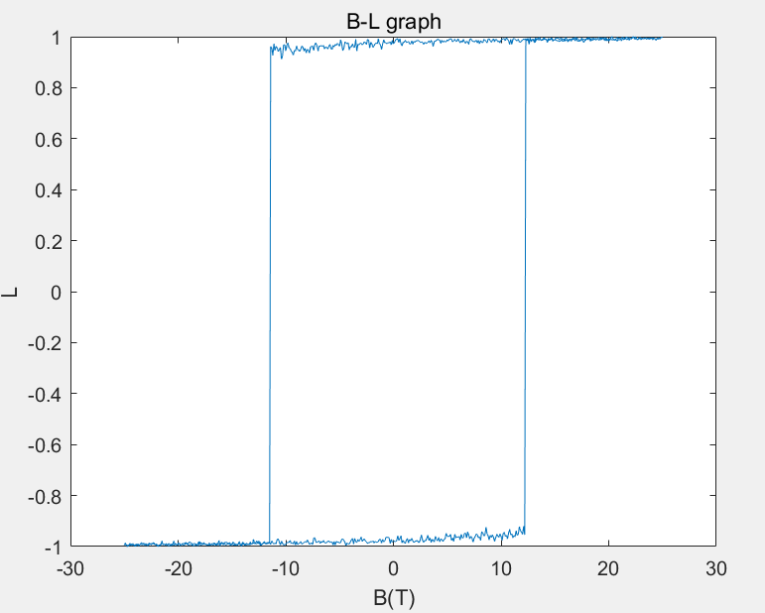

figure Hysteresis

Note that L changes abruptly at around B ~ $±$ 11.4T. Let’s calculate the flipping probability when L is about 1 and B is near -11.4T. By (1),

$dE≅2*\left(6J-11.4μ\right)$ (14)

$P=\exp\left(-\frac{dE}{k_{B}T}\right)$ (15)

When (14) inserted into (15), p = 0.016059. It seems small. However, when one is flipped, it becomes easier for the next one near it to flip since 6 becomes 4 in (14) at this time. This makes kind of chain action making it easier for the next ones to flip. The threshold seems to be around B ~ $±$ 11.4T.

**Approximation**

At first, we need to know roughly where the Curie temperature is located.

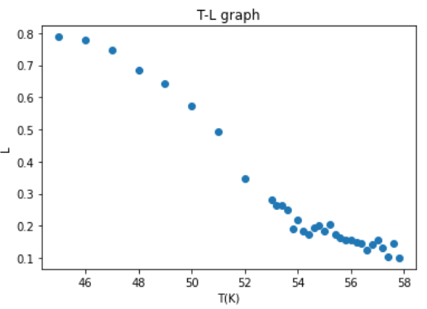

figure T-L graph(rough)

Figure 2 is obtained by averaging 50 data points for each temperature in range 45K ~ 58K.

As seen in figure 2, we can expect that over about 53K, measured data are quite noisy. This noise can affect fitting function badly, so we constrain the range for fitting function to 51K to 52.4K with interval 0.1K.[5]

**Zeroth approximation**

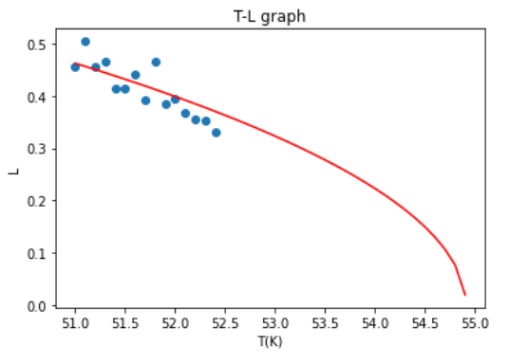

figure zeroth approximation

Fit function :

$\overline{L_{0}}\left(T\right)≅{\left[3\left(1-\frac{T}{Tc}\right)\right]}^{\frac{1}{2}}$

Tc_average : 54.90726598692588

Tc_err : 0.14673343501938452

chi_square/dof : 3.696648053531225

chi/dof_err : 1.3951226017710587

$∆T$ = 14.7204K

In figure 3, the scattered points are obtained by averaging 50 data points for each temperature. Note that fitting function is not calculated with this averaged points. The points are just for visualization.

**First approximation(q as parameter)**

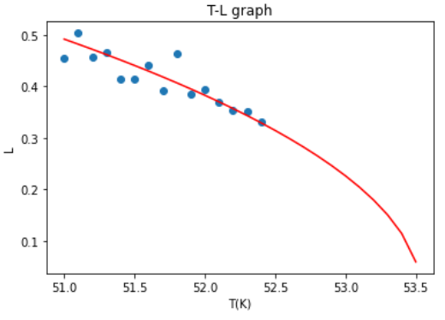

figure first approximation(q move)

Fit function :

$\overline{L_{0}}\left(T\right) ≅ {[theta\left[0\right]*(1-\frac{T}{theta[1]})]}^{1/2}$

theta_average : [ 5.10810816 53.53663584]

theta_err : [0.70943175 0.27939888]

chi_square/dof : 2.476029784547073

chi/dof_err : 1.342887395519544

$∆T$ = 14.1638K

By (10), for theta[0] = 5.10810816, q =4.49054.

When inserted into (12), Tc = 39.3728(K).

This is a lot different from the measured value 53.53663584K ( $∆T$ = 14.1638K).

**First approximation(q = 6)**

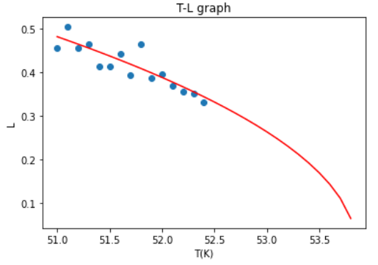

figure first approximation(q=6)

Fit function :

$\overline{L_{0}}\left(T\right)≅{\left[4.37902\left(1-\frac{T}{Tc}\right)\right]}^{\frac{1}{2}}$

Tc_average : 53.85085311461357

Tc_err : 0.09399536420825075

chi_square/dof : 2.4723591210861433

chi/dof_err : 1.2276685225661026

- 3.39K

By (12), theoretical Tc = 57.241K with q=6

( $∆T=$- 3.39K).

chart 1 fitting functions

|  |  |  |  |
| --- | --- | --- | --- |
|  | 0th | 1st(q move) | 1st(q=6) |
| ∆T(K) | 14.7204 | 14.1638 | -3.39 |
| |  | | --- | | χ^2/ $ν$ | | 3.6966 | 2.476 | 2.4724 |
| |  | | --- | | [χ^2/ $ν]$_err | | 1.3951 | 1.3429 | 1.2277 |
| σ (from 1) | 1.9329 | 1.0991 | 1.1993 |

$ν :degree of freedom$

Chart 1 shows a brief summary about fitting functions. All the χ^2/ $ν$ is way above 1. This means the theory(fitting function) might not describe the data well[6].

Actually, this is true because we are using approximations and the data are quite away from respective ‘Tc’s. However, it was inevitable that we chose that data, since above 52.4K there seemed to be some noise which affect fitting process.

Between 0th and 1st, one can see that χ^2/ $ν$ is much higher in 0th. It is likely since zeroth approximate Hamiltonian of system roughly, substituting $-J(\frac{1}{2}q\overline{σ})\sum_{i}{σ_{i}}$ which doesn’t care about individual neighbors. On the other hand, 1st approximation substitutes - $J\sum_{j=1}^{q}{σ_{0}σ_{j}}$ which is more precise.

Between q as parameter and q fixed, ∆T is much smaller in the q fixed model. In our simulation, the number of neighbors are fixed to 6. We can easily expect that setting q as parameter is likely to fall into errors. In q as parameter model, we get q=4.49054. This value is weird since we have at least 6 neighbors for each spin. Therefore, It makes sense that fixed q model best describes the data. However, the calculated values seem to fluctuate according to which range to investigate(i.e. 51K ~ 52.4K), or how many samples we extract(i.e. 50 points for each temperature), etc. For that reason, it needs more experiments to conclude that fixed q model best fit the data.

**IV. CONCLUSIONS**

In the first experiment, we could see hysteresis in magnetization of 3D ising model when changing external magnetic field. This was because that the initial configuration affects significantly on the monte carlo simulation thereby magnetization affected by its history.

In the second experiment, we could compare three kinds of approximations. Among them, 1stapproximation with fixed q model seems to fit the data best. However, we need more experiments changing the range, sample numbers, etc.

Since all these are approximations, they have fundamental limits in describing the data. It is known that there is a better model for describing the 3D ising model suggested in [4]. Further experiments should include fitting data to this model and compare with 0th, 1st appxoimations.

**REFERENCES**

[1] James P. Sethna, “Entropy, Order Parammeters, and complexity”, Oxford University Press.

[2] Pathria, R.K., “Statistical Mechanics”, Academic Press, 2011.

[3] Boram Yun, “Taste Non-Goldstone Pion Decay Constants and Beyond the Standard Model B-parameters in Lattice QCD with Staggered Fermions”, Seoul National University, 2013.

[4] E.Z. Meilikhov, “Curie Temperature for Small World Ising Systems of Different Dimensions”, Jornal of Magnetism and Magnetic Materials, 2006.

Python code : <https://github.com/djflstkddk/Chi_square-minimization>

1. A finite-state Markov chain is ergodic if it doesn’t have cycles and it is irreducible. Here, our definition of ergodicity corresponds to a transition matrix P for which some power $P^{n}$ has all positive matrix elements([1], 169p).
2. [2] 422p
3. [2] 430p
4. [3] 105p. .
5. Choosing the data range is a tricky problem. When too low, the approximation would not work. When too close to Tc, noise comes in play, interrupting fitting process.
6. [3] 107p.