2023-2024学年秋季学期第十七周（6.5-6.11）周报

——钟郑健

1. 机器学习判断带噪自混合信号方向仿真

通过上周提出的设想，本周进行了仿真验证，方案在仿真和实验上都取得了不错的效果。如下图为20db噪声下，算法对自混合信号特征点的提取。

整个仿真的流程：（1）通过带噪自混合信号的自相关序列，计算出平均峰值距离，该距离为估算值，为保证不遗漏特征点，利用MPD/2的间距进行遍历。（2）zero-crossing，所有大于0的值全部去除（3）average && variance, 计算剩余所有谷值的平均值，然后计算出所有估值距离该平均值的距离均值，去除所有大于该距离均值的点（4）MDP judge，以MDP为间距，在MDP间距的点，保留较小的那个，由于该值并非准确值，为避免误差，将该间距扩大一些，增加算法的鲁棒性，即MPD/1.25作为间距。1.25为尝试出的经验值。

依照上述流程，进行了算法有效性仿真验证，表格如下

|  |  |  |  |  |  |  |  |  |  |  |  |
| --- | --- | --- | --- | --- | --- | --- | --- | --- | --- | --- | --- |
| SNR(db)（db）  C | 0.1 | 0.3 | 0.6 | 0.9 | 1.2 | 1.5 | 1.8 | 2.1 | 2.4 | 2.7 | 3 |
| 30 | ✔ | ✔ | ✔ | ✔ | ✔ | ✔ | ✔ | ✔ | ✔ | ✔ | × |
| 25 | ✔ | ✔ | ✔ | ✔ | ✔ | ✔ | ✔ | ✔ | ✔ | ✔ | × |
| 20 | ✔ | ✔ | ✔ | ✔ | ✔ | ✔ | ✔ | ✔ | ✔ | ✔ | ✔ |
| 15 | ✔ | ✔ | ✔ | ✔ | ✔ | × | ✔ | ✔ | ✔ | ✔ | × |
| 10 | ✔ | ✔ | ✔ | × | × | × | ✔ | × | × | × | × |

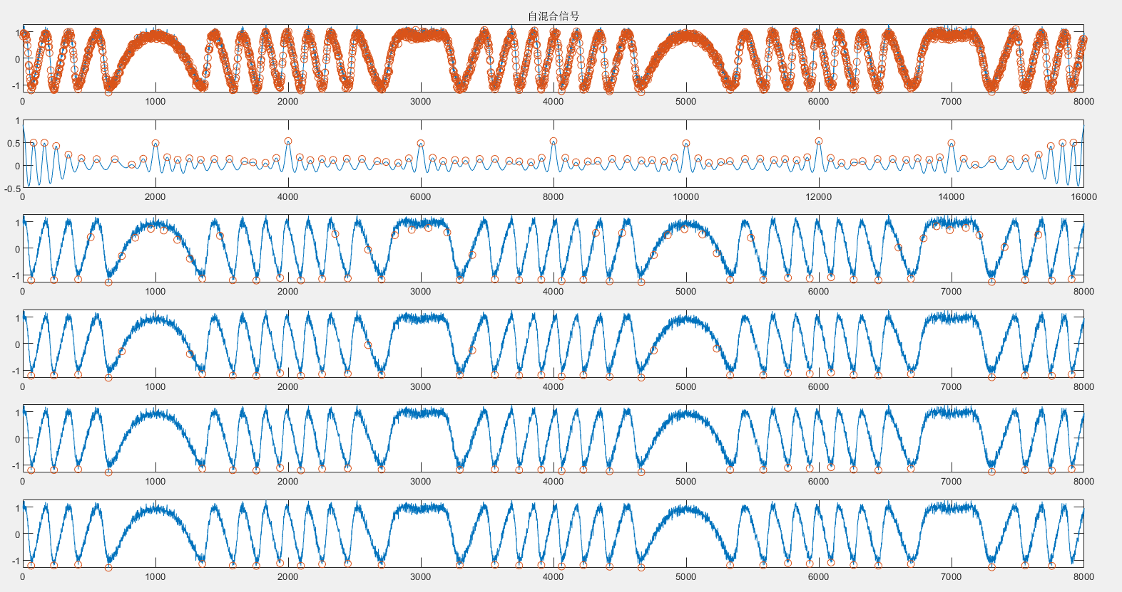

1. 算法对实验信号验证

看出算法对实验信号的验证也同样有效。

