How to find your firmware version?

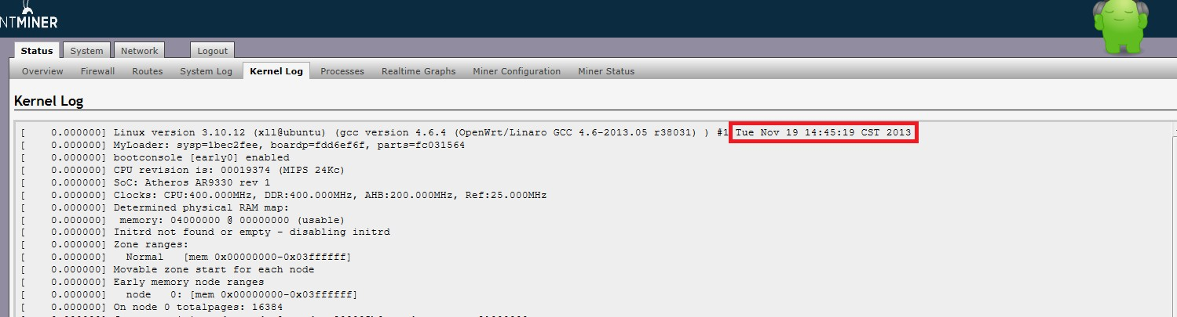

antMiner_openwrt20131119.bin

* Initial Version for the first Batch of AntMiner.

antMiner_openwrt20131129.bin

* Correct the fan speed status
* Change the LAN interface as DHCP client by default, and it can’t conflict with WAN of 192.168.1.x
* Add the loader for PIC MCU. Note: You’re the firmware version of your AntMiner is “Nov 19 2013”, the firmware of PIC MCU can’t be upgraded, but the firmware of openwrt can be upgraded, and it is wok.
* Remove lowmem parameter for cgminer
* Revise the bug of ASIC status checking.
* Clear job buffer when new block arrived.
* Increase the sound of beep when the AntMiner disconnect from Ethernet.

antMiner_openwrt20131212.bin

* Discard the stale nonce when new block is found.
* The default IP is change to 192.168.1.99