Lab10

## 1.) Starting from file Lab_09.RScript, try to run yourself what you saw in “Matrix_03” the primer session.

# Identity Matrix

I1 <- diag(1)  
I1

## [,1]  
## [1,] 1

I2 <- diag(2)  
I2

## [,1] [,2]  
## [1,] 1 0  
## [2,] 0 1

A <- matrix(1:4, nrow=2, ncol = 2)  
A

## [,1] [,2]  
## [1,] 1 3  
## [2,] 2 4

AI<- A%*%I2  
AI

## [,1] [,2]  
## [1,] 1 3  
## [2,] 2 4

# Symmetric Matric

S <- cbind(c(1,2,3),c(2,1,4), c(3,4,3))  
S

## [,1] [,2] [,3]  
## [1,] 1 2 3  
## [2,] 2 1 4  
## [3,] 3 4 3

trS <- t(S)  
trS

## [,1] [,2] [,3]  
## [1,] 1 2 3  
## [2,] 2 1 4  
## [3,] 3 4 3

# Basic properties

X<- cbind(c(1,2), c(3,4), c(5,6))  
Y <- cbind(c(7,8), c(9,10), c(11,12))  
X+Y

## [,1] [,2] [,3]  
## [1,] 8 12 16  
## [2,] 10 14 18

Z <- cbind(c(1,2), c(3,4))  
W <- cbind(c(5,6), c(8,8))  
ZW1 <- Z%*%W  
ZW2 <- W%*%Z  
ZW1

## [,1] [,2]  
## [1,] 23 32  
## [2,] 34 48

ZW2

## [,1] [,2]  
## [1,] 21 47  
## [2,] 22 50

trZW1 <- t(ZW1)  
trZ <- t(Z)  
trW <- t(W)  
trWtrZ <- trW%*%trZ  
trZW1

## [,1] [,2]  
## [1,] 23 34  
## [2,] 32 48

trWtrZ

## [,1] [,2]  
## [1,] 23 34  
## [2,] 32 48

trtrZ <- t(trZ)  
trtrZ

## [,1] [,2]  
## [1,] 1 3  
## [2,] 2 4

Z

## [,1] [,2]  
## [1,] 1 3  
## [2,] 2 4

# Inverse matrix

C <- matrix(c(1,0,3,1), nrow=2, ncol = 2)  
C

## [,1] [,2]  
## [1,] 1 3  
## [2,] 0 1

invC <- solve(C)  
invC

## [,1] [,2]  
## [1,] 1 -3  
## [2,] 0 1

CinvC <- C%*%invC  
CinvC

## [,1] [,2]  
## [1,] 1 0  
## [2,] 0 1

## 2.) Using the file Lab02_mkm_Econometrics1_RodBased_DataHandling,

# a. read dt.wages ad apply ‘data.table’

## Setup

setwd("C:/Users/22700/Desktop")  
library(GGally)

## Loading required package: ggplot2

## Registered S3 method overwritten by 'GGally':  
## method from   
## +.gg ggplot2

library(ggplot2)  
library(stargazer)

##   
## Please cite as:

## Hlavac, Marek (2018). stargazer: Well-Formatted Regression and Summary Statistics Tables.

## R package version 5.2.2. https://CRAN.R-project.org/package=stargazer

library(data.table)  
load("dt_wages(2).RData")

# b. get basic summary statistics. How many observations, how many variables?

dt.wages <- data.table(dt.wages)  
stargazer(dt.wages, type = "text")

##   
## ==============================================================  
## Statistic N Mean St. Dev. Min Pctl(25) Pctl(75) Max   
## --------------------------------------------------------------  
## wage 526 5.896 3.693 0.530 3.330 6.880 24.980  
## educ 526 12.563 2.769 0 12 14 18   
## exper 526 17.017 13.572 1 5 26 51   
## tenure 526 5.105 7.224 0 0 7 44   
## nonwhite 526 0.103 0.304 0 0 0 1   
## female 526 0.479 0.500 0 0 1 1   
## married 526 0.608 0.489 0 0 1 1   
## numdep 526 1.044 1.262 0 0 2 6   
## smsa 526 0.722 0.448 0 0 1 1   
## northcen 526 0.251 0.434 0 0 0.8 1   
## south 526 0.356 0.479 0 0 1 1   
## west 526 0.169 0.375 0 0 0 1   
## construc 526 0.046 0.209 0 0 0 1   
## ndurman 526 0.114 0.318 0 0 0 1   
## trcommpu 526 0.044 0.205 0 0 0 1   
## trade 526 0.287 0.453 0 0 1 1   
## services 526 0.101 0.301 0 0 0 1   
## profserv 526 0.259 0.438 0 0 1 1   
## profocc 526 0.367 0.482 0 0 1 1   
## clerocc 526 0.167 0.374 0 0 0 1   
## servocc 526 0.141 0.348 0 0 0 1   
## lwage 526 1.623 0.532 -0.635 1.203 1.929 3.218   
## expersq 526 473.435 616.045 1 25 676 2,601   
## tenursq 526 78.150 199.435 0 0 49 1,936   
## --------------------------------------------------------------

ncol(dt.wages)

## [1] 24

table(dt.wages[, list(female, nonwhite)])

## nonwhite  
## female 0 1  
## 0 245 29  
## 1 227 25

table(dt.wages[, list(female, nonwhite, south)])

## , , south = 0  
##   
## nonwhite  
## female 0 1  
## 0 158 13  
## 1 154 14  
##   
## , , south = 1  
##   
## nonwhite  
## female 0 1  
## 0 87 16  
## 1 73 11

# 526 observations and 24

# c. reproduce the data-handling steps shown in the slides (and dt.wages).

qplot(factor(educ),data=dt.wages,geom="bar")

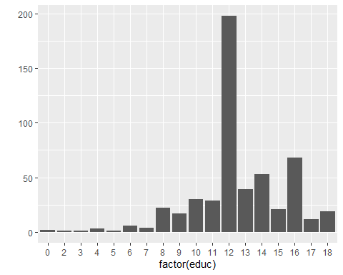

qplot(x=factor(1),fill=factor(educ),data=dt.wages,geom="bar") + coord_polar(theta="y")

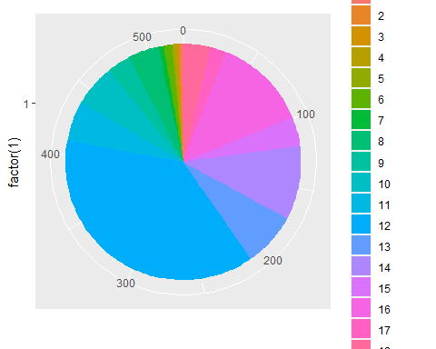

qplot(wage,data=dt.wages,geom="histogram")

## `stat_bin()` using `bins = 30`. Pick better value with `binwidth`.

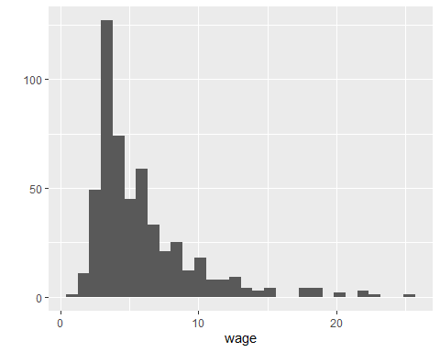

qplot(wage,data=dt.wages,geom="histogram",binwidth=2)

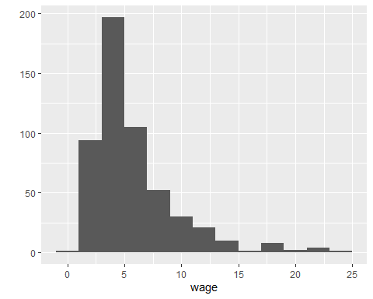

qplot(x=factor("All"),y=wage,data=dt.wages,geom="boxplot")

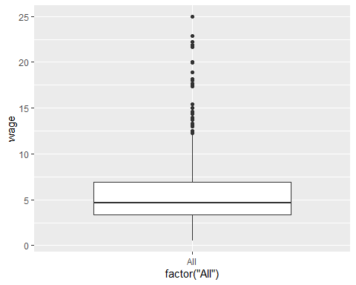

qplot(factor(female),wage,data=dt.wages,geom="boxplot")

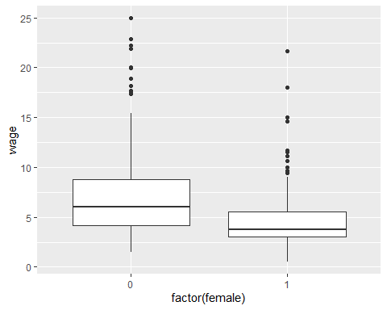

qplot(factor(female),wage,fill=factor(nonwhite),data=dt.wages,geom="boxplot")

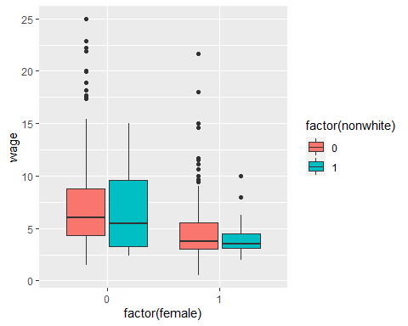

qplot(factor(nonwhite),wage,fill=factor(female),data=dt.wages,geom="boxplot")

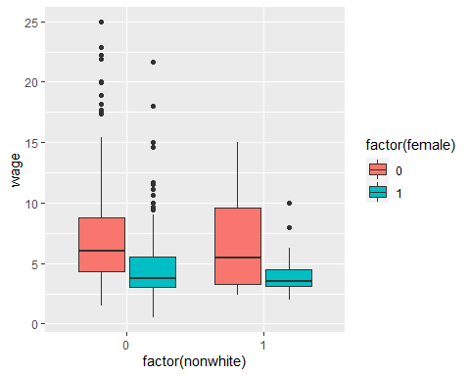

ggplot(dt.wages)+geom_boxplot(aes(factor(educ),exper))

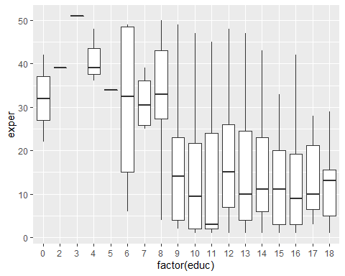

qplot(educ,wage,data=dt.wages,geom="point")

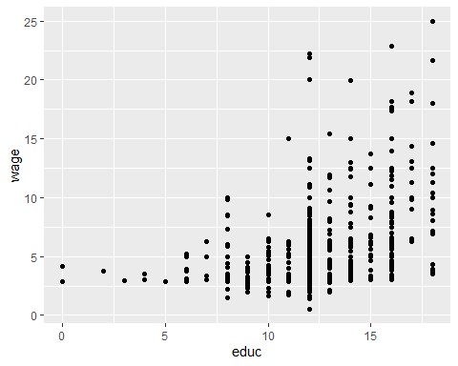

qplot(educ,wage,color=factor(female),data=dt.wages,geom="point")

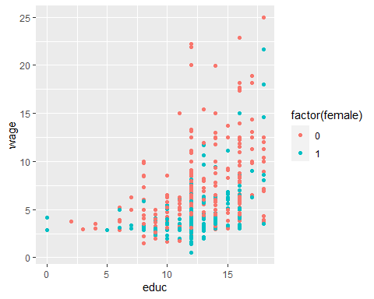

ggplot(dt.wages)+geom_point(aes(educ,wage))+facet_grid(~female)

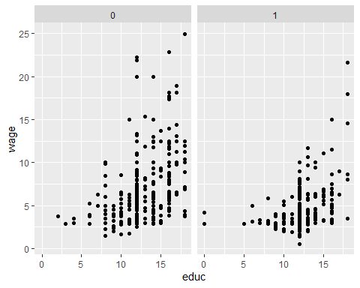

ggplot(dt.wages)+geom_point(aes(educ,wage))+facet_grid(nonwhite~female)

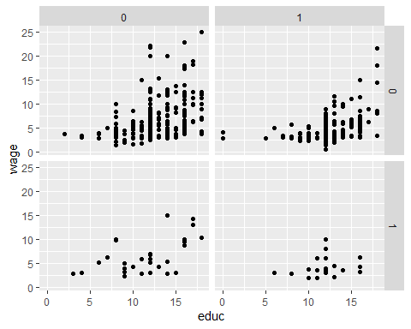

ggplot(dt.wages)+geom_point(aes(educ,wage))+facet_grid(nonwhite~female, margins=TRUE)

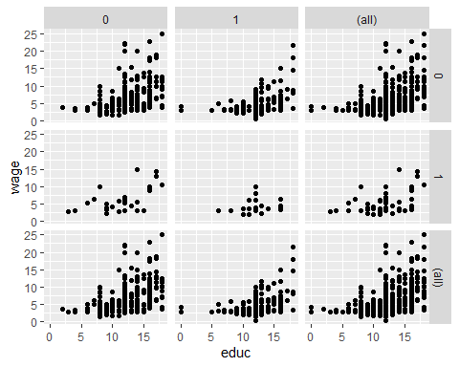

ggpairs(dt.wages[,list(wage,educ,exper)])

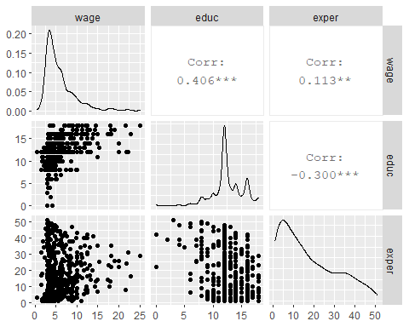

ggpairs(dt.wages[,list(female=factor(female),nonwhite=factor(nonwhite))])

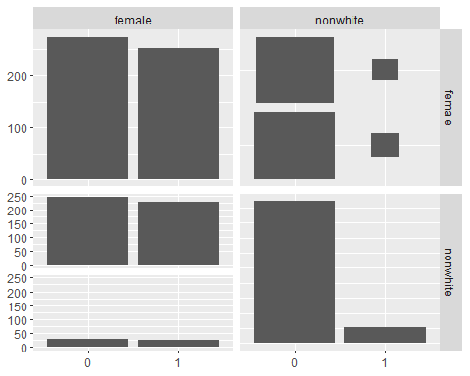

ggpairs(dt.wages[,list(wage,educ,exper,female=factor(female),nonwhite=factor(nonwhite))])

## `stat_bin()` using `bins = 30`. Pick better value with `binwidth`.  
## `stat_bin()` using `bins = 30`. Pick better value with `binwidth`.  
## `stat_bin()` using `bins = 30`. Pick better value with `binwidth`.  
## `stat_bin()` using `bins = 30`. Pick better value with `binwidth`.  
## `stat_bin()` using `bins = 30`. Pick better value with `binwidth`.  
## `stat_bin()` using `bins = 30`. Pick better value with `binwidth`.

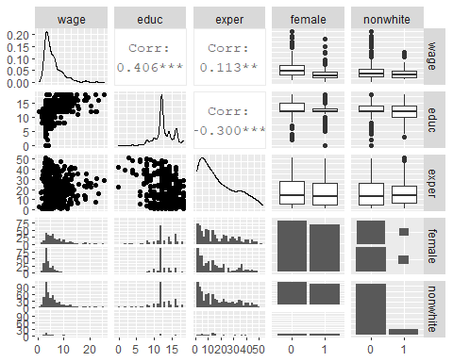

dt.wages[wage>20,][order(-wage)]

## wage educ exper tenure nonwhite female married numdep smsa northcen south  
## 1: 24.98 18 29 25 0 0 1 0 1 0 0  
## 2: 22.86 16 16 7 0 0 1 2 1 0 0  
## 3: 22.20 12 31 15 0 0 1 1 1 0 0  
## 4: 21.86 12 24 16 0 0 1 3 1 1 0  
## 5: 21.63 18 8 8 0 1 0 0 1 0 0  
## west construc ndurman trcommpu trade services profserv profocc clerocc  
## 1: 0 0 0 0 0 0 0 1 0  
## 2: 0 0 0 0 0 0 0 1 0  
## 3: 1 0 0 0 0 0 0 1 0  
## 4: 0 0 0 0 1 0 0 1 0  
## 5: 0 0 0 0 0 0 1 1 0  
## servocc lwage expersq tenursq  
## 1: 0 3.218076 841 625  
## 2: 0 3.129389 256 49  
## 3: 0 3.100092 961 225  
## 4: 0 3.084659 576 256  
## 5: 0 3.074081 64 64

qplot(lwage,data=dt.wages,geom="histogram")

## `stat_bin()` using `bins = 30`. Pick better value with `binwidth`.

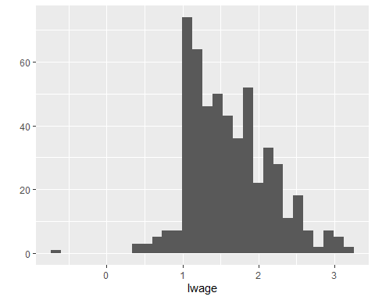

dt.wages[lwage< 0,]

## wage educ exper tenure nonwhite female married numdep smsa northcen south  
## 1: 0.53 12 3 1 0 1 0 0 1 0 0  
## west construc ndurman trcommpu trade services profserv profocc clerocc  
## 1: 1 0 0 0 0 1 0 0 0  
## servocc lwage expersq tenursq  
## 1: 1 -0.6348783 9 1

## 3.) Let’s do a thought experiment: Using the slide-deck UEA_ecoR2PhD CoreLect_06 ATENT_Match _Stk and dt.wages, let’s pretend, for a moment “south,” is a randomly assigned treatment in an experiment.:

# a. Compute a difference-in-means estimator when treatment is “south,” and the outcome is wage.

dt.wages[south==1, mean(wage)] - dt.wages[south==0, mean(wage)]

## [1] -0.7900927

#Mean wage of treated (south=1) - mean wage of untreated (south=0) with second term as approximation for counterfactual.

## b.Now focus on race and gender as control variables (in “x”) and run a regression estimation of treatment effects

reg1 <- lm(wage ~ south + nonwhite + female, data=dt.wages)  
stargazer(reg1, type = "text")

##   
## ===============================================  
## Dependent variable:   
## ---------------------------  
## wage   
## -----------------------------------------------  
## south -0.884***   
## (0.317)   
##   
## nonwhite -0.372   
## (0.499)   
##   
## female -2.552***   
## (0.302)   
##   
## Constant 7.471***   
## (0.243)   
##   
## -----------------------------------------------  
## Observations 526   
## R2 0.130   
## Adjusted R2 0.125   
## Residual Std. Error 3.454 (df = 522)   
## F Statistic 26.104*** (df = 3; 522)   
## ===============================================  
## Note: *p<0.1; **p<0.05; ***p<0.01

## c.Now try to estimate the regression and account for potentially heterogeneous treatment effects.

reg2 <- lm(wage ~ south + nonwhite + female + nonwhite*south + female*south, data=dt.wages)  
stargazer(reg2, type = "text")

##   
## ===============================================  
## Dependent variable:   
## ---------------------------  
## wage   
## -----------------------------------------------  
## south -1.288***   
## (0.447)   
##   
## nonwhite 0.155   
## (0.691)   
##   
## female -2.953***   
## (0.374)   
##   
## south:nonwhite -1.047   
## (0.996)   
##   
## south:female 1.117*   
## (0.630)   
##   
## Constant 7.628***   
## (0.269)   
##   
## -----------------------------------------------  
## Observations 526   
## R2 0.138   
## Adjusted R2 0.129   
## Residual Std. Error 3.446 (df = 520)   
## F Statistic 16.591*** (df = 5; 520)   
## ===============================================  
## Note: *p<0.1; **p<0.05; ***p<0.01

# We have assumed that the treatment effect is homogeneous. In other words, for each individual receiving treatment, the effect of treatment on outcome variables is the same. In this case, the difference between ATE and ATET is very small.

#Assuming that the treatment effect is actually a heterogeneous may be reasonable, therefore, we can add interaction terms between covariates and treatment dummies.

## d.Try to implement a 2-step fitted regression.

south.yes <- subset(dt.wages, south==1)  
south.no <- subset(dt.wages, south==0)  
reg3.1 <- lm(wage ~ nonwhite + female, data=south.yes)  
reg3.2 <- lm(wage ~ nonwhite + female, data=south.no)  
stargazer(reg3.1, reg3.2, type = "text")

##   
## ==================================================================  
## Dependent variable:   
## ----------------------------------------------  
## wage   
## (1) (2)   
## ------------------------------------------------------------------  
## nonwhite -0.892 0.155   
## (0.617) (0.739)   
##   
## female -1.836*** -2.953***   
## (0.436) (0.400)   
##   
## Constant 6.341*** 7.628***   
## (0.307) (0.287)   
##   
## ------------------------------------------------------------------  
## Observations 187 339   
## R2 0.096 0.139   
## Adjusted R2 0.086 0.134   
## Residual Std. Error 2.963 (df = 184) 3.684 (df = 336)   
## F Statistic 9.724*** (df = 2; 184) 27.234*** (df = 2; 336)  
## ==================================================================  
## Note: *p<0.1; **p<0.05; ***p<0.01

dt.wages$y_hat1 <- predict(reg3.1, newdata=dt.wages)  
dt.wages$y_hat0 <- predict(reg3.2, newdata=dt.wages)