Lab 11

## Setup

setwd("C:/Users/22700/Desktop")  
library(data.table)  
library(sandwich)  
library(lmtest)

## Loading required package: zoo

##   
## Attaching package: 'zoo'

## The following objects are masked from 'package:base':  
##   
## as.Date, as.Date.numeric

library(stargazer)

##   
## Please cite as:

## Hlavac, Marek (2018). stargazer: Well-Formatted Regression and Summary Statistics Tables.

## R package version 5.2.2. https://CRAN.R-project.org/package=stargazer

library(ivreg)

## Start with a baseline case from the OVB setting x1, x2 exogeneous.

set.seed(4277)  
x1 <- rnorm(n = 10000, mean = 0 , sd = 3) # create indep. var. 1  
x2 <- rnorm(n = 10000, mean = 0, sd = 4) # create indep. var. 2  
e <- rnorm(n = 10000, mean = 0, sd = 2) # create error  
y <- 2 + 3*x1 + 4*x2 + e # create y according to population model  
  
dt.population <- data.table( y, x1, x2) # creates tables  
dt.population # shows first and last entries of table

## y x1 x2  
## 1: 12.401338 1.9844728 1.4053179  
## 2: -11.889186 3.7137845 -5.9413408  
## 3: 4.365025 -0.6991152 0.8303615  
## 4: 11.837367 2.2627657 1.2572999  
## 5: 2.337068 -1.0545575 1.6133591  
## ---   
## 9996: 6.755700 1.9278786 -1.1874514  
## 9997: 5.838727 2.2457932 -0.1343287  
## 9998: 11.815592 -3.2612595 4.9666709  
## 9999: -18.862087 -0.1292216 -4.4368980  
## 10000: -27.867727 0.8692147 -8.2597914

## Sumary

summary(lm( y ~ x1 + x2, data = dt.population))

##   
## Call:  
## lm(formula = y ~ x1 + x2, data = dt.population)  
##   
## Residuals:  
## Min 1Q Median 3Q Max   
## -8.2536 -1.3495 -0.0108 1.3556 7.0088   
##   
## Coefficients:  
## Estimate Std. Error t value Pr(>|t|)   
## (Intercept) 2.005304 0.020110 99.72 <2e-16 ***  
## x1 3.001855 0.006793 441.88 <2e-16 ***  
## x2 4.002453 0.005050 792.49 <2e-16 ***  
## ---  
## Signif. codes: 0 '***' 0.001 '**' 0.01 '*' 0.05 '.' 0.1 ' ' 1  
##   
## Residual standard error: 2.011 on 9997 degrees of freedom  
## Multiple R-squared: 0.9879, Adjusted R-squared: 0.9879   
## F-statistic: 4.088e+05 on 2 and 9997 DF, p-value: < 2.2e-16

out.y.exog <- lm ( y ~ x1 + x2, data = dt.population) # exog model

## Endogeneous x2

set.seed(1984)  
x1 <- rnorm(n = 1000, mean = 0 , sd = 3) # create indep. var. 1  
x2a <- rnorm(n = 1000, mean = 0 , sd = 3) # create indep. var. 2 - exogeneous part  
x2e <- rnorm(n = 1000, mean = 0 , sd = 2) # create indep. var. 2 - endogeneous  
x2 <- x2a/2+x2e/2  
e <- rnorm(n = 1000, mean = -0.5*x2e , sd = 1.5) # create error  
y <- 2 + 3*x1 + 4*x2 + e # create y according to population model  
plot(e,x2)

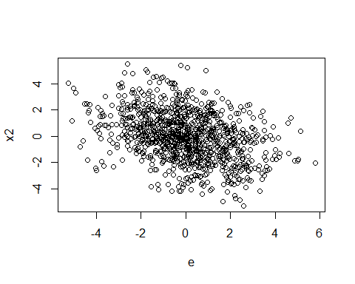

cor.test(x = e, y = x2)

##   
## Pearson's product-moment correlation  
##   
## data: e and x2  
## t = -11.985, df = 998, p-value < 2.2e-16  
## alternative hypothesis: true correlation is not equal to 0  
## 95 percent confidence interval:  
## -0.4077273 -0.2992877  
## sample estimates:  
## cor   
## -0.3546997

dt.pop_endog <- data.table( y, x1, x2) # creates tables  
dt.pop_endog # shows first and last entries of table

## y x1 x2  
## 1: 9.981591 1.2276096 1.3713718  
## 2: -3.418851 -0.9690749 -0.2620121  
## 3: 24.469697 1.9075570 4.7766393  
## 4: -12.091278 -5.5383864 -0.2358250  
## 5: 11.432291 2.8609421 0.8747513  
## ---   
## 996: 14.727192 -0.4964207 3.3344319  
## 997: -22.060201 -6.6921619 -1.2330451  
## 998: -12.214681 -0.2673038 -4.1800850  
## 999: -14.223519 0.3725925 -4.1837752  
## 1000: -18.675992 -3.2856529 -3.2938290

summary(out.y.endog <- lm ( y ~ x1 + x2, data = dt.pop_endog)) # endog model

##   
## Call:  
## lm(formula = y ~ x1 + x2, data = dt.pop_endog)  
##   
## Residuals:  
## Min 1Q Median 3Q Max   
## -4.9917 -1.1129 -0.0328 1.1617 5.2514   
##   
## Coefficients:  
## Estimate Std. Error t value Pr(>|t|)   
## (Intercept) 2.00010 0.05363 37.29 <2e-16 ***  
## x1 2.99067 0.01805 165.70 <2e-16 ***  
## x2 3.64955 0.02924 124.82 <2e-16 ***  
## ---  
## Signif. codes: 0 '***' 0.001 '**' 0.01 '*' 0.05 '.' 0.1 ' ' 1  
##   
## Residual standard error: 1.695 on 997 degrees of freedom  
## Multiple R-squared: 0.977, Adjusted R-squared: 0.977   
## F-statistic: 2.122e+04 on 2 and 997 DF, p-value: < 2.2e-16

## now let’s “find” instruments

z1a <- rnorm(n = 1000, mean = 0.01*x2a , sd = 2.5) # create weak instrument z1 (Assumption iv.2 essentially violated - irrelevant)  
z1b <- rnorm(n = 1000, mean = 0.8*x2a , sd = 0.4) # create instrument z1  
z1c <- rnorm(n = 1000, mean = 0.6*x2a + 0.5*e, sd = 1.5) # create invalid instrument z1 (assumption iv.1 violated (exogeneity))

## Look at instruments – which one should we pick?

plot(z1a,x2)

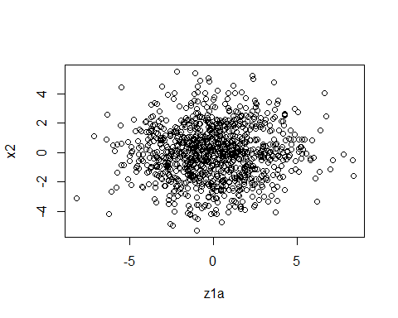

cor.test(x = z1a, y = x2)

##   
## Pearson's product-moment correlation  
##   
## data: z1a and x2  
## t = 1.1882, df = 998, p-value = 0.235  
## alternative hypothesis: true correlation is not equal to 0  
## 95 percent confidence interval:  
## -0.02446539 0.09934630  
## sample estimates:  
## cor   
## 0.03758469

plot(z1b,x2)

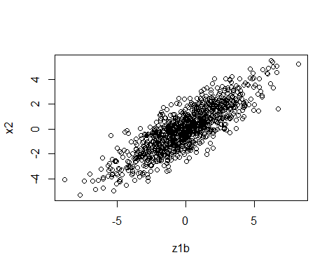

cor.test(x = z1b, y = x2)

##   
## Pearson's product-moment correlation  
##   
## data: z1b and x2  
## t = 47.963, df = 998, p-value < 2.2e-16  
## alternative hypothesis: true correlation is not equal to 0  
## 95 percent confidence interval:  
## 0.8153441 0.8529589  
## sample estimates:  
## cor   
## 0.8351252

plot(z1c,x2)

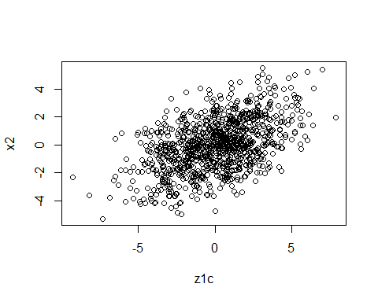

cor.test(x = z1c, y = x2)

##   
## Pearson's product-moment correlation  
##   
## data: z1c and x2  
## t = 17.665, df = 998, p-value < 2.2e-16  
## alternative hypothesis: true correlation is not equal to 0  
## 95 percent confidence interval:  
## 0.4393520 0.5338918  
## sample estimates:  
## cor   
## 0.4880521

## Pick an instrument

z1 <- z1b  
dt.pop_iv <- data.table( y, x1, x2, z1a, z1b, z1c, z1) # creates tables  
dt.pop_iv # shows first and last entries of table

## y x1 x2 z1a z1b z1c  
## 1: 9.981591 1.2276096 1.3713718 1.3734095 2.4232192 1.2647867  
## 2: -3.418851 -0.9690749 -0.2620121 -2.7023805 -2.3929315 -0.8412701  
## 3: 24.469697 1.9075570 4.7766393 3.6059072 5.5835248 4.7619418  
## 4: -12.091278 -5.5383864 -0.2358250 0.5968377 0.9554054 1.2672254  
## 5: 11.432291 2.8609421 0.8747513 5.4673154 -1.4771862 -3.1022598  
## ---   
## 996: 14.727192 -0.4964207 3.3344319 0.7151472 6.3572836 5.5261265  
## 997: -22.060201 -6.6921619 -1.2330451 0.4277337 -1.0941705 1.4792455  
## 998: -12.214681 -0.2673038 -4.1800850 0.1984577 -4.8240764 -2.3064216  
## 999: -14.223519 0.3725925 -4.1837752 -6.2832838 -6.7416969 -4.5420373  
## 1000: -18.675992 -3.2856529 -3.2938290 1.0796213 -2.0979788 -1.3086252  
## z1  
## 1: 2.4232192  
## 2: -2.3929315  
## 3: 5.5835248  
## 4: 0.9554054  
## 5: -1.4771862  
## ---   
## 996: 6.3572836  
## 997: -1.0941705  
## 998: -4.8240764  
## 999: -6.7416969  
## 1000: -2.0979788

## IV on foot (as in the slides)

cov(z1, x2)

## [1] 3.781434

cov(z1, y)

## [1] 14.61454

Den = cov(z1, x2)  
Num = cov(z1, y)  
  
iv_foot = Num/Den   
iv_foot

## [1] 3.864814

#Note that this is not fully accurate, because I would have to use the multivariate estimator.  
  
## Now the 2SLS iv:  
out1st <- lm(x2 ~ z1, data= dt.pop_iv )  
summary(out1st)

##   
## Call:  
## lm(formula = x2 ~ z1, data = dt.pop_iv)  
##   
## Residuals:  
## Min 1Q Median 3Q Max   
## -3.04995 -0.67196 -0.02271 0.69466 2.81068   
##   
## Coefficients:  
## Estimate Std. Error t value Pr(>|t|)   
## (Intercept) 0.02077 0.03192 0.651 0.515   
## z1 0.62029 0.01293 47.963 <2e-16 ***  
## ---  
## Signif. codes: 0 '***' 0.001 '**' 0.01 '*' 0.05 '.' 0.1 ' ' 1  
##   
## Residual standard error: 1.009 on 998 degrees of freedom  
## Multiple R-squared: 0.6974, Adjusted R-squared: 0.6971   
## F-statistic: 2300 on 1 and 998 DF, p-value: < 2.2e-16

dt.pop_iv <- dt.pop_iv[, x2hat:=predict(out1st, newdata=dt.pop_iv)]  
dt.pop_iv  
out2nd <- lm(y ~x1 + x2hat, data= dt.pop_iv )  
summary(out2nd)

##   
## Call:  
## lm(formula = y ~ x1 + x2hat, data = dt.pop_iv)  
##   
## Residuals:  
## Min 1Q Median 3Q Max   
## -10.2953 -2.3599 0.0788 2.2710 10.3341   
##   
## Coefficients:  
## Estimate Std. Error t value Pr(>|t|)   
## (Intercept) 1.99889 0.10785 18.53 <2e-16 ***  
## x1 2.97736 0.03629 82.03 <2e-16 ***  
## x2hat 3.92115 0.07040 55.70 <2e-16 ***  
## ---  
## Signif. codes: 0 '***' 0.001 '**' 0.01 '*' 0.05 '.' 0.1 ' ' 1  
##   
## Residual standard error: 3.408 on 997 degrees of freedom  
## Multiple R-squared: 0.9072, Adjusted R-squared: 0.907   
## F-statistic: 4872 on 2 and 997 DF, p-value: < 2.2e-16

stargazer(out1st, out2nd, type="text")

##   
## =========================================================================  
## Dependent variable:   
## -----------------------------------------------------  
## x2 y   
## (1) (2)   
## -------------------------------------------------------------------------  
## z1 0.620***   
## (0.013)   
##   
## x1 2.977***   
## (0.036)   
##   
## x2hat 3.921***   
## (0.070)   
##   
## Constant 0.021 1.999***   
## (0.032) (0.108)   
##   
## -------------------------------------------------------------------------  
## Observations 1,000 1,000   
## R2 0.697 0.907   
## Adjusted R2 0.697 0.907   
## Residual Std. Error 1.009 (df = 998) 3.408 (df = 997)   
## F Statistic 2,300.456*** (df = 1; 998) 4,871.727*** (df = 2; 997)  
## =========================================================================  
## Note: *p<0.1; **p<0.05; ***p<0.01

# R has this inbuilt as well  
ivB <- ivreg(y~x1+x2|x1+ z1, data=dt.pop_iv)  
summary(ivB)

##   
## Call:  
## ivreg(formula = y ~ x1 + x2 | x1 + z1, data = dt.pop_iv)  
##   
## Residuals:  
## Min 1Q Median 3Q Max   
## -4.95908 -1.15003 -0.01343 1.19775 5.61397   
##   
## Coefficients:  
## Estimate Std. Error t value Pr(>|t|)   
## (Intercept) 2.00080 0.05591 35.79 <2e-16 ***  
## x1 2.99313 0.01882 159.07 <2e-16 ***  
## x2 3.92144 0.03650 107.44 <2e-16 ***  
##   
## Diagnostic tests:  
## df1 df2 statistic p-value   
## Weak instruments 1 997 2297.9 <2e-16 ***  
## Wu-Hausman 1 996 248.9 <2e-16 ***  
## Sargan 0 NA NA NA   
## ---  
## Signif. codes: 0 '***' 0.001 '**' 0.01 '*' 0.05 '.' 0.1 ' ' 1  
##   
## Residual standard error: 1.766 on 997 degrees of freedom  
## Multiple R-Squared: 0.9751, Adjusted R-squared: 0.975   
## Wald test: 1.813e+04 on 2 and 997 DF, p-value: < 2.2e-16

stargazer(out1st, out2nd, ivB, type="text")

##   
## ==========================================================================================  
## Dependent variable:   
## ----------------------------------------------------------------------  
## x2 y   
## OLS OLS instrumental   
## variable   
## (1) (2) (3)   
## ------------------------------------------------------------------------------------------  
## z1 0.620***   
## (0.013)   
##   
## x1 2.977*** 2.993***   
## (0.036) (0.019)   
##   
## x2hat 3.921***   
## (0.070)   
##   
## x2 3.921***   
## (0.036)   
##   
## Constant 0.021 1.999*** 2.001***   
## (0.032) (0.108) (0.056)   
##   
## ------------------------------------------------------------------------------------------  
## Observations 1,000 1,000 1,000   
## R2 0.697 0.907 0.975   
## Adjusted R2 0.697 0.907 0.975   
## Residual Std. Error 1.009 (df = 998) 3.408 (df = 997) 1.766 (df = 997)  
## F Statistic 2,300.456*** (df = 1; 998) 4,871.727*** (df = 2; 997)   
## ==========================================================================================  
## Note: *p<0.1; **p<0.05; ***p<0.01

# if you compare the 2sls and the R-Routine it is exactly identical.   
  
  
# Let's take a look at the other 2 candidates:   
  
# Weak IV is much worse  
iv_weak <- ivreg(y~x1+x2| x1+ z1c, data=dt.pop_iv)  
stargazer(out1st, out2nd, iv_weak, type="text")

##   
## ==========================================================================================  
## Dependent variable:   
## ----------------------------------------------------------------------  
## x2 y   
## OLS OLS instrumental   
## variable   
## (1) (2) (3)   
## ------------------------------------------------------------------------------------------  
## z1 0.620***   
## (0.013)   
##   
## x1 2.977*** 3.000***   
## (0.036) (0.026)   
##   
## x2hat 3.921***   
## (0.070)   
##   
## x2 4.629***   
## (0.087)   
##   
## Constant 0.021 1.999*** 2.003***   
## (0.032) (0.108) (0.078)   
##   
## ------------------------------------------------------------------------------------------  
## Observations 1,000 1,000 1,000   
## R2 0.697 0.907 0.951   
## Adjusted R2 0.697 0.907 0.951   
## Residual Std. Error 1.009 (df = 998) 3.408 (df = 997) 2.471 (df = 997)  
## F Statistic 2,300.456*** (df = 1; 998) 4,871.727*** (df = 2; 997)   
## ==========================================================================================  
## Note: *p<0.1; **p<0.05; ***p<0.01

# Endogeneous IV is even worse  
iv_wrong <- ivreg(y~x1+x2| x1+ z1a, data=dt.pop_iv)  
stargazer(out1st, out2nd, iv_wrong, type="text")

##   
## ==========================================================================================  
## Dependent variable:   
## ----------------------------------------------------------------------  
## x2 y   
## OLS OLS instrumental   
## variable   
## (1) (2) (3)   
## ------------------------------------------------------------------------------------------  
## z1 0.620***   
## (0.013)   
##   
## x1 2.977*** 2.982***   
## (0.036) (0.027)   
##   
## x2hat 3.921***   
## (0.070)   
##   
## x2 2.726**   
## (1.090)   
##   
## Constant 0.021 1.999*** 1.998***   
## (0.032) (0.108) (0.076)   
##   
## ------------------------------------------------------------------------------------------  
## Observations 1,000 1,000 1,000   
## R2 0.697 0.907 0.954   
## Adjusted R2 0.697 0.907 0.954   
## Residual Std. Error 1.009 (df = 998) 3.408 (df = 997) 2.396 (df = 997)  
## F Statistic 2,300.456*** (df = 1; 998) 4,871.727*** (df = 2; 997)   
## ==========================================================================================  
## Note: *p<0.1; **p<0.05; ***p<0.01

# IV does a good job (even though not perfect) at correcting the bias, when you get it exactly right.   
  
# However, weak IV and endogeneous IV can induce a bias that is worse than no correction.   
  
# Outlook: Example for an overidentified IV -- would require more time to properly cover.   
iv_over <- ivreg(y~x1+x2| x1+ z1 + z1a + z1c, data=dt.pop_iv)  
stargazer(out1st, out2nd, iv_over, type="text")

##   
## ==========================================================================================  
## Dependent variable:   
## ----------------------------------------------------------------------  
## x2 y   
## OLS OLS instrumental   
## variable   
## (1) (2) (3)   
## ------------------------------------------------------------------------------------------  
## z1 0.620***   
## (0.013)   
##   
## x1 2.977*** 2.992***   
## (0.036) (0.018)   
##   
## x2hat 3.921***   
## (0.070)   
##   
## x2 3.815***   
## (0.035)   
##   
## Constant 0.021 1.999*** 2.001***   
## (0.032) (0.108) (0.054)   
##   
## ------------------------------------------------------------------------------------------  
## Observations 1,000 1,000 1,000   
## R2 0.697 0.907 0.976   
## Adjusted R2 0.697 0.907 0.976   
## Residual Std. Error 1.009 (df = 998) 3.408 (df = 997) 1.722 (df = 997)  
## F Statistic 2,300.456*** (df = 1; 998) 4,871.727*** (df = 2; 997)   
## ==========================================================================================  
## Note: *p<0.1; **p<0.05; ***p<0.01