Weekend Homework

## Setup

setwd("C:/Users/22700/Desktop")

## Packages

library(GGally)

## Loading required package: ggplot2

## Registered S3 method overwritten by 'GGally':  
## method from   
## +.gg ggplot2

library(ggplot2)  
library(stargazer)

##   
## Please cite as:

## Hlavac, Marek (2018). stargazer: Well-Formatted Regression and Summary Statistics Tables.

## R package version 5.2.2. https://CRAN.R-project.org/package=stargazer

library(data.table)

## The slides show several distributions: binomial, Poisson, normal, Chi Squared, F, and the tdistribution. Choose at least 3 distributions Try to simulate data (e.g. 5000 draws) from a Random Variable that follows this distribution.

set.seed(1)  
A <- rnorm(5000)  
set.seed(2)  
B <- rbinom(5000, 100, 0.25)  
set.seed(3)  
C <- rpois(5000, 10)

## Draw two samples from each variable and report the sample means. Are they equal?

set.seed(4)  
A1 <- sample(A, size = 100)  
set.seed(5)  
A2 <- sample(A, size = 100)  
mean.A1 <- mean(A1)  
mean.A2 <- mean(A2)  
mean.A1

## [1] -0.01210893

mean.A2

## [1] -0.3066046

set.seed(6)  
B1 <- sample(B, size = 100)  
set.seed(7)  
B2 <- sample(B, size = 100)  
mean.B1 <- mean(B1)  
mean.B2 <- mean(B2)  
mean.B1

## [1] 24.95

mean.B2

## [1] 25.13

set.seed(8)  
C1 <- sample(C, size = 100)  
set.seed(9)  
C2 <- sample(C, size = 100)  
mean.C1 <- mean(C1)  
mean.C2 <- mean(C2)  
mean.C1

## [1] 9.75

mean.C2

## [1] 10.16

**there are no sample is equal.**

## Follow the steps for illustrating the Central Limit Theorem using a Poisson and a uniform distribution.

## Uniform Distribution

unif.10 <- data.table (replicate(n=10000,runif(10)))  
mean.unif.10 <- colMeans(unif.10)  
  
unif.100 <- data.table(replicate(n=10000, runif(100)))  
mean.unif.100 <- colMeans(unif.100)  
  
par(mfrow=c(1,2))  
hist(mean.unif.10  
 , probability=FALSE  
 , main="Sample of 10"  
 , xlim=c(0.2,0.8)  
 , ylim=c(0,800)  
 , breaks = 40)  
hist(mean.unif.100  
 , probability=FALSE  
 , main="Sample of 100"  
 , xlim=c(0.2,0.8)  
 , ylim=c(0,800)  
 , breaks = 40)

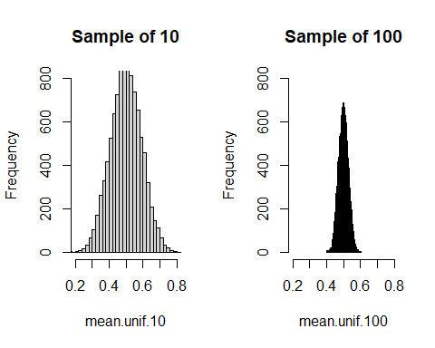 ## Poisson **Poisson Distribution**

pois.10 <- data.table(replicate(n=10000, rpois(10,5)))  
mean.pois.10 <- colMeans(pois.10)  
  
pois.100 <- data.table(replicate(n=10000, rpois(100,5)))  
mean.pois.100 <- colMeans(pois.100)  
  
par(mfrow=c(1,2))  
hist(mean.pois.10  
 , probability=FALSE  
 , main="Sample of 10"  
 , xlim=c(3,7)  
 , ylim=c(0,800)  
 , breaks = 40)  
hist(mean.pois.100  
 , probability=FALSE  
 , main="Sample of 100"  
 , xlim=c(3,7)  
 , ylim=c(0,800)  
 , breaks = 40)

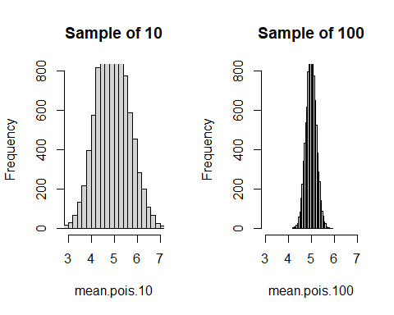

## Normal Distribution

norm.10 <- data.table(replicate(n=10000, rnorm(10)))  
mean.norm.10 <- colMeans(norm.10)  
  
norm.100 <- data.table(replicate(n=10000, rnorm(100)))  
mean.norm.100 <- colMeans(norm.100)  
  
par(mfrow=c(1,2))  
hist(mean.norm.10  
 , probability=FALSE  
 , main="Sample of 10"  
 , xlim=c(-1.0,1.0)  
 , ylim=c(0,800)  
 , breaks = 40)  
hist(mean.norm.100  
 , probability=FALSE  
 , main="Sample of 100"  
 , xlim=c(-1.0,1.0)  
 , ylim=c(0,800)  
 , breaks = 40)

