Simulating evolution in a puzzle game.

Alexander Sowatskey Twaddell – [alexander.sowatskey-twaddell@city.ac.uk](mailto:alexander.sowatskey-twaddell@city.ac.uk)

Computer Science with Games Technology

Consultant Name: Chris Child

Proposed By: Alexander Sowatskey Twaddell

Contents

Agreed Arrangements 1

Introduction 1

Project Proposal 2

Problem to be solved 2

Project Objectives 3

Project Beneficiaries 3

Work Plan 3

Project Risks 3

Risks to your project 3

Risks that my project poses to others 5

Ethics Checklist 5

References 10

Bibliography 10

# Agreed Arrangements

* Not agreements have been made so far

# Introduction

I am fascinated with the idea of simple systems developing complex behaviour. To this end I am going to create a simulation game that has a simple set of actions that can be performed, and I will use an evolutionary algorithm to increase the complexity that can be achieved. I am inspired by games like Dwarf Fortress and Spore where every individual is simulated down to the genes in their body. I will create a game where the player takes control of a species that is simulated down to their physical needs and emotions. This species will then evolve over time to be able to handle more complex actions and decisions.

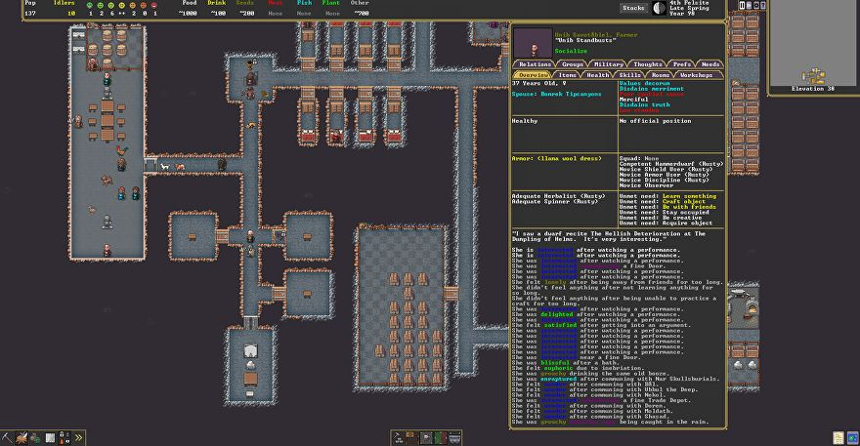 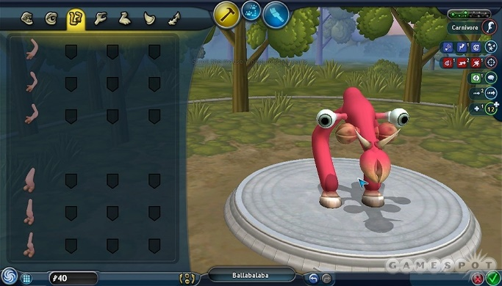

Figure 1 - Dwarf Fortress - (Smith, 2021)

Figure 2 - Spore - (Segers, 2009)

# Project Proposal

## Problem to be solved

The problem to be solved is to create a game that uses a neural net to simulate individual actions and have this net change via the NEAT evolutionary algorithm. The game loop will run like this:

1. Members will get new sensory information
2. Members will use physical needs to update current emotions
3. They will use sensory information and current emotions as input to a neural net
4. The neural net will output a new task for them to do

Games and projects like David Rand’s YouTube evolution project(davidrandallmiller, 2020) that implement the NEAT algorithm to train the neural network only allow for simple behavior to be exhibited. This is because the neural net controls how the agent performs an action.

Figure 1 - Agents moving to locations after being trained - (davidrandallmiller, 2020)

For my project I want to abstract away the how an agent does something and focus the neural net on deciding the action to take. In this way I will be able to create a more complicated game world to simulate in, and the agents will be able to evolve complex decision trees, rather than action trees.

Further on to that, I want to examine using an attractiveness score to control the breeding of my members, rather than using a simple loss score. Typically, with the NEAT algorithm, once a simulation has completed, agents with the lowest loss are used to populate a new generation which then runs the simulation again. This allows the NEAT algorithm to trend towards the optimal solution. In my world, there may not be an optimal solution as the complexity will be high, and so I want to use a member-to-member attractiveness to decide which members produce new offspring with each other. I am doing this in the hopes that the game will produce subsets of the same species that have different decision trees for different situations.

Finally, the gameplay loop will be that the player must design and evolve a species that can overcome a specific natural disaster that they know to be coming in the future. To aid them, the player will be able to influence how the neural net’s mutate over time, by making some mutations more likely than others, or by introducing new mutations altogether into the possible mutation pool.

## Project Objectives

* Main Goal: This project shall give the end user a game experience where they create a species that can survive and evolve in each level environment.

## Project Beneficiaries

1. There is a recent demand for simulation games that use evolution as a concept, and so any people who like to play these kinds of games will benefit.
2. I would like to create a research paper on the method I use for combining the attractiveness score and the mating choice and how this effects the NEAT algorithm. Anyone interesting in this topic will benefit.

## Work Plan

## Project Risks

### Risks to your project

* Computer breakdown/loss of work – Daily uploads to a git repo with my most recent work.
* Over complexity leads to not being able to finish the project – Focusing on the key evolution aspect first before creating levels. At the end I can then deliver a “sandbox” experience with the key gameplay element. A sandbox experience would just be a randomly generated world and a created species, but with no goal in mind.

### Risks that my project poses to others

* Potential for abuse by creating a species that looks similar to something real and then treating it badly. – This will be mitigated because a lot of what the species will do is not controlled by the player and so they can only define how they evolve. There will also be no way to evolve ethically bad decisions, eg slavery, sexual abuse, bullying will not be included as a possibility.
* Project taken out of proportion that it accurately simulated evolution – I will add a clear warning that it is not an accurate simulation, but one created for a game.

# Ethics Checklist

|  |
| --- |
| **Research Ethics Review Form: BSc, MSc and MA Projects**  **Computer Science Research Ethics Committee (CSREC)**  <http://www.city.ac.uk/department-computer-science/research-ethics> |

**Part A: Ethics Checklist**

|  |  |  |
| --- | --- | --- |
| **A.1 If you answer YES to any of the questions in this block, you must apply to an appropriate external ethics committee for approval and log this approval as an External Application through Research Ethics Online - https://ethics.city.ac.uk/** | | *Delete as appropriate* |
| 1.1 | Does your research require approval from the National Research Ethics Service (NRES)?  e.g. because you are recruiting current NHS patients or staff?  If you are unsure try - https://www.hra.nhs.uk/approvals-amendments/what-approvals-do-i-need/ | **NO** |
| 1.2 | Will you recruit participants who fall under the auspices of the Mental Capacity Act?  Such research needs to be approved by an external ethics committee such as NRES or the Social Care Research Ethics Committee - http://www.scie.org.uk/research/ethics-committee/ | **NO** |
| 1.3 | Will you recruit any participants who are currently under the auspices of the Criminal Justice System, for example, but not limited to, people on remand, prisoners and those on probation?  Such research needs to be authorised by the ethics approval system of the National Offender Management Service. | **NO** |
| **A.2 If you answer YES to any of the questions in this block, then unless you are applying to an external ethics committee, you must apply for approval from the Senate Research Ethics Committee (SREC) through Research Ethics Online -**  **https://ethics.city.ac.uk/** | | *Delete as appropriate* |
| 2.1 | Does your research involve participants who are unable to give informed consent?  For example, but not limited to, people who may have a degree of learning disability or mental health problem, that means they are unable to make an informed decision on their own behalf. | **NO** |
| 2.2 | Is there a risk that your research might lead to disclosures from participants concerning their involvement in illegal activities? | **NO** |
| 2.3 | Is there a risk that obscene and or illegal material may need to be accessed for your research study (including online content and other material)? | **NO** |
| 2.4 | Does your project involve participants disclosing information about special category or sensitive subjects?  *For example, but not limited to: racial or ethnic origin; political opinions; religious beliefs; trade union membership; physical or mental health; sexual life; criminal offences and proceedings* | **NO** |
| 2.5 | Does your research involve you travelling to another country outside of the UK, where the Foreign & Commonwealth Office has issued a travel warning that affects the area in which you will study?  *Please check the latest guidance from the FCO -* [*http://www.fco.gov.uk/en/*](http://www.fco.gov.uk/en/) | **NO** |
| 2.6 | Does your research involve invasive or intrusive procedures?  These may include, but are not limited to, electrical stimulation, heat, cold or bruising. | **NO** |
| 2.7 | Does your research involve animals? | **NO** |
| 2.8 | Does your research involve the administration of drugs, placebos or other substances to study participants? | **NO** |
| **A.3 If you answer YES to any of the questions in this block, then unless you are applying to an external ethics committee or the SREC, you must apply for approval from the Computer Science Research Ethics Committee (CSREC) through Research Ethics Online - https://ethics.city.ac.uk/**  **Depending on the level of risk associated with your application, it may be referred to the Senate Research Ethics Committee.** | | *Delete as appropriate* |
| 3.1 | Does your research involve participants who are under the age of 18? | **NO** |
| 3.2 | Does your research involve adults who are vulnerable because of their social, psychological or medical circumstances (vulnerable adults)?  This includes adults with cognitive and / or learning disabilities, adults with physical disabilities and older people. | **NO** |
| 3.3 | Are participants recruited because they are staff or students of City, University of London?  For example, students studying on a particular course or module.  If yes, then approval is also required from the Head of Department or Programme Director. | **NO** |
| 3.4 | Does your research involve intentional deception of participants? | **NO** |
| 3.5 | Does your research involve participants taking part without their informed consent? | **NO** |
| 3.5 | Is the risk posed to participants greater than that in normal working life? | **NO** |
| 3.7 | Is the risk posed to you, the researcher(s), greater than that in normal working life? | **NO** |
| **A.4 If you answer YES to the following question and your answers to all other questions in sections A1, A2 and A3 are NO, then your project is deemed to be of MINIMAL RISK.**  **If this is the case, then you can apply for approval through your supervisor under PROPORTIONATE REVIEW. You do so by completing PART B of this form.**  **If you have answered NO to all questions on this form, then your project does not require ethical approval. You should submit and retain this form as evidence of this.** | | *Delete as appropriate* |
| 4 | Does your project involve human parti­­­­­cipants or their identifiable personal data?  *For example, as interviewees, respondents to a survey or participants in testing.* | **YES** |

**PART B: Ethics Proportionate Review Form**

If you answered YES to question 4 and NO to all other questions in sections A1, A2 and A3 in PART A of this form, then you may use PART B of this form to submit an application for a proportionate ethics review of your project. Your project supervisor has delegated authority to review and approve this application under proportionate review. You must receive final approval from your supervisor in writing before beginning the planned research.

However, if you cannot provide all the required attachments (see B.3) with your project proposal (e.g. because you have not yet written the consent forms, interview schedules etc), the approval from your supervisor will be ***provisional***. You **must** submit the missing items to your supervisor for approval prior to commencing these parts of your project. Once again, you must receive written confirmation from your supervisor that any provisional approval has been superseded by with ***full approval*** of the planned activity as detailed in the full documents. **Failure to follow this procedure and demonstrate that final approval has been achieved may result in you failing the project module.**

Your supervisor may ask you to submit a full ethics application through Research Ethics Online, for instance if they are unable to approve your application, if the level of risks associated with your project change, or if you need an approval letter from the CSREC for an external organisation.

|  |  |  |
| --- | --- | --- |
| **B.1 The following questions must be answered fully.**  **All grey instructions must be removed.** | | *Delete as appropriate* |
| 1.1. | Will you ensure that participants taking part in your project are fully informed about the purpose of the research? | **YES** |
| 1.2 | Will you ensure that participants taking part in your project are fully informed about the procedures affecting them or affecting any information collected about them, including information about how the data will be used, to whom it will be disclosed, and how long it will be kept? | **YES** |
| 1.3 | When people agree to participate in your project, will it be made clear to them that they may withdraw (i.e. not participate) at any time without any penalty? | **YES** |
| 1.4 | Will consent be obtained from the participants in your project?  Consent from participants will be necessary if you plan to involve them in your project or if you plan to use identifiable personal data from existing records. “Identifiable personal data” means data relating to a living person who might be identifiable if the record includes their name, username, student id, DNA, fingerprint, address, etc.  *If YES, you must attach drafts of the participant information sheet(s) and consent form(s) that you will use in section B.3 or, in the case of an existing dataset, provide details of how consent has been obtained.*  *You must also retain the completed forms for subsequent inspection. Failure to provide the completed consent request forms will result in withdrawal of any earlier ethical approval of your project.* | **YES** |
| 1.5 | Have you made arrangements to ensure that material and/or private information obtained from or about the participating individuals will remain confidential? | **NO** |

|  |  |  |
| --- | --- | --- |
| **B.2 If the answer to the following question (B2) is YES, you must provide details** | | *Delete as appropriate* |
| 2 | Will the research be conducted in the participant’s home or other non-University location?  *If* ***YES****, you must provide details of how your safety will be ensured.*  *Will be an online game demo that will be sent out* | **YES** |

|  |  |  |  |
| --- | --- | --- | --- |
| **B.3 Attachments**  **ALL of the following documents MUST be provided to supervisors if applicable.**  **All must be considered prior to final approval by supervisors.**  **A written record of final approval must be provided and retained.** | ***YES*** | ***NO*** | ***Not Applicable*** |
| Details on how safety will be assured in any non-University location, including risk assessment if required (see B2) |  |  | **X** |
| Details of arrangements to ensure that material and/or private information obtained from or about the participating individuals will remain confidential (see B1.5)  *Any personal data must be acquired, stored and made accessible*  *in ways that are GDPR compliant.* |  |  | **X** |
| Full protocol for any workshops or interviews** |  |  | **X** |
| Participant information sheet(s)** |  |  | **X** |
| Consent form(s)** |  |  |  |
| Questionnaire(s)**  *sharing a Qualtrics survey with your supervisor is recommended.* |  |  | **X** |
| Topic guide(s) for interviews and focus groups** |  |  | **X** |
| Permission from external organisations or Head of Department**  *e.g. for recruitment of participants* |  |  | **X** |

*\*\*If these items are not available at the time of submitting your project proposal, then* ***provisional approval*** *can still be given, under the condition that you must submit the final versions of all items to your supervisor for approval at a later date.* ***All*** *such items* ***must*** *be seen and approved by your supervisor before the activity for which they are needed begins. Written evidence of* ***final approval*** *of your planned activity must be acquired from your supervisor before you commence.*

# References

# Bibliography

davidrandallmiller. (2020, December 13). *I programmed some creatures. They evolved.* Retrieved from Youtube: https://www.youtube.com/watch?v=N3tRFayqVtk&t=2623s

Segers, A. (2009, June 21). *Spore Walkthrough*. Retrieved from Gamespot: https://www.gamespot.com/articles/spore-walkthrough/1100-6198224/

Smith, G. (2021, Jan 16). *dwarf-fortresss-new-ui-looks-so-beautiful-i-could-cry-despite-still-looking-like-this*. Retrieved from RockPaperShotgun: https://www.rockpapershotgun.com/dwarf-fortresss-new-ui-looks-so-beautiful-i-could-cry-despite-still-looking-like-this