SP\_IT

Game Design Document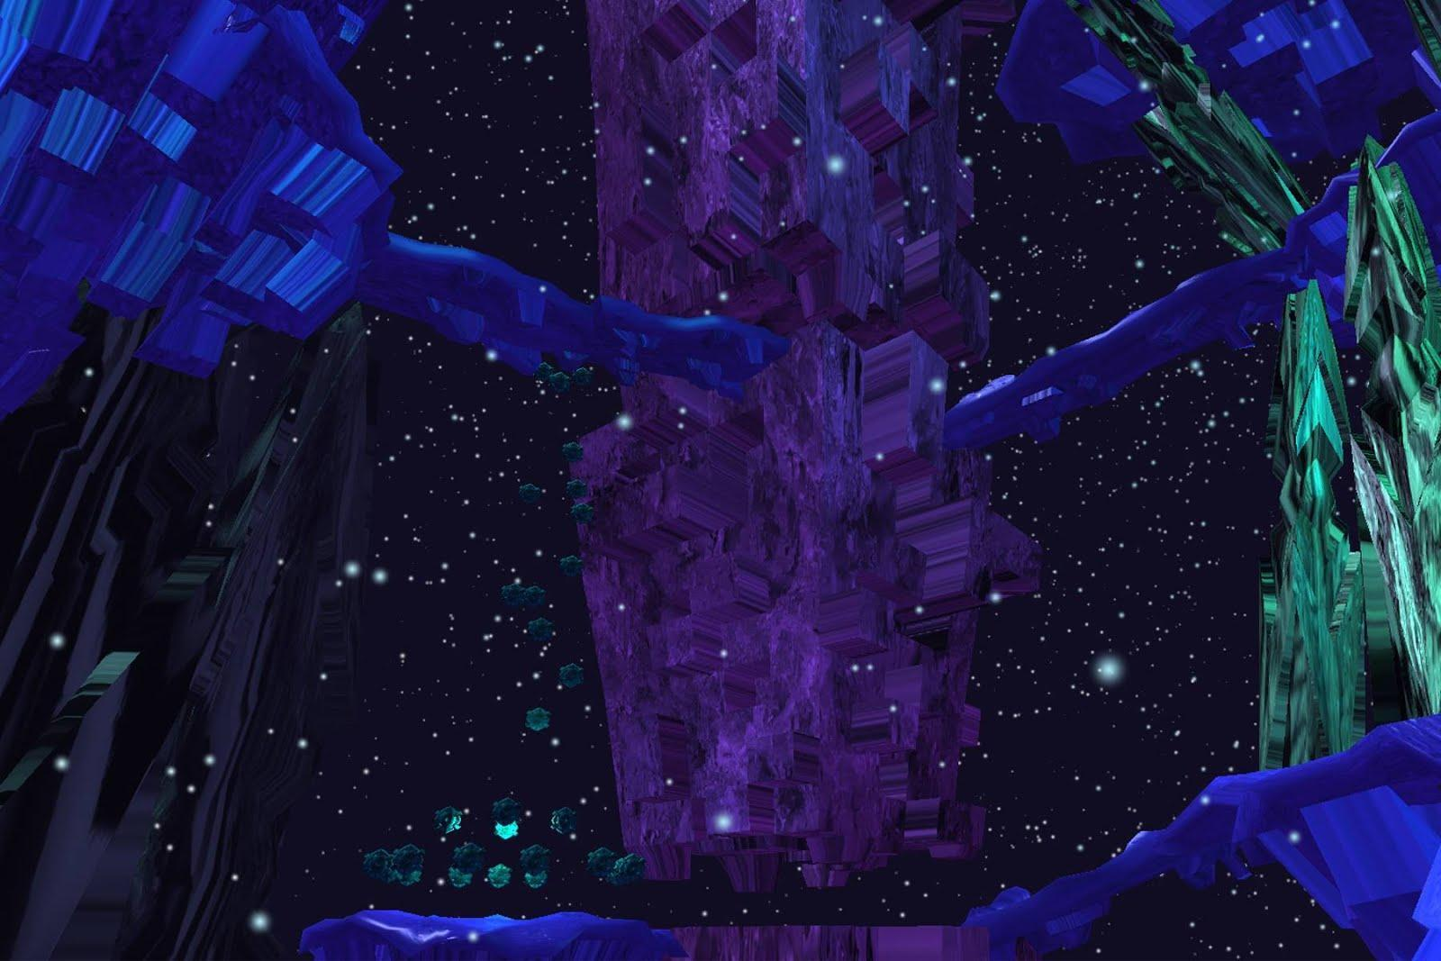

1.0 Overview

Split is a 3D, first person, puzzle exploration game using the Oculus Rift. The player must travel through a cold otherworldly plane that has been torn apart on a material and metaphysical level. Pieces of the world float separate from each other and divided between two planes of existence. The monolithic machinery keeping the world together has shut down, and it is up to the player to restart the world and pull it back into a singular dimension of space and time. Explore a world split between two dimensions, fix archaic contraptions to unlock sections of the ruined landscape, and collect the scattered quantum cores to power the machinery that will bring the world back from the brink of desolation.

1.1 Key Features

Sprawling Otherworldly Environment

* Explore a world far removed from reality, filled with mysterious machines, alien vistas, and bizarre monolithic architecture
* Brutalist style designs and aesthetics give the world a fresh feel

Two Dimensions of the World at Once with Oculus Rift

* Experience a world in two dimensions at once, one world in the left eye, one world in the right using the Oculus Rift
* Solve puzzles and navigate ruined areas by alternating worlds with the literal blink of an eye.

Use Curiosity to Problem Solve and Progress Through the Game

* The game provides an open world for the player to roam and explore. Objectives are discovered by exploring visual points of interest and by solving puzzles scattered throughout the level.

2.0 Objectives Descriptions

The main objective of the game is to search the level to find the quantum cores, which will be used to restore power to the machinery at the heart of the world and pull the world back together both physically and extradimensional. There are also side objectives in the form of puzzle solving. Many of the quantum cores will be hidden behind or be blocked by puzzles in the world and the player will need to figure out how to solve them in order to progress.

2.1 Main Objective

The player will have to collect 5 quantum cores (and one basic tutorial/starting core) to complete the game. These cores are scattered around the game world in 5 distinct areas. To collect one of the cores the player will have to walk up to it and hit a button to reactivate it. Once reactivated, the core is placed in a basic inventory, and can be brought to core area (which the player sees at the very beginning of the game, and which acts as a hub for the 5 areas). When a core is placed in one of the pylons of the core area, it will cause more aesthetics set pieces to appear in the world, and parts of the world that were in separate dimensions will be brought together. 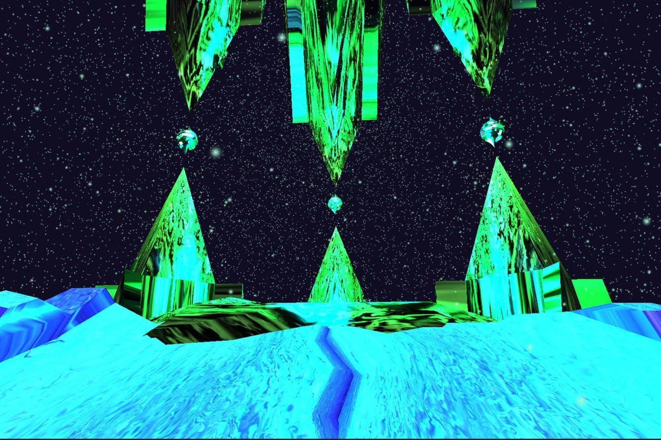

All 5 cores will have a puzzle that is needed to be solved in order to reach it or collect it.

When all 5 cores are collected by the player and placed in all 5 pylons of the core area, they will win the game.

2.2 Puzzle Objectives

2.2.1 - Wall Puzzle

This puzzle has a series of colored and iconified buttons that are connected to a series of tabbed / unique icon walls. These walls are visually blocking a pattern “code” that is needed to unlock a gate that will allow the player to proceed. Each button is connected to walls with a corresponding tab icon, and when a button is pressed it will switch those walls between the left-eye dimension and right-eye dimension. To see the code, all walls must be in one eye or the other, which allows the player to close one eye (the eye that now has all the walls in it) and clearly see the pattern code. When the pattern code is visible, another series of buttons will appear that allow the player to input the code. If the code is inputted correctly, a previous blockade or gate along the path will open and allow the player to move forward.

|  |  |  |  |  |  |  |
| --- | --- | --- | --- | --- | --- | --- |
| Walls | Buttons | Buttons | Buttons | Buttons | Buttons | Buttons |
|  | Star | Crescent Moon | Triangle | Circle | Square | X |
| Plaid | ✔ | ✔ | ✔ |  |  |  |
| Stripes |  |  | ✔ | ✔ | ✔ |  |
| Filled In |  | ✔ |  |  | ✔ | ✔ |

2.2.2 - Colored-Tile Puzzle

This puzzle has an arrangement of colored buttons that, depending on what color they are set to, raise or lower a gate or walkway. By pressing the buttons to change their colors, the player can input the correct series of colors to raise the gate or walkway in a way that allows the player to progress. The correct series of colors will be hinted to the player using environmental hints (Example: The gate is colored blue, when all the buttons are blue, the gate will move in the appropriate way.)

2.2.3 - Tone Puzzle

A series of tones of a scale (5 note scale?) play when the player activates the master sound cube. The sounds from the sound cube correspond to a collection of buttons on a wall near a bridge, over a gap, fractured between each dimension. When the player presses one of the buttons a note from the scale plays, and piece or pieces of the fractured bridge move. If the player presses the buttons in the same order as the scale the bridge move to allow the player to cross the gap and collect the goal object.

2.2.4 - Cube Manipulation Puzzle

Two cubes divided into quadrants, like a tic-tac toe board, exist in each eye. Specific quadrants in each cube has color that corresponds to each eye over layed on it. The goal of the puzzle is manipulating the cubes’ rotation through button presses so all colored quadrants line up. Buttons correspond to either rotating one cube vertically or horizontally, or both vertically or horizontally. More difficult variations of the puzzle will move both cubes requiring the player to plan button clicks in a specific order. Once all quadrants line up the cubes merge into one cube and the puzzle is solved.

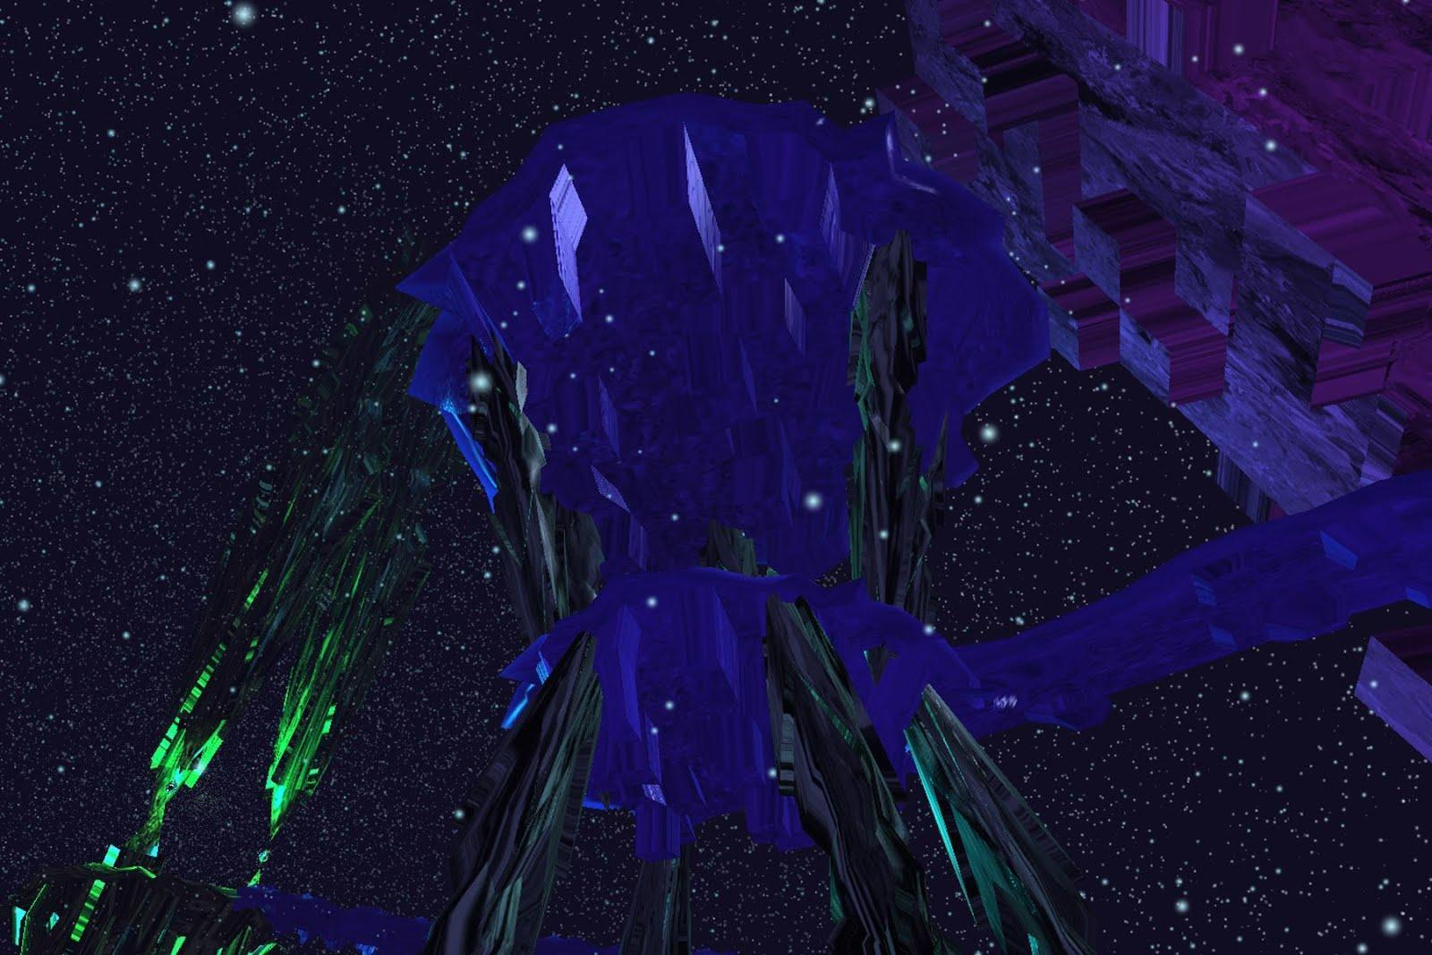

3.0 General Gameplay Elements

3.1 Controls and Mapping

The game is played with a standard controller (Xbox Preferably), in tandem with the Oculus Rift Headset.

* Movement
  + A - Jump
  + Left Control Stick - Move left, right, forward, or backwards
  + Rotating Head with Rift Headset On - Moves the gameview in the direction that the player is turning their head.
    - Right Control Stick - Moves the view in the same way but slower. Limited to left right movement only (rotation on the x axis, up or down movement is only controlled by the Oculus Rift)
  + Close Left Eye or Right Eye - Makes it easier to see objects that only exist in one world or the other
  + Hold Right Trigger - Causes the player to sprint (accelerated movement)
* Interaction
  + X - Interact Button
    - Allows the player to pick up quantum cores and interact with certain puzzle elements.

3.2 Environment Overview

The world of Split is dark and otherworldly, but is not unwelcoming. There are 5 distinct areas of the game with one area each having a quantum core at the end of it. Areas are all connected to the central hub of the core area. This area is where the player has to bring back the quantum cores. There are 5 pylons that the player can connect the quantum cores to in order to win the game.

* As players clear an area, a light will pop up on the path leading to the completed to the area to show the player that they have already completed that section.
* The paths will drop two at a time, giving the player two potential choice of progression.
  + When the tutorial/starting core is placed, the first two paths will drop down.
  + When the player completes the first two paths and places the respective cores, two more paths will drop (2 cores and 1 starting core)
  + When the player completes the second two paths the last path will drop down (4 cores and 1 starting core)
  + When the player completes the final path and inserts the core they will win the game (5 main cores and 1 starting core)
* 5 Paths
  + The Ruins - A rundown area full of toppled architecture and tilted platforms. Looks more degraded than other areas and has more random geometries.
  + The Tower - An area with more verticality and vertical movement. Larger, tall objects and architecture populate this area and the quantum core is located towards the top of the tower.
  + The Temple - A more compact area, with several covered, “indoors” rooms. Feels more like traveling through a smaller building, with the quantum core hidden somewhere inside.
  + The City- A series of building like platforms that the player must navigate. This area has many ramps leading to and from buildings. Different buildings will have different unique architectures and the quantum core will be hidden in a more specialized building
  + The Forest - A large plain with “tree-like” obelisks growing out of it. The player must navigate this area by climbing into the branched and moving from branch to branch towards a light source that marks where the center of the forest and quantum core is. The area is dense and filled with geometry, making it difficult to navigate and almost “maze-like.” Smaller platforms will be scattered throughout to provide “clearings” for better visuals and to give the player moments of rest.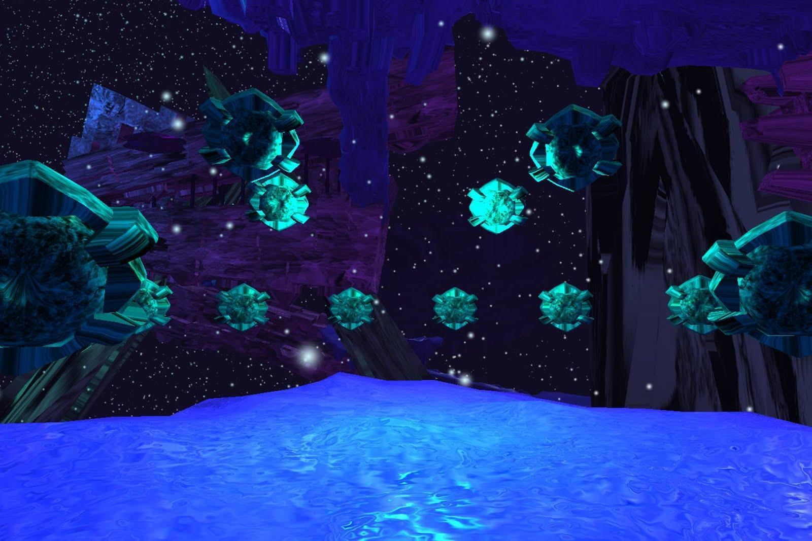

3.3 Machine Entity Objects

* Lookers - These are small, spherical eyeball looking machines that sparsely populate the world. They will rotate to follow the player wherever he is moving. They can be used in the environment to help draw the player’s eye to hard to see paths and hidden areas of the map.
  + The Lookers are the closest thing to sentient life in the game beyond the player. They will have areas where they may be gathered in visually interesting ways to imply meetings or other intelligent functions.
  + The player should be able to view them as helpful, and to understand their role as pathfinders and affordances, but will also find them somewhat creepy and mysterious.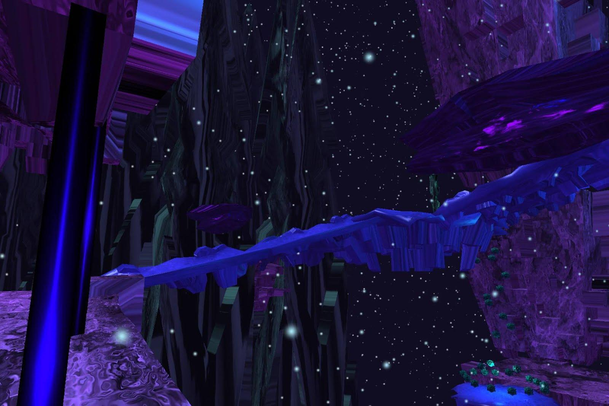
* Flying Trams - These are angular ovoid machines that fly in fixed paths throughout areas of the level. They will move in a specific direction until they are destroyed by a collider out of the player’s view. These will spawn at short set intervals to give the illusion that they are a never ending “train” They range in size, from smaller, fast-moving trams, to gigantic, slow-moving mega-trams.
  + Trams can also be used to push the player in certain directions by having them lead and move in the direction of important objectives or down important paths.

3.4 Dimension Shift Details

The player can actively “switch dimensions” by closing one eye or another and viewing the game only through one eye. Each “dimension” will have specified colors that help delineate which dimension each object is in or linked to.

* Green- Left Eye Dimension
* Purple - Right Eye Dimension
* Blue - Default, Dimensional objects that have been merged.

*Dimension colors are not set yet and will be looked at and finalized in the coming weeks.

3.5 Puzzle Mechanics

* Dimension Shifting With Oculus and Blinking - This is one of the MAJOR game mechanics. Some objects will only be visible to the player in one eye of the Oculus or the other. Objects in the left-eye dimension will only appear in the player’s left eye, and objects in the right-eye dimension will only appear in the player’s right eye. The player can navigate better or solve puzzles by physically closing one eye or the other, in essence “switching dimensions” on the fly.
* Colored Tile Buttons - These buttons change colors when stepped on. If the colors are changed in a specific pattern or arrangement, they will unlock a walkway or gate
* Colored Wall Buttons - These buttons are two colors, which are symbolic of the left-eye or right-eye dimensions. When these buttons are pressed, a wall or gate corresponding to them will switch from being in one eye dimension to being in the other eye dimension.
* Dimension Walls - These are walls or objects that only exist in one dimension and are used to block or obscure the player’s view of patterned codes or affordances in the environment. These are usually controlled by Colored Wall Buttons or are statically in one dimension or another depending on how they are used.

4.0 Asset List

4.1 Visual Assets

* Low poly models of level areas (to be seen in distance)

4.2 Environment Assets

* Buildings
* Floor Button
* Tower Segment
* Walk way
  + Long
  + Short
* Wall Segment
* Wall Corner / Pillar
* Switch Panel
* Power Core
* Forest Towers
* Holograms

4.3 Puzzle Assets

* Wall Puzzle
  + Wall
  + Tab / unique icon on top of wall that corresponds to buttons. (To make each wall visible to the player. Each Tab / unique object should be placed that it is always visible when looking at the puzzle)
    - Need at least 3 unique tab designs.

Paper Prototype Walls and Tabs (Art Asset Placeholders)

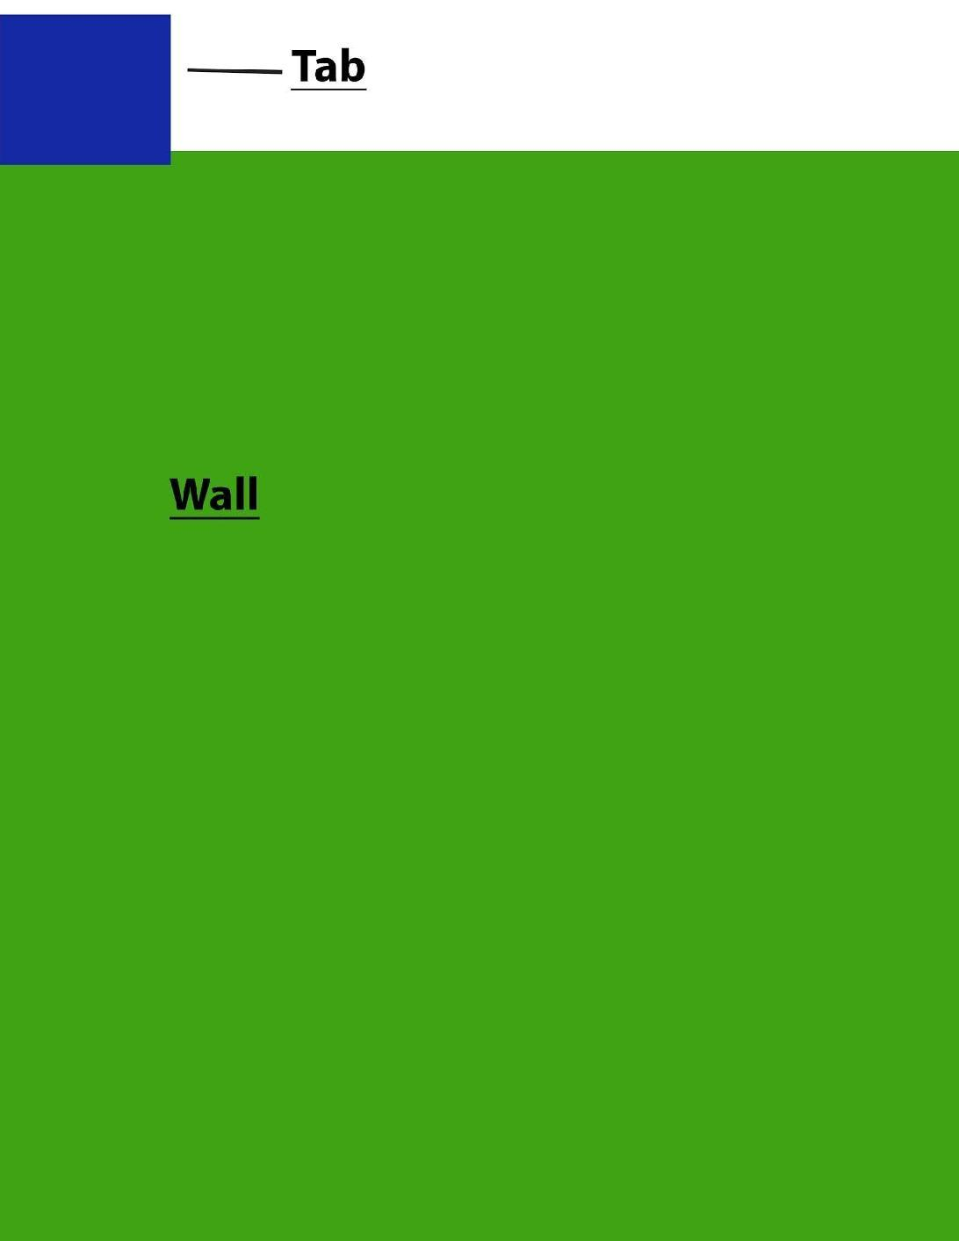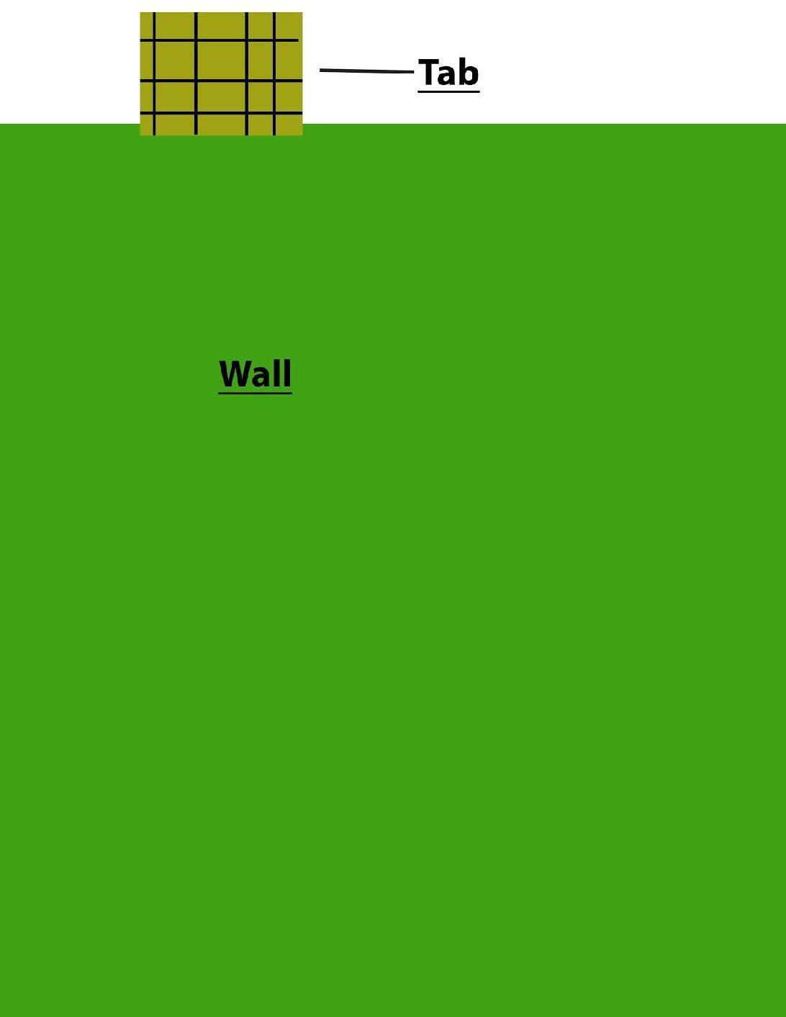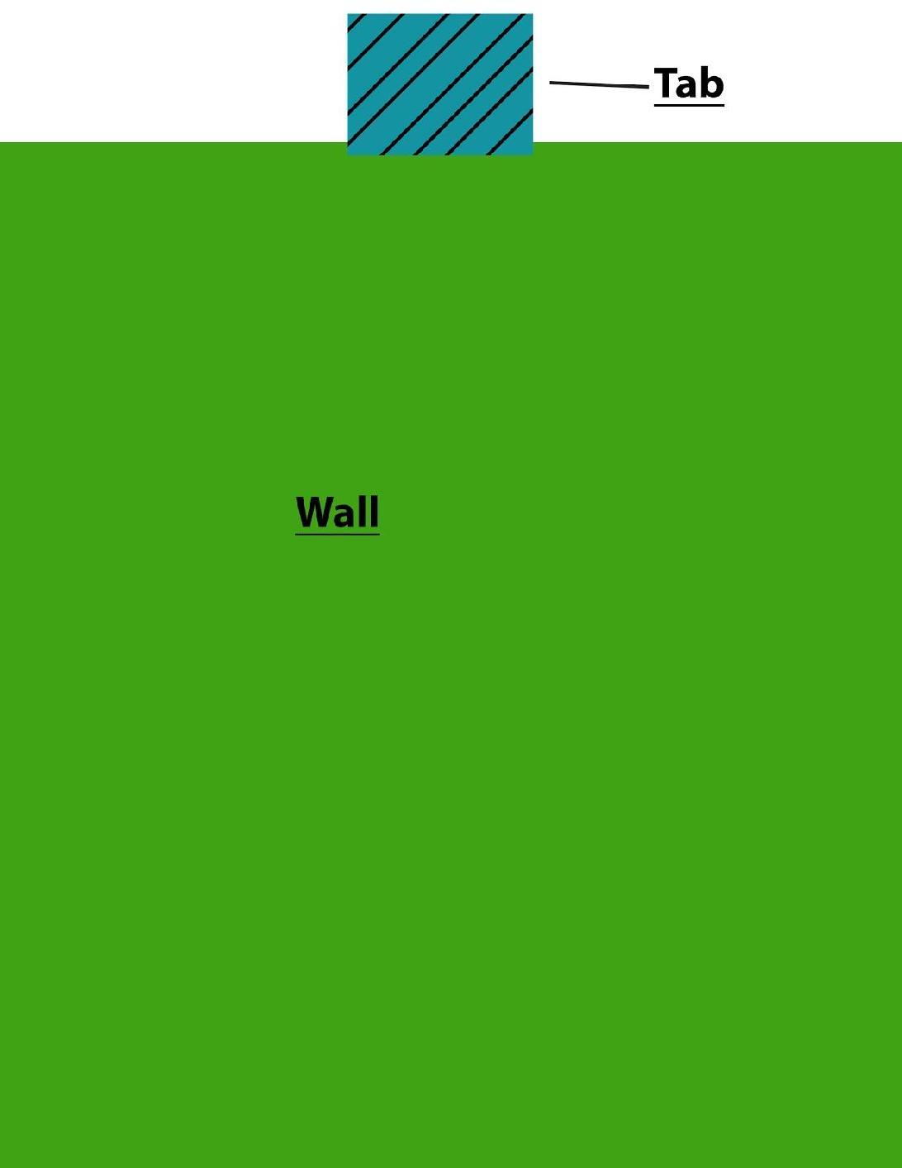

* + Button Icons, with different symbol than corresponding Tab / unique icon(To help distinguish each button's function. Icons can be different from example.)
    - Need at least 12 button icons to allow for puzzle variation.
  + Wall texture.
  + Pedastal model for holding buttons.
    - Texture for pedastal
  + Arrow Button Stand (Stand that holds all 4 arrow buttons)
    - Currently arrows are laid out horrizontally. Maybe, a pedastal with a circular mount would be ideal.

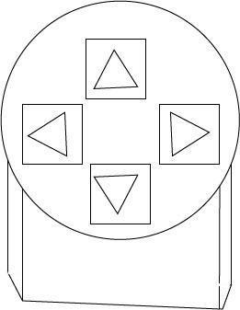

* Tone Puzzle
  + Need bridge asset
    - 3 slight variations on the bridge.
    - Bridges need railings.
    - Texture
  + Master Sound Cube
    - Orb shaped button
    - Pedestal for button to sit on.
  + Reset Button
    - Squashed Capsule button
    - Tube shaped pedastal
  + Tone Buttons
    - Rectangular button
    - Texture that meets world feel for button.
      * Each tone button has the same texture.
  + Tone Button Wall
    - Wall with single parabolic curve.

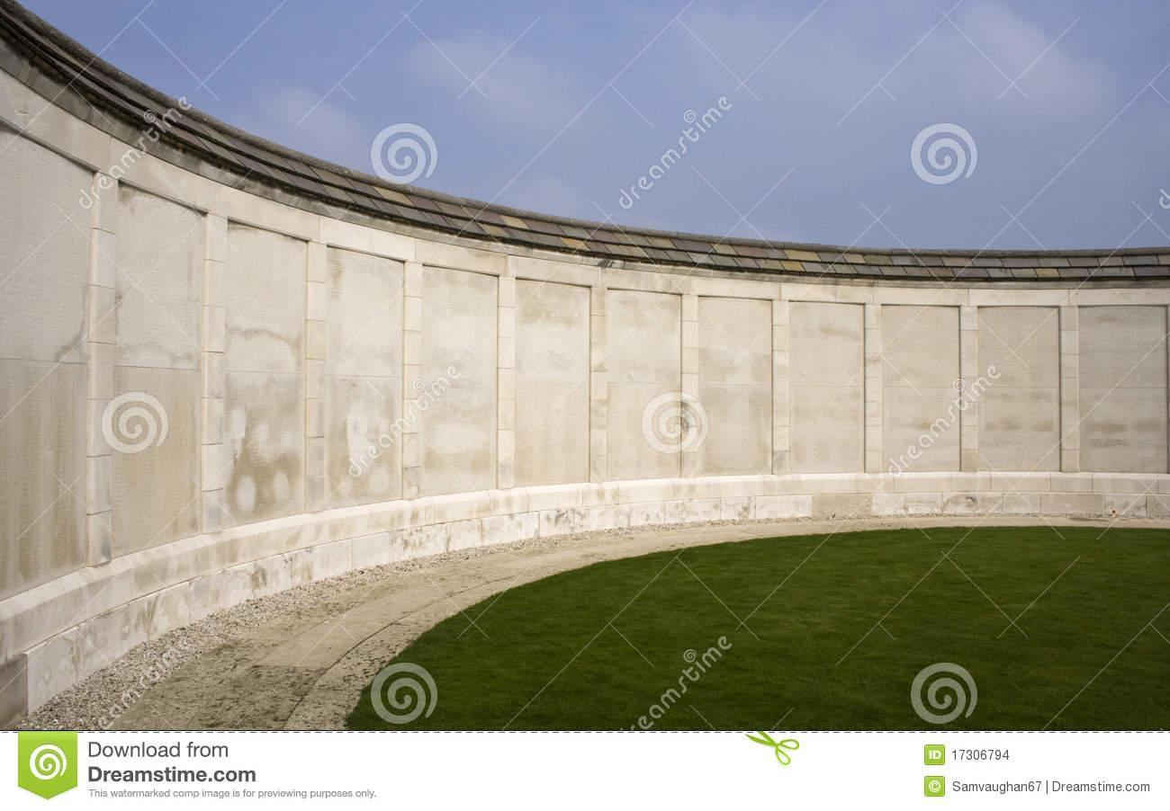

* Colored Tile Puzzle
  + Pedastal for each tile. (Each Pedastal should be the same)
  + Button Texture
* Cube Manipulation Puzzle
  + Cube design

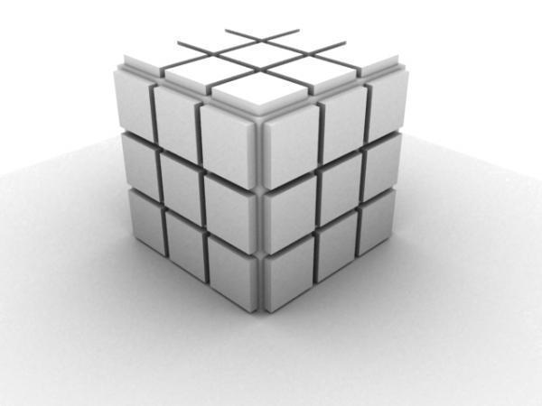

* + Colored Texture to apply to one segment of the cube.
    - Seperate color for each world.
  + Buttons for manipulating cubes.
    - Button Models
    - Button Textures

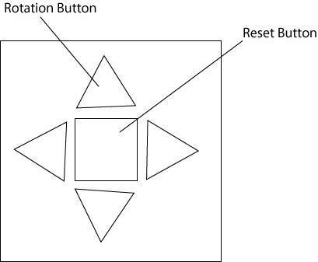

* + Button Pedestal for holding each set of buttons.

Paper Prototype Buttons (Art Asset Placeholders)

