Module 1 Critical Thinking Option 1

Alex Stampfl

Colorado State University Global

CSC372 Programming II

George Bindu

September 14th, 2024

**Program Screenshots:**

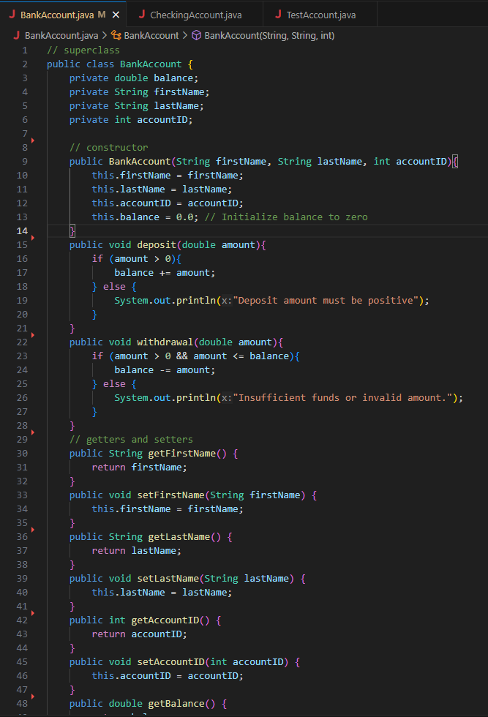

**Output**

**Git Repository:**