

PostgreSQL Project
Small Company Database
Αλέξανδρος Στολτίδης (2824)

Contents
Files and Installation
Files, Installation and Execution ……………………………………………………… 3

Basic Structure
Tables and Relations …………………………………………………………………….. 4
Entity Relationship (ER) Representation ……………………………………………. 5 – 6
Relational Data Mapping ……………………………………………………………….. 6 – 7
3NF and BCNF ……………………………………………………………….……………. 7 – 8

Microsoft Access
Tables and Forms ………………………………………………………………………… 9
Reports and Switchboard ……………………………………………………………… 10

Additional Information
Upcoming Update Features ……………………………………………………………. 11
Sources and Studying Material ……………………………………………………….. 11

Files and Installation
File Structure
- Database or Database.accdb: MS-ACCESS Tables, Queries, Forms, Reports and Switchboard
- Diagrams (Directory)
  - ER_Diagram or ER_Diagram.erx: Entity Relationship (ER) Diagram
  - RDM or RDM.draw.io: Relational Data Mapping (RDM) Diagram
- Images (Directory)
  - Database_Forms or Database_Forms.png: MS-ACCESS Forms
  - Database_Reports or Database_Reports.png: MS-ACCESS Reports
  - Database_Tables or Database_Tables.png: MS-ACCESS Tables
  - ER_basic_notation or ER_basic_notation.png: Basic ER Diagram
  - ER_min_max or ER_min_max.png: ER Diagram with (min, max)
  - RDM or RDM.png: Relational Data Mapping Diagram
- Project Instructions (Directory)
  - Instructions or Instructions.pdf: Project Instructions
  - Installation Guide or Installation Guide.pdf: Installation Instructions for PostgreSQL, ODBC Driver and MS-ACCESS Connection

Installation
For Relational Data Mapping (RDM) Diagrams Install Draw.io or Open From Browser with https://app.diagrams.net/
For PostgreSQL and MS-ACCESS Follow the Instructions on Installation Guide
Execution
Open Database or Database.accdb with Microsoft Access
Go to Forms→Switchboard, Right Click and Open
If you have an ODBC Installed Run Queries with Pass-Through

Small Company Database

Basic Structure and Data
A company consists of many Departments, Employees and Projects

Department’s Attributes
Name

Employee's Attributes
First Name
Last Name
Phone Number

Project's Attributes
Name

Database Relations
- A Department can, but is not necessary, to have many Employees (0, N)
- A Department can, but is not necessary, to control many Projects (0, N)
- An Employee must necessarily work for only one Department (1,1)
- An Employee can, but is not necessary, to work on Many Projects (0, N)
- A Project must be controlled by only one Department (1, 1)
- A Project must be developed by at least one Employee (1, N)

Entity Relationship (ER) Representation

Instructions to Open the ER Diagram
- On Submit Folder Search for the File Diagrams/ER_Diagram or for Diagrams/ER_Diagram.erx
- Download and Launch ER2SQL
- On ER2SQL go to File → Open and Select the Diagrams/ER_Diagram or the Diagrams/ER_Diagram.erx

ER Diagram (Basic Notation)
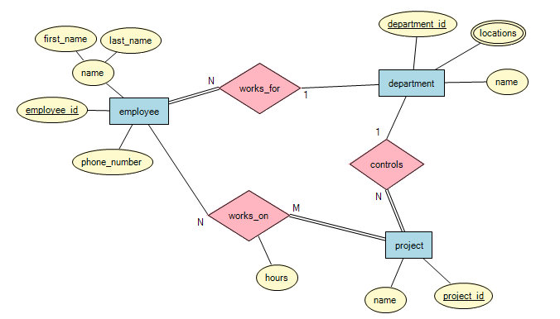
ER Diagram ((min, max) Notation)
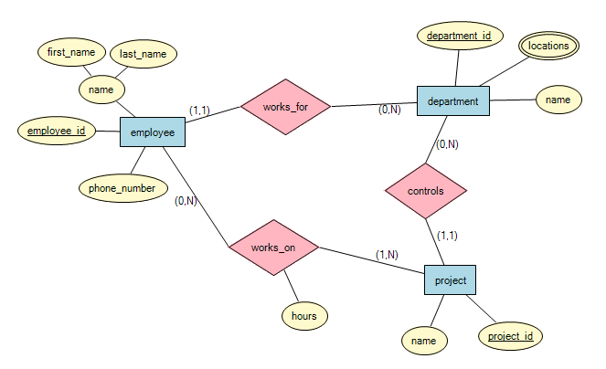

Relational Data Mapping
Instructions to Open the Relational Data Mapping Diagram
Download and Install Or Open Online Draw.io from https://app.diagrams.net/
Online Driver
- Open Existing Diagram or
- File → Open from → Device and Select Diagrams/RDM or Diagrams/RDM.draw.io
Downloaded Program
- File → Open and Select Diagrams/RDM or Diagrams/RDM.draw.io

Relational Data Mapping Diagram Relations

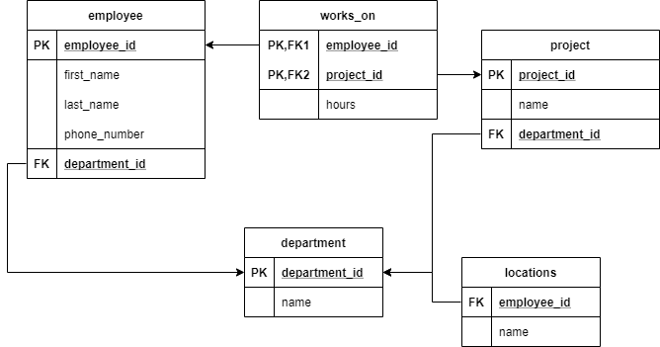

3NF and BCNF
Employee Table
employee_id | first_name | last_name | phone_number | department_id

Department Table
department_id | name

Locations Table
employee_id | name

Project Table
project_id | name | department_id

Employees – Projects (works-on) Table
employee_id | project_id | hours

3NF Criteria
- Must be in 1NF
- There are NO Transitive Dependencies

All Above Tables Indicate that all 3NF Criteria are Valid
- There are no Transitive Dependencies since Non-Prime Attributes Depend Only on Prime Attributes (Primary Keys)
- Are in 1NF
- All Columns of each Table have Different Column Names
- Every Cell Can Store Single Values
- All Inputs in the Same Column have the Same Format

BCNF Criteria
- Must be in 3NF
- If A → B then A must be a Super Key
If A Derives B and B is a Prime Attribute A Can Not be a NON-Prime Attribute

All Above Tables Indicate that all BCNF Criteria are Valid
- All Above Tables are in 3NF
- No Prime Attribute is Derived by a Non-Prime Attribute

Database with MS Access
Tables
- Departments
- Employees
- Locations (Attached to Departments)
- Projects
- Work On (Relationship Between Employees and Projects)
- Switchboard Items (Used for Switchboard)
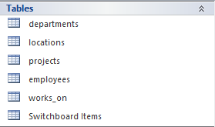

Forms
- Departments Form to Insert a Department
- Locations Form to Insert a Location
- Projects Form to Insert a Project
- Employees Form to Insert an Employee
- Working Project Form to Assign Project to Employee
- Switchboard to Control All Forms Above

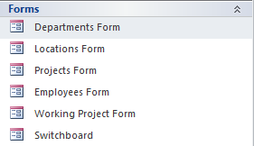

Reports
- Employees and Projects: Displays Employee’s Info and the Name of the Project the Employee is working on
- Employees and Departments: Displays Employee’s Info and the Name of the Department the Employee is working for
- Departments and Projects: Displays Department’s Name and the Name of the Project the Department Controls
- Departments Table: Displays all Departments
- Locations Table: Displays all Locations
- Projects Table: Displays all Projects
- Employees Table: Displays all Employees

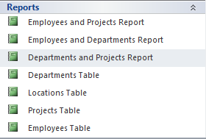

Switchboard and Database
Open Switchboard
On Microsoft Access
- Forms → Switchboard (Right Click → Open)
- Navigate Options Connected to Forms
(Note: Maintain Data Option Feature is to be Added on Future Versions)

Upcoming Update
- Connect Database to a Node.js API with “pg” Driver to get rid of MS-ACCESS
- Implement Delete and Maintain Queries to Accomplish a Complete Database Functionality (CREATE, INSERT, UPDATE, DELETE)
- Create a Trigger to Randomize IDs if they are not Specified, like MongoDB Does
- Create a Super-Class Person to Overlap or Disjoint with the Different Employees the Company may have

Sources and Studying Material
Relational Data Mapping: https://www.youtube.com/watch?v=CZTkgMoqVss
ACCESS Forms: https://www.youtube.com/watch?v=dEaQIrw3CZY
ACCESS Reports: https://www.youtube.com/watch?v=1XUeGq80R5Q&t=55s
ACCESS Switchboard: https://www.youtube.com/watch?v=NF2GSvzV7qg&t=163s
3NF: https://www.youtube.com/watch?v=aAx_JoEDXQA
BCNF: https://www.youtube.com/watch?v=NNjUhvvwOrk&t=103s

