Supplementary Figures

Contents:
Figure S1: See panels below
Figure S2: See panels below
Figure S3: See panels below
Figure S4: See panels below
Figure S5: See panels below
Figure S6: See panels below
Figure S7: See panels below

Figure S1a. Forest plot of fasting blood glucose (FBG): NMN vs placebo. Random-effects model (DerSimonian-Laird). Squares represent individual study mean differences (MD) with 95% confidence intervals (CI); diamond represents the pooled estimate.
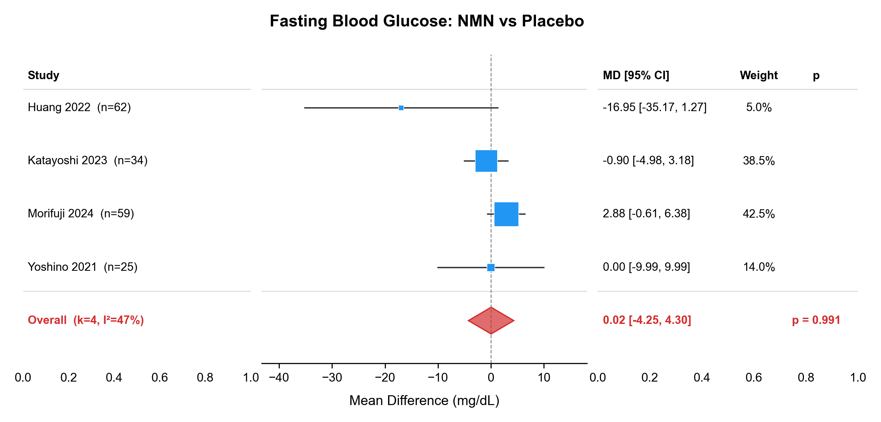

Figure S1b. Forest plot of fasting blood glucose (FBG): NR vs placebo.
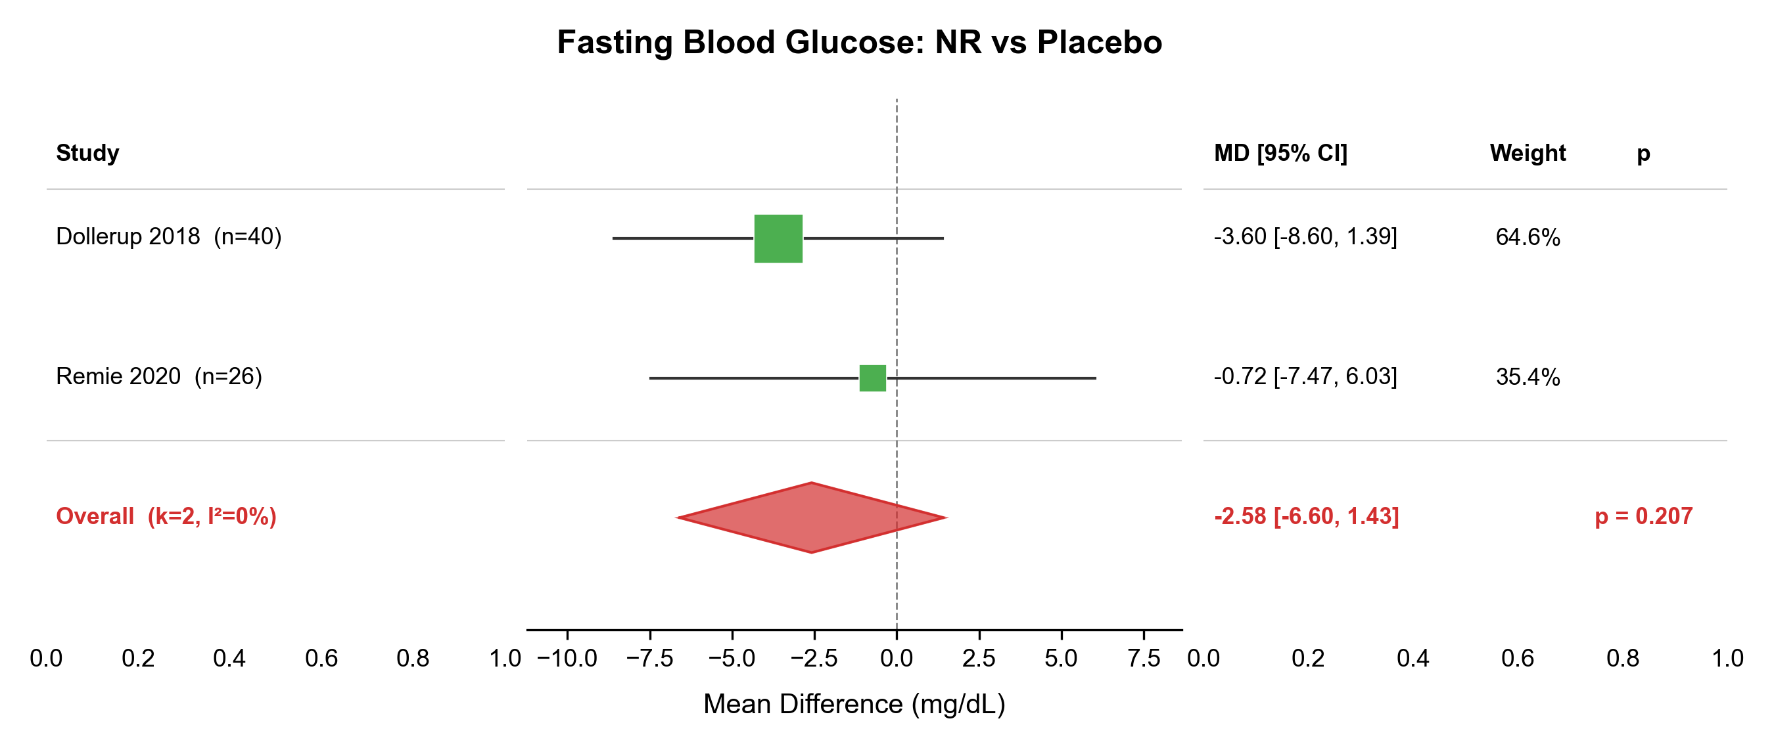

Figure S1c. Forest plot of glycated haemoglobin (HbA1c): NMN vs placebo.
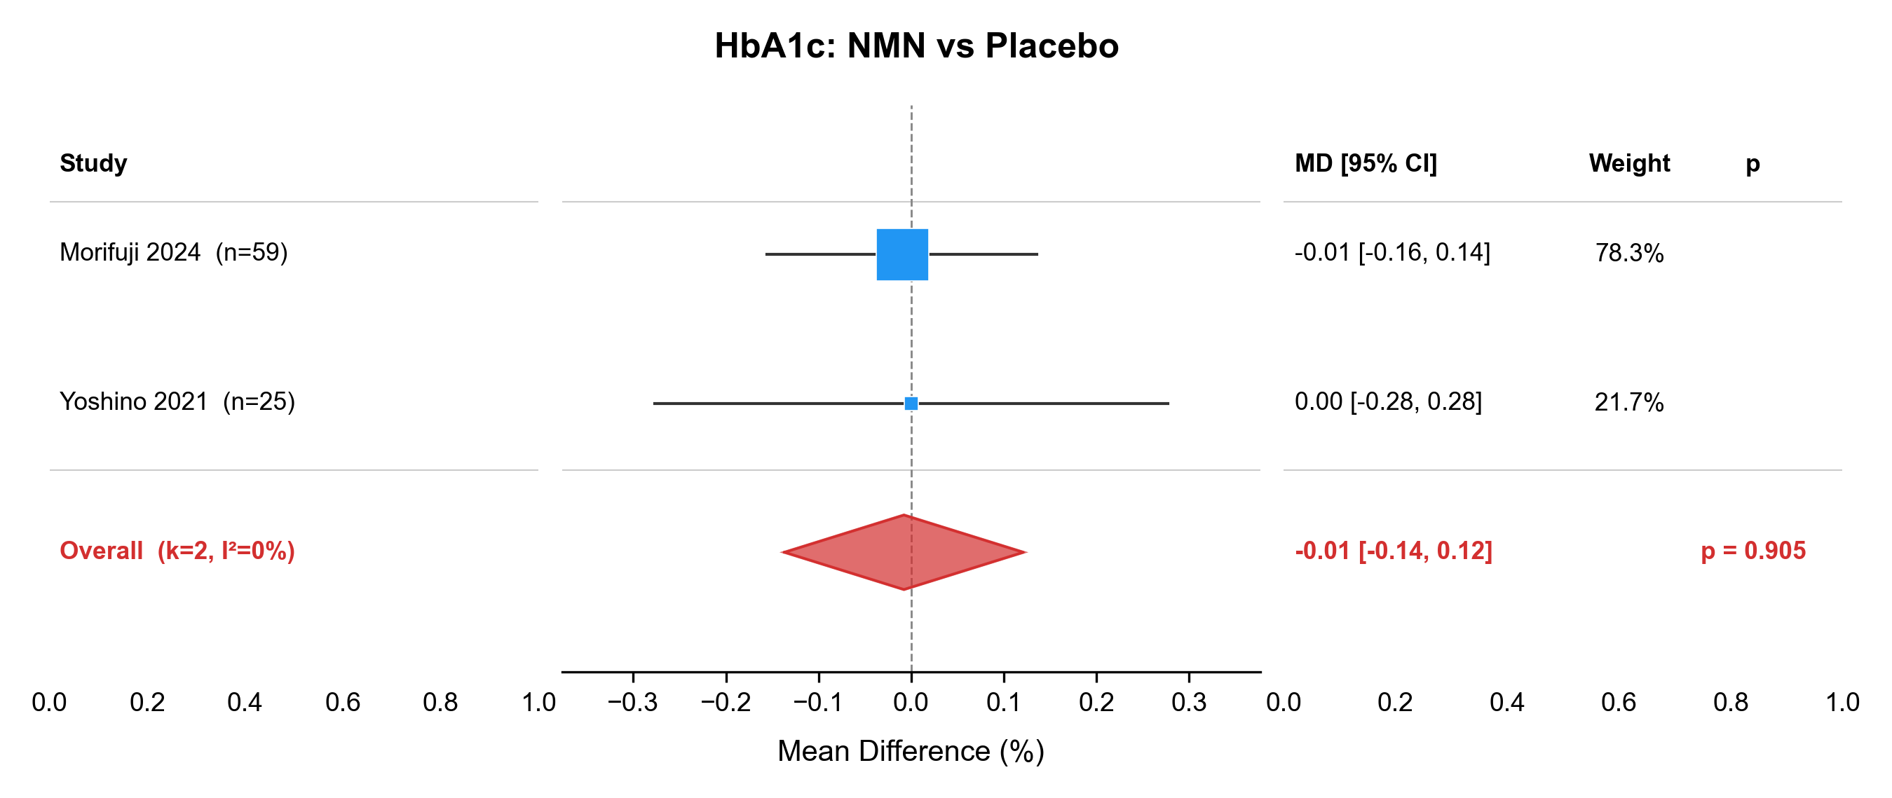

Figure S1d. Forest plot of fasting insulin: NMN vs placebo.
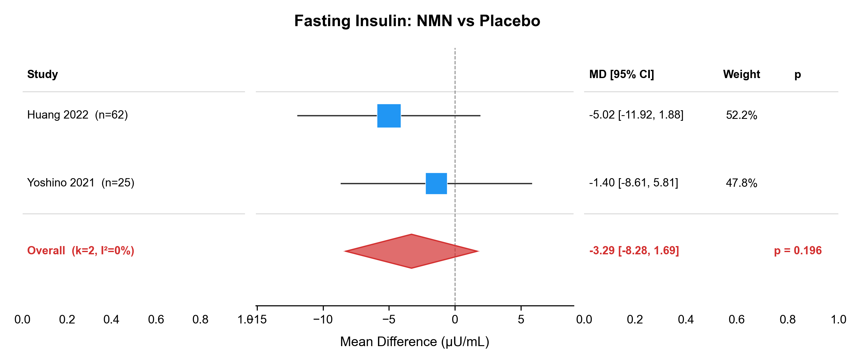

Figure S2a. Forest plot of total cholesterol (TC): NMN vs placebo.
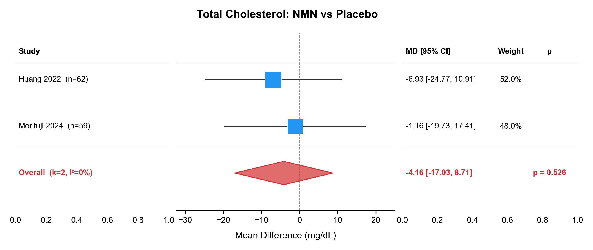

Figure S2b. Forest plot of total cholesterol (TC): NR vs placebo.
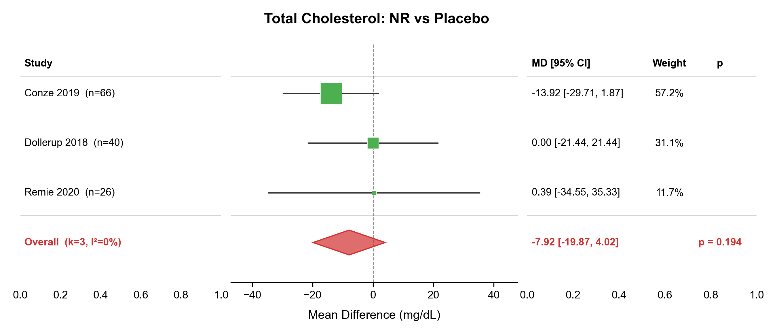

Figure S2c. Forest plot of low-density lipoprotein cholesterol (LDL-C): NMN vs placebo.
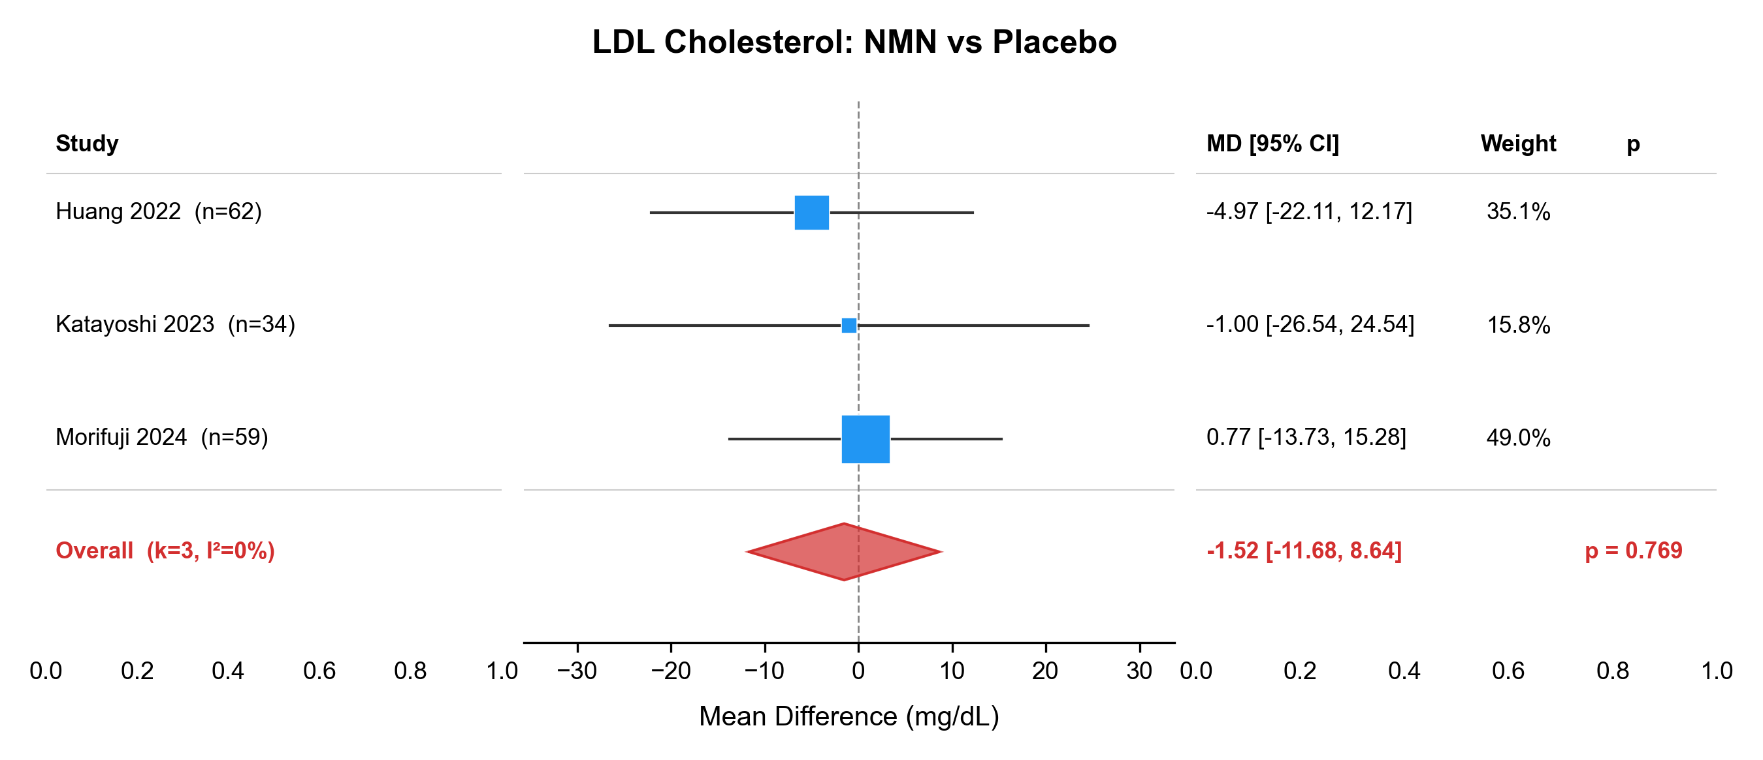

Figure S2d. Forest plot of low-density lipoprotein cholesterol (LDL-C): NR vs placebo.
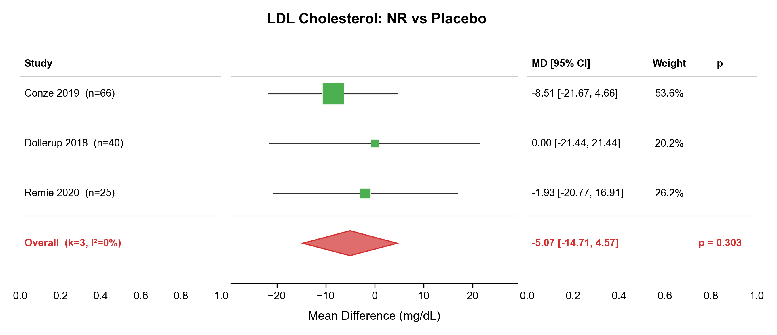

Figure S2e. Forest plot of high-density lipoprotein cholesterol (HDL-C): NMN vs placebo.
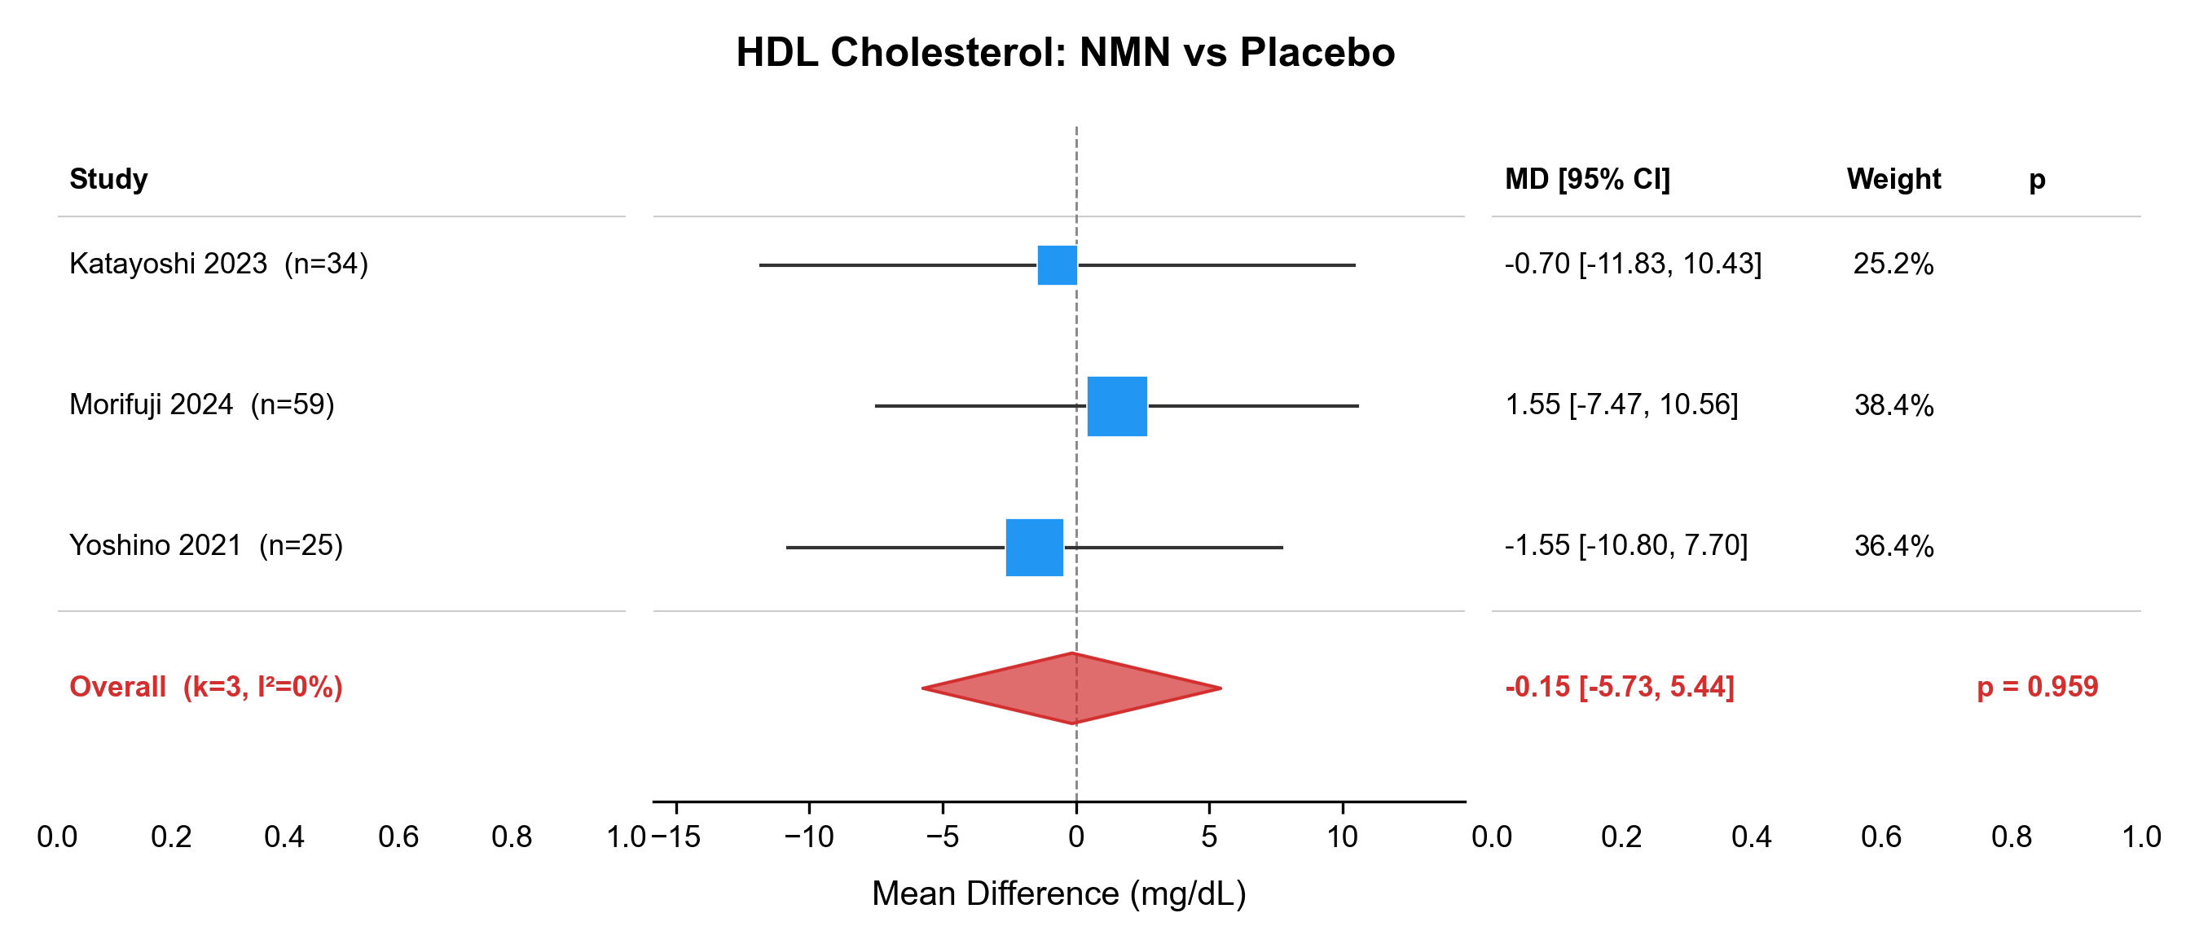

Figure S2f. Forest plot of high-density lipoprotein cholesterol (HDL-C): NR vs placebo.
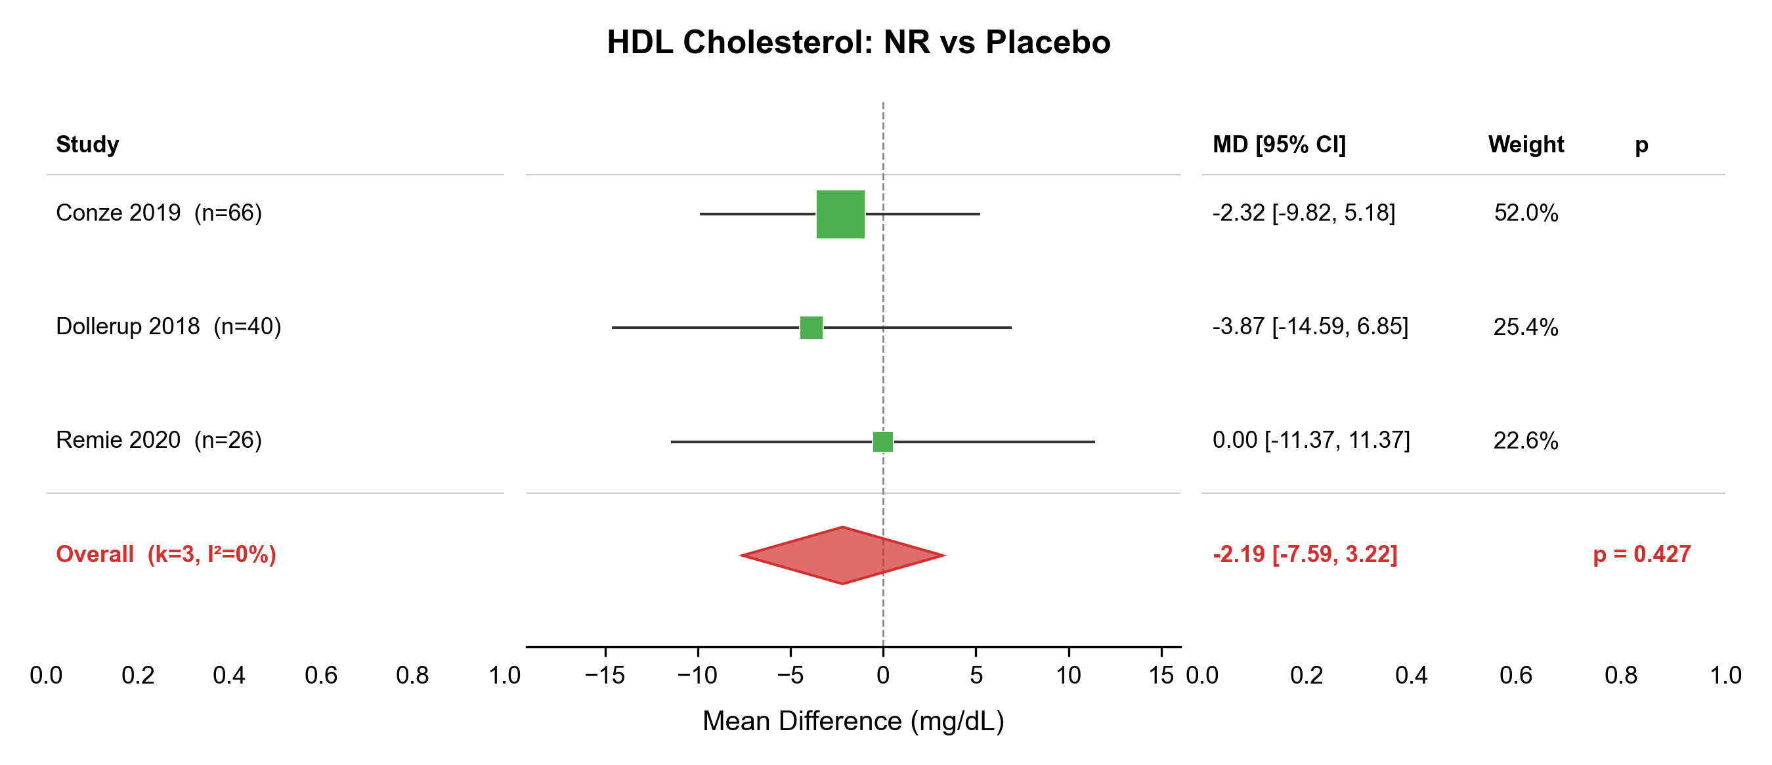

Figure S2g. Forest plot of triglycerides (TG): NMN vs placebo.
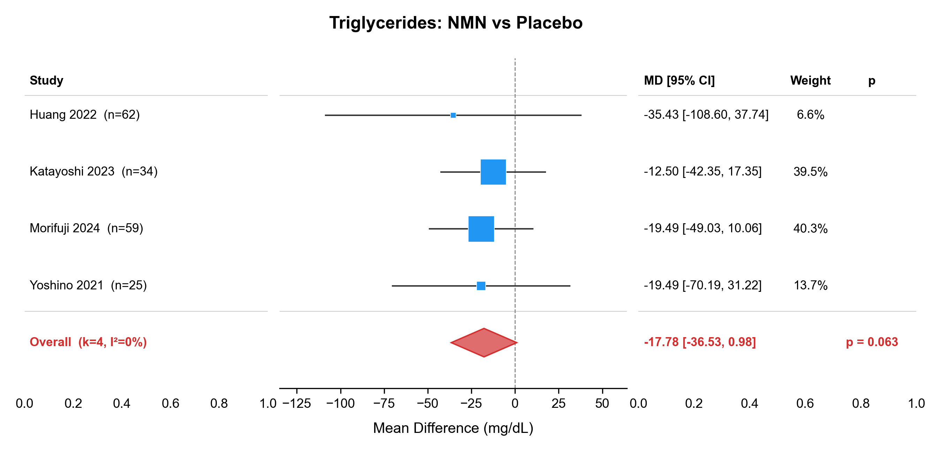

Figure S2h. Forest plot of triglycerides (TG): NR vs placebo.
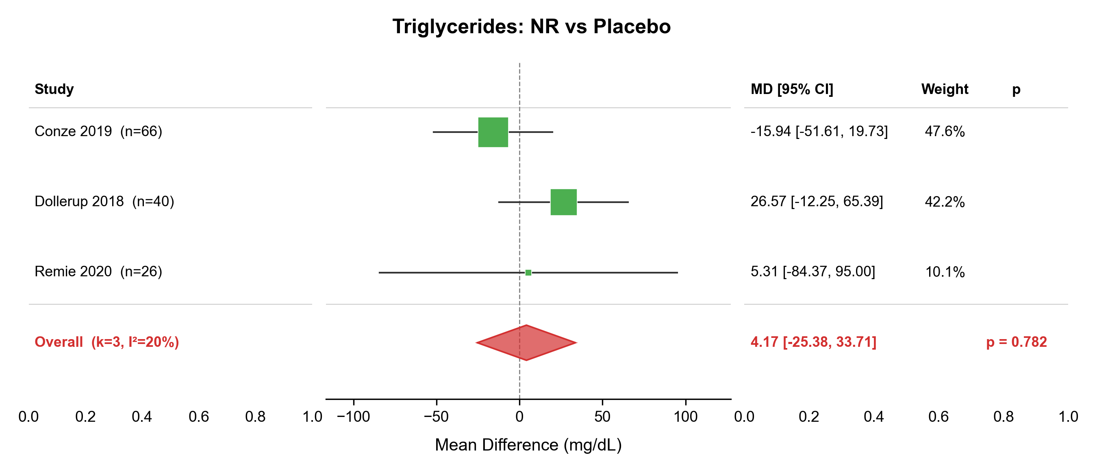

Figure S3a. Forest plot of alanine aminotransferase (ALT): NMN vs placebo.
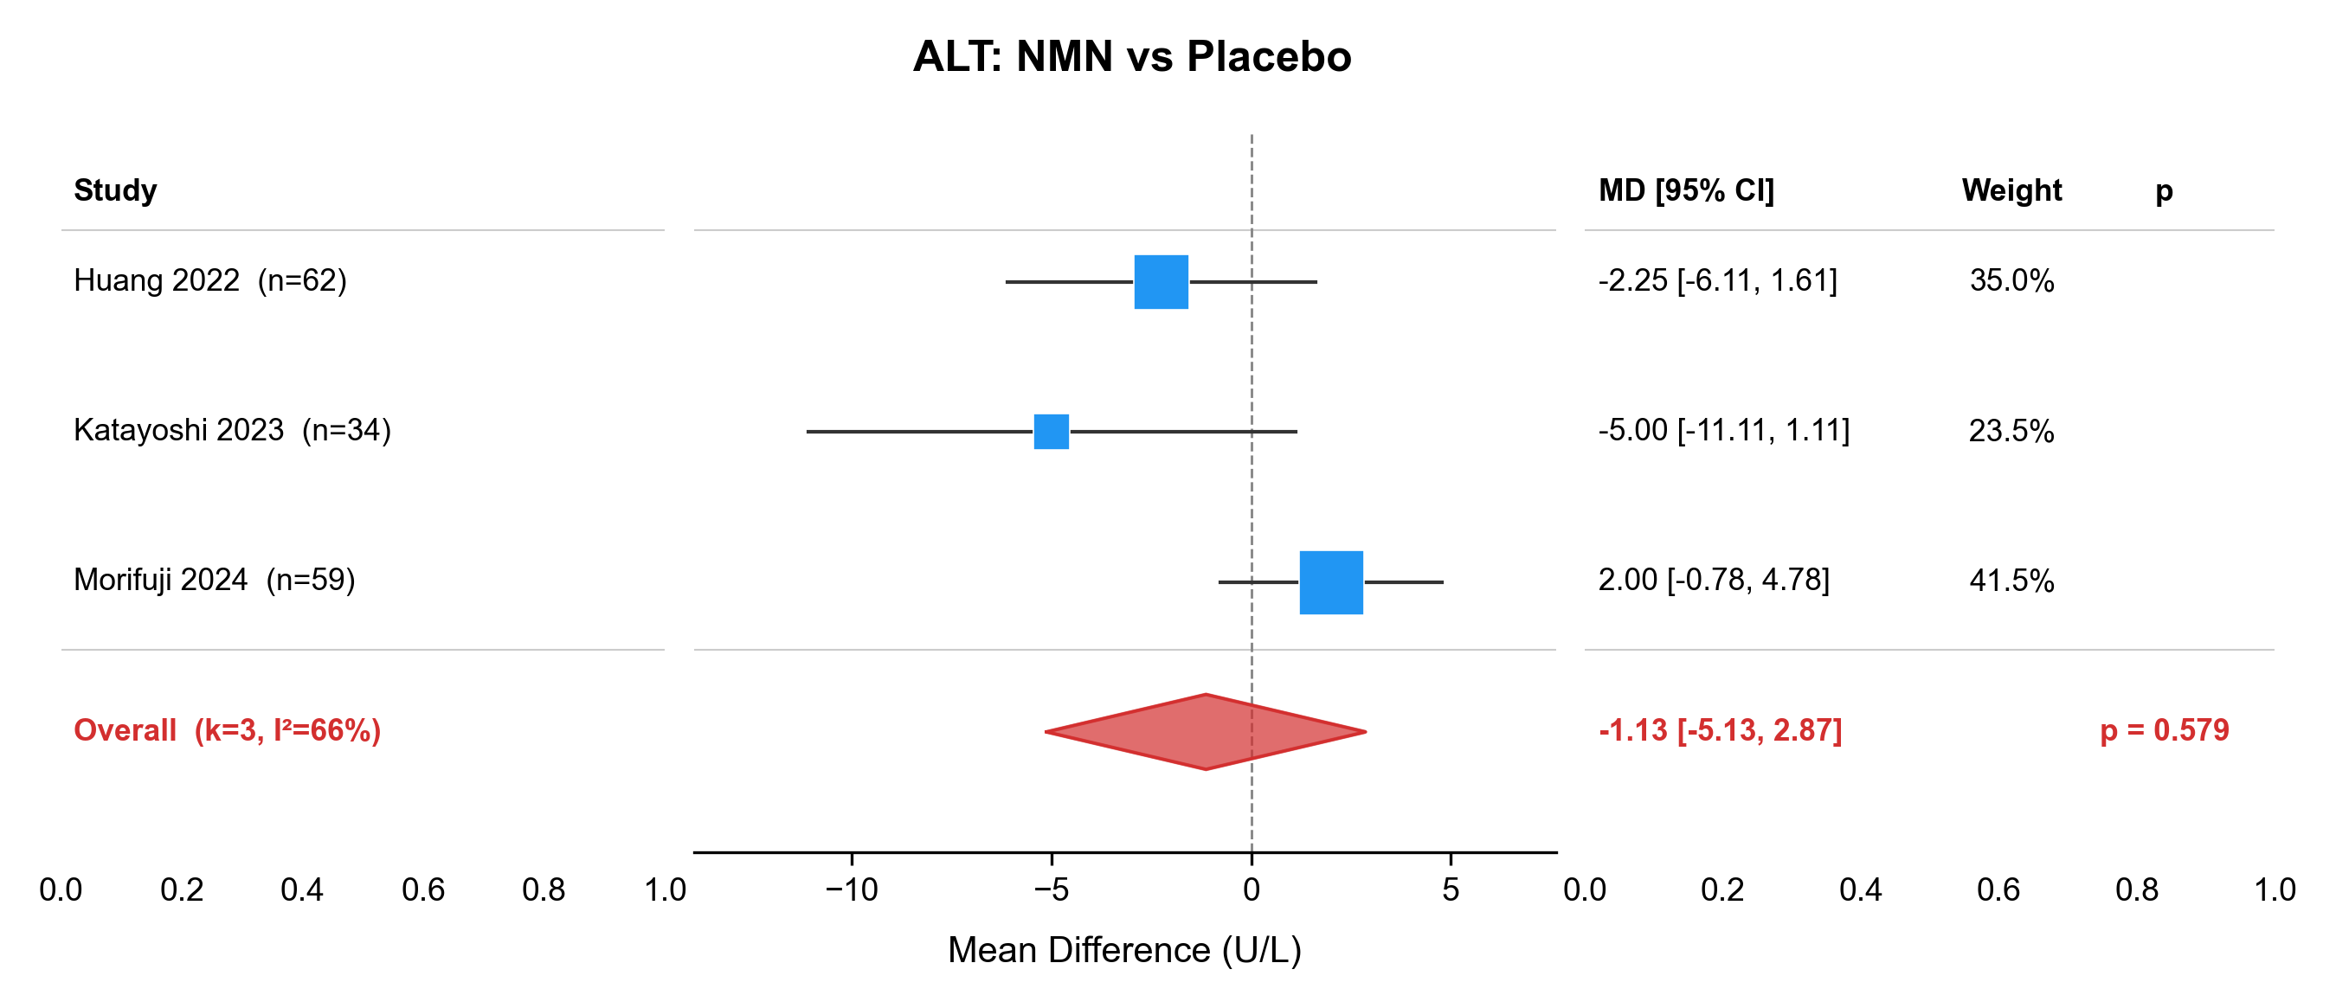

Figure S3b. Forest plot of alanine aminotransferase (ALT): NR vs placebo.
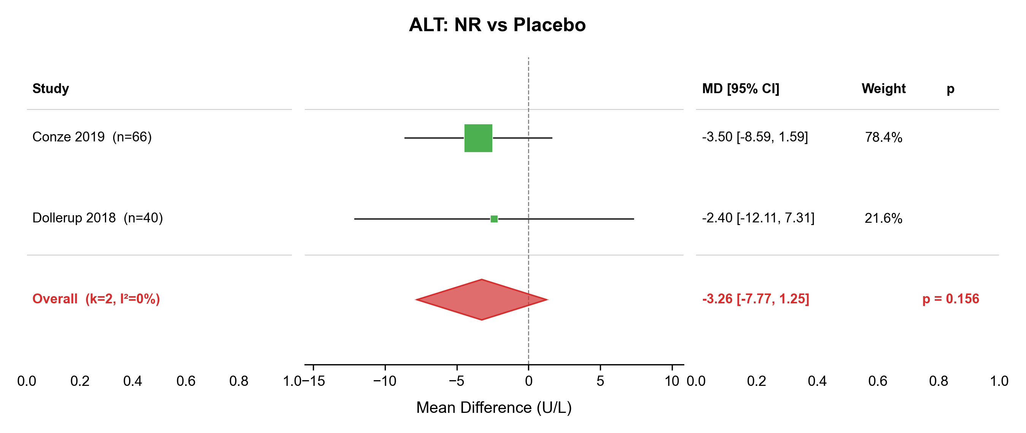

Figure S3c. Forest plot of aspartate aminotransferase (AST): NMN vs placebo.
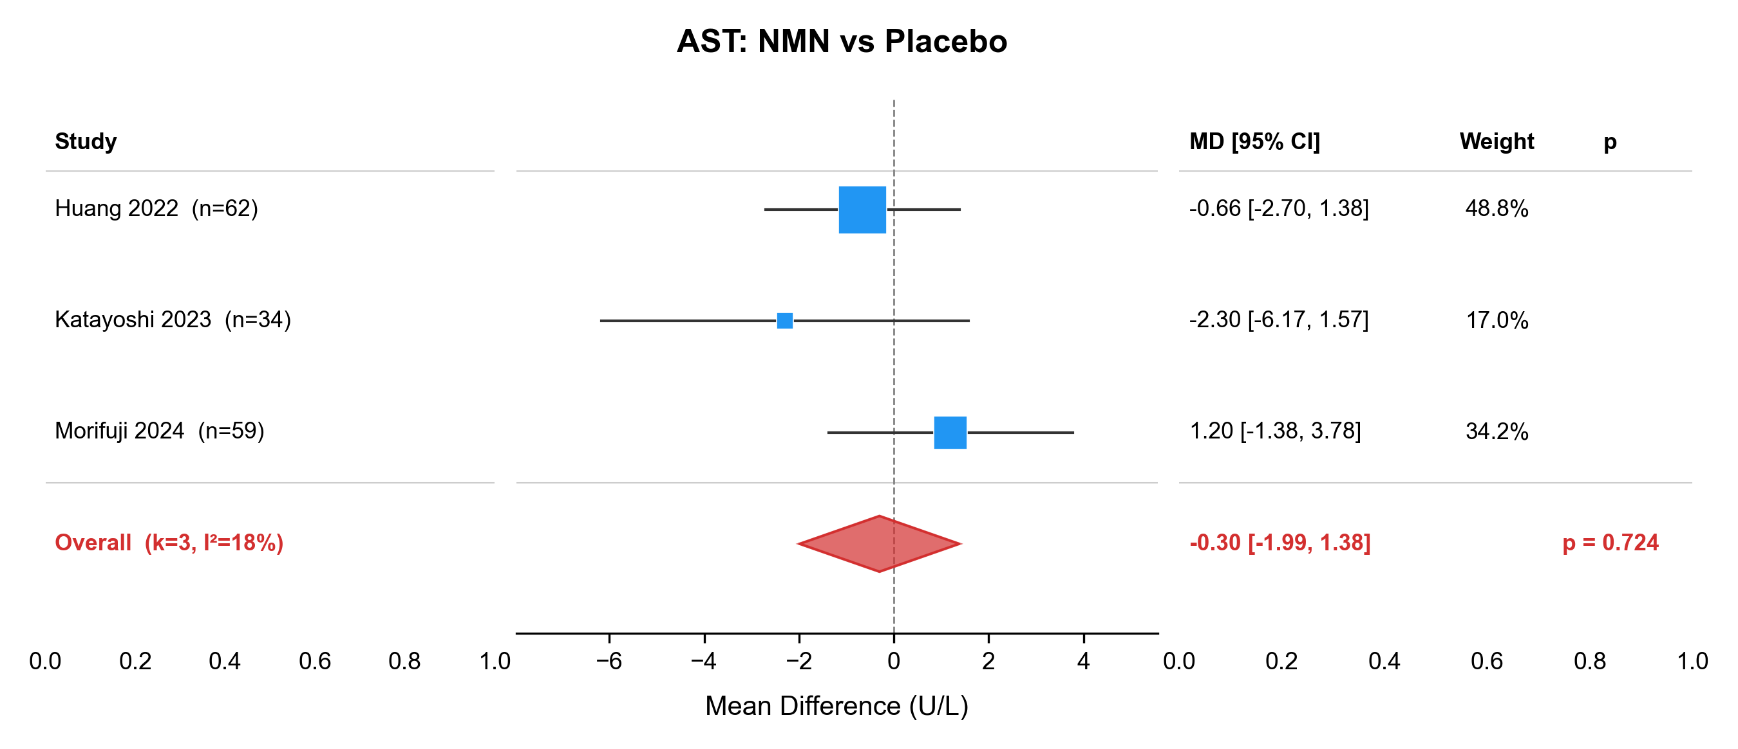

Figure S4a. Forest plot of systolic blood pressure (SBP): NMN vs placebo.
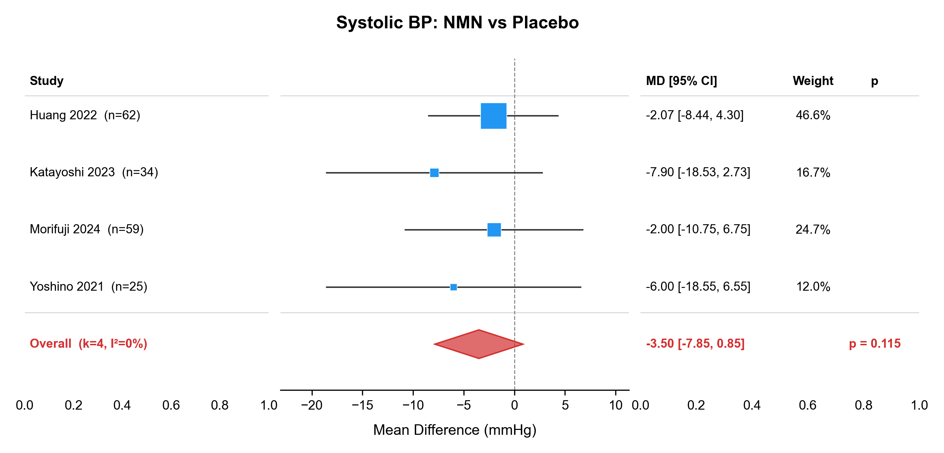

Figure S4b. Forest plot of diastolic blood pressure (DBP): NMN vs placebo.
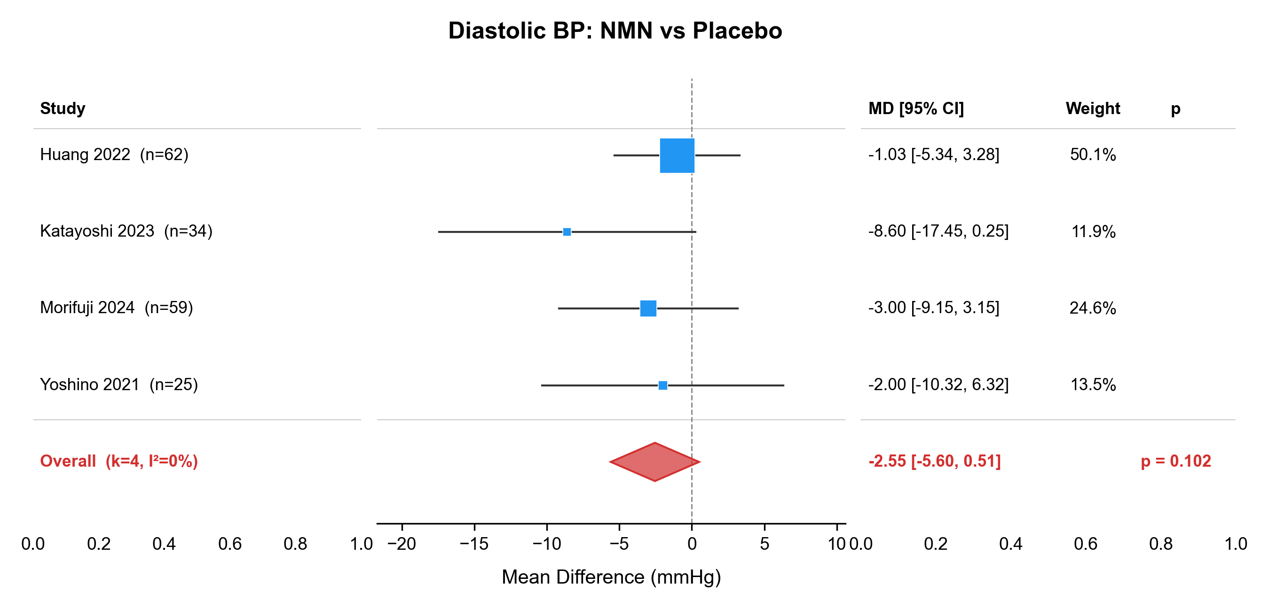

Figure S5a. Forest plot of body mass index (BMI): NMN vs placebo.
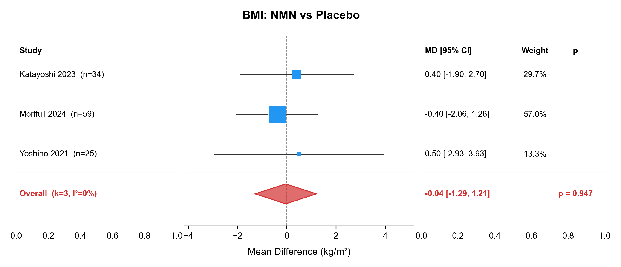

Figure S5b. Forest plot of body weight: NMN vs placebo.
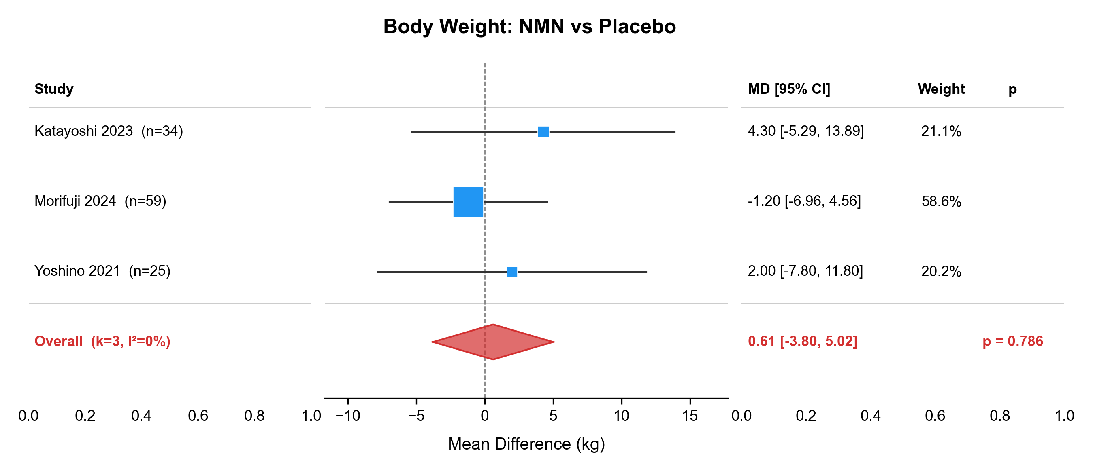

Figure S6. Outcome reporting matrix showing which outcomes were reported (filled) or not reported (empty) across included studies. Rows represent metabolic outcomes; columns represent individual studies grouped by precursor (NMN or NR).
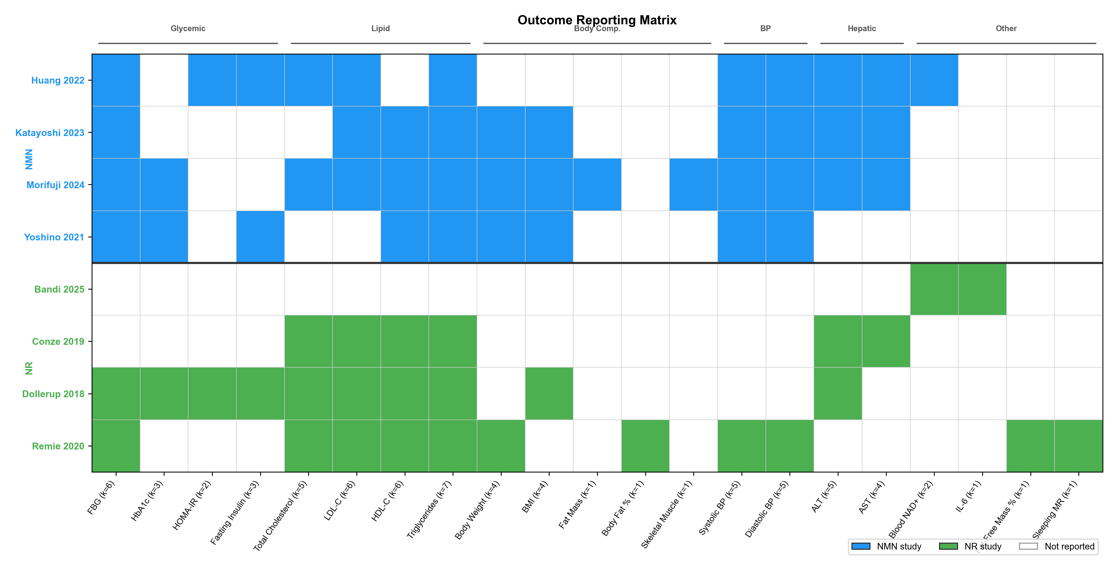

Figure S7a. Leave-one-out sensitivity analysis forest plot for ALT (NMN vs placebo). Each row shows the pooled estimate after excluding the named study.
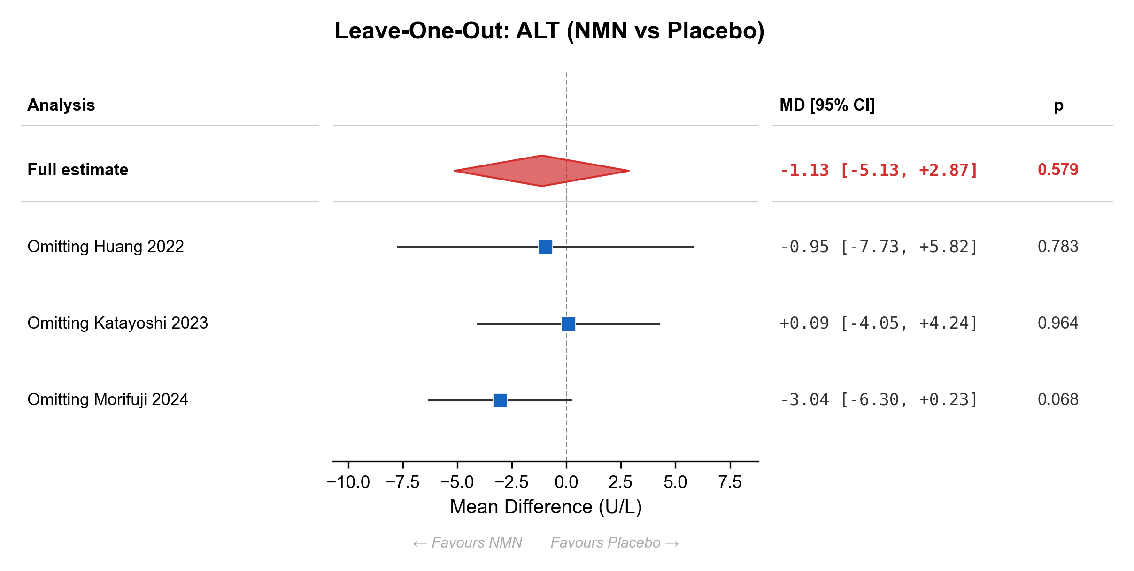

Figure S7b. Leave-one-out sensitivity analysis forest plot for SBP (NMN vs placebo). Each row shows the pooled estimate after excluding the named study.
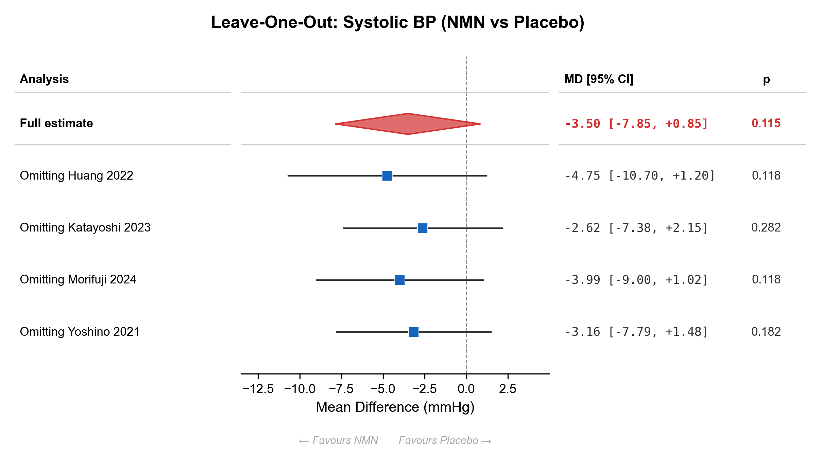

Figure S7c. Leave-one-out sensitivity analysis forest plot for fasting insulin (NMN vs placebo). Each row shows the pooled estimate after excluding the named study.
