**Revision**

I’ve been revising the following topics:

* Amazon Web Services
* ElasticSearch
* Puppet
* Ansible
* Jenkins
* CI Pipeline

Resources used:

* QA slide decks/notes/documents on DevOps technologies
* AWS Docs https://aws.amazon.com/documentation/
* DigitalOcean <https://www.digitalocean.com/community/tutorials>
* TutorialsPoint <https://www.tutorialspoint.com/>
* Jenkins docs https://jenkins.io/doc/

I used AWS EC2 instances to provide a Linux environment to work in. This was SSH’d into with Putty.

**ElasticSearch project**

**Server EC2 Instances**

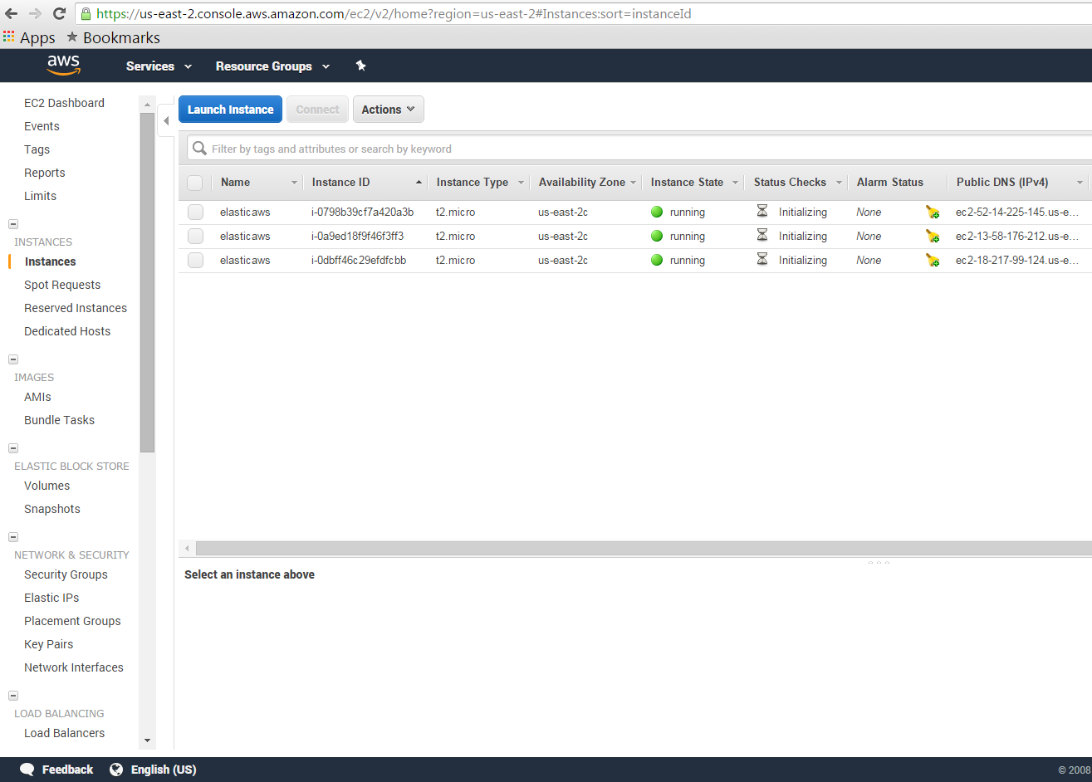

**PuTTY (SSH connection)**

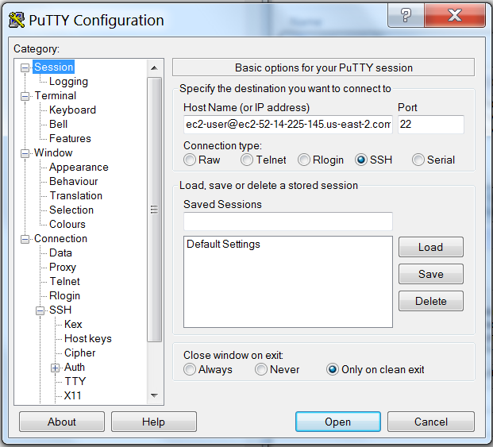

**SSH EC2 Connection successful**

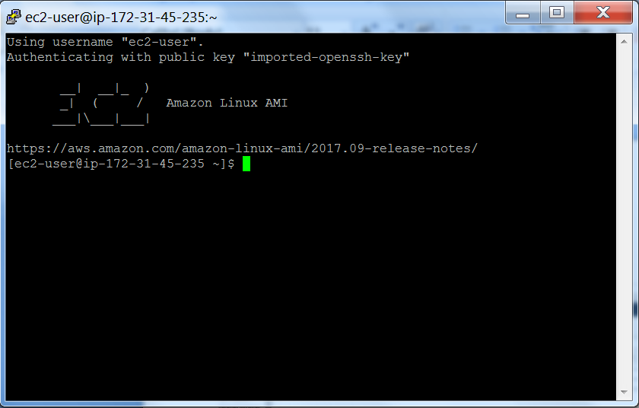

**Installation of ElasticSearch**

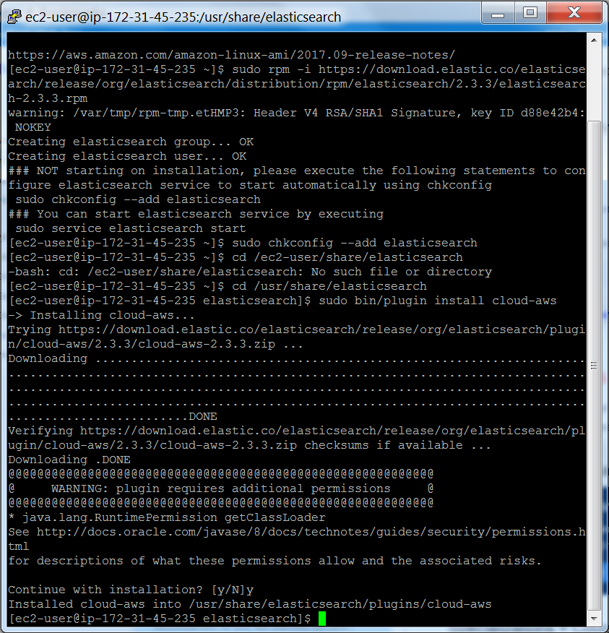

**Indexing some data in ElasticSearch, then reading it back with a search**

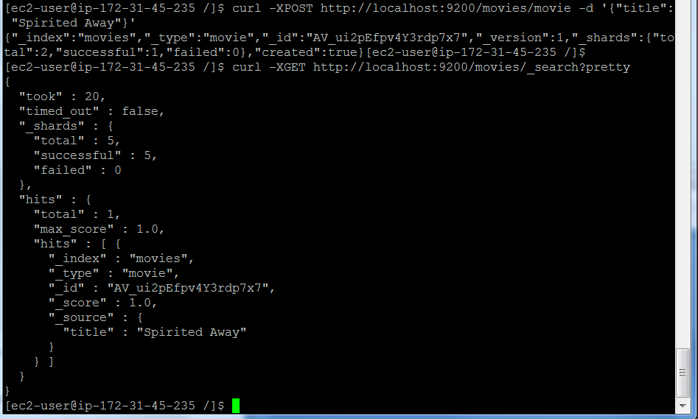

**Indexing two files to the same category, then reading one back using its ID.**

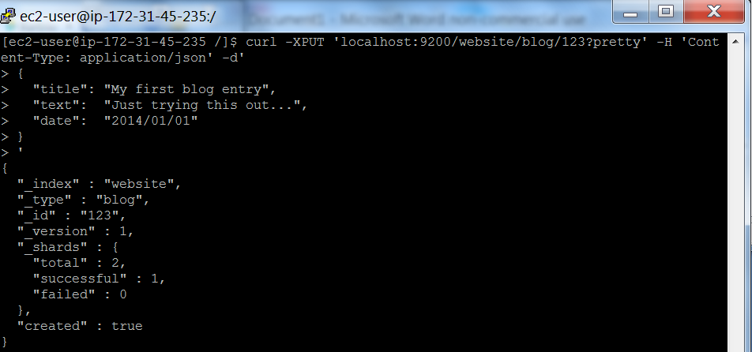

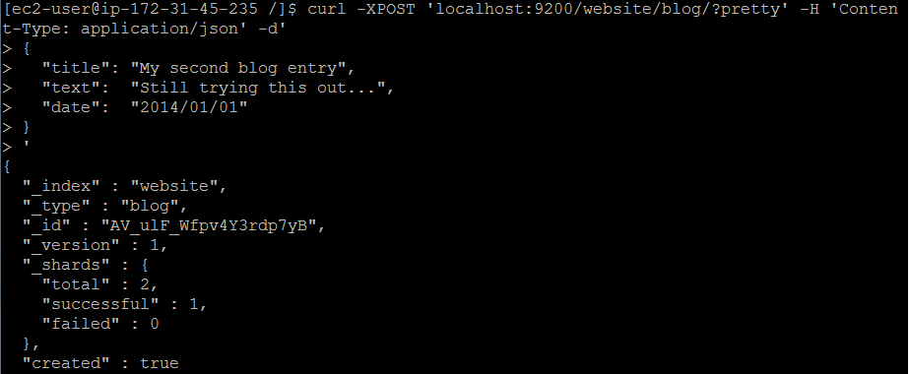

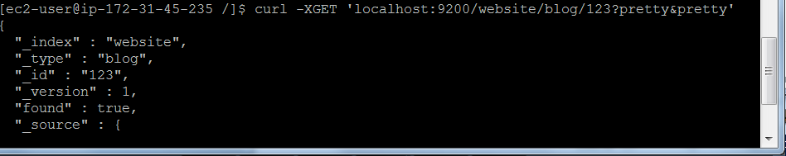

**Searching for a non-existent file (no matching ID).**

