1. Right click the postgres DB on the AWS hosted server in pgAdmin and select “Backup…”

1. Write a name and press the backup button

1. In your running local database server right click the postgres DB and select restore

1. Click the folder icon in the filename field to browse for the file

1. You might have to search for \* to see the file. Open it and click restore  
     
   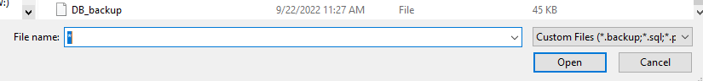
2. Graphical user interface, text, application

   Description automatically generatedYou will probably have an error due to postgis & rdsadmin missing. But the other tables have been filled with the data from the AWS server DB. Refresh the local DB

1. A picture containing graphical user interface

   Description automatically generatedTables should now be visible. And you can right click view to run the SQL command and see what’s inside them

