**Senior Project Proposal 2023-2024**

Name: Alex Thompson  
Degree & Major: Computer Science  
Project Advisor Name: Professor Michael O’Neill

Expected Graduation Date: May 4th, 2024

Problem Statement

Many popular software and websites don't accept all image file formats, which can slow down and frustrate the user, which can be solved with a program that can easily convert image files to desired formats. One of my hobbies is to edit videos, and images are used quite often during the process. Since some of these editing programs, like Adobe's Premiere Pro, have not caught up with current standards of storing images, the "WebP" format is not supported. WebP is used often on the internet due to it being efficient for storing images, so when saving an image from the internet to use in the program, an error message pops up showing it is not supported. The problem is that there are many image formats different programs and devices create that may not be supported on every platform where you need images, so people need a converter of sorts to turn their image into an accepted file format. The reason why this problem is a big deal is because when someone, like me, is editing videos, editing photos, or even posting on social media platforms, a large amount of file formats are not accepted. To back up my assertions, according to Adobe's website, Adobe Premiere Pro does not accept the file format of "Webp". (https://helpx.adobe.com/premiere-pro/using/supported-file-formats.html)

For another example, according to the social media platform Discord, the platform does not accept the file format of "Tiff" (<https://discord.com/developers/docs/reference#:~:text=Make%20sure%20that%20you're,file%20types%20are%20not%20supported>). My solution is to create a desktop program that is an image file converter that allows a user to import and export the image to a desired file format. A benefit of the solution is that having an "all-in-one" program on a user's desktop allows for quick and efficient converting file formats without needing to spend time researching about formats and worrying if a format is accepted or not. There are websites that allow for the conversion of image files, but to open up the browser and find a website for the specific file format is a long process. My program will solve the problem of having an image file type that is not supported by a piece of software or social media website. The program will allow a user to import any image file type and convert the image to a desired file format.

Project Description

The project will be a program that will allow the user to choose an image file from a less desirable format and export the image into a more desirable file format. Image formats that will be accepted are PNG, JPEG, WebP, Tiff, and BMP. There will be a user interface that will display the image the user chose and a drop-down box to allow the user to choose what format they want to convert the image into. The program will use the C++ programming language with the “Qt” framework to implement the user interface. The program will use the OpenCV library to properly import images to manipulate them in code. There is no additional software or equipment needed to complete or use the program.

Personal Motivation

The idea behind the project is based on my own personal frustrations in my hobbies, as I use images quite a lot in some of my favorite hobbies. The main purpose of programming is to make the redundant tasks much easier, so to create a repetitive process many others and I despise going through is a huge motivation for me to create this program. With this project, I am able to learn how to create a program with C++ that has a functional user interface, as I have not done so in the C++ programming language. User interfaces are very important for programs, as the program should be as easy as possible for users to navigate and use, so to create an easy-to-use program that others can use is another personal motivation. The program requires me to learn how to import images into code so I can change information about the image, which is an important aspect of different types of programs I would have to create in the future.

Outline of Future Research Efforts

In order for the project to start, I have done research to make sure the creation of my program is a reasonable task that involves learning new aspects that will further my career skills. I will create a requirements document to show the complete description of the project before fully starting on the creation of the program. The construction of the program will start before next semester where I will build a functional prototype that should be able to do the main aspects of the final program. During the creation of the program, research will be done to make the program function as intended based on the requirements. A test plan will be constructed during the process of creation of the project. The program will be completed before the end of next semester. The final report will be completed after the program has been created, and the project presentation will be done around that time as well.

Schedule

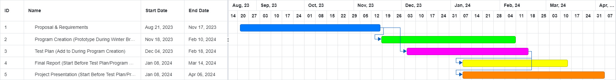



(Full Chart)