# Iteration 1

## Goal:

Implement Dynamic Document Structure and Output Results as Html Elements.

## Class Diagram of Starting System

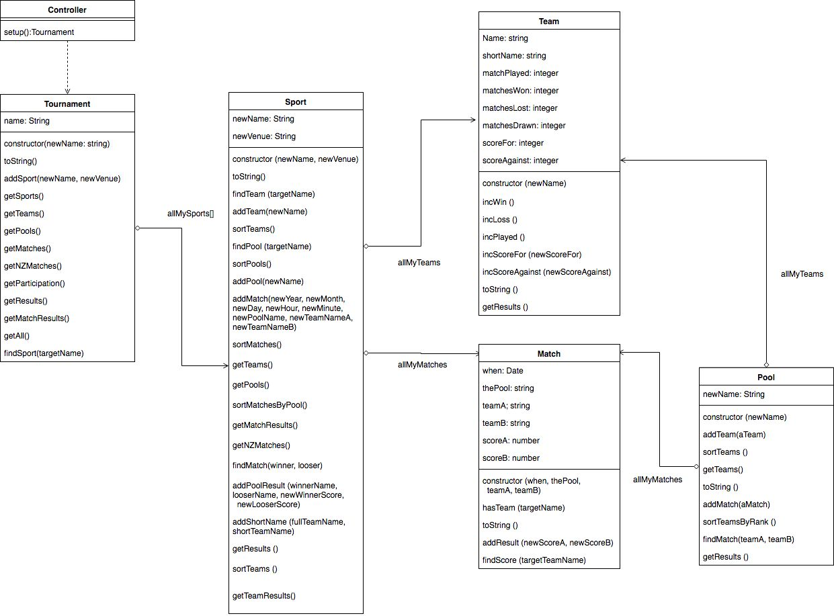

## Tasks:

|  |  |  |  |  |
| --- | --- | --- | --- | --- |
| Task | Description | Products | Time est: | Time Taken |
| Planning | * Complete Worksheet and Planning sheet | * Worksheet | 2 hours | 2.5 hours |
| Analysis: | * Look at HTML DOM Examples and Test possible element generation. * Look at some web pages and analyse structure * Build Class Diagram of existing System | * Class Diagram | 1 hour  30 mins  1hour | 40 mins  20 mins  1 hour |
| Designing: | * Build a wireframe. * Complete Complex algorithm sheet | * Wireframe * Algo worksheet | 30 mins  30 mins | 30 Mins |
| Building | * Creating Base Structures in Html Document (header/main/footer etc..) * Dynamically Generating Match Results * Dynamically Generating Team Results * Dynamically Generating All Match Results * Debugging | * Structured web page | 15 mins  30 mins  30 mins  40 mins | 20 mins  1 hour  30 mins  30 mins  15mins |
| Testing | * Check all Data is displayed through comparison * Run through standard Js. | * Tested Web page | 15 mins  30 mins | 30 mins  1 hour |

## Standard JS Log

For Standard JS Log please check the iteration folder for all text. All of the errors occurred are from using multiple files for each class, and not being able to independently port variables over as they treat each object independently. Other errors occurred are from pre-provided functions (setextensions.js). Fixing this will also be part of next iteration.

## Wireframe

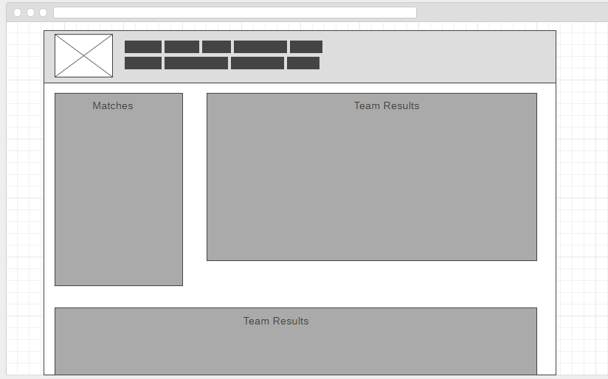

## Review:

### Mistakes:

I made the mistake of rushing into my dynamic creation as my first iteration, rather than taking a step back and looking at the code, which would have revealed that the code would need fixing to comply with standard js, and certain optimizations could be taken. For example, duplicate functions were found, as well as some results being questionably added to certain storage elements just before they are being returned into the page. Another mistake I made was my code adaption routine. I tried commenting out previous code and replacing them line by line, but it increased complexity unnecessarily, as well as ‘bloating’ the document. The last major mistake I made was not fixing the document structure first up. This added to more time spent necessary styling the document without a standardized structure.

### What I Will do Different Next Iteration

My adaption process will work side by side the function of the old code, but with a clear function to adapt in, rather than commenting out each line and adapting them. This approach will hopefully reduce confusion and possible editing of the wrong functions.