# Iteration 3

## Goal:

Add a menu to select a country colour scheme for the page

## Class Diagram of CountryStyle – New class for this iteration

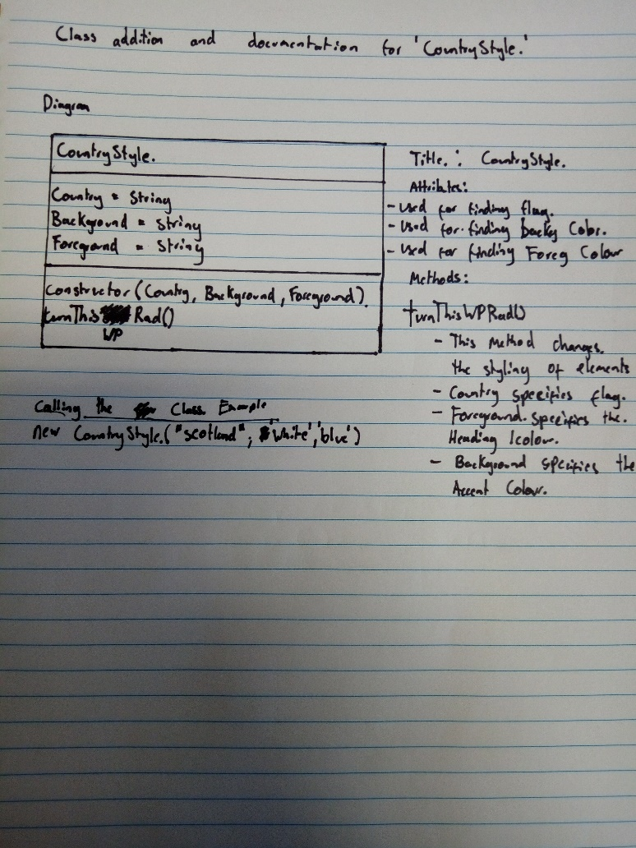

## Tasks:

|  |  |  |  |  |
| --- | --- | --- | --- | --- |
| Task | Description | Products | Time est: | Time Taken |
| Planning | * Complete Worksheet and Planning sheet | * Worksheet | 1 hour | 1.5 hours |
| Analysis: | * Create a class diagram for CountryStyle | * Class Diagram | 1hour  2 hours | 30 mins  2 hours |
| Designing: | * Create an activity diagram for how the webpage should change | * Activity Diagram * Algo worksheet | 30 mins  30 mins | 15 mins  30 Mins |
| Building | * Create CountryStyle class.   + Build Constructor   + Build the method to change style * Create class objects and store in allMyStyles * Create an html menu to select a country. * Add all images to folders | * Working assignment (Hopefully!). * A drop-down menu that will change styles | 15 mins  1 hour  15 mins  15 mins  30mins | 15 mins  1.5 hours  30 mins  20 mins  30 mins |
| Testing | * Run through standard js * Change between all styles and ensure no errors occur with colour changing. | * Tested Web page | 15 mins  10 mins | 30 mins  10 mins |

## Standard JS Log

Exceptions listed in the log below are technicalities that the system can’t pick up, not the fact that it isn’t in camel case. Notice the addition of one more variable that was added with the blurb.

Our new StandardJs log:

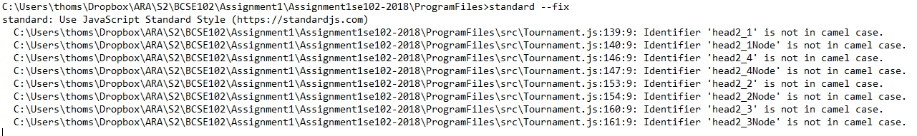

## Activity Diagram

## 

## Review:

### Mistakes:

The main mistakes I made were based on my initial development of the function that would change the styling of the webpage.

At first, I used 2 functions that would change the styling, but it made calling the changes strenuous and caused bloating of the html file. I then realized I had to develop a separate class to make adding new styles as easy as possible, and to reduce assigning global variables.

If I had taken the time to plan my approach with a more comprehensive approach, I could have avoided excess time being spent on the iteration.

I also made mistakes using branch merge in GitHub. I overwrote one of the files with an earlier version of it by not fixing conflicts properly. I will take care to manage this more carefully in the future

### What I Will do Different Next Iteration

Write a class diagram first, as analysis still seems to be a poor point in the process for me. Allocating more time to plan an approach will be beneficial for development time. Also taking care to back up and commit more regularly, as well as merging after I finish each iteration.