# Iteration 5: Controller

## Goal:

Implement a smart controller which loads data from an external json file

## Class Diagram of Controller with changes explained

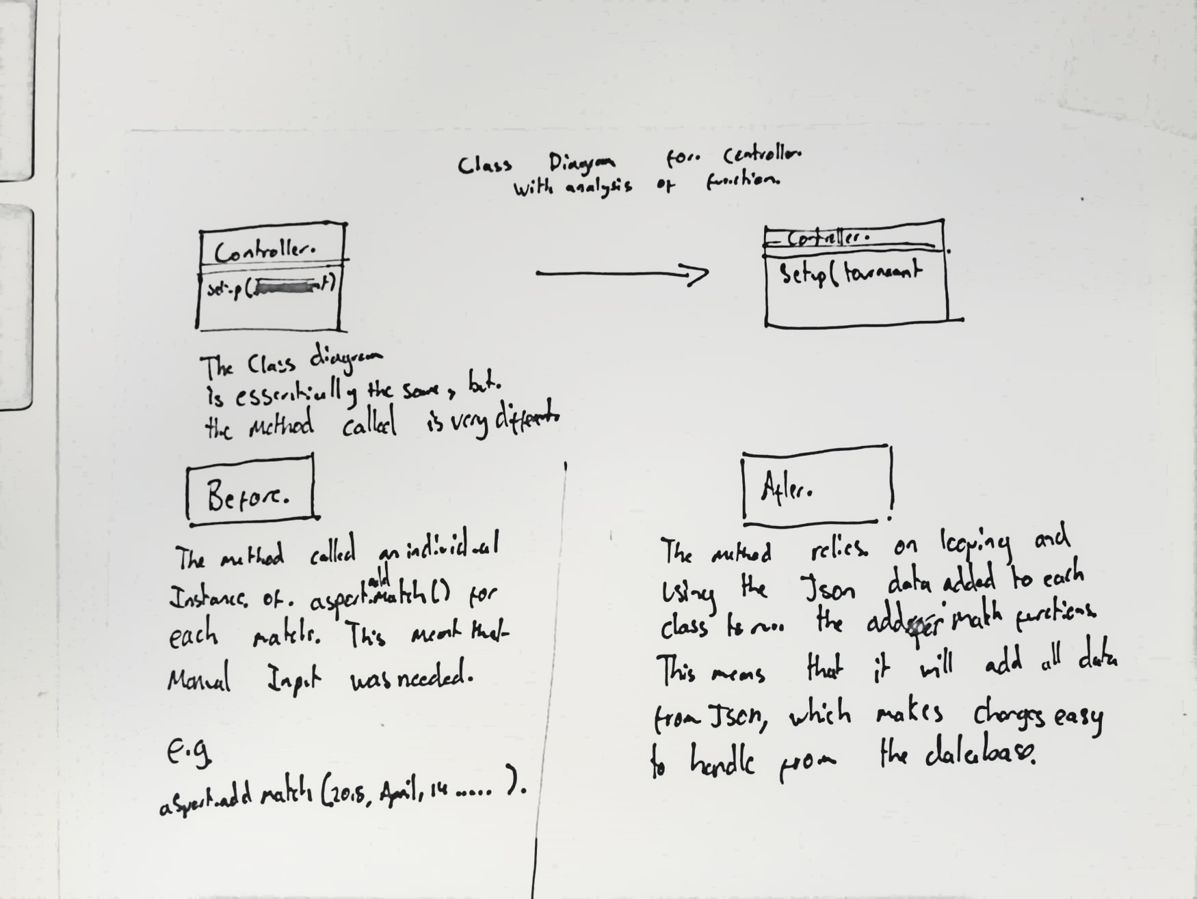

## Tasks:

|  |  |  |  |  |
| --- | --- | --- | --- | --- |
| Task | Description | Products | Time est: | Time Taken |
| Planning | * Complete Worksheet and Planning sheet | * Worksheet | 1 hour | 1 hours |
| Analysis: | * Create a comparison class diagram for controller * Complex algorithm worksheet | * Class Diagram * algorithm | 30mins  30 mins | 30 mins  30mins |
| Designing: | * create activity diagram | * Pseudocode | 30 mins | 15 mins |
| Building | * Create Callable functions to loader support * Edit controller to remove add matches and load it from file * Edit index to support the new loading method | * Working assignment (Hopefully!). * Fileloader script file | 30 mins  30 mins  30mins | 40 mins  1 hours  30mins |
| Testing | * Run through standard js | * Tested Web page | 15 mins | 15 mins |

## Standard JS Log

Exceptions listed in the log below are technicalities that the system can’t pick up, not the fact that it isn’t in camel case.

Our new StandardJs log:

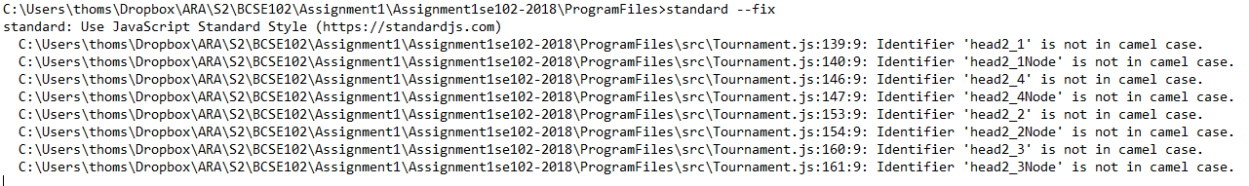

## Activity Diagram

## C:\Users\thoms\Downloads\41045844_283662905797637_8095924051999981568_n.jpg

## Review:

### Mistakes:

I made a few mistakes due to the increased complexity of my program as it grows. I had issues with reused variable names and appending to an improper div structure.

My naming techniques for html elements are inconsistent, which has lead to me implementing the results to a wrong div and in general not behaving like intended.

I also made the mistake of fragmenting my function base for the reading of json data within 2 separate files. This made editing and debugging more sluggish, but my time limit pressured me to leave them as they were for refactoring in a later iteration.

### What I Will do Different Next Iteration

Variable tables may be a suitable step to manage variable calling and creation to manage during planning and coding.