# Iteration 6: Wrapping up

## Goal:

Clean up Visual and Backend Polish for final iteration and Implement new Styling Elements from iteration 4

## Class Diagram of Complete System

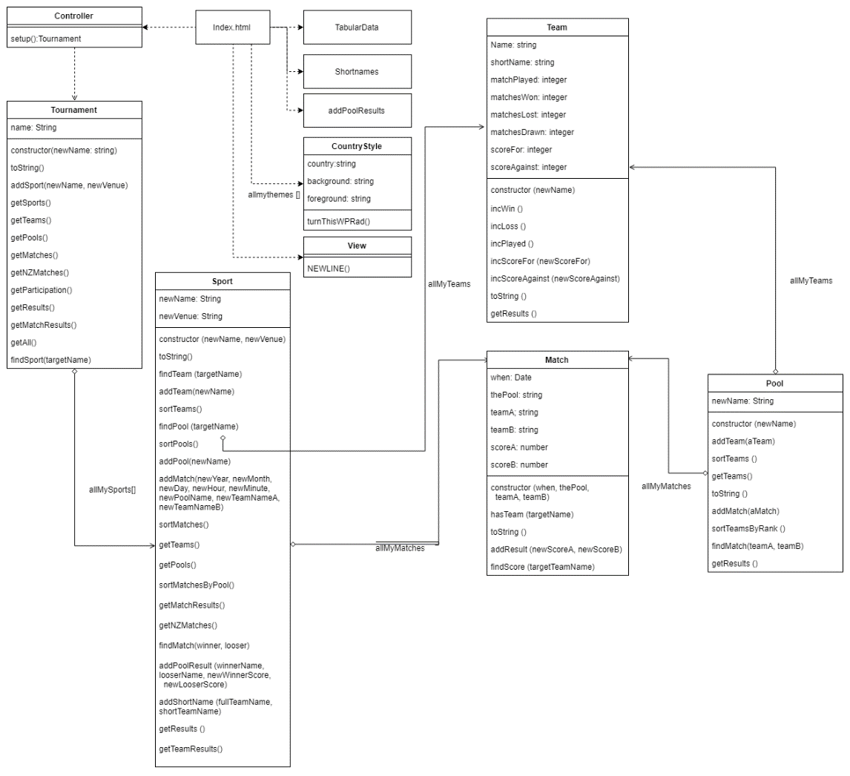

## Tasks:

|  |  |  |  |  |
| --- | --- | --- | --- | --- |
| Task | Description | Products | Time est: | Time Taken |
| Planning | * Complete Worksheet and Planning sheet | * Worksheet | 1 hour | 1 hours |
| Analysis: | * Create a complete system diagram with all added files during development | * Class Diagram | 30 min | 15 mins |
| Designing: | * Create wireframe for grid additions | * Wireframe * Algo worksheet | 30 mins  30 mins | 30 mins  30 Mins |
| Building | * Create a dynamically styled navigation bar with jump to functions * Implement Grid into CSS (Replace Flexbox) * Style new elements of table implemented in iteration 4 * Comment and ensure documentation for all new files are complete | * Working assignment (Hopefully!). * Fully finished polished webpage | 30 mins  40 mins  30 mins  15mins | 45 mins  1.5 hours  30 mins  15mins |
| Testing | * Run through standard Js * Verify HTML validity * Verify CSS Validity | * Tested, Html and CSS Valid Web page ( check verification subfolder) | 15 mins  10 mins  10 mins | 30 mins  10 mins  10 mins |

## Standard JS Log

Exceptions listed in the log below are technicalities that the system can’t pick up, not the fact that it isn’t in camel case.

Our Final StandardJs log:

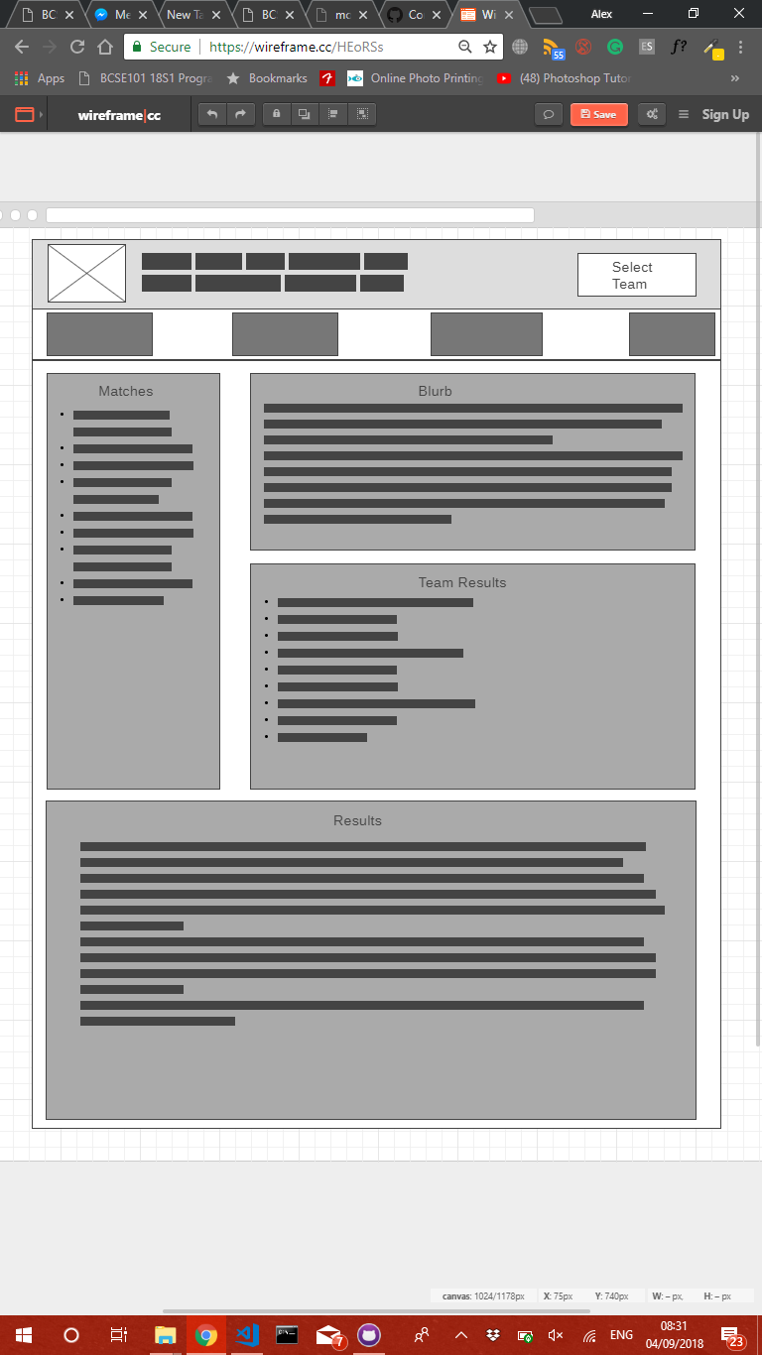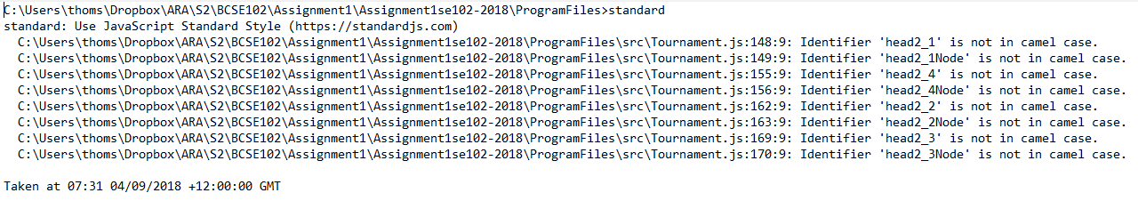Wireframe

## Review:

### Mistakes:

I did not think about page structure when implementing my Nav division in index.html. this resulted in adverse styling, with no background, which caused great annoyance. I had to add a parent division to fix this.

Another issue I faced with the nav bar was the fact that the blurb was appended to the team results div. This made the jump to for team results always go to the blurb, not the team results as expected. I had to add a new parent div for blurb to make it jump correctly

It seems these issues are a result of improper analysis of html box theory. This maybe a result of the hierarchy being compromised because of dynamic generation, whereas standard html is more easily visible and analyzable.

### What I have learnt from this Iteration and this Assignment.

I have learnt that planning is incredibly important in software development as it helps streamline productivity and ensure a well-polished and implemented product. It is important to take care in the planning stage, as improper planning may result in setbacks, more so than with no planning at all. In future assignments and projects, I will take care not too rush through to coding, as a lot of time earlier in this project could have been saved with proper planning.

I also found the use of GitHub incredibly effective throughout this assignment. In future assignments, I will use features such as branching and merging and committing more consistently to allow for more efficient and effective version control.