# Iteration 1

## Goal:

To create custom sprites to fit the CHCH brief

## Class Diagram of Starting System

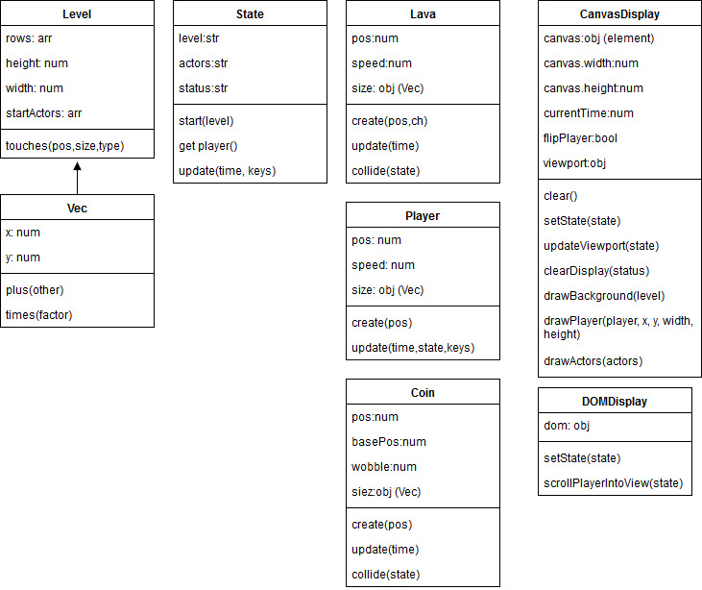

## Tasks:

|  |  |  |  |  |
| --- | --- | --- | --- | --- |
| Task | Description | Products | Time est: | Time Taken |
| Planning | * Complete Worksheet and Planning sheet | * Worksheet | 2 hours | 1 hour |
| Analysis: | * Analyse Existing images * Build Class Diagram of existing System | * Class Diagram | 1 hour  30 mins | 40 mins  20 mins |
| Designing: | * Decide Theme of characters/ sprites and blocks * Complete Complex algorithm sheet | * Wireframe * Algo worksheet | 30 mins  30 mins | 30 Mins |
| Building | * Edit Images to requirements | * Themed characters | 1.5 hrs | 1.5 hours |
| Testing | * Check Items display properly * Run through standard Js. | * Tested Web page | 15 mins  30 mins | 30 mins  30 mins |

## Standard JS Log

For Standard JS Log please check the iteration folder for all logs.

## Character and Sprite Ideas

|  |  |  |
| --- | --- | --- |
| Character | Other Sprites | Background |
| * Construction worker * Wants to clear work site of cones | * Collectible: red Cone * Solid: Gothic stone Brick * Dangerous: Liquefaction | ???? |

## Review:

### Mistakes:

I decided to start editing images straight away, rather than deciding on a theme first. This led to multiple versions and ideas I wanted to try with the characters, which took a long time to fix and edit them after I decided on a change as they were flattened.

### What I Will do Different Next Iteration

I will use Photoshop files and layering to introduce a version control with layers, so changes can be made to the sprites if necessary, as well as a rollback feature. I will also discuss themes and decide on sprites before I start editing them to reduce time spent on them