**Weather App**

**By Tosun Mihai-Alexandru Informatics in English Year 2, Group 1**

**Abstract Description**

During this semester I will develop one Android application in Android Studio using multiple tools that try make people’s lives easier.

## Introduction

Weather App will be one mobile app for Android devices, designed for helping people fast to know how is weather in different locations around the globe.

## Target Audience

The app will easy target a large public because it is very practical for all types of people. Whenever someone want to travel to other city or decided to make a spontaneous journey just need to search the location and the app would show the temperature in real time.

## Similar Applications

**The Weather Channel** which is probably the most used app for weather in the world with +100 millions downloads.

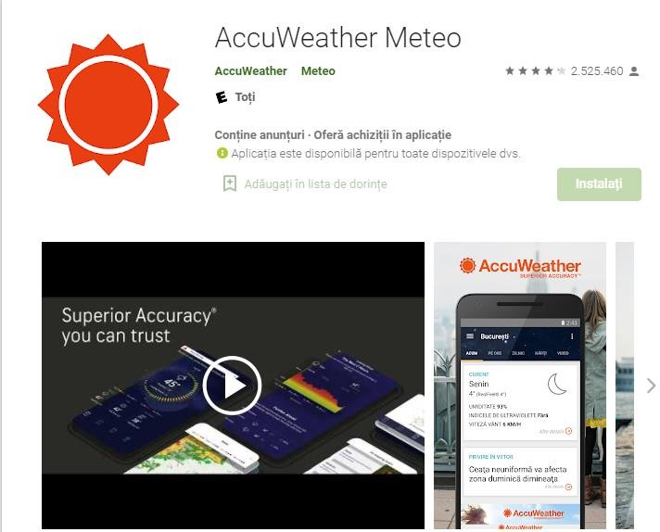**AccuWeather Meteo** is other application for weather with

### +100 millions downloads and

4.2 rating.

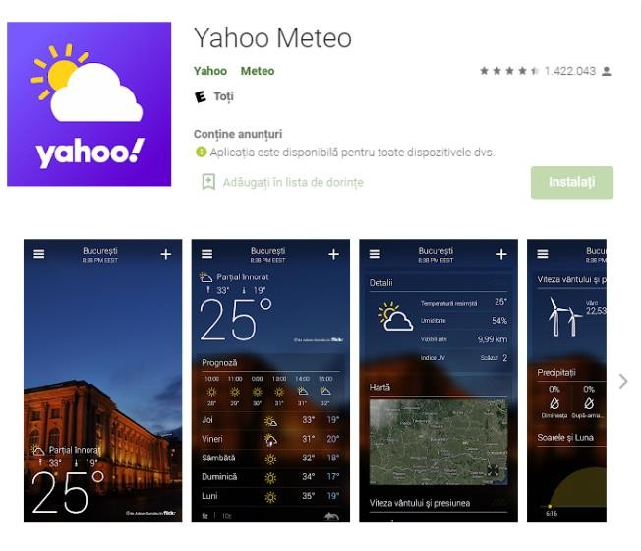**Yahoo Meteo** with +10 millions downloads and 4.6 rating.

## The Author’s contribution

The idea is clearly implemented in that moment, but there are few things and functions that would be originals and the code will be my own contribution.

## Design of the application

## This is the main screen of the application. It shows the temperature of the searched city. The image in the background is illustrated for the weather in that city. To search for another city, you must press the button below to move to the next screen

## The search screen is basically simple with one button upper left and the place where you need to write the city. After searching, application will go back to main screen where the data will be updated.

## 5.References

#### Youtube

* + Magazin Play
  + Stack overflow