Reader Disagreement Identifies Residual Diagnostic Risk in Automated Arrhythmia ECG Interpretation

Khanh Duy Tran
School of Electrical Engineering, International University – Vietnam National University, Ho Chi Minh City, Vietnam

Disclosures: The author has nothing to disclose.

Reader disagreement during electrocardiographic (ECG) interpretation may signal cases near diagnostic boundaries, yet conventional evaluation typically reduces the adjudication process to a single final reference label, discarding information about how readily consensus was reached. Automated ECG interpretation has shown strong performance in rhythm and conduction diagnosis, particularly for arrhythmias, and has increasingly been extended to derive clinically relevant information beyond categorical classification.^{1,2} Prior work has demonstrated limited expert agreement in difficult AI–reader discordant ECGs, while uncertainty estimation can support referral of lower-confidence automated interpretations for expert review.^{3,4} We therefore first evaluated whether uncertainty-based referral reduced the overall burden of automated diagnostic error and then examined whether the excess patient-level error risk associated with reader disagreement declined in parallel or persisted across retained coverage.
This retrospective secondary analysis used the Clinical Outcomes in Digital Electrocardiology (CODE) datasets from the Telehealth Network of Minas Gerais, Brazil, comprising standard 12-lead ECGs acquired predominantly with TEB ECGPC or ErgoPC 13 devices.¹ CODE-15%, including 345,779 ECGs from 233,770 patients recorded between 2010 and 2016, served as the model-development cohort.⁵ Independent evaluation used CODE-test, an arrhythmia- and conduction-focused set of 827 ECGs from 827 patients collected in 2018. Each ECG was independently interpreted by 2 cardiologists for 6 prespecified rhythm and conduction diagnoses, with disagreements adjudicated by a third senior specialist.¹ The analysis used only publicly available, de-identified data; the source CODE study was approved by the Research Ethics Committee of the Universidade Federal de Minas Gerais (protocol 49368496317.7.0000.5149).¹
An ensemble of 5 lightweight 1-dimensional convolutional neural networks with the same architecture was trained using different random seeds, and their predicted probabilities were averaged. Following prior work, model confidence was defined from the diagnosis-specific decision threshold, and whole ECGs were referred according to their least confident diagnosis.³
For each ECG, confidence was defined by its least confident diagnosis, and progressively lower-confidence ECGs were referred according to the previously described uncertainty framework.³ Error burden was defined as the proportion of retained ECGs containing at least 1 incorrect diagnosis among the 6 labels. Reader disagreement was then examined in relation to this error burden. The primary comparison used a risk ratio (RR) to compare the occurrence of any model error between ECGs with reader disagreement and those with reader consensus, while a prevalence ratio (PR) descriptively quantified enrichment of reader disagreement among ECGs containing any model error relative to the overall cohort. Confidence intervals were estimated by bootstrap resampling of whole ECGs, preserving all 6 labels within each ECG.
Diagnostic errors were concentrated in the lowest-confidence ECGs. At full coverage, 61 of 827 ECGs (7.4%) contained at least 1 diagnostic error, decreasing to 40 ECGs (5.1%) at 95% coverage and 29 ECGs (3.9%) at 90% coverage (Figure 1A). This progressive reduction in error burden as lower-confidence ECGs were referred indicates that confidence distinguished more from less reliable automated ECG interpretations.
Across 80% to 100% coverage, ECGs with reader disagreement maintained a consistently higher patient-level diagnostic error rate than those with reader consensus (Figure 1B), rather than the excess risk emerging only as lower-confidence ECGs were added. The mean error-risk difference across this range was 26.4 percentage points (95% CI: 6.4–49.7).
At full coverage, any diagnostic error occurred in 11 of 33 ECGs with reader disagreement (33.3%) compared with 50 of 794 ECGs with reader consensus (6.3%; RR: 5.29; 95% CI: 2.70–8.85). This full-coverage association was significant by two-sided Fisher exact test (P<0.001). Reader disagreement was uncommon overall, occurring in 33 of 827 ECGs (4.0%), but was present in 11 of 61 ECGs containing any diagnostic error (18.0%; PR: 4.5; 95% CI: 2.6–6.8). Thus, reader disagreement was enriched among error-containing ECGs and marked a subgroup with persistently greater diagnostic error risk across the examined referral range.
In 9 of the 11 ECGs with both reader disagreement and diagnostic error, the error involved the disputed diagnosis; in the remaining 2, it involved a different diagnosis. Thus, disagreement most often marked difficulty in the same diagnostic decision, while occasionally reflecting broader interpretive difficulty. Disagreement should not be interpreted as evidence that the adjudicated reference was incorrect, but rather as a marker of an interpretive boundary where independent cardiologists did not initially converge, consistent with prior expert readjudication of difficult AI–reader discordant ECGs.⁴
Uncertainty-based referral reduced overall error burden but did not eliminate the excess risk associated with reader disagreement. Automated diagnostic uncertainty supports referral, whereas reader disagreement marks residual diagnostic difficulty that persists after lower-confidence ECGs are excluded. In arrhythmia assessment, these findings suggest that a single inconclusive tracing may prompt repeat or longitudinal evaluation. More broadly, collapsing expert annotations into one adjudicated label discards information about label reliability; preserving individual reader labels and adjudication history may therefore improve evaluation of automated ECG systems. This retrospective analysis was based on a modest number of disagreement ECGs; therefore, the findings warrant confirmation in larger cohorts.
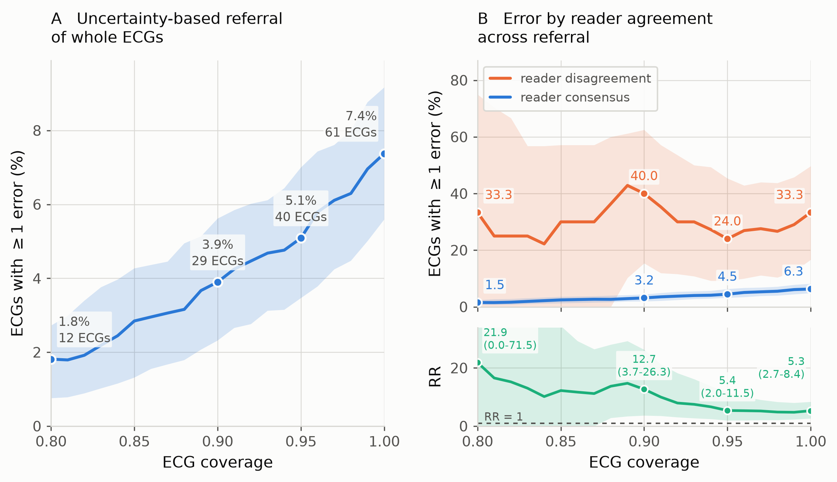
Figure 1. Uncertainty-Based Referral and Reader Disagreement in Automated ECG Diagnosis. (A) Error burden across uncertainty-based whole-ECG referral using the least confident diagnosis to define ECG-level confidence. (B) Patient-level diagnostic error across retained coverage, stratified by reader disagreement versus consensus. The corresponding risk ratio (RR) compares both groups; the dashed line denotes RR = 1. Circles mark annotated coverage levels; shading represents 95% ECG-level bootstrap confidence intervals.
References
1. Ribeiro AH, Ribeiro MH, Paixão GMM, et al. Automatic diagnosis of the 12-lead ECG using a deep neural network. Nat Commun. 2020;11:1760.
2. Wei G, Di X, Zhang W, et al. Estimating critical values from electrocardiogram using a deep ordinal convolutional neural network. BMC Med Inform Decis Mak. 2022;22:295.
3. Vranken JF, van de Leur RR, Gupta DK, et al. Uncertainty estimation for deep learning-based automated analysis of 12-lead electrocardiograms. Eur Heart J Digit Health. 2021;2:401–415.
4. Mayourian J, La Cava WG, de Ferranti SD, et al. Expert-level automated diagnosis of the pediatric ECG using a deep neural network. J Am Coll Cardiol EP. 2025;11:1308–1320.
5. Ribeiro AH, Paixão GMM, Lima EM, et al. CODE-15%: a large scale annotated dataset of 12-lead ECGs. Zenodo. Published June 9, 2021. https://doi.org/10.5281/zenodo.4916206.

