# GIATA Mapping



GIATA Country

Uastralia

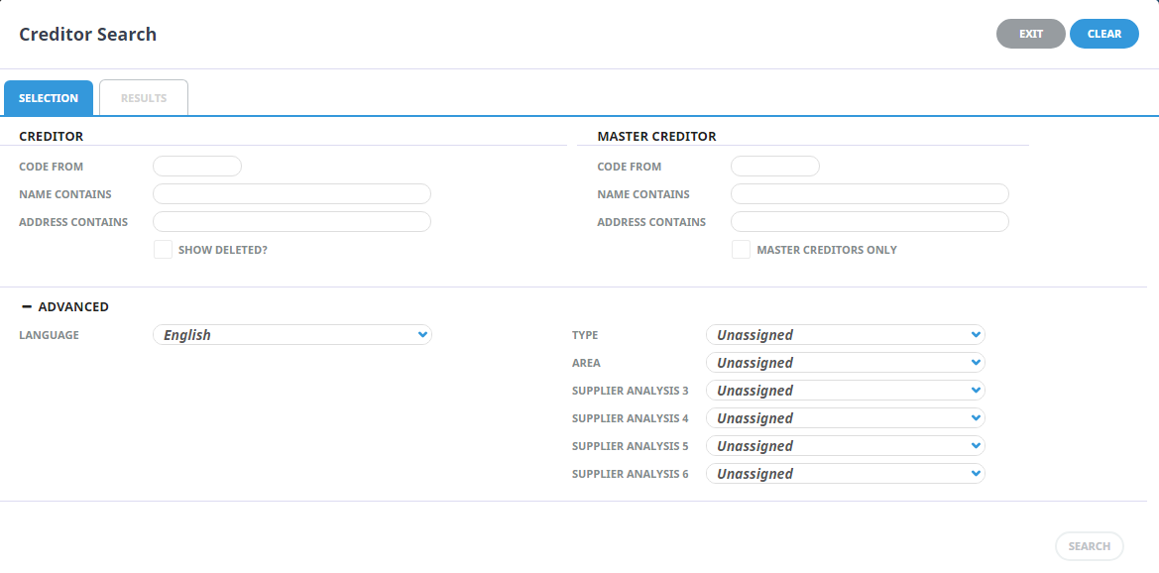

Tourplan Supplier Search

# GIATA Mapping

|  |  |  |  |  |
| --- | --- | --- | --- | --- |
| TOURPLAN SUPPLIER | | |  | GIATA SUPPLIER |
| NAME | **ADDRESS1** | **ADDRESS2** | **MATCH** | **NAME & CITY** |
| Aarons Hotel | 12 Main St | Sydney | ✓ | Aarons Hotel  Sydney |
| Hilton Hotel Darling Harbour | 1 Darling Harbour | Sydney | ✓ | Hilton Darling Harbour, Sydney |
| Novotel Darling Harbour | 15 Wharf St | Sydney | ✓ | Novotel Darling Harbour, Sydney |
| Sheraton Manly | 14 Main St | Sydney | 🗶 | NO MATCH FOUND |
| Westin Apartments | 12 Queen St, The Rocks | Sydney | ✓ | Westin Apartments The Rocks,  Sydney |



**EDIT**

**EDIT**

**EDIT**

**EDIT**

**EDIT**

# GIATA Hotel Selection

|  |  |  |  |
| --- | --- | --- | --- |
| HOTEL NAME | CITY | COUNTRY |  |
| Aarons Hotel | 12 Main St | Sydney |  |
| Hilton Hotel Darling Harbour | 1 Darling Harbour | Sydney |  |
| Novotel Darling Harbour | 15 Wharf St | Sydney |  |
| Sheraton Manly | 14 Main St | Sydney |  |
| Westin Apartments | 12 Queen St, The Rocks | Sydney |  |

**SELECT**

**SELECT**

**SELECT**

**SELECT**

**SELECT**