**Note**: All buttons created will be in the Tour Plan style. For designing and layout purposes I have just used word shapes as close to the real buttons and styles as possible

# Mapping tool

## Search Screen

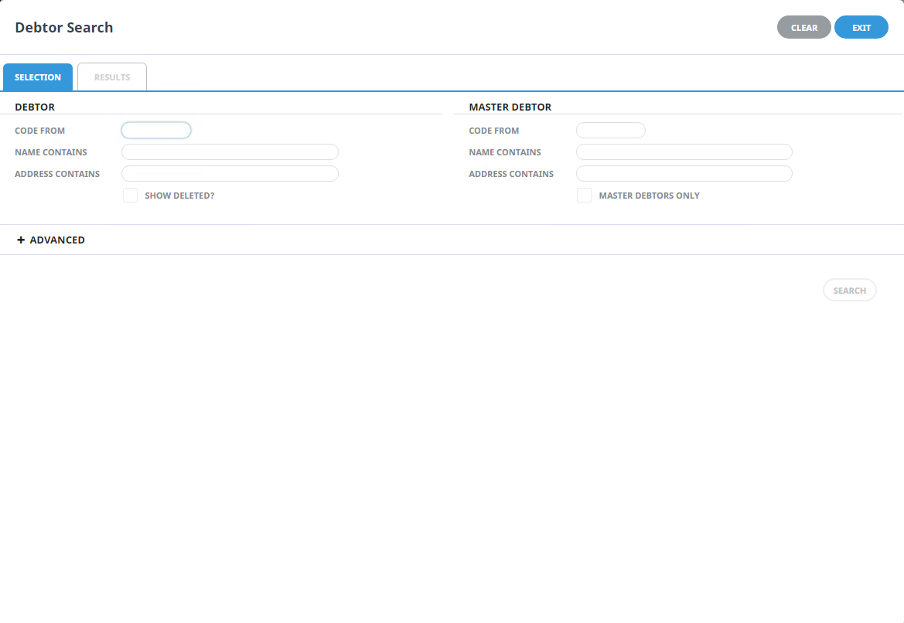Similar to the Creditor Search Function in NX

Tourplan Supplier Search

**SEARCH ALL**

Changes from original design:

1. No selecting by Giata Country.   
   In the initial stages of planning we thought that we could improve performance by limiting the search results to be by country. This ended up not being needed as we have now integrated the Mapping Giata project with the new Tourplan Media Library Platform.

The supplier search will work in the same way as a Creditor search will work as this functionality has already been built.

1. The extra option for the searching of all Tourplan suppliers

If the client (APTC) wants to view all their suppliers as opposed to specific ones then this will be available

## Results and mapping Screen

Similar to the results tab in Creditor search

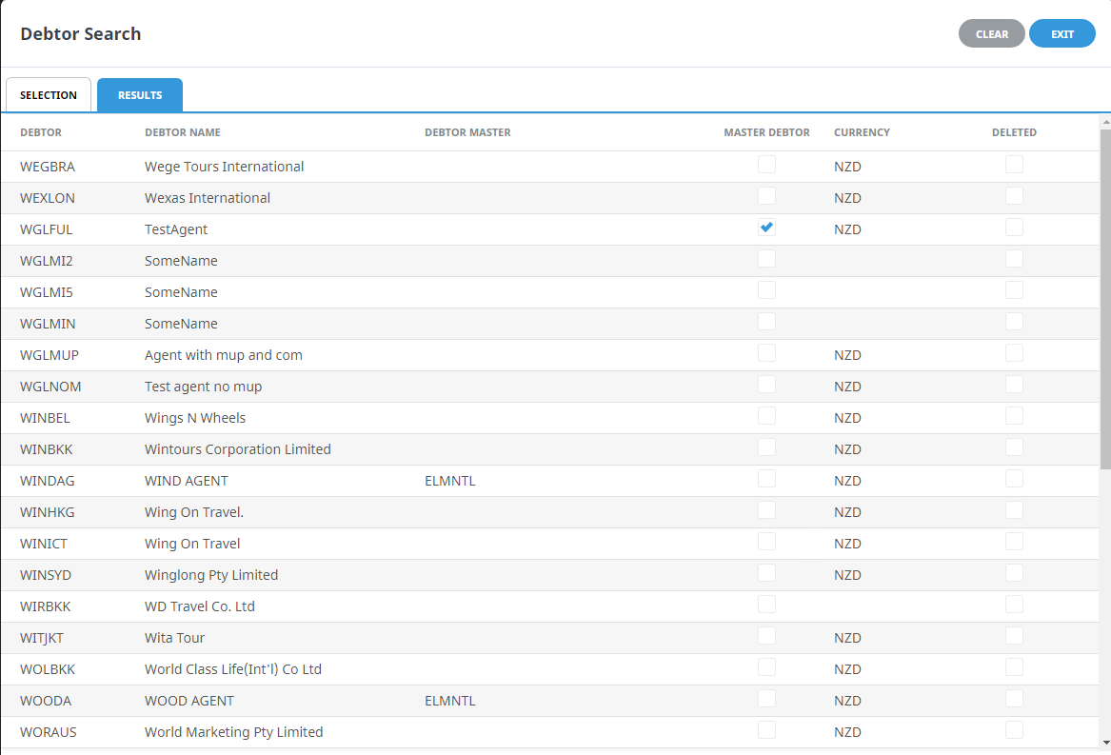

Tourplan Supplier Search

**SAVE ALL**

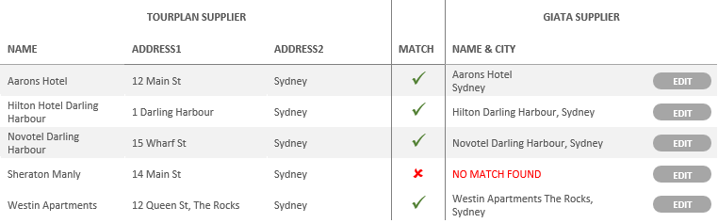

**SAVE**

**SAVE**

**SAVE**

**SAVE**

**SAVE**

Changes from original design:

1. Individual saves for all matched pairings

If the client (APTC) wanted to save just an individual match then they can by clicking the save button next to the pairing

1. Limiting the amount of information the client sees through the use of pages

By limiting the amount that the client can see they will not get over-whelmed by all suppliers and their matched partner. It also provides a way for the client to go through the matches in sections without having to do the whole lot in one. If the client does want to just push through all the matches then that can be done too through the save all button.

Questions:

* Do you want to see client suppliers that have already been matched, or just all unmatched? (Or option for one or the other?)
* Thoughts on some changes to the labels:
  + “GIATA SUPPLIER” should be changed to “TOURPLAN GLOBAL SUPPLIERS”
    - This change should happen as it is not specific Giata supplier data we are getting, rather the supplier data is coming from Tourplan Global Suppliers
  + “TOURPLAN SUPPLIER” should be changed to “APTC SUPPLIERS” ( “(client) SUPPLIERS”)
    - Should be made more specific to the client and comparing “TOURPLAN SUPPLIER” to “TOURPLAN GLOBAL SUPPLIERS” could get confusing for the client.

Tourplan Global Supplier Selection screen

# Tourplan Global Hotel Selection

|  |  |  |  |
| --- | --- | --- | --- |
| HOTEL NAME | CITY | COUNTRY |  |
| Aarons Hotel | 12 Main St | Sydney |  |
| Hilton Hotel Darling Harbour | 1 Darling Harbour | Sydney |  |
| Novotel Darling Harbour | 15 Wharf St | Sydney |  |
| Sheraton Manly | 14 Main St | Sydney |  |
| Westin Apartments | 12 Queen St, The Rocks | Sydney |  |

**SELECT**

**SELECT**

**SELECT**

**SELECT**

**SELECT**

Questions:

* Should I change the Selection title to “Tourplan Global Hotel selector”?